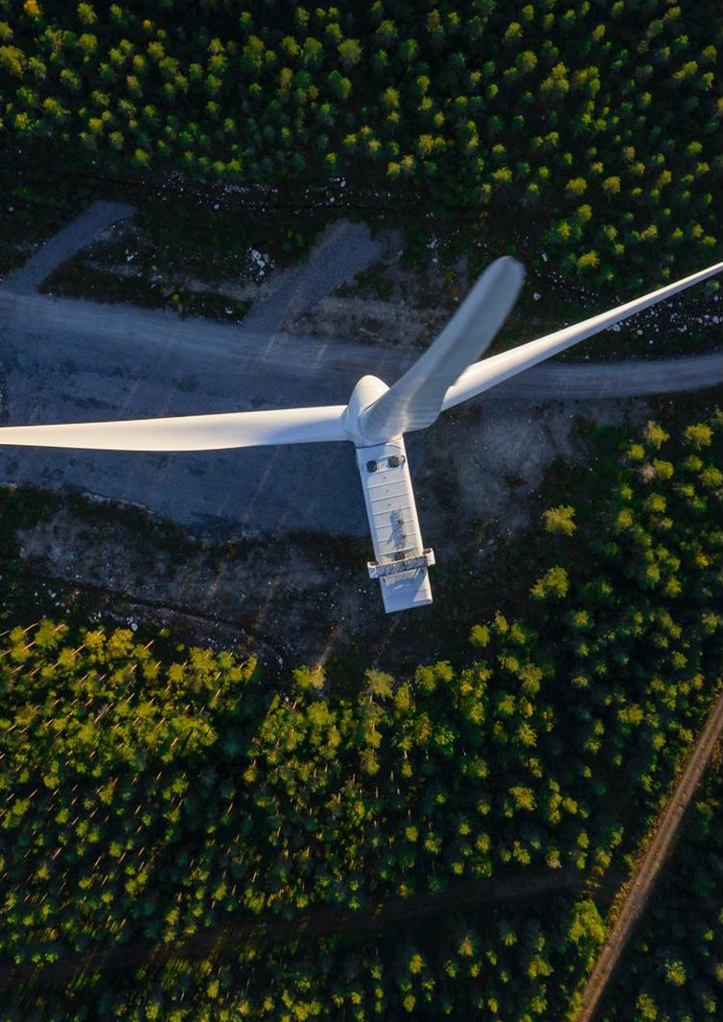


ENVIRONMENTAL IMPACT REPORT
Wind Energy Park 48 (46) Wind Farms approx. 316.8MW (303.6MW), Transformer Stations, Electrical Connection Networks, Construction and Modernization of Communication and Access Routes

loc. Cerchezu, Constanța County
Beneficiary:
South Wind SRL
Report title:
Environmental Impact Report
Date
December 2025



Document control sheet

Project | "Wind Energy Park 48 (46) Wind approx. 316.8MW (303.6MW), Transformer stations, Electrical connection networks, construction and modernization of communication and access routes"
Contracting Entity | South Wind SRL
Service Provider | SC Ramboll South East Europe SRL
Version | [Final version]
Date | December 2025
Document title | Environmental impact report

Prepared by: | Vlad Dinu  Ruxandra Florentina Buga Oana Falup  Nicoleta David  Andreea Bianca Badea
Verified by: | Gabriela Mușat
Approved | Ileana Fălcescu

2

Table of contents

- INTRODUCTION 7
- PROJECT OWNER 8
- PROJECT DESCRIPTION 8
  - Overview of the project 8
  - Project location 11
  - Description of the physical characteristics of the project 12
    - Current situation 12
    - Main stages of the project 13
    - Project implementation schedule 13
    - Transport route for turbine components 14
    - Foundations 14
    - Technological platforms 15
    - Wind turbines 15
    - Transformer station 16
    - Underground power lines 17
    - Work required for site organization 18
    - Demolition work 20
    - Site restoration work 21
    - Information on the nature and quantity of materials and natural resources used, including water, land, soil, and biodiversity 21
  - Technological processes 22
    - Technology used 22
    - Production profile and capacity 23
  - Planning/spatial planning 24
  - Estimation of the type and quantities of emissions and waste 25
    - Emissions into surface water and groundwater 25
    - Atmospheric emissions 25
    - Soil and subsoil contamination 27
    - Noise and vibrations 28
    - Waste 30
- ANALYSIS OF FEASIBLE ALTERNATIVES 34
  - Alternative "0" 34
  - Alternatives identified and studied 35
- DESCRIPTION OF RELEVANT ASPECTS OF THE CURRENT STATE OF THE ENVIRONMENT 37
  - Social and economic environment 37
    - Study area 37
    - Population size and structure 37
    - Health status 39
    - Economic aspects 43
  - Biodiversity 44
    - Presentation of the project's intersection areas with protected natural areas 45
    - Presentation of the project's neighbouring areas with protected natural areas 46
    - Green Infrastructure 56
    - Migration Color 57
    - Information about local flora and fauna 65
  - Soil/subsoil and land use 92
    - Study area 92
    - General information on soil/subsoil 93
    - Current condition of the soil/subsoil in the site area 94
    - Land use 96
  - Water/Water bodies 98
    - Study area 98
    - Surface water 98
    - Groundwater 102
  - Air 104
    - Study area 104
    - Brief description of existing pollution sources in the project area 104
    - Current state of air quality 107
  - Noise 110
    - Study area 110
    - Brief description of existing pollution sources in the project area 111
  - Cultural conditions and cultural heritage 11
    - Study area 112
    - Description of the project in relation to elements of cultural heritage 112
    - Intangible cultural heritage 113
  - Landscape 114
    - Study area 114
    - Project location and landscape types 114
    - Landscape fragmentation 116
    - Topography 117
  - Brief description of the likely evolution of the state of the environment if the project is not implemented 117
- DESCRIPTION OF ENVIRONMENTAL FACTORS LIKELY TO BE SIGNIFICANTLY AFFECTED BY THE PROJECT
120
- POTENTIAL IMPACT, INCLUDING CROSS-BORDER IMPACT, ON
ENVIRONMENTAL COMPONENTS – who is responsible for which factor 123
  - Identification of effects and forms of impact 123
    - Project construction and operation 123
    - Use of natural resources 124
    - Technologies and substances used 124
    - Emissions of pollutants, noise, vibrations, light, heat, and radiation, creation of
discomfort, waste disposal and recovery 125
    - Risks to human health, cultural heritage, or the environment (e.g., due to accidents or disasters) 125
    - Climate change 125
  - Social and economic environment 125
    - Sensitivity class and magnitude classes for assessing the potential impact on the social and economic environment, including on public health 125
    - Impact forecast 130
    - Measures to avoid and reduce impact 134
  - Biodiversity 134
    - Sensitivity classes and magnitude classes for assessing the impact on biodiversity 13
    - Conclusions of the Appropriate Assessment Study 138
    - Impact forecasting 139
    - Measures to avoid and reduce impact 174
  - Soil/Subsoil 181
    - Sensitivity classes for assessing impact on soil/subsoil 181
    - Magnitude classes for assessing impact on soil/subsoil 182
    - Impact prediction 183
    - Measures to avoid and reduce impact 187
  - Water/water bodies 187
    - Sensitivity classes and magnitude classes for water 187
    - Impact prediction 189
    - Impact avoidance and mitigation measures 194
  - Air 195
    - Sensitivity and magnitude classes 195
    - Significance thresholds 196
    - Impact forecasting 196
    - Measures to avoid and reduce impact 203
  - Impact generated by noise and vibrations 203
    - Sensitivity classes and magnitude classes for assessing the impact of noise and vibrations 203
    - Significance thresholds 204
    - Impact prediction 204
    - Measures to avoid and reduce impact 212
  - Cultural conditions and cultural heritage 212
    - Sensitivity classes and magnitude classes for assessing impact on cultural heritage 212
    - Impact forecasting 213
    - Measures to avoid and reduce impact 215
  - Landscape 215
    - Sensitivity and magnitude classes for assessing landscape impact
215
    - Impact forecast 217
    - Impact avoidance and reduction measures 221

Cumulative impact of the project 222
    - Existing/planned projects in the analyzed area 22
    - Cause-and-effect mechanisms for cumulative impact analysis 225
    - Level of current pressures 229

Climate change 229
    - Climate change mitigation (climate neutrality) 230
    - Climate Change Adaptation Review (STAGE 1 Analysis) 230
      - Sensitivity 230
      - Exposure 234
      - Vulnerability 252
    - Detailed analysis for adaptation to climate change (STAGE 2 of analysis)
. 255
      - Probability analysis 255
      - Severity and risk analysis 256
      - Identification of options for adaptation to climate change 259

Impact in a transboundary context 263
- DESCRIPTION OF FORECASTING METHODS 274
VIII.1.
Description of the methodology used to assess the environmental effects of the project 274
VIII.
Description of the methodology used to assess the impact on
climate change 281
VIII.3.
Description of the methodology used to assess the impact on protected natural areas 292
- MEASURES TO AVOID AND REDUCE IMPACT AND MONITORING –
each responsible for which factor 298
  - Measures to avoid and reduce significant environmental impact 298
  - Monitoring 299
- RISK SITUATIONS 306
  - Introduction 306
  - Compliance with safety distances 306
    - Safety distance from public roads of national or county interest .309
    - Safety distance from municipal or local public roads 309
    - Safety distance from railways 309
    - Safety distance from overhead power lines (LEA) and telecommunications lines
309
    - Safety distance from bridges 309
    - Safety distance from dams 310
    - Safety distance from residential buildings 310
  - Other risks 310
    - Seismic risk 310
    - Landslide risk 312
    - Lightning risk 312
    - Risk of strong winds 313
    - Fire risk 314
    - Risk of flying debris or ice 315
- NON-TECHNICAL SUMMARY 317
Project overview 317
Project location 317
Project characteristics 317
Raw materials and natural resources 317
Estimation of the type and quantities of emissions and waste 318
Description of relevant aspects of the current state of the environment 318
Description of significant environmental effects due to the project 319
Analysis of reasonable alternatives 319
- BIBLIOGRAPHY 321
- Appendices
322

INTRO

The name of the project is "Wind farm 48 (46) wind turbines approx. 316.8MW (303.6MW), transformer stations, connection networks, construction and modernization of communication and access roads," proposed to be located outside the town of Cerchezu, Constanța County.
For the construction of the wind farm, urban planning certificate no. 129/28.11.2022 was issued with extended validity extended validity, by the Constanța County Council.
According to the initial assessment decision no. 54/07.02.2025, issued by the Constanța Environmental Protection Agency, the following is stated:
- the project falls under Law 292/2018, falling under Annex no. 2, point 3, letter i) "Installations for the production of energy from wind power" and 10 e - "construction of roads, ports, and port facilities, including fishing ports, other than those provided for in Annex No. 1";
- the proposed project falls under Article 28 of Government Emergency Ordinance No. 57/2007 on the regime of protected natural areas, the conservation of natural habitats, wild flora and fauna, as subsequently amended and supplemented. The project site is located approximately 2.8 km from the boundary of the ROSAC007 I Dumbrăveni - Valea Urluia - Lacul Vederoasa site, approximately 6.3 km from ROSPA0l 66 Plopeni - Chimogeni, approximately 7.2 km from ROSPA0036 Dumbraveni, approximately 14.4 km from ROSACO157 Hagieni Forest Cotul Văii, approximately 18.6 km from ROSPA0094 Hagieni Forest, ROSPA0l 51 Ciobăniţa Osmancea, approx. 19.4 km from ROSPA000I Aliman-Adamclisi, approx. 410 m from the protected natural area BG0000569 Kardam and approx. 3.64 km from the protected natural area BG0000570 Izvorovo Kraiste;
- The proposed project does not fall under the provisions of Articles 48 and 54 of Water Law No. 107/1996, as amended and supplemented.
- The project falls under Law No. 22 of February 22, 2001, ratifying the Convention on Environmental Impact Assessment in a Transboundary Context, adopted in Espoo on February 25, 1991, as amended and supplemented, being included in Annex 1, point 22.
- According to the Framework Stage Decision issued by DJM Constanța, the Wind Farm Project 48 (46) wind turbines approx. 316.8MW (303.6MW), Transformer stations, Electrical connection networks, construction and modernisation of communication and access routes", proposed to be located outside the town of Cerchezu, Constanța County, is subject to environmental impact assessment, the project is not subject to assessment of impact on water bodies and appropriate assessment. Thus, it was necessary to prepare an Environmental Impact Report (EIR).
The Environmental Impact Report was based on the following:
- The provisions of Article 11 and Annex No. 4 of Law 292/2018 on the environmental impact assessment of public and private projects.
- The General Guide applicable to the stages of the environmental impact assessment procedure and the guide for environmental impact assessment in a cross-border context and other specific guides for different areas and categories of projects approved by Order 269/2020;
- Proposal on relevant environmental protection aspects to be developed in the Environmental Impact Report for "Wind Farm 48 (46) wind turbines approx. 316.8MW (303.6MW), Transformer stations, Electrical connection networks, construction and modernisation of communication and access routes", proposed to be located outside the built-up area of Cerchezu, Constanța County, submitted by the project owner by letter no. 132/02.12.2025 registered with DJM Constanța under no. 8684/02.12.2025;
- The guide on environmental issues submitted by DJM Constanța by letter no. 1932/09.12.2025.
- Conclusions of the Adequacy Assessment Study for the PUZ stage;
- The environmental report prepared at the PUZ stage;
- Study on the risk of collision of gliding birds within the future Cerchezu Wind Farm, Constanța County
- The Shadow Flicker study, carried out following a request from the Bulgarian side to assess the impact of physical factors in a cross-border context, in particular light effects.
- Favorable Permit no. 81/17.12.2025 issued by the National Agency for Environment and Protected Areas, as the competent authority responsible for the administration of protected natural areas ROSAC0071 Dumbraveni -Valea Urluia – Lacul Vederoasa, ROSPA0166 Plopeni-Chirnogeni, ROSAC0157 Padurea Hagieni Cotul – Vaii, ROSPA0094 Padurea Hagieni, ROSPA0151 Ciobanita Osmancea, ROSPA0001 Aliman-Adamclisi for the project "Wind farm 48 (46) wind turbines approx. 316.8MW (303.6MW), transformer stations, electrical connection networks, construction and modernization of communication and access routes," located in the commune of Cerchezu, Constanța County;
- Address No. 99.00.268-40/17.09.2025 of the Ministry of Environment and Waters of Bulgaria, concerning the transboundary SEA procedure at PUZ phase, by which mandatory conditions were communicated for inclusion in the regulatory act to be issued by the competent Romanian authorities, applicable to both the planning and design phase and the post-implementation monitoring phase.
The environmental impact report was prepared by Ramboll South East Europe, a company certified by the Ministry of Environment and listed in the Register of Certified Experts for the preparation of environmental studies in the following areas and studies: Environmental impact assessment report (RIM-2, RIM-3, RIM-7, RIM-11a, RIM-11b, RIM-11c); Site report (RA-7; RM-3, RM-11a), environmental report (RM-11b, RM-11c, RM-13b); Safety report (RS-2, RS-11c); Environmental balance sheet (BM-2, BM-11b, BM-11c); Approximation assessment study (EA); Climate change study (EGSC), Air quality assessment studies (EGCA), Biodiversity monitoring (MB):
- Certificate Series RGX No. 333/06.11.2025,
- Certificate Series RGX No. 430/04.12.2025,
- Certificate Series RGX No. 777/18.12.2025.

PROJECT OWNER

Name of the holder: SOUTH WIND SRL
Address of the holder: Str. Comana, no. 4, 1st floor, sector 1 Bucharest, Romania, Telephone: +40728030 019, Email:andreea.raducu@ox2.com , Website: https://www.ox2.com/ro/romania
Contact person: Andreea Răducu, phone: +40 728 030 019, e-mail: andreea.raducu@ox2.com
Legal representatives/authorized representatives: Lăcrămioara Diaconu-Pințea, Administrator South Wind SRL.

PROJECT DESCRIPTION

General presentation of the project

This project involves the construction of a wind farm (wind turbines), including: wind turbines, access roads and assembly/maintenance platforms, electrical substations (own), medium and high voltage electrical network, and telecommunications network. The land on which the investment is to be made is located outside the town of Cerchezu, in Constanţa County. The wind farm will be built exclusively on land classified as "arable".
SOUTH WIND SRL intends to build and operate a wind power plant equipped with 48 (46) wind turbines with an individual capacity ranging from 6.2 to 7MW/h.
The Stereo 70 coordinates of the turbines belonging to the Cerchezu Wind Farm are:
No. | Turbine name | Stereo 70 coordinates
No. | Turbine name | X | Y
1 | TI | 260599.019 | 752012.767
2 | T2 | 260707.001 | 750671.999
3 | T3 | 259835.487 | 752269.785
4 | T4 | 261197.145 | 751390.489
5 | T5 | 264646.238 | 749691.162
6 | T6 | 262150.001 | 752014.999
7 | T7 | 261952.001 | 753482.999
8 | T8 | 262714.286 | 752564.203
9 | T9 | 262762.001 | 753715.999
10 | T10 | 263531.999 | 752025.001
11 | T11 | 264173.999 | 753446.001
12 | T12 | 264090.001 | 751208.499
13 | T13 | 265301.333 | 753471.417
14 | T14 | 265151.10 | 752424.777
15 | T15 | 264856.001 | 750707.999
16 | T16 | 265247.999 | 750123.001
17 | T17 | abandoned due to restrictions imposed by Transgaz Notice
18 | T18 | 265937.827 | 752799.265
19 | T19 | 266231.999 | 752217.001
20 | T20 | 265753.999 | 750950.001
21 | T21 | 267572.999 | 754183.001
22 | T22 | 267318.999 | 753366.001
23 | T23 | abandoned due to restrictions imposed by Transgaz Notice
24 | T24 | 268239.002 | 752787.999
25 | T25 | 267693.001 | 752097.001
26 | T26 | 267999.280 | 751304.764
27 | T27 | 266832.497 | 750852.505
28 | T28 | 268624.561 | 751945.673
29 | T29 | 268896.999 | 751221.001
30 | T30 | 268321.998 | 750535.004
31 | T31 | 269066.999 | 749761.001
32 | T32 | 270335.50 | 747726.001
33 | T33 | 266498.001 | 753303.999
34 | T34 | 267816.00 | 746256.001
35 | T35 | 266886.352 | 745032.913
36 | T36 | 267011.500 | 745651.001
37 | T37 | 266552.771 | 746815.687
38 | T38 | 265559.50 | 747640.001
39 | T39 | 265007 | 748383.000
40 | T40 | 264502.835 | 747360.956
41 | T41 | 263530.00 | 746831.999
42 | T42 | 262344 | 747152.999
43 | T43 | 263300.00 | 746135.001
44 | T44 | 263248.999 | 745343.500
45 | T45 | 264211.50 | 743,775.501
46 | T46 | 265013 | 743344.001
47 | T47 | 264628 | 742443.001
48 | T48 | 261159.314 | 750172.055

In order to feed the energy produced into the grid, the wind turbines are connected to each other via an underground cable system (LES) to the 33 kV/110 kV transformer stations (two in number) located within the studied area. In order to connect the wind farm to the National Energy System (SEN), an underground electrical connection will be made from the 33kV/110kV transformer stations to the 110/400kV station and subsequently to the 400kV Deleni station in the area.
The electrical network connecting the turbines to the 33kv - 110kv substations, located on plots A 5/28 and A 207/11, will be buried at a depth of 1.00 - 1.50 m and will be located on developed/undeveloped service roads in the studied area.
Based on TRANSGAZ SA opinion no. 34618/948/10.05.2023, two locations, power plants T17 and T23, were abandoned because they did not comply with the legal distances from the main pipelines identified in the opinion. The resulting wind farm will consist of 46 wind turbines with an individual capacity of between 6.2 and 7 MW each, totaling a final capacity of 303.6 MW.
The following works will be carried out to implement the project:

- Construction of foundations and technological platforms for the installation of wind turbines;
- Installation of wind turbines with an individual power ranging from 6.2 to 7 MW each, with
a total power of approximately 316.8 MW (303.6 MW);
- Construction of agricultural roads for heavy traffic, within the limit of 5.5 m;
- Construction of two 33 kV/110 kV transformer stations;
- Installation of 33 kV underground power lines to connect the wind turbines to the transformer stations.
To implement the project, work will be carried out to construct the turbine foundations and improve the soil, modernize existing roads and build new roads within the plots, construct assembly platforms, build electrical substations and connections to the turbines, organize the construction site, install video surveillance poles, and the installation of settlement gauges to monitor the behaviour of the foundations.
Based on the study of solutions for connecting the wind farm to the National Energy System, the beneficiary
decided on the connection solution, namely through underground cables laid along roads. These connection cables between the internal transformer stations and the connection point(s) to the SEN, as well as the main transformer station/necessary works in the existing ones, are not covered by this project, as they are regulated separately in terms of environmental protection under other procedures.

Project location

The transition to alternative energy sources is an imperative necessity for contemporary society.
Wind turbines, which produce electricity by converting the kinetic energy of the wind, contribute significantly to the sustainable development of the region due to their ecological and non-polluting characteristics. The installation and operation of these turbines are in line with the major objectives of the European Union and Romania regarding the implementation of green energy production technologies.
Romania's efforts to obtain renewable and non-polluting energy are in line with current legislation, such as EU Directive 2018/844 of May 30, 2018, and Directive 2009/28/EC of April 23, 2009. According to studies, electricity generated by wind turbines has one of the lowest carbon footprints, with most emissions generated during the manufacturing and construction of the turbines (United Nations Economic Commission for Europe. Carbon Neutrality in the UNECE Region: Integrated Life-cycle Assessment of Electricity Sources, 2022).
During operation, emissions generated during maintenance operations are very low. Thus, wind turbines contribute to the prevention of CO2, SO2, NOx, and dust emissions that would have been generated by the use of non-renewable energy sources.
The implementation of the project in the studied territory, totaling a power of 316.8 MW (303.6 MW), is based on national and international conventions on energy and climate change, on the basis of which Romania has developed the Integrated National Energy and Climate Change Plan 2020-2030, as well as Romania's Energy Strategy 2022-2030, with a view to 2050, and Romania's Long-Term Strategy for GHG Reduction: Romania Neutral in 2050.
The proposed project responds to the overall objective of Romania's Energy Strategy, namely to grow the energy sector in a sustainable manner, in line with national, European, and global benchmarks. The implementation of this plan will contribute to the development of the national energy system and also to Romania's compliance with its international obligations (the Paris Agreement and subsequent strategies).
The continued increase in the use of renewable resources has been identified as the main solution for reducing the environmental pressures generated by the energy sector due to the exploitation of fossil fuels.
In addition, building a "resilient Energy Union with a forward-looking climate change policy" is a major priority for the European Commission. The Energy Union Strategy, through its five dimensions: energy security, an integrated internal energy market, energy efficiency, decarbonisation of the economy, and research and innovation, provides a framework for achieving this priority.
As part of the "Clean Energy for All Europeans" package, the EU has also revised its EU energy targets for 2030, with a share of at least 32% of energy from renewable sources, which was subsequently revised as part of the "Fit for 55" package to at least 40% by 2030.

Encouraging projects that enable the use of renewable energy ensures the dimension relating to the decarbonization of the economy. This dimension affirms that "an ambitious climate change policy is an integral part of our energy union" and aims to make the EU the world leader in renewable energy.
The project is not directly related to protected natural areas and is not necessary for the conservation of species and habitats of Community interest within protected natural areas. However, ensuring the use of energy from renewable sources will reduce greenhouse gas emissions, improve environmental quality, and have a positive impact on biodiversity.
It is estimated that the proposed project represents a major investment in the area, an investment that will generate viable, direct, and indirect opportunities for long-term improvement of the socio-economic situation of the community, without creating significant effects on environmental factors.

Description of the physical characteristics of the project

Current situation

This project involves the construction of a wind farm (wind turbines), a wind power plant including: wind turbines, access roads and assembly/maintenance platforms, electrical substations (own), medium and high voltage electrical network and telecommunications network. The land on which the investment is to be made is located outside the built-up area of the commune of Cerchezu, Constanţa County. The wind farm will be built exclusively on land classified as "arable".
SOUTH WIND SRL intends to build and operate a wind power plant equipped with 48 (46) wind turbines with an individual capacity of 6.2 - 7 MW/h.
In order to feed the energy produced into the grid, the wind turbines are connected to each other via an underground cable system (LES) to the 33 kV/110 kV transformer stations (two in number) located within the studied area. In order to connect the wind farm to the National Energy System (SEN), an underground electrical connection will be made from the 33kV/110kV transformer stations to the 110/400kV station and subsequently to the 400 kV station in the area.
The electrical network connecting the turbines to the 33kv - 110kv substations, located on plots A 5/28 and A 207/11, will be buried at a depth of 1.00 - 1.50 m and will be located on developed/undeveloped service roads in the studied area.
Based on TRANSGAZ SA opinion no. 34618/948/10.05.2023, two locations, power plants T17 and T23, were abandoned because they did not comply with the legal distances from the main pipelines identified in the opinion. The resulting wind farm will consist of 46 wind turbines with an individual capacity ranging from 6.2 to 7 MW each, totaling a final capacity of 303.6 MW.
The following works will be carried out to implement the project:
- Construction of foundations and technological platforms for the installation of wind turbines;
- Installation of wind turbines with a total capacity of approx. 316.8 MW (303.6 MW);
- Construction of agricultural roads for heavy traffic, within the limit of 5.5 m;
- Construction of two 33 kV/110 kV transformer stations;
- Installation of 33 kV underground power lines.
.

To implement the project, work will be carried out to construct the turbine foundations and improve the soil, modernize existing roads and build new roads within the plots, construct assembly platforms, build electrical substations and connections to the turbines, organize the construction site, install video surveillance poles, and installing settlement gauges to monitor the behavior of the foundations.
Based on the study of solutions for connecting the wind farm to the National Energy System, the project beneficiary decided on the connection solution, namely underground cables laid along roads. These connection cables between the internal transformer stations and the connection point(s) to the SEN, as well as the main transformer station/necessary works in the existing ones, are not covered by this project, as they are regulated separately in terms of environmental protection under other procedures.

Main stages of the project
The main stages of the project are as follows:
- Construction stage;
- Operation stage;
- Decommissioning stages.
The main works to be carried out during the construction phase are:
- Works for the organization of the construction site;
- Works for the development of access roads, namely works for the rehabilitation of existing service roads and works for the construction of new roads;
- Works to develop the technological platform specific to each wind turbine;
- Construction works for the foundations of the wind turbines;
- Excavation and laying of underground electrical cables connecting the turbines to the power station;
- Transport of turbine components and materials;
- Construction of 33/110 kV transformer stations and the command and control system for the
wind farm;
- Installation works for wind turbines;
- Site restoration works;
During the operational phase, in addition to the actual operation of the wind turbines and transformer stations, periodic maintenance and repair activities will be carried out. The operational phase of the wind farm is estimated to last 40 years.
At the end of the wind farm's life cycle, the wind farm will be decommissioned, consisting of dismantling the turbines and removing them from the site, demolishing the foundations to a depth that allows agricultural activities to resume and replenishing the soil in the demolished area, the excavation of underground electrical cables, the decommissioning of transformer stations, technological platforms, and access roads within the plots for the purpose of returning them to agricultural use.

Project implementation schedule

The duration of the works is approximately 3 years from the start date. The estimated start date of the works is Q4 2026, with completion in Q4 2029.

Transport route for turbine components
To date, the transport routes for the components needed to implement wind farm.

Foundations

The reinforced concrete foundations for the installation of wind turbines will be cylindrical in shape with foundation piles, with a diameter varying between 18 and 30 m and a variable depth (depending on local foundation conditions). The depth and diameter of the foundation for each turbine will comply with the minimum requirements imposed by the turbine manufacturer and will be calculated based on the geological structure, which will be identified by the Geotechnical Study.
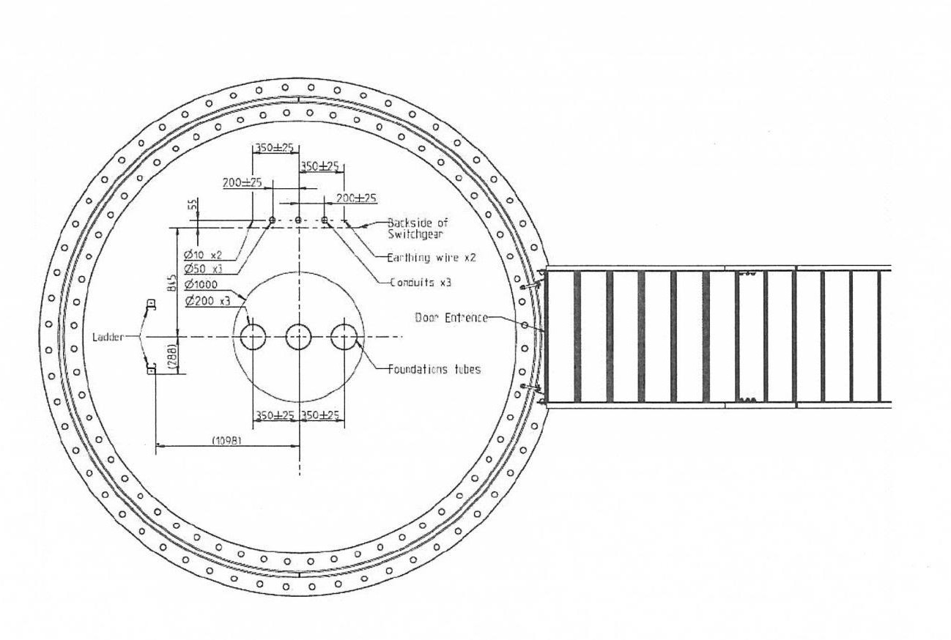
The following figure shows the section of the turbine foundation.

Figure no. 1 Turbine foundation section¹

The area occupied by the wind turbine foundations is aproximately 3 ha.

Technological platforms

The technological platforms for crane installation will be located near the turbines and will have average areas between 700 and 2,000 m², meaning paved areas on which cranes used for the installation, maintenance, and decommissioning of wind turbines will be mounted. In some cases, there will be a short section of internal road, approximately 5 m wide, between the technological platform and the service road at the end of the plot. The following figure shows a schematic example of a technological platform proposed for the implementation of the project.
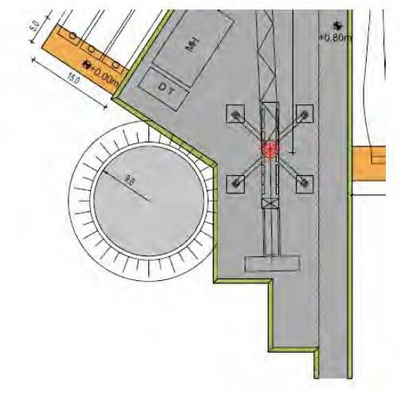

Figure 2 Schematic representation of the technological platform for the wind turbine²

The area occupied by the technological platforms for wind turbines is 55.76 ha.

Wind turbines

The height of the wind turbine tower will be between 155-165 m, measured at the rotor axis, to which is added the rotor, with 3 blades 75-85 m long. The main components of the wind turbine are listed below:

- The tower (pylon) – consisting of several sections, with a height of 155-165 m (at the nacelle), is a slightly conical metal structure
- Nacelle – located at the top of the tower, it includes the following components: rotor shaft, gearbox, generator, and transformer. A medium-intensity warning light will be installed on the nacelle, in accordance with the requirements of the Romanian Civil Aviation Authority.
The locations of the turbines were chosen taking into account the safety and protection distances from municipal infrastructure elements, as indicated in the "Technical Standard on the delimitation of protection and safety zones for energy capacities," approved by ANRE Order No. 239/2019.
The following figure illustrates the vertical dimension for the wind turbine.
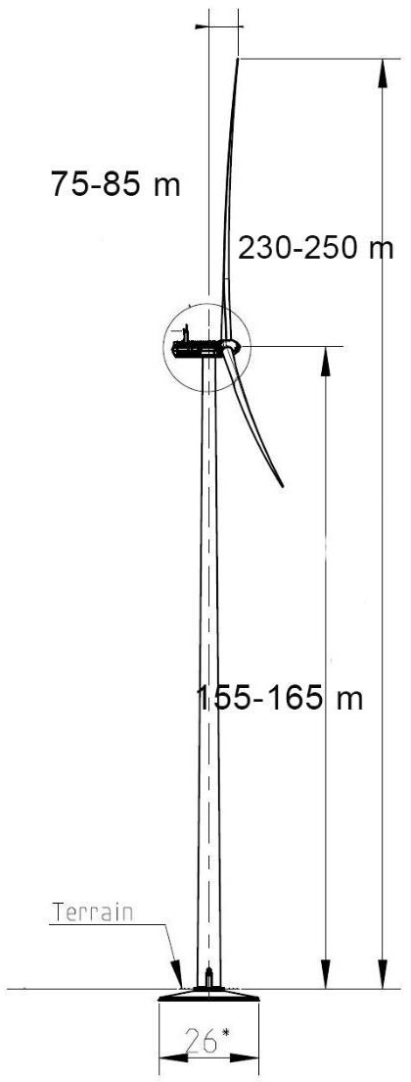

Figure 3 Schematic representation of the vertical dimensions for the wind turbine3

Transformer station

The proposed wind farm will have two areas for internal 33/110 kV transformer stations, whose location has been optimized based on the distances from the wind turbines they serve.
The 110/33 kV internal transformer stations will be of the indoor-outdoor type, with the 110 kV equipment located outdoors and the 33 kV equipment indoors. The stations will be equipped with a 110 kV cell, 33/110 kV transformers of various capacities (e.g., 63 MVA), and the medium-voltage cells will be connected to a single uninterrupted busbar. The stations will also be equipped with a service transformer.

The areas allocated for the construction of the 33/110 kV transformer station components are approximately 3 ha.
The transformer stations will operate automatically and will not have permanent operating personnel.
There will be no water supply or sewage systems within the transformer stations. The proposed locations for these transformer stations are shown on the following map.
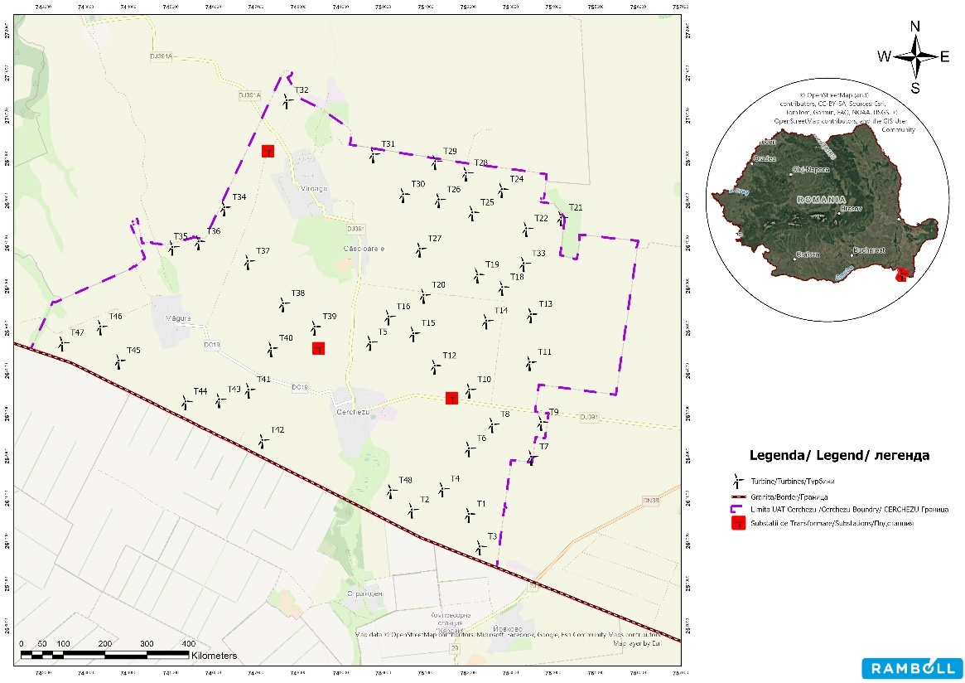

Figure no. 4 Proposed locations for transformer stations

Underground power lines

The external LES network (connection to the SEN) is not covered by this Environmental Impact Report; it will be regulated from an environmental protection perspective through a separate procedure. However, it was considered prudent to analyze the current version of the proposed solution, as it is an essential part of the project. However, the current version is not final, as the connection study has not been completed.
The total length of the underground interconnection lines for the turbines (internal) in the wind farm is 57.78 km.

The areas required for the underground power lines have not been included in the land use balance because the trenches will be located along the service roads (under one side), which constitute the access routes to the farm, already quantified separately.

Work required for site organization

In order to carry out the proposed investments, three temporary construction sites are required on plots A251/1/31, A367/15, and A250/9. The construction sites will occupy a temporary area of approximately 3,000 m²each (total 9,000 m²).
The following works will be required to set up the construction site:
- Delimitation and fencing of the construction site area;
- Preparing the land for the installation of the necessary equipment;
- Construction of the access road;
- Setting up and organizing the area for separate waste collection;
- Placing containers for storage, sanitary facilities, etc.;
- Utility provision - electricity, water supply, wastewater management;
- Placement of the PSI picket and signage in accordance with the legal provisions in force;
- Providing lighting for the facility;
- Installation of CCTV surveillance equipment.
The construction site will be located on the area corresponding to the investment site. The spaces intended for the construction site will be located on land that is already registered and fenced off for the duration of the construction works. The construction site and material storage will be located within the project area and will not require the occupation of additional land.
The location of the site organizations in the project area is shown in the figure below.

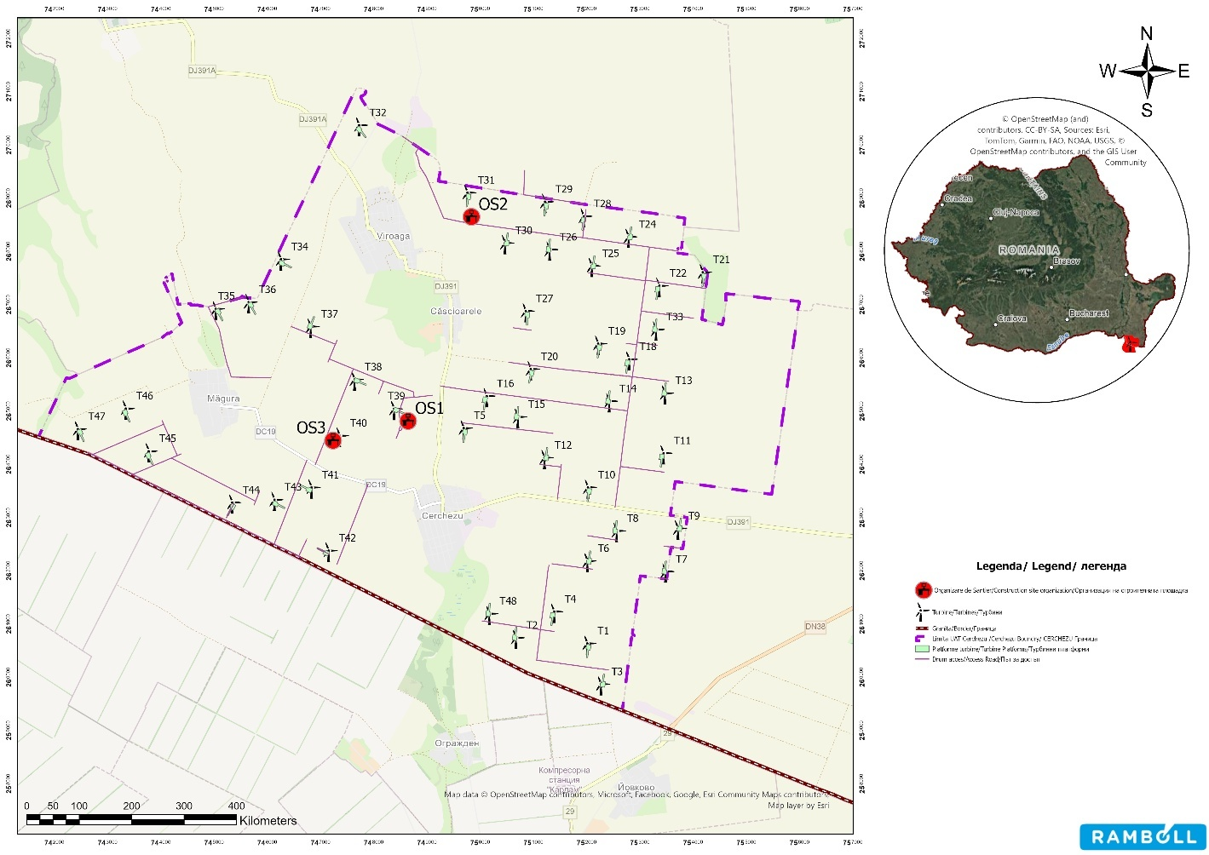

Figure no. 5 Location of site organizations

Technological organization

In accordance with the specific nature and execution technologies for construction and assembly works, the following technical equipment will be located on the construction site during the project implementation period:
- Crawler and wheeled construction machinery for various mechanized works—excavation, loading, pushing, compaction, etc.;
- Lifting, transport, and load handling equipment;
- Machinery and equipment for transporting and pouring concrete;
- Motor vehicles;
- Hand tools and small mechanization equipment;
- Various tools, implements, and devices.

Provision of utilities in the organization of the construction site
- Domestic water (bathrooms and toilets) – domestic water will be delivered to the construction site using water tankers transport.
- Drinking water will be delivered in plastic containers from specialized suppliers;
- Wastewater – wastewater will be collected in sealed septic tanks that will be emptied by a specialized company;
- Ecological toilets - will be emptied and sanitized by a specialized company;
- Electricity - the electricity needed to run the construction site will be provided by generators or, if possible, by connecting to the public electricity grid.
- Waste generated by the site organization will be selectively collected in bins marked with the waste code and handed over to an authorized company for disposal/recycling.
Decommissioning of the construction site
Upon completion of the construction works related to the wind farm, the site organisation will be decommissioned, and the land will be restored to its original condition, as follows:
- Removal of equipment;
- Fencing removal (if applicable);
- Dismantling of crushed stone platform;
- Renaturation of the surface with topsoil in the area where the construction site was located.
General aspects regarding the organization of the construction site
All work equipment used to carry out the works on the site must be technically, functionally, and safety compliant in terms of occupational health and safety and traffic safety.
Lighting in the work areas shall be provided by local or zonal temporary lighting installations connected to the distribution boards. These shall provide the necessary and sufficient light intensity for the work processes to be carried out in safe conditions.
The construction site will be enclosed by continuous fencing. The continuity, technical condition, and security of the construction site fencing will be checked periodically to prevent any unauthorized access to the premises. Security for the investment will be provided by a company specializing in security and surveillance services, on a contractual basis.
Waste resulting from the activities of each contractor and subcontractor will be collected from the work site, transported, and temporarily stored at the site's own collection point. The activity will be organized and carried out in a controlled and supervised manner, so that the amount of waste in the work area is kept to a minimum at all times in order to avoid additional risks in terms of occupational health and safety. The removal of waste from the site shall be carried out only by authorized economic operators, using appropriate means of transport and only to authorized landfills. Liability for any breach of this provision shall lie solely with the natural or legal person, the beneficiary having no liability in this case.
During the execution of the works, all occupational safety measures provided for in the legislation in force shall be complied with, in particular: the Regulation on occupational safety and health in construction, the Occupational Safety Act, the General Occupational Safety Regulations, and the Specific Occupational Safety Regulations for different categories of works.

Demolition works

Currently, there are no buildings on the site that need to be demolished for the implementation of the project.
The construction of the wind farm does not require the demolition of existing buildings.

If the wind farm needs to be decommissioned, this will mainly consist of the following activities:

• site setup and organization work - similar to the construction phase of the wind farm. The chosen location will be used temporarily and will be restored to its original use upon completion of the work;
• dismantling of turbines and their removal from the site;
• demolition of foundations to a depth that allows agricultural activities to resume (approx. 1 m below ground level) and soil replenishment in the demolished area;
• unearthing of underground electrical cables and their removal from the site;
• decommissioning of transformer stations - dismantling of equipment and installations and their removal from the site;
• decommissioning of technological platforms and access roads within the plots for the purpose of returning them to agricultural use;
• restoration of the construction site in the affected areas.
For the decommissioning stage, it will be necessary to develop a specialized technical project, in accordance with the regulations in force at the time. Currently, legal procedures require obtaining a termination notice for this type of work, with the corresponding procedure for obtaining environmental approval.

Site restoration works

Upon completion of the construction works, the Contractor shall ensure the restoration of the natural environment of the areas temporarily occupied but not affected by the project interventions. The areas affected by the construction works shall be restored to a condition that ensures the landscape integration of the elements subject to restoration works. This work will be carried out by cleaning up the area (complete removal of waste resulting from specific work activities, including household waste), planting species of vegetation specific to the area, etc. The restoration works are intended both to ensure the landscape restoration of the affected areas and to reduce the risk of invasive alien plant species entering and establishing themselves on the affected areas, which would endanger the areas in the vicinity of the proposed project.

Information on the nature and quantity of materials and natural resources used, including water, land, soil, and biodiversity

Raw materials and natural resources

The raw materials and natural resources used for the construction of new facilities within the wind farm project are presented in the following table.

Table 1 Raw materials and construction materials used in the execution phase

Material | Unit of measurement | Foundation | Cables | Roads
Steel and ferrous materials | Tons | 1,147.70 | - | -
Aluminum and aluminum alloys | Tons | - | 72.22 | -
Copper | Tons | 0.46 | 18.40 | -
Polymers | Tons | 0.46 | 161.00 | -
Concrete | Tons | 22,245.14 | - | -
Water | Tons | 7,785.77 | - | -
Crushed stone | m | - | - | 1,184,018.53

These estimates were based on the study by Razdan, P., & Garrett, P. (2019). Life cycle assessment of electricity production from an onshore V150-4.2 MW wind plant. Vestas Wind Systems A/S.

Chemical substances and preparations

The execution of the works will require the use of materials which, due to their composition or potential effects on the health of employees, are classified as hazardous chemical substances and preparations. These substances and materials are represented by:
- Fuels (diesel, gasoline) used for the operation of equipment and means of transport;
- Lubricants (oil, grease);
- Coolant.
The main substances used, together with the nature of the risk generated by their use, are presented in the following table.
Table 2 Raw materials and construction materials used
in the execution phase
No. | Name of substance/preparation  Chemical | Classification and labeling of chemical substances or preparations  Chemical
No. | Name of substance/preparation  Chemical | Category Hazardous/Non-hazardous  (H/N) | Quantities | Degree of hazard
1 | Fuel | P | 38.33 tons | High degree of  flammability
2 | Coolant / other glycols | P | 3.22 tons | Flammable, irritant
3 | Oil | N | 19.17 tons | Flammable

Technological processes

SOUTH WIND SRL is considering the development and commissioning of a new production capacity for
electricity from renewable sources.

Technology used

The wind turbine converts the kinetic energy of the wind into electricity. The turbines are equipped with a rotor with three blades arranged equidistantly on the rotor hub. The rotor is driven by the force of the wind. The speed of the blades is directly proportional to the speed of the air mass, the density of the air, and the temperature of the air passing through the rotor. The movement of the rotor is transmitted through a speed multiplier to the electricity generator.
The turbines to be installed at the wind farm are equipped with:
- a system that allows the rotation speed and blade pitch to be adjusted according to wind speed and direction in order to maximize energy production and reduce loads and noise;
- an automatic nacelle rotation system ("yaw system") so that the rotor always operates in the prevailing wind direction.
The turbines operate at variable generator rotor speeds. They are programmed to start when the wind speed reaches 3 m/s and to stop when the wind speed exceeds 24 m/s.
During strong winds, the turbines will be automatically shut down by reducing the angle of the blades and activating the braking system.
The electricity generated by the turbine-generator assembly is transported through the internal electrical network of the wind farms, consisting of 33 kV underground power lines (LES), to the electrical substation, where the voltage is increased from 33 to 110 kV. Thus, the power produced in the wind farms can be discharged through a 110 kV underground power line to the 110/400 kV station.
Throughout the lifetime of the wind farm, maintenance and repair work will be carried out on both the wind turbines and the power stations. The turbines require annual servicing and periodic, annual, or multi-annual maintenance work. The materials needed for turbine maintenance will be brought to the site as needed, thus avoiding their storage in the wind farm area. In the event of technical malfunctions, the turbine monitoring system automatically alerts the designated personnel to remedy them.
The main maintenance works carried out annually at the power station are as follows by:

- Checking the oil level in the transformer;
- Checking for oil leaks;
- Checking cables and circuits;
- Checking the condition of the paint.

Repair activities will include on-site repairs of components and equipment that do not require special intervention.
During the lifetime of wind turbines, it may be necessary to replace certain equipment or components, ranging in size from small to very large, thus requiring the use of heavy-duty vehicles (for example: replacing a defective blade will require both oversized transport to remove the defective blade from the site and bring in the new blade, as well as the transport and use of heavy-duty cranes on site to dismantle and install the blades).

Profile and production capacity

The production capacity of a wind farm depends on wind conditions (especially wind speed at hub height). According to Razdan, P., & Garrett, P. (2019), for a wind turbine, at low wind speeds of 7 m/s, annual production can reach 14,892 MWh/year.
For a wind farm consisting of 46 turbines with a unit installed capacity ranging from 6.2 to 7 MW, the estimated annual production (AEP) can be expressed based on the reference values in the Siemens Gamesa environmental documentation (SG 6.6-155 platform), which indicates a cumulative net production of 7,965,427.252 MWh for 15 turbines over a period of 20 years (average wind conditions, IEC II). This results in an average production of approximately 26,551 MWh/turbine/year, or a total estimated annual production for 46 turbines of approximately 1,221,366 MWh/year (≈ 1,221 GWh/year).

Planning/land use

The permits and authorizations required for the project according to Urban Planning Certificate No. 129 of November 28, 2022, with extended validity, issued by the Constanța County Council, are as follows:
- Water supply – RAJA SA Constanța or the alternative system used in the absence of the public network;
- Electricity supply – E-Distribuție Dobrogea SA;
- Telephony – Telekom România Comunication SA/ Orange România SA/ RCS&RDS;
- Sanitation – Operator for the collection of construction waste;
- Constanța Land Registry and Real Estate Advertising Office;
- Constanța County Directorate for Culture;
- M.A.D.R. – Constanța County Directorate for Agriculture;
- A.N.I.F. – Constanța Territorial Branch of I.F.;
- M.A.I, S.R.I, M.A.P.N – Defense Major Village;
- Special Telecommunications Service;
- Romanian Civil Aviation Authority;
- R.A.J.D.P. Constanța
- S.N.T.G.N. Transgaz SA Mediaș – Constanța Regional Operations;
- C.N.T.E.E. Transelectrica SA – S.T. Constanța;
- Agricover Credit IFN SA – mortgage registration;
- Agreement with private owners, natural persons/legal entities;
- Geotechnical study;
- Study of coexistence with other objectives and activities;
- Project verification reports for quality requirements in accordance with the provisions of Law No. 10/1995 (republished) on quality in construction;
- Site plan on topographic/cadastral support drawn up in the Stereographic 1970 projection system, approved by the cadastre and real estate advertising office, in .pdf and .dwg or .dxf format.
- Opinion/administrative act of the competent authority for environmental protection

Estimate of the type and quantities of emissions and waste

Emissions into surface waters and groundwater

During the execution period, the main sources of water pollution are:

- Soil handling works – generation of soil particles that can reach surface waters through runoff. In the case of large quantities of suspensions, these can accumulate in watercourses, causing changes in water turbidity with effects on aquatic flora and fauna;
- Traffic to and from work sites or areas from which construction materials are brought (quarries, ballast stations, concrete stations, etc.);
- Accidental spills of chemicals, fuels, and oils from the operation of construction equipment or due to improper handling of transport vehicles;
- Improper handling, commissioning, or storage of materials used in the execution of works (concrete, aggregates, etc.), which may end up in surface waters through rainwater runoff;
- Improper storage and management of waste resulting from construction works;
- Inadequate storage and management of domestic wastewater resulting from sanitary facilities within the construction site organization, with management being ensured appropriately through authorized operators;
- It should be noted that the construction site is not proposed to be located near any surface water bodies,
- thus greatly reducing the risk of contamination associated with the sources mentioned above.

During the project operation phase, there will be no direct sources of emissions into water. The project does not propose the discharge of water into groundwater or surface water bodies. The only sources with the potential to contaminate water bodies are accidental in nature and may be caused by accidental spills of substances used in maintenance work on turbines or in the transformer station (mainly oils and other lubricants for the mechanical parts of the turbines).
During the decommissioning phase, the main sources are associated with the organization of the construction site and the storage areas for materials resulting from demolition. The main potential sources for groundwater may be associated with the temporary storage and inadequate management of waste resulting from demolition, in particular used oil collected from wind turbine generators.
The potential sources that may have negative effects on surface and groundwater during this stage are similar to those during the construction stage.

Atmospheric emissions

During the execution of the works necessary for the completion of the project, the main sources of atmospheric emissions will be:
- Earthmoving activities (topsoil removal, excavation, levelling, loading, unloading, transport) and construction materials (crushed stone for access roads) – stationary uncontrolled sources. Pollutants: suspended particulates and sedimentable particulates;
- Temporary storage of powdery materials (sand, soil) that can be carried by the wind – stationary, uncontrolled sources. Pollutants: suspended dust and sedimentable dust;
- Wind erosion on disturbed or vegetation-free land surfaces – stationary uncontrolled sources. Pollutants: suspended dust and sedimentable dust;
- Generators for power supply in construction sites and
- work fronts – stationary directed sources. Pollutants: NO2, SO2, CO, dust;
- Mobile emission sources (vehicles and machinery involved in land development and the transport of materials and equipment during construction works) – stationary controlled sources. Pollutants: NOx, SOx, CO, suspended particulates, heavy metal particles;
- Activities involving the handling and installation of wind turbine components – stationary uncontrolled sources.
- Stationary sources of atmospheric pollution will occur during the execution of the works proposed for the achievement of the objective and will be represented by earthmoving activities (excavation, soil stripping, loading –unloading, transport), and the handling and installation of wind turbine components. The dust generated by the handling of materials and wind erosion is mainly of natural origin (soil particles, mineral dust).
- The estimation of pollutant emissions generated by construction activities was carried out according to the EMEP/EEA 2023 –2.A.5.b Non-residential construction methodology, using the following equation:

𝐸𝑀
= 𝐸𝐹
× 𝐴
×𝑑 × (1 −𝐶𝐸 ) × (24 ) × (𝑆 ) where:

𝑃𝑀10
𝑃𝑀10
𝑎𝑓𝑓𝑒𝑐𝑡𝑒𝑑

𝑃𝐸 9

- EF - emission factor corresponding to the types of buildings constructed on the site, i.e. non-residential buildings → according to 2.A.5.b Construction and demolition table 3.3;
- Aaffected–total area developed in the project → 114.71 ha;
- d -duration of construction works → 0.5 years;
- CE - efficiency of emission control measures → 0.5 according to 2.A.5.b Construction and demolition, p. 9;
- PE – evaporation index → 41.6 (calculated according to the formula in 2.A.5.b Construction and demolition, p. 9);
- s – soil sediment content → 40% (determined based on the soil type in the site area).
The results of the emission calculations for the PTS, PM10, and PM2.5 indicators are presented in the following table.

Table 3 Uncontrolled emissions associated with wind farm construction operations

 | Emissions
 | kg/h | g/s | t / per exec
TSP | 277.2 | 76.9 | 2,426.3
PM10 | 83.3 | 24.0 | 735.6
PM2.5 | 8 | 3.2 | 73.7

The emissions estimated in the table above reflect all dust emissions generated by wind erosion and earthmoving activities (excavation, compaction), turbine components, and other materials.
The estimation of pollutant emissions generated by non-road mobile sources (machinery) was performed using the EMEP/EEA calculation methodology –1.A.4. Non-road mobile machinery 2019, Tier 1, which takes into account the type of fuel, consumption of fuel used and the factors of emission corresponding to pollutants characteristics. The results are presented in the table below:

Table 4 Mobile sources during the execution period

Source name | Pollutants and mass flows
Source name | NO2* |  | CO |  | CO |  | SO |  | PM10
Source name | g/h | g/s | g/h | g/s | g/h | g/s | g/h | g/s | g/h | g/s
Dump truck | 251.4 | 0.070 | 84,131.8 | 23.370 | 286.8 | 0.080 | 26.6 | 0.007 | 56 | 0.016
Excavators | 157.1 | 0.044 | 52,582.4 | 14.606 | 179.3 | 0.050 | 16.6 | 0.005 | 35 | 0.010
Front loader | 94.3 | 0.026 | 31,549.4 | 8,764 | 107.6 | 0.030 | 10 | 0.003 | 21 | 0.006
12.5 kW generator | 18.9 | 0.005 | 6,309.9 | 1.753 | 21.5 | 0.006 | 2 | 0.001 | 4.2 | 0.001
20T truck crane | 62.9 | 0.017 | 21,033 | 5.842 | 71.7 | 0.020 | 6.7 | 0.002 | 14 | 0.004
*NO2 calculated as 29% of NOX

Order 462/1993 does not set limits for mobile sources. The order indicates that pollutant emissions from road vehicles are limited as a preventive measure by the technical conditions set out in the technical inspections carried out periodically throughout the life of road vehicles registered in the country.
During the operation of the facility, there will be no sources of atmospheric pollutant emissions. Occasionally, maintenance operations may be carried out. These operations generate atmospheric pollutant emissions, mainly from vehicles used to transport personnel, but their contribution is insignificant.
During the decommissioning period, the emission sources involved will be similar to those mentioned in the execution phase.

Soil and subsoil contamination

During the execution phase, the potential sources of soil, subsoil, and groundwater degradation will be
represented by:
- Improper storage of construction equipment and materials;
- Improper management and storage of waste resulting from the works, as well as household waste generated by the personnel involved in the execution of the works;
- Traffic of vehicles and machinery involved in the achievement of the objective. Along with air pollution, there is a possibility that a certain amount of atmospheric pollutants (SO2, NOx, heavy metals) may reach the soil, which may lead to changes in its characteristics;
- Accidental spills of fuels, lubricants, and other chemicals from vehicles and machinery involved in construction work or from their improper storage;
- Degradation of soil quality through improper handling/storage of uncovered/excavated material, implicitly leading to erosion and/or spreading;
- Soil contamination with germinative material belonging to ruderal and/or invasive and potentially invasive alien species, as a result of soil handling activities, as well as traffic of machinery and working personnel;
- Deposition of dust resulting from the excavation, loading, transport, and unloading of construction materials;
- Inadequate management of domestic and technological wastewater resulting from the organisation of the construction site and work fronts.
During the operational phase, the potential sources of pollution will be as follows:
- Road traffic of maintenance team vehicles, which is an occasional source of atmospheric emissions
(CO, NOX, SO2, PM10, and heavy metals) from exhaust gases.
- Accidental spills of fuels and lubricants from waste transport vehicles and personnel involved in maintenance activities;
- During the project decommissioning phase, potential sources of soil pollution will be similar to those during the construction phase, as the work will be carried out using the same types of equipment

Noise and vibrations

Current background noise level

The background noise in the Cerchezu area is typical of a rural settlement in Dobrogea and is caused by a combination of diffuse sources, with diurnal and seasonal variability. In the absence of major industrial sources in the immediate vicinity, the dominant component of background noise is associated with current household activities, local traffic, and, seasonally, agricultural activities, to which is added the influence of weather conditions (especially wind).
Typical sources contributing to background noise:
- Local and transit road traffic (cars, utility vehicles, occasionally heavy vehicles), intermittent; contribution increases during morning and afternoon rush hours.
- Household activities (tools, small machinery, maintenance work), mainly during the day.
- Agricultural activities (tractors, combines, transport), with seasonal intensification; can generate episodes of noise of varying duration and high levels for short periods.
- Natural/biological sources (wind, birds, dogs), particularly relevant in the evening/at night, when overall levels decrease and isolated events become more noticeable.

Quiet areas estimated at European level

According to data on quiet areas published by the European Environment Agency in 2017, the project site is mainly located in an area with low noise levels.

Project implementation phase

The main sources of noise will be:
- traffic in the work areas (temporary turbine platforms) and on access roads access roads;
- excavation activities, handling of materials from quarries, and their loading and unloading;
- operation of machinery (transport vehicles, heavy trucks, concrete mixers, excavators, cranes, bulldozers, compressors) – operation of engines, handling and transport of loads;
- the handling and installation of wind turbine components.
An estimate of the noise level generated during the project execution phase was made using SoundPlan 9.2 software.

Project operation phase
During the operational phase, there are two main categories of noise sources that will be generated:
• noise caused by the rotation of the blades (contact with the air);
• mechanical noise created by the operation of the nacelle components (generator, gearbox).
Vehicles will travel on access roads to carry out maintenance activities. These will take place throughout the entire operating period, but will be intermittent and at long intervals.
During the decommissioning period, the emission sources involved will be similar to those mentioned in the execution phase.

Vibration level
During the construction of the turbines at the site, vibrations of varying intensities will be generated depending on the operations carried out. At certain intensities, vibrations can have a direct negative effect on both people and buildings in the vicinity of the construction site.
Ground vibration (GBV) is the oscillatory movement of the ground around an equilibrium position that can be described in terms of displacement, velocity, or acceleration. Vibration displacement is the distance a body moves away from its static position. Velocity is the instantaneous movement of this body over a certain period of time, and acceleration is the rate of change of velocity.
The frequency range of greatest concern for GBV is approximately 1 Hz to 100 Hz. Typical vibrations from construction and transportation activities usually fall within the range of 10–30 Hz, with a median around 15 Hz.
Peak Particle Velocity (PPV –mm/s) is generally accepted as the most appropriate indicator for assessing the potential for damage to a building. It represents the highest value recorded in the three mutually perpendicular directions of the vibratory movement.
At European level, the following standards set limits for vibrations in the context of damage to buildings: the Dutch standard SBR-A (2017), the German standard DIN 4150-3 (2016), the British standard BS 7385-2 (1993) and the Swiss standard SN 640 312: (1989). These are presented in the following table.
Table 5 Mobile sources during the execution period

Type of  building | SBR-A limits depending on the type of vibration manifestation (mm/s) |  |  | DIN 4140-3 limits depending on the type of vibration manifestation (mm/s) |  | BS 7385-2 limits depending on the type of vibration manifestation (mm/s) |  | SN 640 limits  312: 1989 according to  depending on the type of vibration manifestation  (mm/s)
 | Short duration | Repetitive – short duration  Short | Continuous | Repetitive – short duration  Short | Continuous | Repetitive – short duration | Continuous | Generally applicable
Fragile buildings  –monuments | 2.9 | 3.0 | 2.5 | 8 | 2.5 | - | - | 3
Residential buildings –masonry | 5.0 | 5.0 | 5.0 | 15 | 5 | 15 | 7.5 | 5
Concrete buildings  concrete | 20 | 20 | 10 | 40 | 10 | 50 | 25 | 12

In the construction activities to be carried out within the analyzed project, vibrations will occur repeatedly for short periods of time.
The area of influence represents the area inside or adjacent to a construction site, including buildings or structures that could be affected by vibrations emanating from construction activity. According to information in the specialist literature, the distances at which the PPV value is 5 mm/s specific to different types of machinery used are presented in the following table.
Table 6 Specific area of influence for each type of equipment

Type of equipment | Distance (m) at which the PPV value is  5 mm/s
Dump truck | 4
Bulldozer | 4.5
Excavator | 4.5
Truck crane | 4

Given the limited distance over which vibrations can propagate in the context of the project's scale and location, it can be concluded that the vibrations produced during the execution phase are not likely to affect buildings, structures, or other edifices of interest to the communities in the area.

Waste

The following categories of waste will be generated during the project execution phase:
- Construction waste: metal waste (ferrous and non-ferrous), excavated soil, concrete waste, electrical cable waste, wood waste, plastics, ballast waste;
- Packaging waste: paper/cardboard, plastics, packaging containing residues or contaminated with hazardous substances;
- Waste oils from machinery/equipment used in the performance of the works (other engine, transmission, and lubricating oils);
- Used tires;
- Used batteries and accumulators;
- Household waste resulting from the social activities of the personnel involved in the execution of the works.
Waste will be collected separately on site in appropriate containers, paying particular attention to hazardous waste, which must not be mixed with non-hazardous waste. Temporary storage of waste directly on the ground will be avoided as far as possible.
The fertile soil layer uncovered during construction works will be stored in separate piles and will be reused mainly for the rehabilitation of areas temporarily affected by the works. For surplus excavated soil, locations will be identified where it can be transported in cooperation with local authorities, or attempts will be made to identify construction sites that require this type of material. If this is not possible, the soil can be transported to landfills that use this material as a cover layer. The rest of the construction waste will be handed over to authorized economic agents for recovery or disposal. Recyclable waste will be collected separately and delivered for recycling. Waste oils from machinery will be collected in sealed metal containers, depending on the type of waste oil generated, in specially designated areas (not directly on the ground).

During the operation of the wind farm, the following categories of waste will be generated:
- Waste oils (hydraulic oils, transmission and lubricating oils, insulating oils—present in various turbine equipment, as well as in transformers within the transformer station, which must be changed or replenished at certain intervals);
- Filter materials (air filters), polishing materials;
- Packaging waste from substances and components used in maintenance operations;
- Household waste generated by personnel involved in maintenance work.
This waste will be produced during maintenance and repair work. Most of the household waste will come from maintenance and repair work, as the electrical substation is designed so that it does not require permanent operational staff.
The personnel performing operating and maintenance tasks will be responsible for managing the waste resulting from those tasks. They will be required to deliver the waste to authorized operators according to category so that it can be recovered and/or disposed of. In addition, the companies responsible for the management and maintenance of the wind farm must comply with the environmental protection requirements established by the wind farm operator.
Waste oils, the main type of waste generated by maintenance activities, will be collected in sealed metal containers and handed over to authorized economic operators for recovery.
During the decommissioning phase, significant amounts of waste will be generated, including waste from electrical and electronic equipment, as well as equipment from the transformer station and wind turbine components. In addition, there will be substantially more concrete debris, metal waste, and electrical cable waste than there was during the construction phase. This is largely due to the partial decommissioning of the turbine foundations and the removal of underground electrical cables. The presence of hazardous fluids in the equipment on site will require special attention during the decommissioning phase.
An estimated summary of the quantities of waste generated during the project's execution and operation phases is presented in the following table. The estimate was made based on information gathered from similar projects.

Table 7 Waste estimated to be generated during the construction and operation phases

Waste name | Estimated quantity  (tonnes)  (tons) | Physical | Waste | Management method
Execution stage
Mixed municipal waste | 41.48 | S | 20 03 01 | Specially designed areas equipped with wheelie bins will be created. These will be collected periodically by authorised operators and transported to waste disposal sites  .
Plastic construction waste | 0.12 | S | 17 02 03 | It shall be collected separately in specially designated temporary storage areas within the construction site and at the work fronts. It shall be collected periodically by authorized operators and transported for recovery
Paper and cardboard packaging  cardboard | 0.84 | S | 15 01 01 | They will be collected separately in specially designated temporary storage areas within the construction site and work fronts. They will be periodically collected by authorized operators and transported for recycling.
Plastic packaging | 0.50 | S | 15 01 02
Wood waste from  construction | 0.88 | S | 17 02 01
Metal mixtures | 259.25 | S | 17 04 07
Concrete | 32.93 | S | 17 01 01
Ballast waste | 20.74 | S | 17 05 08
Electrical wires | 0.027 | S | 17 04 11 | Specially designated areas.
Excavated material | 48.53 | S | 17 05 | Stored in the work front area and subsequently reused as filler material.

Waste name | Estimated quantity  (tons)  (tons) | Physical  Physical | Waste  waste | Management method
Packaging containing residues/contaminated with hazardous substances | 0.77 | S | 15 01 10 | It will be collected and stored separately, for transport to disposal facilities by authorized operators. An exception is packaging that is returned to the manufacturer (e.g., IBCs).
Waste oils (engine/transmission/lubricating oils) | 1.30 | L | 13 02 08 | They will be collected in closed, labeled containers and stored in a closed area with a concrete platform. They will be handed over to authorized units  authorized for collection and recovery.
Oil filters | 0.15 | S | 16 01 07 | They will be collected in sealed bags/metal containers, stored in specially designated areas, and handed over to authorized operators for disposal.
Worn tires | 0.77 | S | 16 01 03 | They will be collected on concrete platforms on construction sites and handed over to authorized units.
Batteries and accumulators | 0.50 | S | 16 06 05 | They will be collected in metal containers and stored in specially designated areas and handed over to authorized operators for recovery.
Operating stage
Non-chlorinated hydraulic mineral oils (oil for hydraulic braking systems) | 0.35 | L | 13 01 10 | They shall be collected in metal containers and stored in specially designated areas and handed over to authorised operators for disposal.
Non-chlorinated mineral oils for engines, transmissions, and lubrication (emergency lubrication system) | n.a | L | 13 02 05 | They will be collected in metal containers and stored in specially designated areas, and will be handed over to authorised operators for disposal.
Synthetic engine, transmission, and lubricating oils (transmission system, return system) | 2.30 | L | 13 02 06 | They will be collected in metal containers and stored in specially designated areas, then handed over to authorised operators for disposal.
Non-chlorinated mineral heat transfer and thermal insulation oils | 23.00 | L | 13 03 07 | They will be collected in metal containers and stored in specially designated areas, then handed over to authorised operators for disposal.
Packaging waste containing residues/contaminated with hazardous substances | 0.19 | S | 15 01 10 | They will be collected and stored separately for transport to disposal facilities by authorized operators. An exception is made for packaging that is returned to the manufacturer (e.g., IBCs).
Plastic packaging waste | 0.176 | S | 15 01 02 | They shall be collected separately in specially designated temporary storage areas within the site organization and at the work fronts. They shall be collected periodically by authorized operators and transported for  for recovery.
Filter materials (air filters) | 0.176 | S | 15 02 03 | They shall be collected separately in specially designated temporary storage areas within the site organization and at the work fronts. They shall be periodically collected by authorized operators and transported for recovery.
Filter materials (oil filters, polishing materials) | n.a | S | 15 02 02 | They will be collected in sealed bags/metal containers and stored in specially designated areas and handed over to authorized operators for disposal.
Electrical and electronic waste | n.d. | S | 16 02 14 | They will be collected in metal containers and stored in specially designated areas and handed over to authorized operators.
* Physical state: Solid-S, Liquid-L, Semisolid-SS.
** In accordance with the list of wastes provided for in European Commission Decision 2014/955/EU and Annex 2 to Government Decision No. 856/2002 on waste management records and for the approval of the list of wastes, including hazardous wastes, with subsequent amendments and additions.

At all stages of the project, contracts will be concluded with authorized companies that will ensure the disposal/recovery of all types of waste generated. All waste generated as a result of the project, at all stages, will be temporarily stored only on specially designed areas, on concrete platforms, under appropriate conditions, so as not to influence the activities carried out on site.
Temporary storage of waste is carried out in accordance with the specific legislation in force, as follows:
• on concrete platforms, covered/uncovered;
• specially designated areas;
• in transportable containers, metal drums;
• in closed and covered spaces.
Throughout all stages of the project, waste management records will be kept in accordance with Government Emergency Ordinance No. 92/2021 on waste management, as amended and supplemented, Government Decision No. 856/2002 and Law No. 249/2015 on the management of packaging and packaging waste, as amended and supplemented. All persons involved in the execution, decommissioning, and operation of the project will be trained in waste handling and sorting by category into containers specifically designated for each category of waste.
In the case of hazardous waste, special management measures shall be taken (separate storage only on impermeable surfaces) to prevent contamination of other waste or the soil.Within the construction site, the contractor shall set up platforms specifically designed for the collection and management of all types of waste resulting from the execution of the works, equipped with bins, containers, and receptacles specifically designed for the temporary storage of waste. The platforms shall be designed to allow the safe handling of waste by authorized contractors. Temporary storage of waste shall be carried out separately for each type of waste, with each container or receptacle intended for storage being labeled with the corresponding waste code, in accordance with Government Decision 856/2002, as amended and supplemented.
The company will have a waste management plan for the site, specifying the name of the waste produced, the waste code, the quantity produced, the quantity recovered, the destination of the waste, and the stock remaining at the end of the year. Pollution due to waste generation is considered to be insignificant. During both the construction and operation phases, the company will take all necessary measures to ensure that waste disposal and recovery are carried out in a controlled manner, without polluting the environment, so that no direct and significant impact on environmental factors is expected, but only an indirect impact through the disposal of this waste by specialized companies. In the case of WEEE (waste electrical and electronic equipment) - electrical and electronic tools, the company is obliged to recycle them in accordance with Government Decision 448/2005 on waste electrical and electronic equipment. WEEE will be collected separately and temporarily stored in a specially designed, waterproof, appropriately marked area. Hazardous waste (used transmission and hydraulic oil) will be collected by a specialized/authorized company in accordance with the contract for the replacement/disposal of used oil generated on site.

ANALYSIS OF FEASIBLE ALTERNATIVES
Four alternatives were studied during the project implementation process:
- Alternative "zero" - without project implementation
- Alternative I – initiated in 2011 (consisting of three wind farms) – 117 wind turbines with a total installed capacity of 351 MW
- Alternative II - initiated in 2022 - 48 wind turbines, with a total installed capacity of 316.8 MW
- Alternative III - was initiated in 2023 after obtaining TRANSGAZ SA approval no. 34618/948/10.05.2023, following which the T17 and T23 power plants were abandoned, so the new wind farm will comprise 46 wind turbines, with a total installed capacity of 303.6 MW.
In terms of location, it was chosen in 2011 based on general wind maps for Romania, which showed that Constanța County is located in an area with very good potential, with a constant speed of 6.65 m/s. The Cerchezu UAT was chosen due to its flat terrain and generally favorable NNW-S orientation.
The following aspects were taken into account when determining the locations of the wind turbines:
- ease of contracting private land;
- logistical/transport accessibility;
- energy potential (calculated using the windPRO program)
- distances to localities;
- distances from the network of protected areas / Natura 2000;
- proximity distances to the energy network.
The advantages and disadvantages of each alternative and the justification for choosing the optimal alternative.

Alternative "0"

Alternative "zero" was considered as a reference point against which the other alternatives for the various elements of the project under analysis were compared. The main impacts associated with adopting alternative "zero" are:
- loss of opportunity to exploit the high wind potential in this area;
- loss of job opportunities (estimated at 30 to 75 direct jobs in the construction phase and 10 to 20 jobs in the operation phase);
- pre-construction and during construction);
- loss of economic opportunities that would support the local community in socio-economic development that would enable environmental problems to be solved;
- loss of interest among private investors in future industrial development projects in the region and in Romania;
- loss of support for the development of a reliable alternative for electricity production in accordance with European and national policies;

- failure to achieve the objectives set at national level regarding the decarbonisation of the energy sector and the promotion of renewable energy resources for a Romania that is neutral in terms of GHG emissions by 2050.

Alternatives identified and studied

Alternative I consists of three wind farms comprising 117 wind turbines of 3 MW/turbine, with a total farm capacity of 351 MW and three transformer stations.
This option requires a total land area of 473.09 ha (according to the scoping decisions issued in 2013: DEI 14866/29.04.2013, DEI 14867/22.04.2013, DEI 14868/22.04.2013), of which 3.90 ha are permanently occupied by buildings and 469.19 ha are temporarily occupied by works. In this variant, the land with its current agricultural function - arable land - requires the transformation of its use category into "technical and urban facilities", which implies the removal of 5 ha of arable land from agricultural use.
The advantage of this alternative is the total power of 351 MW of the three wind farms, which will replace an equivalent amount of electricity produced from fossil fuels, thus contributing to the fulfillment of national and European commitments to decarbonize the energy system and diversify energy production sources, ensuring energy independence.
The disadvantage of Alternative I is the large number of wind turbines envisaged in the project, which implies a high density of turbine locations with effects on inhabited areas through an increase in noise levels, intensification of the shadowing phenomenon, and agglomeration of the natural landscape.
Added to this is the area of land affected by the construction of new roads, foundations, and platforms for the 117 wind turbines and three transformer stations.
Furthermore, in 2011, when the Appropriate Assessment Study was carried out for the three parks around Cerchezu, from which the analyzed project was derived, the ROSPA0166 site was not declared a protected area, and the Adequacy Assessment Study was not based on an assessment in relation to the conservation objectives of Natura 2000 sites, as the specific conservation objectives had not been defined at that time. The main conclusion of this Appropriate Assessment Study was that the location of wind turbines in the area of interest, which is already anthropized, will have an insignificant impact on local vegetation, flora, and fauna.
Alternative II consists of building a wind farm consisting of 48 wind turbines with a capacity of 6.6 MW/turbine, with a total park capacity of 316.8 MW and 4 transformer stations.
This option requires a total land area of 3,027.77 ha, of which 309.34 ha will be permanently occupied by buildings and 2,718.43 ha will be temporarily occupied by construction works. In this option, the land currently used for agriculture - arable land - needs to be reclassified as "technical and urban facilities," which means taking 309.34 ha of arable land out of agricultural use.
The advantage of this alternative is the significantly lower number of turbines, which minimises the disadvantages of the first option, and the greater distance between the turbines.
By reducing the number of turbines provided for in the project, the distance between wind farms is increased to over 600 m, compared to approximately 350 m in the situation approved in 2011, and the lower density results in a more balanced use of natural resources and reduces pressure on biodiversity both during the project implementation period and during the wind farm's operation.
The disadvantage of Alternative II is the lower power of the energy park and the incompatibility of the T17 and T23 turbine sites with the natural gas transmission network, which led to the emergence of Alternative III.
Alternative III consists of building a wind farm consisting of 46 wind turbines with individual power ranging from 6.2 to 7 MW/turbine, with a total power of 303.6 MW and two transformer stations.
This option requires a total land area of 3,027.77 ha, of which 292.52 ha will be permanently occupied by buildings and 2,735.25 ha will be temporarily occupied by works, as identified in the Zonal Urban Plan phase. In this option, the land currently used for agriculture - arable land - needs to be reclassified as "technical and urban facilities," which means taking about 30 ha of arable land out of agricultural use.
The advantage of this alternative is its compatibility with the natural gas transport network, in addition to the advantages of Alternative II related to the smaller number of wind turbines and lower density.
The disadvantage of Alternative III is the lower amount of electricity produced.
Following the analysis of the alternatives, Alternative III is considered optimal for the following reasons:
a) minimisation of negative environmental impacts by reducing the number of wind turbines; more efficient use of air currents through optimal positioning of the turbines in relation to each other, at greater distances, which leads to their operation in the best conditions and increased efficiency of the wind farm.

DESCRIPTION OF RELEVANT OF CURRENT
CURRENT STATE OF THE

Social and economic environment

Study area

Study area for the social and economic component, which includes the population and human health related to the project "Wind Energy Park 48 (46) wind power plants approx. 316.8MW (303.6MW), transformer stations, electrical connection networks, construction and modernisation of communication and access routes" is the Cherchezu UAT. The nearest localities are: T32 at 1.1 km from Viroaga, T5 at 1 km from Cerchezu, T35 at 1 km from Măgura, T3 at 1.56 km from the Bulgarian locality of Iovkov, T47 at 2.1 km from the Bulgarian locality of Kraiste, T9 at 3.98 km from Negru Vodă.

Population size and structure

According to the latest census conducted in 2021, the total population by domicile of the commune of Cerchezu, as of July 1, was 1,360 people, of whom 645 were women and 711 were men.

The population structure by age and gender on the date of the last census is presented in the table
below:

Table 8 Population structure on the date of the last census (2021)
 |  | AGE GROUPS
 | Total | Under 5 | 5  9 | 10  14 | 15  19 | 20  24 | 25  29 | 30  34 | 35  39 | 40  44 | 45  49 | 50  54 | 55  59 | 60-  64 | 65  69 | 70  74 | 75  79 | 80  84 | over  85
Total | 1349 | 71 | 74 | 80 | 80 | 87 | 84 | 105 | 79 | 91 | 94 | 112 | 72 | 72 | 78 | 83 | 32 | 31 | 24
Male | 711 | 45 | 33 | 44 | 39 | 54 | 46 | 62 | 43 | 44 | 56 | 65 | 41 | 38 | 30 | 37 | 15 | 9 | 10
Female | 638 | 26 | 41 | 36 | 41 | 33 | 38 | 43 | 36 | 47 | 38 | 47 | 31 | 34 | 48 | 46 | 17 | 22 | 14
Source: processed data from the National Institute of Statistics

The population density of Cerchezu commune was 16.25 inhabitants/km²in 2021, being more low compared to the county density (108.6 inhabitants/km²) , regional density(71.2 inhabitants/km²) and national density (84.4 inhabitants/km²) .

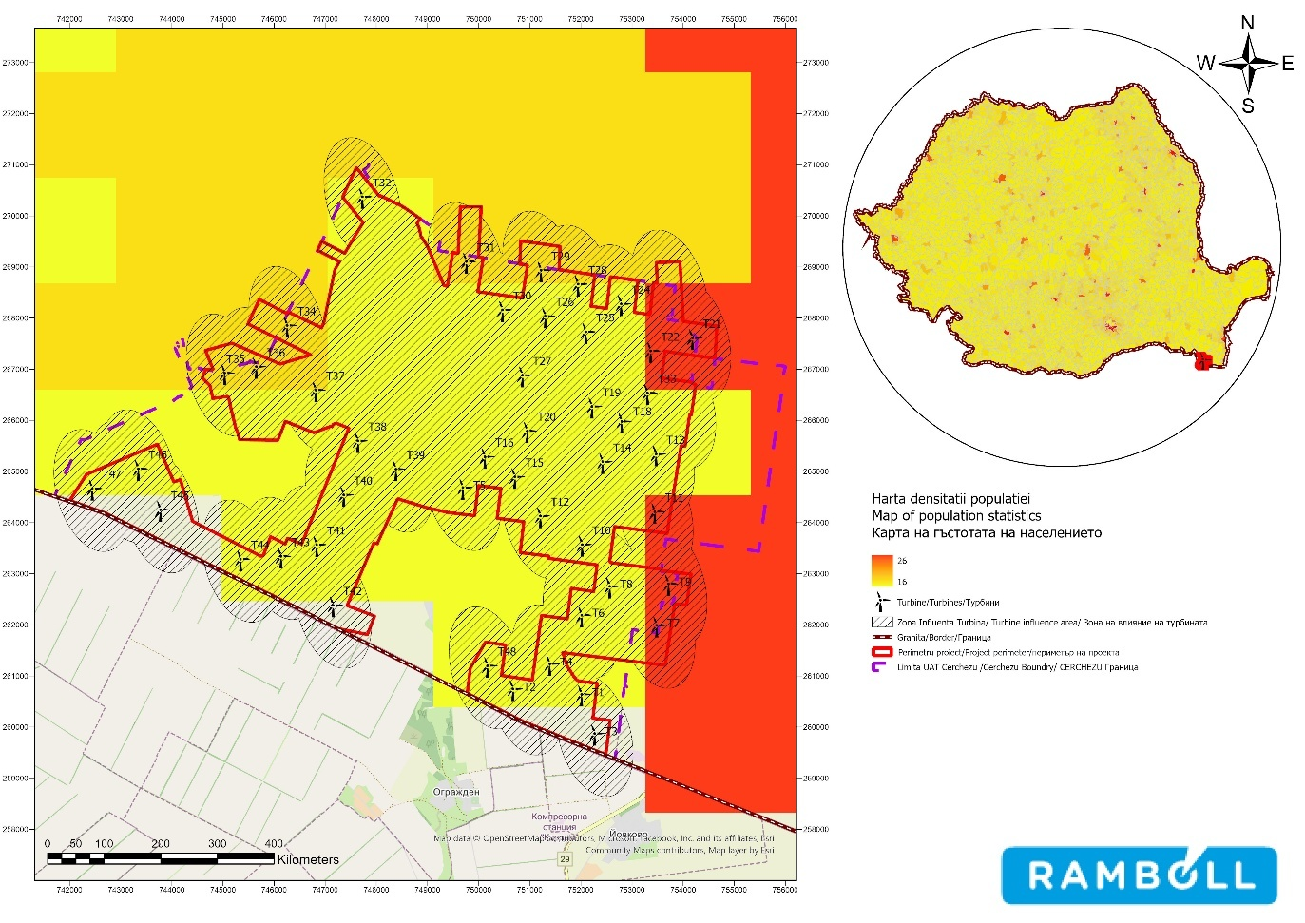

Figure 6 Population density in Cerchezu commune
Population evolution

According to data provided by the National Institute of Statistics, the population evolution in Cerchezu commune shows a downward trend between 2011 and 2025, due to both natural movement (births and deaths) and migration. Compared to 2011, the population of Cerchezu commune will decrease by 17% in 2025.
Population

1600

1400

12

10

80

600

400

200

0
2011
2019
2020
2021
2022
2023
2024
2025

Source: processed by INS
Figure 7 Population evolution in Cerchezu commune between 2011 and 2025

In terms of the distribution of the commune's population by gender between 2011 and 2025, the male population is larger than the female population. Compared to 2011, in 2025 the female population in Cerchezu will have decreased by about 22%, and the male population by 12%.
Population movement

The main demographic indicators characterizing population movement are: natural increase and migratory increase. Between 2012 and 2022, the natural increase at the county level recorded increasingly negative values, peaking in 2021, with the increase at the rural level reaching -696 people in 2022. The growth rate continues to decline and, at the rural level, is lower than at the regional, macro-regional, and national levels.
The low natural growth rates explain the aging population in rural areas, as a result of the migration of young people of working age from rural communities to urban and industrial centers in Constanța County or outside it.
The migration rate is negative. Permanent migration, expressed as the difference between the number of arrivals and departures, has been negative since 2005, reaching -10 persons in 2022.
Ethnicity

There is only one ethnicity registered in the commune of Cerchezu: Romanian 4 .
25F

Religion

In terms of religion, most of the inhabitants of Cerchezu commune are Orthodox Christians (90.84%), while 8.52% do not disclose their religious affiliation.

Health

The National Center for Monitoring Risks in the Community Environment, established by Order No. 2846/2002, has as its object of activity, among others, monitoring health in relation to the environment. Through its activities of monitoring and assessing the health status of the population and the prevalence of risk factors, it participates in prioritizing strategic public health objectives.
The National Program for Monitoring Determinants in the Living and Working Environment (hereinafter- PN V) is an organized set of activities and services established by law to protect public health by preventing diseases associated with risk factors in the living and working environment.
Thus, for the area of health protection and prevention of diseases associated with risk factors in the living environment, six methodologies are defined, applied by the National Institute of Public Health and the territorial Public Health Directorates, of which the following are relevant for establishing the current state of the population and human health in relation to this project:
  - Protecting public health in relation to water hygiene through "Monitoring of drinking water distributed in a centralized system in large supply areas" with the aim of protecting public health by preventing diseases associated with risk factors in the living and working environment;
  - Protecting public health in relation to air hygiene through the "Assessment of the health impact of pollutants in ambient air in urban areas" which, in order to protect health and prevent diseases associated with ambient air pollution by specific atmospheric pollutants, monitors the health status of the population in relation to air pollution.
- 4https://galdobrogeasv.ro/legaturi-utile/

Human health can also be affected by poor environmental quality. With regard to the effects of environmental pollution on the health of the population, the following should be noted:
• The effects of air quality on human health
Atmospheric air quality can influence specific health indicators. Monitoring the evolution of these indicators can give us an insight into the impact of atmospheric pollution on the health of the population.
Air pollution, in the form of fine particulate matter (PM2.5) and exposure to ozone, contributed, according to estimates 5, to 7% of all deaths in 2019 (over 17,000 deaths) – a much higher proportion than the EU average (4%). In most cases, air pollution contributes to deaths from cardiovascular and respiratory diseases and certain types of cancer.
Some of the most harmful air pollutants to human health are PM10 and PM2.5.
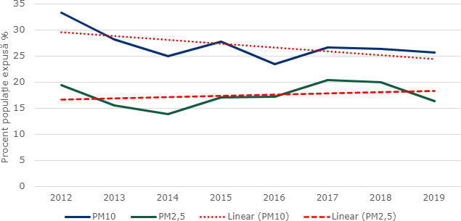
National emissions of PM10 and PM2.5, reported at European level, showed a downward trend from 2012 to 2017, followed by an upward trend. According to European data, the average annual exposure of the population to PM10 and PM2.5 air pollution in 2012-2019 showed a downward trend for PM10 emissions and a slight upward trend for PM2.5 emissions:

Source: Processing based on ECHI Data Tool data (https://webgate.ec.europa.eu/dyna/echi/?indlist=10a)
Figure 8 National trend in average annual exposure to PM10 and PM2.5 pollution between
2012-2021

The results recorded at national air quality monitoring stations have shown that air pollution is higher in urban areas than in rural areas. The population living in large urban agglomerations, but also near roads and industrial centers, is more exposed to pollution.
In Constanța County, a single station monitors the PM2.5 fraction of suspended particulate matter, CT2 – an urban background station located in the town hall park area. Recordings made in accordance with current regulations showed an upward trend between 2017 and 2019, followed by a decline until 2024. The values recorded were around 12 µg/m3, which is below the limit value, with no exceedances recorded during the analysis period.
In the commune of Cerchezu, the most significant source of air pollution is currently transport (road traffic), but even this is insignificant given that the commune has only one county road and three communal roads. The main pollutants from transport that affect human health are: particulate matter (PM10 and PM2.5), COx, NOx, SOx, volatile organic compounds, heavy metals, benzene, and other unburned hydrocarbons.
In Romania, there are no statistics on the number of cases of respiratory or cardiovascular diseases caused by the transport sector or air pollution.
Mortality caused by respiratory diseases and cardiovascular diseases accounts for a significant percentage of overall mortality at the national level, with a higher proportion in urban areas compared to rural areas, due to the fact that urban areas are much more polluted.


The situation regarding deaths associated with air pollution at the county level is as follows:
Other causes
43
9
Respiratory diseases
Perinatal disorders Malformations
9
Ischemic heart disease

Cerebrovascular diseases
9
Circulatory system diseases
1
0
Diseases of the nervous system
1
14
Tumors

Source: Processing based on INS data
Figure 9 Deaths associated with air pollution

Effects of noise pollution on human health

Another stress factor that can aggravate certain conditions (hearing loss, mental illness, cardiovascular disease, endocrine disorders) is noise, which is one of the most widespread threats to public health in industrialized countries.
In the municipality of Cerchezu, traffic is not a significant source of noise, given that the municipality's roads are local roads (county and municipal).
Wind turbines can generate a constant and characteristic noise, which can affect sleep quality and cause acoustic discomfort. An important reference value is the noise level outside homes, which should not exceed the limit imposed by national and international regulations.
Persistent noise, including at night, can affect sleep quality and lead to insomnia, cognitive impairment, and anxiety or irritability.
Some studies suggest that long-term exposure to noise from wind turbines can have a negative impact on the cardiovascular system, increasing the risk of high blood pressure, heart disease, and stroke.
Individual reactions to noise can vary depending on personal factors, context, and individual sensitivity. Some people may be more sensitive to the specific noise of wind turbines and may experience more pronounced adverse effects.

The effects of water quality on human health

The occurrence of diseases related to the quality of water intended for human consumption is caused by the excess or deficiency of certain chemical elements in water, but also by the presence of substances foreign to the normal composition of water. Water has a varied chemical composition, with a large number of dissolved chemical elements. As a result of pollution, other chemicals may be added to the normal composition, which can have a multitude of effects on the human body.

Water can be a means of transmission for numerous toxic chemicals. These can enter the body through the water we drink every day in small quantities, but over a long period of time, contributing to chronic conditions. There are situations when toxic substances are present in large quantities and can cause acute poisoning.
In Constanța County, the quality of drinking water is monitored by the Constanța Public Health Department. Chemical parameters are measured periodically: nitrites, nitrates, pesticides, cadmium, lead, and indicator parameters: oxidizability, turbidity, ammonium, aluminum, iron, manganese.
The drinking water distribution network in the municipality of Cerchezu is owned by the operator S.C. RAJA S.A. Constanța, has a length of 12 km, serves a population of 563 inhabitants, and provides a volume of water of 19 m³/day. ZAP Cerchezu holds a sanitary operating permit issued in 2014 and valid until 2023 6.
28F
The quality of drinking water distributed to the population of Cerchezu commune is satisfactory, with no parameters for which the system could be declared non-compliant. The microbiological parameters and physical-chemical indicators of the water fall within the values allowed according to the analysis reports 7.
29F
There are no public fountains or drinking fountains in the municipality of Cerchezu.

Green spaces and their effects on health and quality of life

Green spaces are a functional category within or adjacent to localities, whose specific nature is determined primarily by vegetation and secondarily by the built environment, including facilities and equipment intended for cultural, educational, sporting, or recreational activities of the population.
Depending on the nature of the property, green spaces can be public (parks, squares, sports and leisure areas, planted areas for protection and forests of various types, and areas with spontaneous vegetation that fall within the public domain) or private (green spaces that are privately owned and not used in the public interest).
From an ecological perspective, urban green spaces are a true moderator of the impact of human activities on the environment. They make an important contribution to the chemical purification of the atmosphere, maintaining the day-night balance in favor of oxygen production, but also to its physical purification by retaining dust and powders. Thus, a leaf area of 25 m²provides the oxygen needed for one person,
Grass lawns retain 3–6 times more dust than bare ground, and a mature tree retains 10 times more impurities than a lawn the size of its crown projection on the ground.
At the county level, the area of green spaces declined between 2010 and 2019, followed by an upward trend that reached 1,080 ha in 2022, which, relative to a resident population of 656,631 inhabitants, means a green space area of 16.45 m2 per inhabitant, well below the European standard of 26 m2 of green space per inhabitant.

6https://dspct.ro/wp-content/uploads/2024/04/RAPORT-JUDETEAN-APA-POTABILA-2023.pdf
7 County report on the state of the environment, 2022

Climate change and its effects on health and quality of life

The main effects of climate change on health are related to extreme weather events, changes in the distribution of climate-influenced diseases, and changes in environmental and social conditions. Over the past decade, river and coastal flooding has affected millions of people in Europe. Health effects include injuries, infections, exposure to chemical hazards, and mental health consequences. Heat waves have become more frequent and intense, causing tens of thousands of premature deaths in Europe. This trend is expected to increase and intensify unless appropriate adaptation measures are taken. The spread of tick species, Asian tiger mosquitoes, and other disease vectors increases the risk of diseases such as Lyme disease, tick-borne encephalitis, West Nile fever, dengue fever, Chikungunya, and leishmaniasis 8.
30F
Low temperatures in winter and average maximum and minimum temperatures in summer can contribute to increased mortality from cerebrovascular disease and myocardial infarction, and high/low relative humidity in the same month can also be a risk factor for cerebrovascular disease and myocardial infarction.

Economic aspects

Labor

According to the National Institute of Statistics, in the commune of Cerchezu, the average number of employees shows a downward trend between 2018 and 2024, with the lowest value recorded in 2022 (77 employees) and the highest in 2024 (104 employees).
Thus, in 2022, the number of employees was 3.75% lower than in 2018 and 35.06% higher than in 2022.
With regard to the labor force participation rate, no data is available at the local level, but at the county level in Constanța, it is relatively constant between 2018 and 2022, reaching 66.8 in 2022, which is higher than the national average.
According to data provided by the National Institute of Statistics, in the commune of Cerchezu, the lowest number of unemployed persons was recorded in November 2014 (8 unemployed persons), and the highest number was recorded in June and July 2021 (67 unemployed persons). In December 2022, the number of unemployed people in the commune of Cerchezu was 44.
According to data recorded by the National Institute of Statistics, in the municipality of Cerchezu between 2010 and 2023, the number of unemployed people showed an upward trend. In 2023, the number of unemployed people reached 44, which is 54% higher than in 2013.

8 Climate change is an increasing risk to ecosystems, human health, and the economy in Europe, European Environment Agency, 2017

Standard of living

An overview of the standard of living in the study area can be expressed by indicators such as the relative poverty rate 9 , which showed a downward trend between 2012 and 2024 for the South-East Development Region, which includes Constanța County and, implicitly, Cerchezu Commune. However, by correlating county-level data with commune-level data and taking into account the economic profile of the area, it can be concluded that the relative poverty rate in Cerchezu is higher than that at the county level.
Relative poverty rate (%)
26
40
35
30
25
20
15
10
5
0
2014 2015 2016 2017 2018 2019 2020 2021 2022 2023 2024
Romania South East Region Linear (South-East Region)

Source: processed by INS

Biodiversity

Figure 10 Relative poverty rate
As part of the Presentation Memorandum for obtaining the Environmental Agreement for the project "Wind farm 48 (46) wind turbines approx. 316.8 MW (303.6 MW), transformer stations, connection networks, construction and modernization of communication and access roads" (loc. Cerchezu, Constanța County), a spatial analysis (GIS) was carried out, taking into account all elements of the project (including those located at a distance), in order to identify potentially affected Natura 2000 sites.
Based on the results of this analysis, carried out according to methodological criteria (intersection, proximity/area of influence, species mobility, and ecological connectivity), the final list of Natura 2000 sites to be included in the assessment of the Cerchezu project was established, as presented in the tables in the memorandum (e.g., "Natura 2000 sites analyzed and identification of those potentially affected").
Table 9 Complete list of Natura 2000 sites included in the impact assessment of the Cerchezu wind farm and the reason for their inclusion in the analysis
No. | Natura 2000 site | Intersection | SCI  Neighboring | SPA  neighboring
1 | ROSCI0071 / ROSAC0071 Dumbrăveni – Urluia Valley –  Vederoasa Lake |  | X
2 | ROSCI0157 / ROSAC0157 Hagieni Forest – Cotul Văii |  | X
3 | ROSPA0036 Dumbrăveni |  |  | X
4 | ROSPA0166 Plopeni–Chirnogeni |  |  | X
5 | ROSPA0094 Hagieni Forest |  |  | X
6 | BG0000569 Kardam (BG) |  | X
7 | BG0000570 Izvorovo–Kraishte (BG) |  | X

9 The relative poverty rate is defined as the share of poor people (according to the relative estimation method) in the total population. People in households with a disposable income per adult equivalent (including or excluding the equivalent value of consumption from own resources) below the poverty threshold are considered poor.

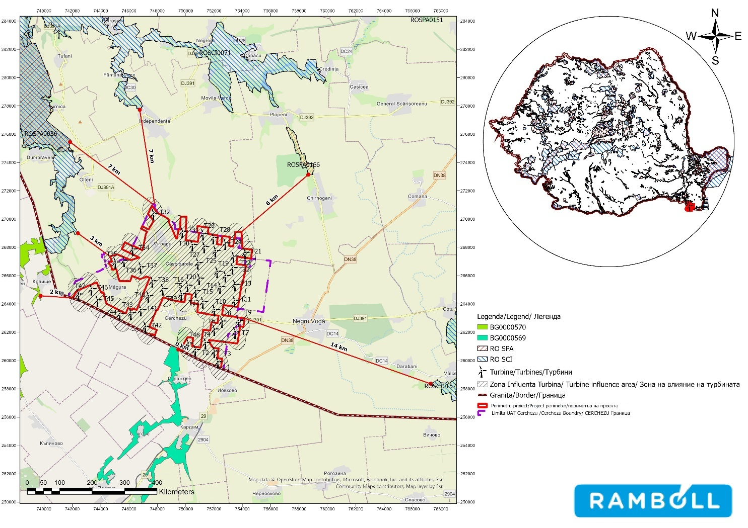

Figure 11 Natura 2000 sites included in the analysis of sites potentially affected by the wind farm

Presentation of the areas of intersection of the project with protected natural areas
As part of the documentation, a GIS spatial analysis was performed to identify relevant protected natural areas (ANPIC/Natura 2000), taking into account all components of the project, including distant elements and potential cross-border characteristics. The analysis looked at overlap (intersection) and proximity (neighborhood/area of influence) criteria to figure out which sites to include in the impact assessment.
The results indicate that the location and elements of the project do not overlap with the boundaries of any Natura 2000 site, so no areas of intersection with protected natural areas are identified. Consequently, the assessment focuses on neighbouring sites/sites potentially affected by indirect effects (particularly associated with the proximity and mobility of species), including the cross-border component: BG0000569 Kardam (≈0.41 km from the project boundary), ROSAC0071/ROSCI0071 Dumbrăveni–Valea Urluia–Lacul Vederoasa (≈2.79 km) and BG0000570 Izvorovo–Kraishte (≈3.64 km).

Presentation of the areas adjacent to the project with protected natural areas
In order to characterize the spatial relationship between the project site and the network of protected natural areas, a GIS proximity analysis was performed, identifying and ranking the Natura 2000/ANPIC areas located in the vicinity of the project and in its area of influence, including in a cross-border context.

ROSAC0071(ROSCI0071) Dumbrăveni - Valea Urluia - Lacul Vederoasa

It was declared a site of Community importance by MMDD Order No. 1964/2007 on the establishment of the protected natural area regime for sites of Community importance, as an integral part of the European ecological network Natura 2000 in Romania, with subsequent amendments and additions.
The area has been designated a Site of Community Importance because it is home to at least eight types of habitats protected at European level, three of which are priority habitats, i.e. strictly protected: Pontic-Sarmatian steppes - approximately 160 ha in the site, Ponto-Sarmatic deciduous scrub present in coastal areas, on stony substrate, with limestone on the surface, covering a total area of approximately 200 ha within the site, and East European downy oak forests, whose total area has been estimated at approximately 900 ha. Within these habitats, 58 rare plant species, protected at national level, have been identified. Four of these are also protected at European level: Centaurea jankae, Echium russicum, Himantoglossum caprinum, and Potentilla emilli-popii.
ROSCI0071 Dumbrăveni - Valea Urluia - Lacul Vederoasa covers an area of 17,971 ha and overlaps with ROSPA0036 Dumbrăveni (2,056 ha), Pădurea Dumbrăveni (2,361 ha), ROSPA0001 Aliman - Adamclisi (19,468 ha), Aliman Fossil Site (2,351 ha), ROSPA0007 Balta Vederoasa (2,144 ha), Lake Vederoasa (IV.30), ROSPA0039 Danube - Ostroave (16,224 ha), Bratca Forest (IV.26), Petroșani Limestone Cliffs (2,350 ha). ROSAC0071 (ROSCI0071) Dumbrăveni - Valea Urluia - Lacul Vederoasa is located in the following localities: Vlahii, Aliman, Floriile, Adâncata, Crângu, Adamclisi.
Located in southern Dobrogea, the ROSCI0071 Dumbrăveni - Valea Urluia - Lacul Vederoasa site has a rich biodiversity, due to a mosaic of different habitats developed on a varied geomorphology: here we find limestone cliffs with caves, rocky and loess hills, valleys with temporary waters, permanent watercourses, and lakes. Intercalated with forests, we find scrubland and ponto-sarmatic grasslands.
The types of habitats present in the site are as follows:

  - 62C0* Ponto-Sarmatic steppes
  - 91I0 * Euro-Siberian forest-steppe vegetation with Quercus spp.
  - 3150 Natural eutrophic lakes with Magnopotamion or Hydrocharition vegetation
  - 40C0* Ponto-Sarmatic deciduous scrub
  - 6430 Hygrophilous tall herb communities of the lowlands, montane and
alpine
  - 91F0 Mixed riparian forests with Quercus robur, Ulmus laevis, Fraxinus excelsior or Fraxinus angustifolia, along major rivers - Ulmenion minoris -
  - 91AA Ponto-Sarmatic forest vegetation with downy oak
  - 91M0 Balkan-Pannonian forests of oak and hornbeam

In terms of importance for the conservation of endangered habitats, the forest-steppe formations in the site are a top priority. Two types of vegetation have been identified:
  - Mixed Danubian-Western Pontic forests of Quercus penduliflora and Tilia tomentosa with Viola jordanii. This type of habitat has a small area at national level, with only approx. 3000 ha, presenting a very high conservation value. Within the study area, they represent 2% of the total area. They are characterized by the Querco penduculiflorae-Tilietum tomentosae plant association. The phytocoenoses are made up of European sub-Mediterranean and continental species, as well as Caucasian species. The tree layer is composed of Quercus penduculiflora oak, Tilia tomentosa silver linden, these two species being characteristic of this type of habitat, Acer tataricum Tatarian maple, Fraxinus ornus manna ash, Carpinus orientalis oriental hornbeam, with specimens of Acer campestre field maple, Fraxinus excelsior ash, Sorbus torminalis, and Ulmus procera.
  - Pontic vegetation of oak-hornbeam forest-steppe and Tatar maple forest. In the country, it is reported on relatively small areas totaling 16,000 ha in southern and southeastern Romania. In the rest of Europe, this habitat has not been reported to date. The characteristic association observed is Quercetum penduculiflorae-cerris. Edificatory species observed: Tatarian maple Acer tataricum, Turkey oak Quercus cerris, downy oak Quercus penduculiflora. Threatened plant species in these forests: Asphodeline lutea, Crocus pallisii, Mercurialis ovata, Myrrhoides nodosa, Pipitatherum virescens.
The site is home to plant species protected at European level - Annex II of the Habitats Directive.-: Centaurea jankae, Himantoglossum caprinum, five-fingered cinquefoil Potentilla emilii-popii, Echium russicum snakehead Echium russicum.
Among the invertebrate species, the Lepidoptera order of butterflies is best represented. Of these, six butterflies are protected at European level by the Habitats Directive: Lycaena dispar, a vulnerable species that prefers habitats with swampy or wet oak forests rich in Polygonum bistorta, a plant that is the insect's staple food; the stag beetle Lucanus cervus, whose presence is determined by the old trees in the Dumbrăveni forest; the moth Eriogaster catax, a species very rarely reported in Romania; two other species are Catopta thrips and Asthena anseraria.
Among the reptile and amphibian species present in the site, we mention the Dobrogea crested newt Triturus dobrogicus, the red-bellied toad Bombina bombina, the European pond turtle Emys orbicularis, and others. One of the most important species is the Dobrogea tortoise Testudo graeca, declared a natural monument and strictly protected by law. Currently, the population of this species is in sharp decline.
This site is home to a rich birdlife, with over 100 species of birds identified. Some bird species have large populations, such as birds of prey, larks, woodpeckers, nightjars, and others. For this reason, it has been designated a Special Protection Area for birds.
The mammal fauna includes a significant number of species, including the otter Lutra lutra, the European ground squirrel Spermophilus citellus, and many species of bats.

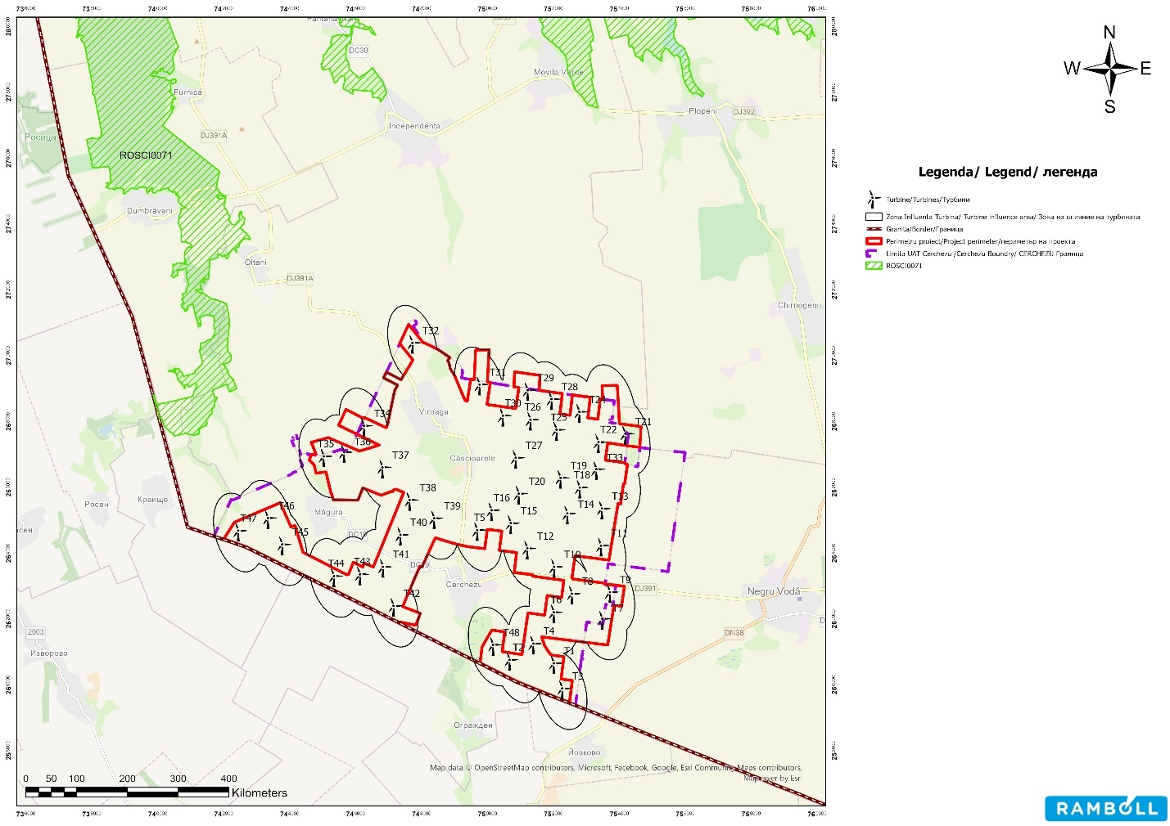

Figure 12 Location of the project in relation to ROSAC0071(ROSCI0071) Dumbrăveni - Valea Urluia - Lacul Vederoasa

ROSPA0036 Dumbrăveni

A special bird protection area was established by Government Decision No. 1284/2007 on the declaration of special bird protection areas as an integral part of the European ecological network Natura 2000 in Romania, with subsequent amendments and additions.
ROSPA0036 Dumbrăveni is of particular importance due to its 22 bird species of European conservation interest, being important because two globally threatened species are present here, the European roller Coracias garrulus, which nests here, and the Montagu's harrier Circus macrourus.
The site is also important because it is a major nesting area for species threatened at EU level, such as the Syrian woodpecker (Dendrocopos syriacus), the lesser grey shrike (Lanius minor), the booted eagle (Hieraaetus pennatus), the ortolan bunting (Emberiza hortulana), the woodlark (Lullula arborea), the Levant sparrowhawk (Accipiter brevipes), the black kite (Milvus migrans) and the long-legged buzzard (Buteo rufinus). The site is particularly important during the migration period for birds of prey.
ROSPA0036 Dumbrăveni, covering an area of 2,056 ha, overlaps with ROSCI0071 Dumbraveni-Valea Urluia-Lacul Vederoasa and Pădurea Dumbrăveni and is located in the following localities: Șipotele, Tufani, Furnica, Dumbrăveni, Olteni.
From an avifaunal point of view, the Dumbrăveni Forest - together with its surroundings - is home to significant populations of protected bird species. The following categories have been identified within the site: 23 species listed in Annex 1 of the Birds Directive; 66 migratory species listed in the annexes to the Bonn Convention on Migratory Species; 2 globally endangered species.

The protected area is an important nesting site for numerous species, such as the Syrian woodpecker Dendrocopos syriacus, the ortolan bunting Emberiza hortulana, the lesser grey shrike Lanius minor, the Levant sparrowhawk Accipiter brevipes, the tawny pipit Anthus campestris, the hen harrier Circus cyaneus, the booted eagle Hieraaetus pennatus, the Montagu's harrier Circus macrourus, and the European roller Coracias garrulus, the latter two species being globally threatened.
The site is crossed during migration by numerous species of birds of prey, including the booted eagle (Circus pygargus), the hen harrier (Circus cyaneus), the Montagu's harrier (Circus macrourus), the peregrine falcon (Falco peregrinus), and the black kite (Milvus migrans).
The 22 bird species listed in Annex I to Council Directive 2009/147/EC include: A402 Accipiter brevipes, A403 Buteo rufinus, A092 Hieraaetus pennatus, A231 Coracias garrulus, A246 Lullula arborea, A339 Lanius minor, A379 Emberiza hortulana, A084 Circus pygargus, A082 Circus cyaneus, A083 Circus macrourus, A103 Falco peregrinus, A338 Lanius collurio, A242 Melanocorypha calandra, A533 Oenanthe pleschanka, A255 Anthus campestris, A089 Aquila pomarina, A243 Calandrella brachydactyla, A224 Caprimulgus europaeus, A321 Ficedula albicollis, A429 Dendrocopos syriacus, A072 Pernis apivorus, A073 Milvus migrans.
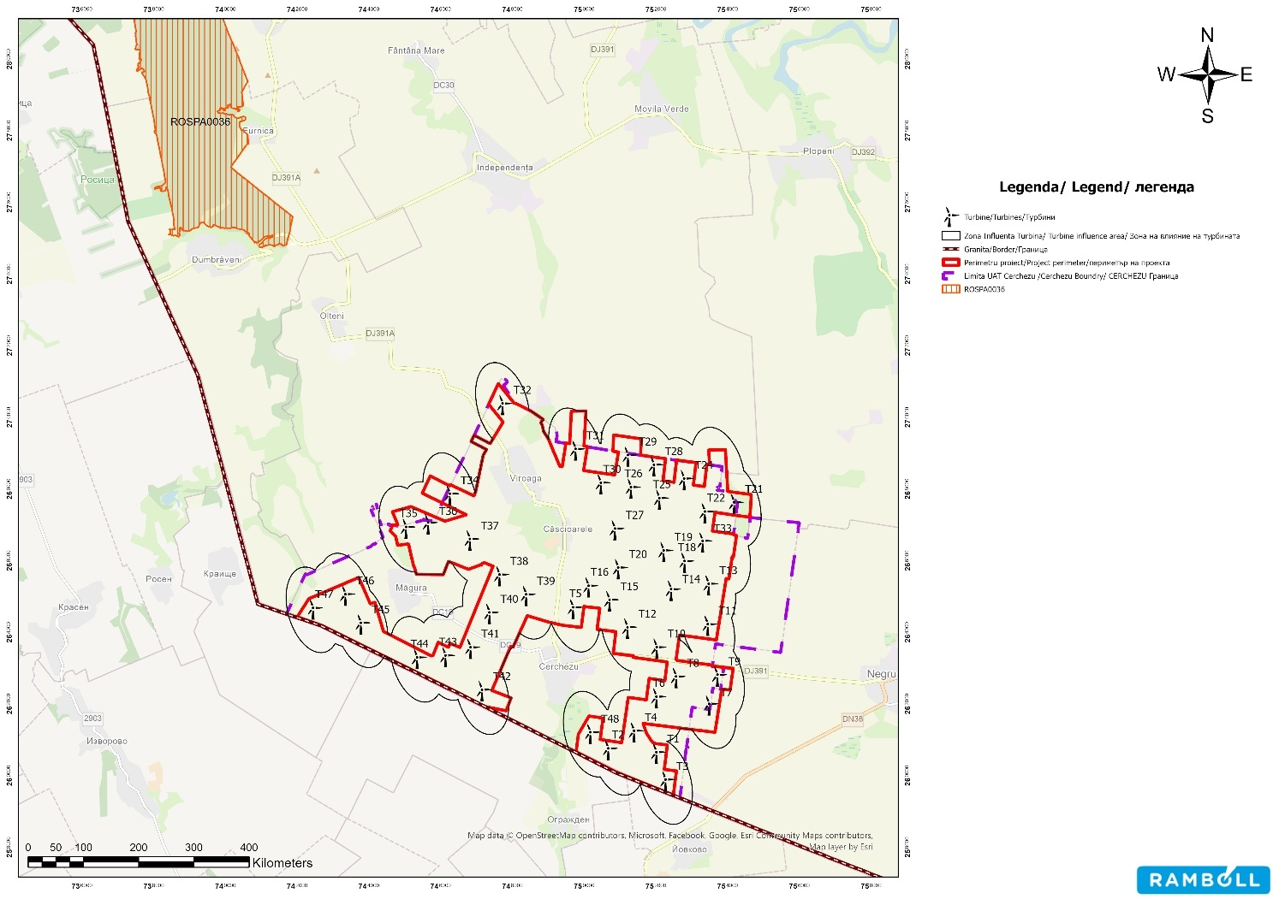
Figure no. 13 Location of the project in relation to ROSPA0036 Dumbrăveni

ROSPA0094 Hagieni Forest

It was established as a special bird protection area by Government Decision No. 1284/2007 on the declaration of special bird protection areas as an integral part of the European Natura 2000 ecological network in Romania, with subsequent amendments and additions.
The R0SPA0094 Hagieni Forest site is home to significant populations of protected bird species, namely 48 species of Community importance for conservation.
ROSPA 0094 Hagieni Forest covers an area of 1,374 ha and is located within ROSCI 0157 Hagieni-Cotul Văii Forest, partially overlapping with the Hagieni Forest reserve (code 2360).
This site is home to significant populations of protected bird species: 48 species listed in Annex 1 to Directive 2009/147/EC of the European Parliament and of the Council of November 30, 2009, on the conservation of wild birds; 38 migratory species listed in the annexes to Law No. 13/1998 on Romania's accession to the Convention on the Conservation of Migratory Species of Wild Animals, adopted in Bonn on June 23, 1979: 5 globally endangered species.
The site is important for the nesting populations of the following species: Falco cherrug, Falco vespertinus, Coracias garrulus, Aquila heliaca, Accipiter brevipes, Antus campestris, Calandrella brachydactyla, Lanius minor, Milvus migrans, Pernis apivorus, Picus canus, Lullula arborea, Melanocorypha calandra.
The site is important during the migration period for the following species: Larus melanocephalus, Larus minutus, Pelecanus crispus, Phalacrocorax pygmaeus.
Site designated by the Romanian Ornithological Society as an IBA - Important Bird Area, according to the following
criteria developed by BirdLife International: C1, C2, C3, C6.

The 48 bird species listed in Annex I to Directive 2009/147/EC include: Accipiter brevipes, Alcedo atthis, Anthus campestris, Aquila heliaca, Burhinus oedicnemus, Buteo rufinus, Calandrella brachydactyla, Caprimulgus europaeus, Ciconia ciconia, Charadrius alexandrinus, Chlidonias hybridus, Chlidonias niger, Circaetus gallicus, Circus aeruginosus, Circus cyaneus, Circus macrourus, Circus pygargus, Coracias garrulous, Dendrocopos medius, Dendrocopos syriacus, Dryocopus martius, Egretta alba, Emberiza hortulana, Falco cherrug, Falco columbarius, Falco peregrinus, Falco vespertinus, Ficedula albicollis, Ficedula parva, Himantopus himantopus, Hieraaetus pennatus, Lanius minor, Lanius collurio, Larus melanocephalus, Larus minutus, Lullula arborea, Melanocorypha calandra, Milvus migrans, Nycticorax nycticorax, Oenanthe pleschanka, Pelecanus crispus, Pernis apivorus, Picus canus, Philomachus pugnax, Phalacrocorax pygmeus, Porzana porzana, Recurvirostra avosetta, Tadorna ferruginea.

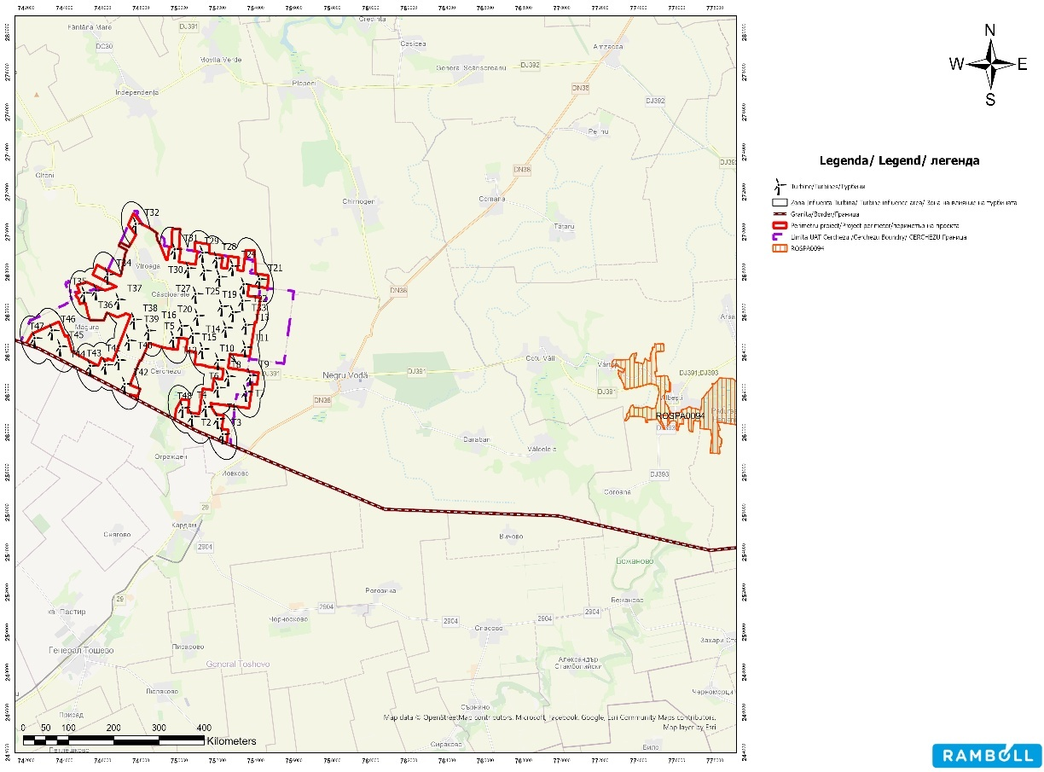

Figure no. 14 Location of the project in relation to ROSPA0094 Hagieni Forest

ROSAC0157 Hagieni Forest - Cotul Văii

It was established by Order of the Minister of Environment and Sustainable Development No. 1964/2007 on the establishment of the protected natural area regime for sites of Community importance, as an integral part of the European ecological network Natura 2000 in Romania, with subsequent amendments and additions.
ROSCI0157 Hagieni Forest - Cotul Văii is of great scientific importance due to its 6 habitats and 18 species
of Community interest for which it has been designated.

R0SCI0157 Hagieni-Cotul Văii Forest covers an area of 3618 ha and overlaps with R0SPA0094 Hagieni Forest and Hagieni Forest Reserve-code 2.360.
Habitat types present in the site - 6 habitat types:

- 3150 Natural eutrophic lakes with Magnopotamion or Hydrocharition vegetation
- 6430 Communities of tall hygrophilous grasslands from the plains to the mountain and alpine levels
alpine
- 91AA Ponto-Sarmatic forest vegetation with downy oak
- 40C0* Ponto-Sarmatic deciduous scrub
- 62C0* Ponto-Sarmatic steppes
- 91M0 Balkan-Pannonian forests of oak and hornbeam

The site hosts:

- 7 mammal species listed in Annex II to Directive 92/43/EEC Spermophilus citellus, Mesocricetus newtoni, Rhinolophus mehelyi, Miniopterus schreibersii, Rhinolophus ferrumequinum, Myotis capaccinii, Mustela eversmannii;
- 2 species of amphibians and reptiles listed in Annex II to Directive 92/43/EEC: Testudo graeca, Emys orbicularis;
- 4 plant species listed in Annex II to Directive 92/43/EEC: Himantoglossum caprinum, Potentilla emilii-popii, Centaurea jankae, Echium russicum:
42 Other important species of flora and fauna:Anacamptis pyramidalis, Beta trigyna, Centaurea napulifera ssp. thirkei, Centaurea rutifolia ssp. jurineifolia, Centaurea varnensis, Chamaecytisus jankae, Colchicum fominii Convolvulus lineatus, Crocus chrysanthus, Dictamnus albus, Galanthus elwesii, Heliotropium dolosum, Hottonia palustris, Minuartia bilykiana, Myrrhoides nodosa, Nepeta parviflora, Ononis pusilla, Onosma taurica, Opopanax bulgaricus, Orchis purpurea, Orchis simian, Ornithogalum comosum, Ornithogalum oreoides, Paeonia peregrine, Paeonia tenuifolia, Parietaria lusitanica ssp. serbica, Phleum subulatum, Plumbago europaea, Prunus tenella, Rindera umbellate, Salvia ringens, Salvinia natans, Scabiosa micrantha, Scorzonera mollis, Seseli tortuosum, Silene dichotoma, Stachys oblique, Sternbergia colchiciflora, Stipa ucrainica, Trapa natans, Trigonella gladiate, Trigonella monspeliaca and animals: Vipera ammodytes, Lacerta viridis, Lacerta taurica, Coluber jugularis.

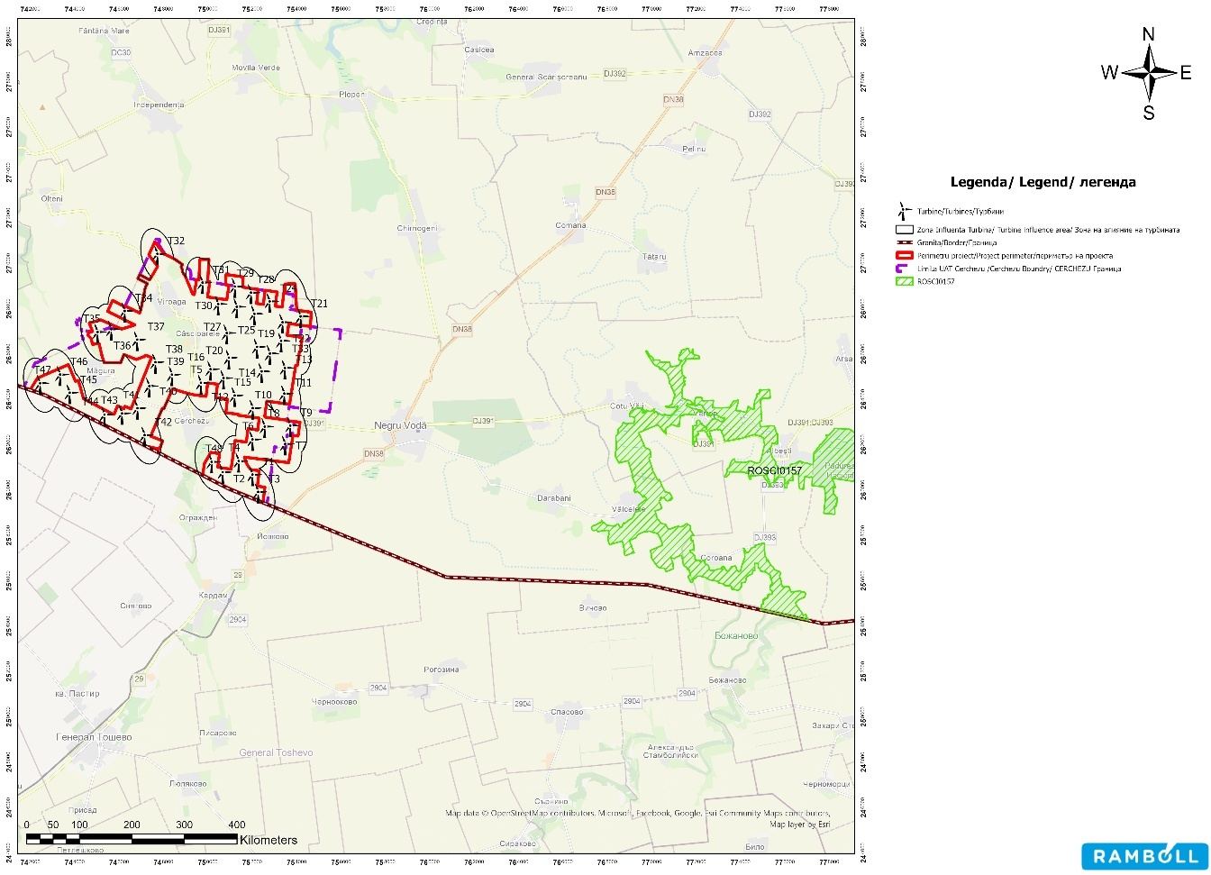
Figure no. 15 Location of the project in relation to ROSAC0157 Hagieni Forest - Cotul Văii

ROSPA0166 Plopeni-Chirnogeni

The natural bird protection area was declared in 2016 by Government Decision No. 663/2016 on the establishment of the protected natural area regime and the declaration of special bird protection areas as an integral part of the Natura 2000 ecological network in Romania. The site covers an area of 137.20 ha and is designated for nine bird species, namely: Anthus campestris, Buteo rufinus, Circus cyaneus, Dendrocopos syriacus, Emberiza hortulana, Falco columbarius, Falco vespertinus, Lanius collurio, and Lanius minor. The site runs from north to south, between the towns of Plopeni and Chirnogeni (Constanța County), along the road connecting the two towns. Red-footed falcons (Falco vespertinus) nest in the crows' nests in the walnut trees lining the road. On the sides of the road, within the site, there are more or less degraded grasslands. Also within the site there are significant acacia plantations that may in the future shelter other colonies of red-footed falcons. Around the site there are agricultural areas that are hunting grounds for red-footed falcons.
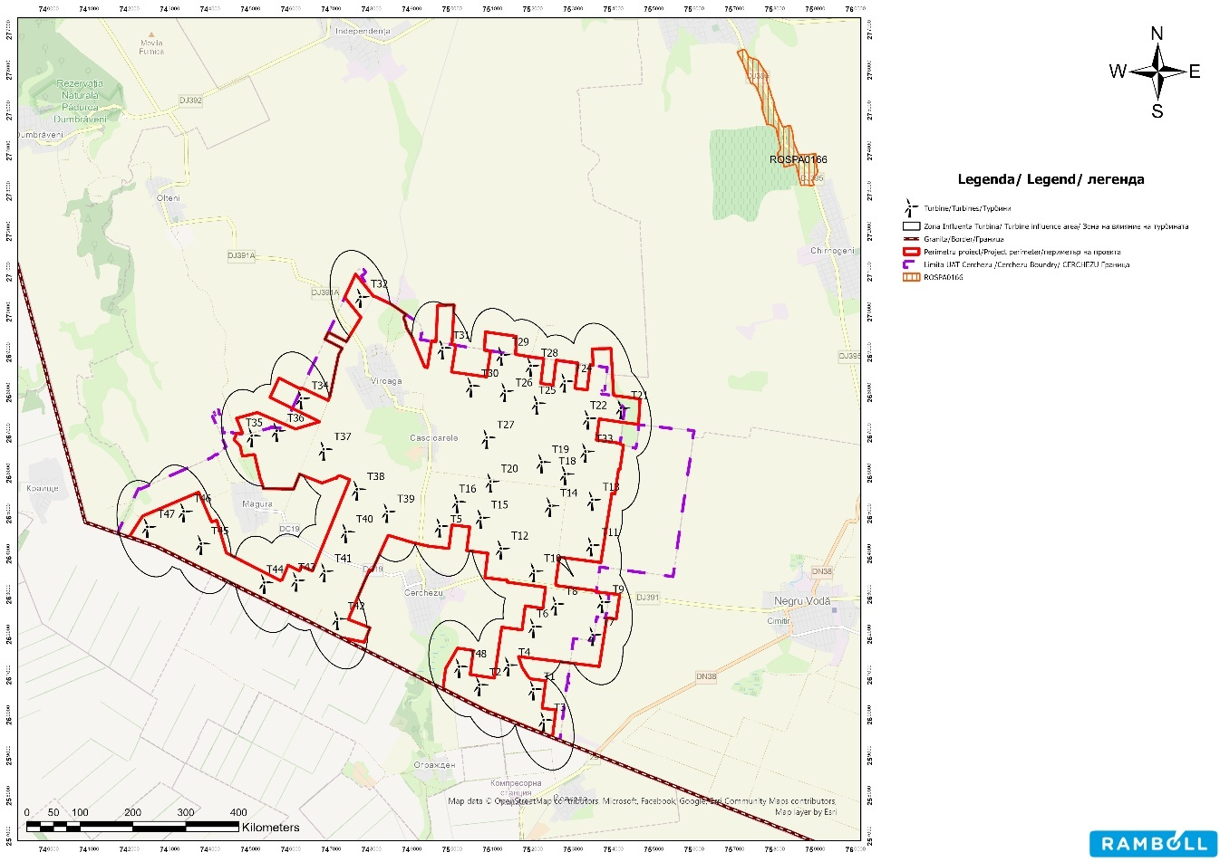
Figure no. 16 Location of the project in relation to ROSPA0166 Plopeni-Chirnogeni

For the project "Wind farm 48 (46) wind turbines approx. 316.8MW (303.6MW), Transformer stations, Connection networks, construction and modernisation of communication and access routes", located in the commune of Cerchezu, Constanța County, was issued by the National Agency for Environment and Protected Areas, as the competent authority responsible for the administration of the protected natural areas ROSAC0071 Dumbraveni -Valea Urluia – Lacul Vederoasa, ROSPA0166 Plopeni-Chirnogeni, ROSAC0157 Hagieni Cotul – Vaii Forest, ROSPA0094 Hagieni Forest, ROSPA0151 Ciobanita Osmancea, ROSPA0001 Aliman-Adamclisi, Favorable Opinion No. 81/17.12.2025.

BG0000569 Kardam

It was established as a site of Community importance in 2008 and covers an area of 918.92 ha. The site is important for its invertebrate fauna. The small isolated patches of steppe and dry karst valleys and canyons are important for small mammals and rare steppe bats.
The site has been designated for the protection of eight species of fauna: four reptiles (Testudo hermanni, Testudo graeca, Emys orbicularis, Elaphe ouromates) and four mammals (Vormela peregusna, Spermophilus citellus, Mustela eversmanii, Mesocricetus newtoni) and two habitats (6110 Rocky grasslands with pioneer species and 6210 Steppe grasslands).
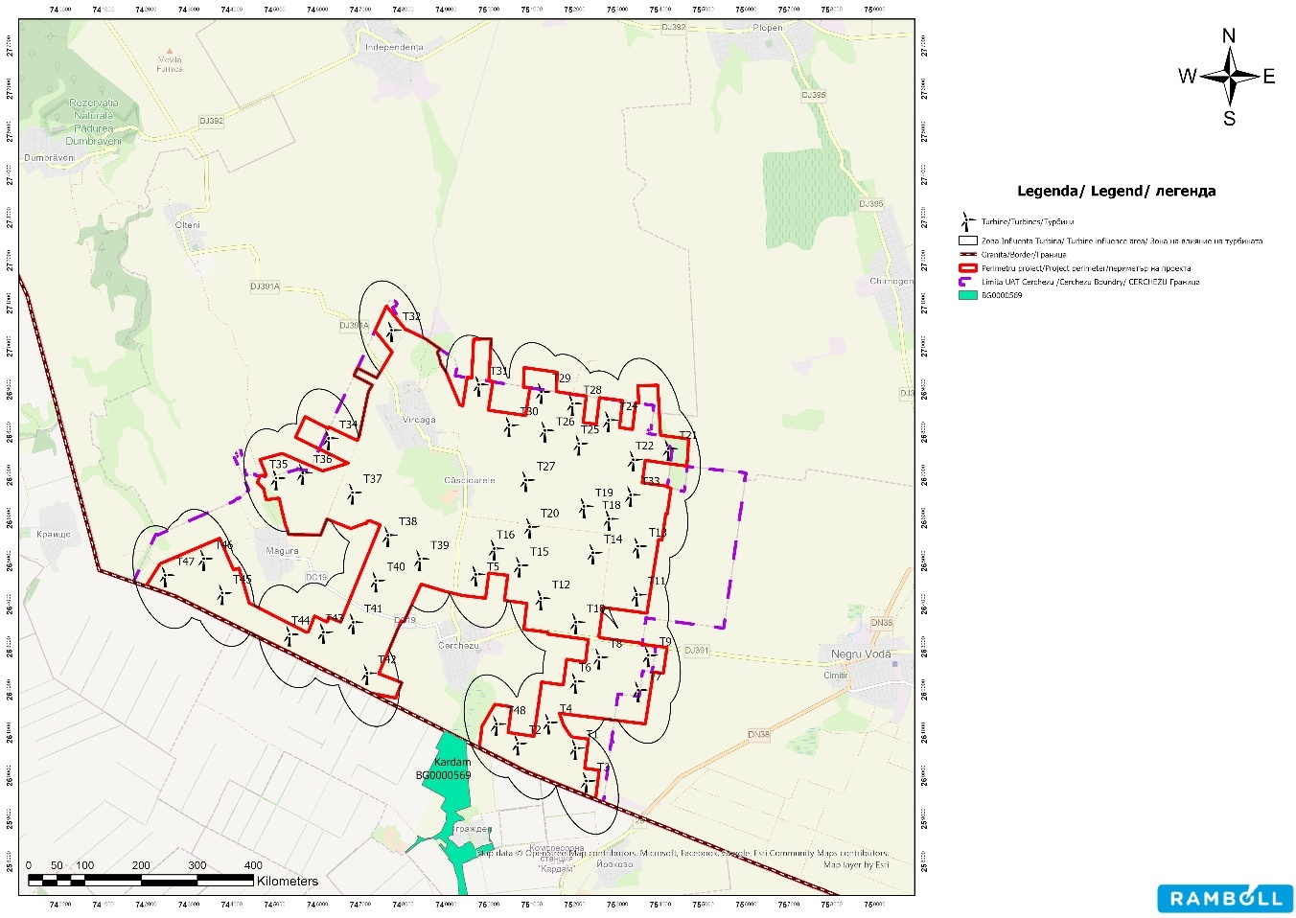

Figure 17 Location of the project in relation to BG0000569 Kardam

BG0000570 Izvorovo – Kraishte

It was established as a site of Community importance in 2008 and covers an area of 1081.52 ha. The site is important for the existing invertebrate fauna. Small isolated patches of steppe and dry karst valleys and canyons are important for small mammals and rare steppe bats.
The site has been designated for the protection of 11 species of fauna: 4 reptiles (Testudo hermanni, Testudo graeca, Rmys orbicularis, Elaphe ouromates), 6 mammals (Canis lupus, Vormela peregusna, Spermophilus citellus, Rhinolophus mehelyi, Mustela eversmanii, Mesocricetus newtoni) and one invertebrate (Lycaena dispar) and two habitats (6110 Rocky grasslands with pioneer species and 62C0 Ponto-Sarmatic steppes).

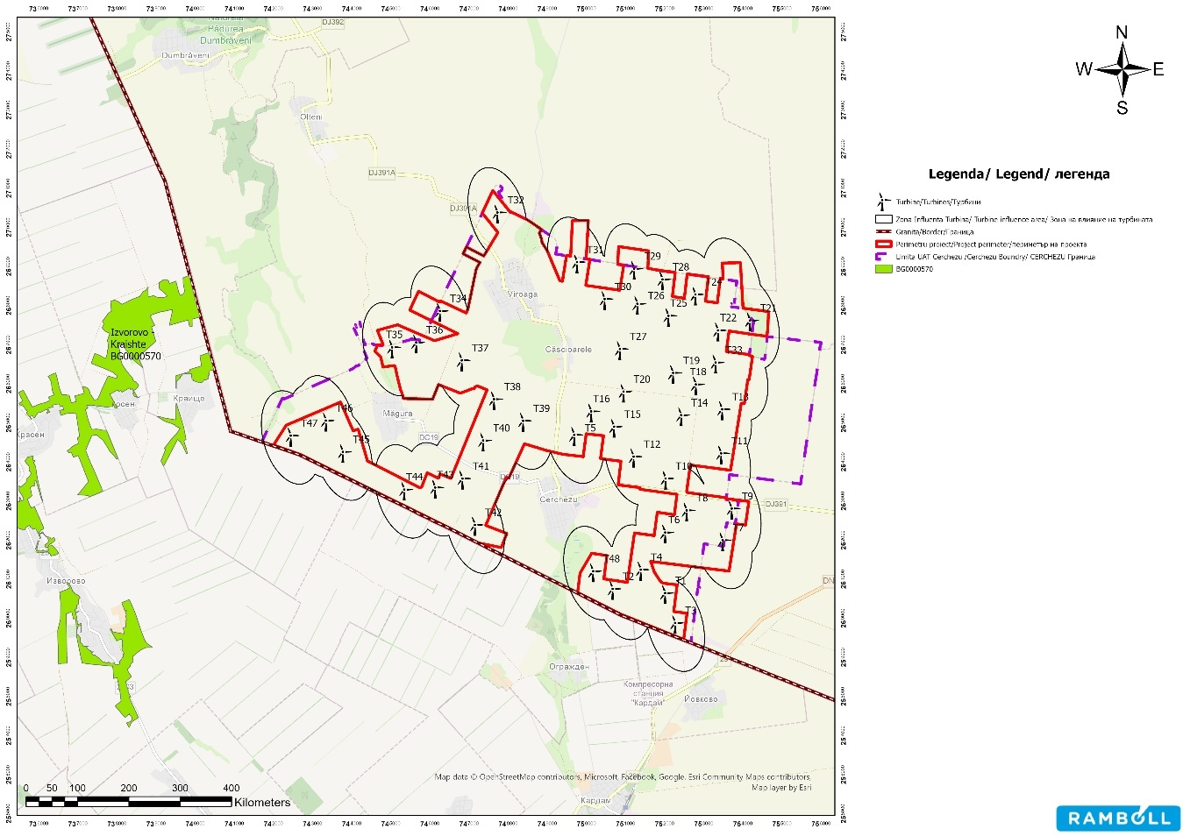

Figure 18 Location of the project in relation to BG0000570 Izvorovo – Kraishte

A detailed analysis of the project's impact on biodiversity components for the two areas in Bulgaria was carried out in the Appropriate Assessment Study prepared at the PUZ stage, as well as in the annexes to this study, and was submitted to the Bulgarian side as part of the cross-border environmental impact assessment procedure with Bulgaria for the PUZ stage. By letter No. 99-00-268-22/26.06.2025, the Ministry of Environment and Water of the Republic of Bulgaria communicated that, " The impact analysis of the project to build 46 turbines near the border with Bulgaria is objective and the proposed measures are sufficient to minimize/eliminate the negative impact on biodiversity and in particular on Natura 2000 protected areas."
The environmental impact assessment procedure in a cross-border context at the PUZ stage was completed after analyzing all studies and requests for clarification. The Ministry of Environment and Water of the Republic of Bulgaria, by letter no. 99.00.268-40/17.09.2025, sent the mandatory conditions to be included in the regulatory act to be issued by the competent authorities in Romania for the investment in question, both in the planning and design phase and in the monitoring measures following the implementation of the investment proposal, respectively after the construction of the proposed investment, namely:
,, 1. "Wind Farm 48 (46) wind turbines, transformer stations, electrical connection networks, construction and modernization of communication and access roads" – will be implemented in compliance with all the measures set out in the Environmental Report submitted, with a view to preventing, reducing, and eliminating adverse effects on the environment, the living environment, and the health of the population, as a result of the project's implementation.

- Given that the energy park is located in the immediate vicinity of the border with the Republic of Bulgaria, an assessment of the impact of physical factors in a cross-border context, in particular light effects, will be carried out during the design phase. The assessment will be forwarded to the Republic of Bulgaria;
- The paint used for wind turbines (tower and rotor) must be of the "absorbent" type so as not to create conditions for reflections of incident light;
- After the implementation of the investment proposal, controlled monitoring of noise levels, non-ionizing radiation, and light effects at the border with the affected Bulgarian localities will be ensured. The results of the monitoring will be sent to the Republic of Bulgaria.
The conditions imposed by the Bulgarian state were included in Environmental Notice No. 8/20.11.2025, issued by the Constanța County Directorate for Environmental Protection, a document that was translated into Bulgarian and English and sent, in accordance with the procedures in force, to the Ministry of Environment and Water of the Republic of Bulgaria.
Also, for condition No. 2 mentioned above, the Shadow Study was sent, whose conclusions indicate that the results show a negligible impact on the analyzed area, including in the case of cross-border roads and the evaluated receptors, a conclusion supported by the use of a conservative modeling scenario based on the largest turbine configuration and an extended analysis radius.

Green Infrastructure

Green infrastructure is a strategically planned network of natural and semi-natural areas with other environmental features, designed and managed to provide a wide range of ecosystem services 10.
Within natural and semi-natural ecosystems, there are established intra- and interspecific connections through which material, energy, and information exchanges take place, ensuring their productivity, adaptability, and resilience.
Natural and semi-natural ecosystems account for approximately 47% of the country's surface area, 45% is accounted for by agricultural ecosystems, and the remaining 8% is accounted for by buildings and infrastructure.
Semi-natural habitats arise from the interaction between human activities and the natural environment. These semi-natural habitats can arise as a result of traditional agricultural activities (grazing, mowing), forest management (traditional forestry, deciduous forests, and wooded pastures), water management (wetlands: marshes, artificial lakes, or irrigation systems), traditional landscape conservation, depollution and land abandonment (natural reforestation), and the creation of buffer or protection zones.
The characteristics of semi-natural habitats are: high biodiversity, the need for continuous management, cultural and ecological value.
At European level, three types of agricultural land with high natural value have been identified:
- land characterized by large areas of semi-natural vegetation (limited human intervention),
- land characterized by mosaic landscapes (hedges, rows of trees, etc.)
- land with low natural value but which represents important ecological corridors for the maintenance of rare habitats and species, areas important for the nesting of certain rare bird species or for migratory birds (cereal crops)¹¹.

10 [2] European Commission (2013), Green Infrastructure (GI): Enhancing Europe's Natural Capital, COM/2013/0249 final, Green Infrastructure Strategy, p. 3.

In Romania, land with high natural value can be classified according to the criteria proposed by the European Forum for Nature Conservation and Pastoralism into natural and semi-natural grasslands in mountain areas; traditional extensive orchards (the old hayfields are almost entirely preserved); mosaic landscapes (grasslands, trees, shrubs, and agricultural plots with abundant biodiversity); grasslands near forests characterized by a high diversity of fauna (birds, invertebrates, mammals, etc.).
In the project area, it was found that agricultural land accounts for the largest share, occupying about 88% of the total. A smaller share is represented by grasslands (about 4.5%) and localities (about 5%).
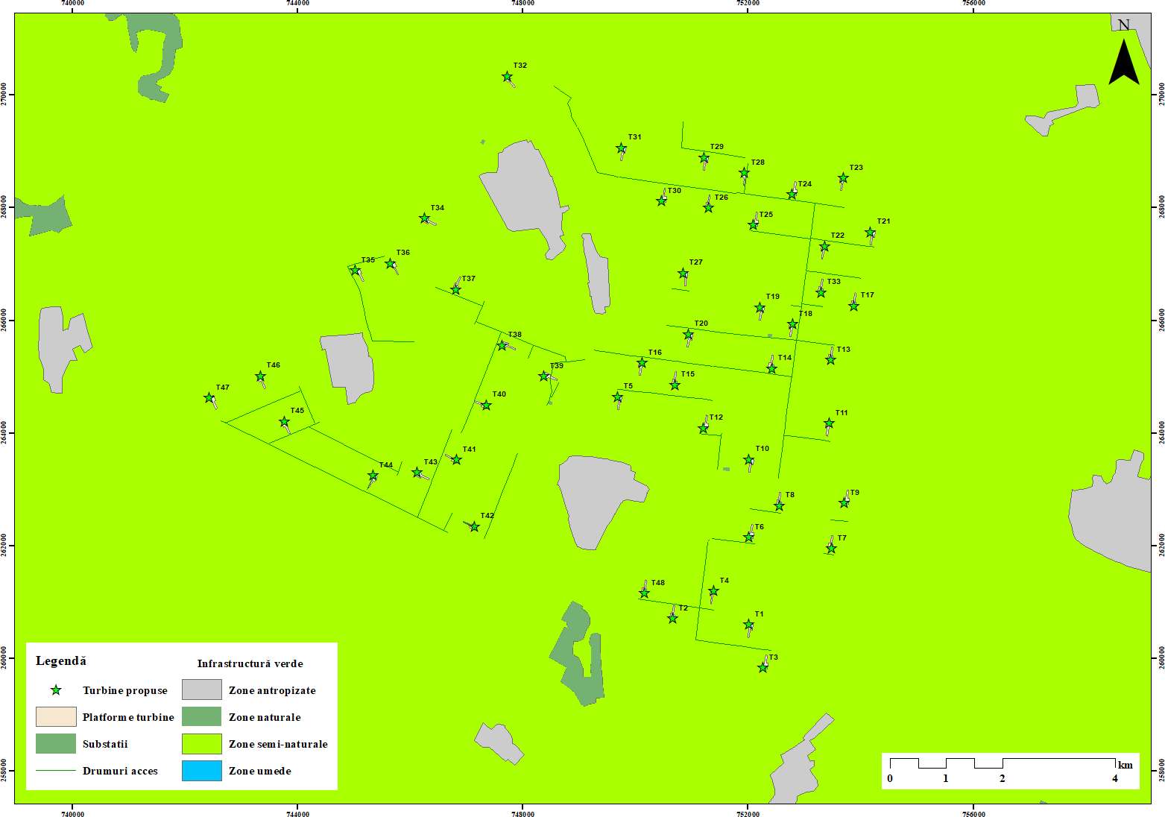

Figure no. 19 Green infrastructure in the site area

Migration color

By analyzing the distance and the species/habitats for which these areas were designated, it was identified that a number of 5 protected natural areas on the territory of Romania may be potentially affected directly/indirectly by the project.

According to data from the specialist literature, the project site is located on the East Albica-Danube migration route12. According to this study, the highest number of migratory species were reported to the north and northeast of the analyzed park site.

11 Thematic publication of the National Rural Development Network no. 42, year II,
12 Drugescu and Geacu, 2002

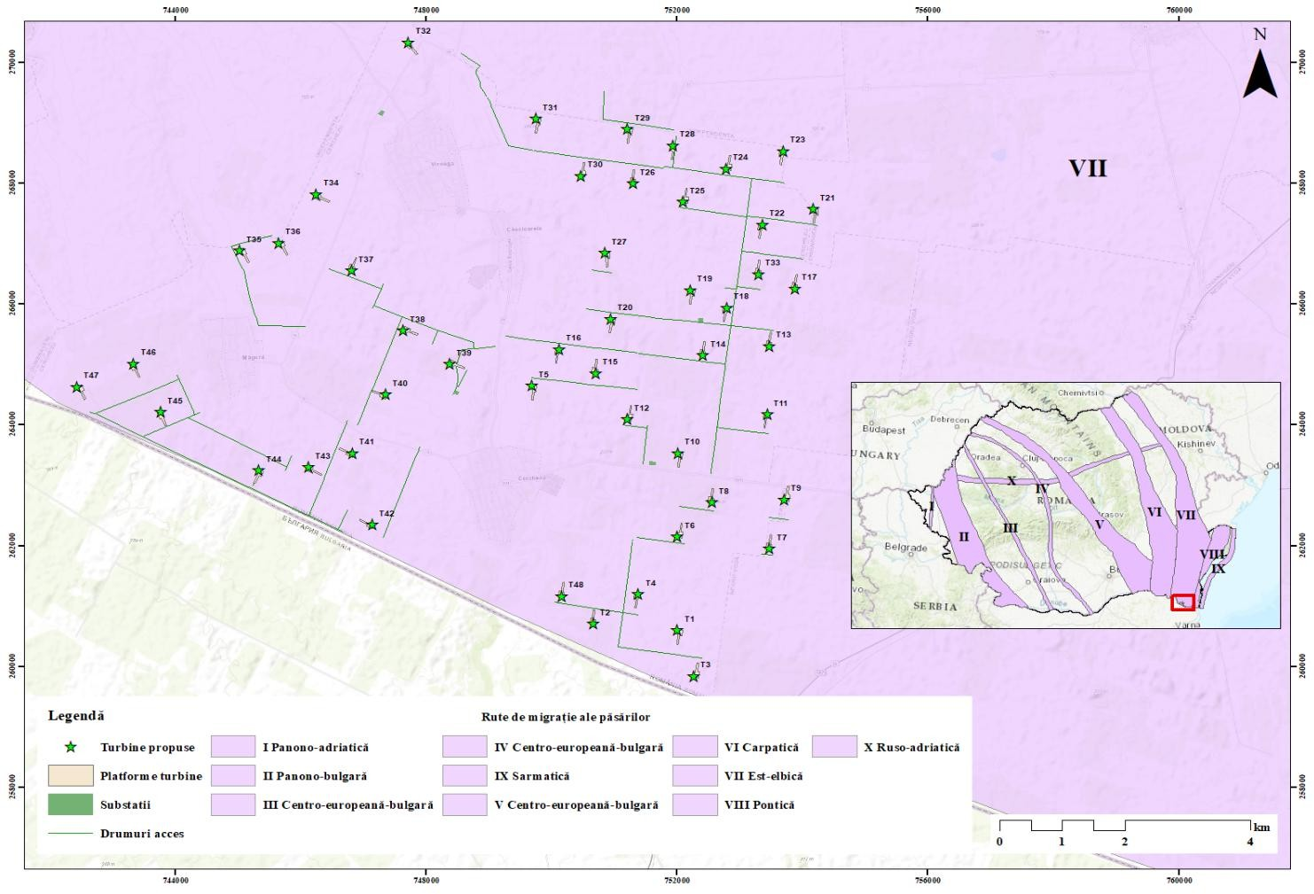
Figure no. 20 Location of the project in relation to migration routes

At the end of 2012, the National Institute for Research and Development of the Danube Delta (INCDDD) completed, under a contract financed by the Ministry of Environment and Forests, "Study on recommendations for areas in Dobrogea where the location of wind farms should be restricted due to the migration corridors of gliding birds (diurnal birds of prey, storks, pelicans) and due to the wintering of geese and swans." The study proposed the following areas:
- Areas where wind farms and related infrastructure are excluded, where their construction is recommended to be prohibited: these areas include Natura 2000 sites (SPAs and SCIs), the Danube Delta Biosphere Reserve, national and natural parks, and nature reserves/bird sanctuaries on the mainland of Dobrogea. The area of the proposed exclusion zones represents 50.4% of the region's total area.
- High-risk areas: In these areas, a series of restrictions on the location and operation of wind farms are necessary to minimize the risk of collision (e.g., monitoring using radar technology, built-in microphones to monitor collision rates, etc.), with long-term monitoring (minimum 10 years) of gliding bird species and/orpopulations of geese and swans that winter there. The proposed high-risk areas cover 36.4% of the Dobrogea region.
- Moderate risk areas: in these areas, long-term monitoring of gliding bird species and/or wintering goose and swan populations is necessary. The proposed moderate risk areas cover 13.2% of Dobrogea's surface area.

These areas only take into account areas that are important for bird species and do not include other types of areas with building restrictions for wind farms (e.g., areas important for bat species, localities, public road networks, information on the nesting of bird species).
From the conclusions of the "Study on recommendations for areas in Dobrogea where the location of wind farms should be restricted due to the migration corridors of gliding birds (diurnal birds of prey, storks, pelicans), and due to the wintering of geese and swans," conducted by the Danube Delta National Research and Development Institute in 2012, it appears that the project is located in an area of moderate risk in terms of bird species conservation and natural habitats. In areas with moderate risk. Moderate risk areas cover approximately 206,100 ha, representing 13.2% of the surface area of Dobrogea. In moderate risk areas, in order to establish conditions for the construction or operation of wind farms, long-term monitoring of gliding bird species and/or wintering goose and swan populations is necessary.

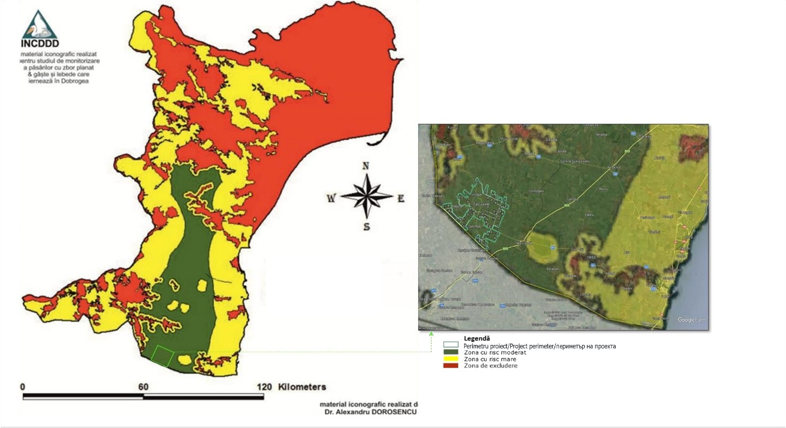

Figure 21 Map showing areas where wind turbine construction may be permitted, but where construction or operation will need to be restricted due to the migration of gliding birds and/or wintering populations of geese and swans.

The project site is located near the distribution areas of the red-breasted goose (Branta ruficollis). In Romania, the red-breasted goose population is found in the lowlands of Bărăgan and Dobrogea, near large lakes, which they use for roosting. In milder winters, several thousand geese remain to winter in Ukraine and even in southern Russia. When it is cold, the geese move rapidly south to the Dobrogea region of Romania and Bulgaria.
The most important areas for the species remain the sites in southeastern Romania, mainly the regions of Bărăgan, the Danube Delta, and Dobrogea (Figure 2-13), where several protected areas have been declared for the species: Balta Albă - Amara - Jirlău, Ianca - Plopu - Sărat, Lake Strachina, Iezerul Călărași, Gura Ialomiței - Berteștii de Sus, Balta Mică a Brăilei Natural Park, Lake Oltina, the Danube Delta, and the Razim-Sinoe lagoon complex.
The latest estimate of the national population of red-breasted geese for the period 2013-2022 is approximately 9,915-23,641 individuals wintering in Romania, representing about 42% of the global population. The following figure shows the distribution of the red-breasted goose (Branta ruficollis) in Romania for the period 2000-2022 (EEA grid, 10x10 km, in ETRS89 projection system).The tables below present the structural and functional relationships and the analysis of the relationships between habitats/species and ecosystems at the level of the analyzed sites.

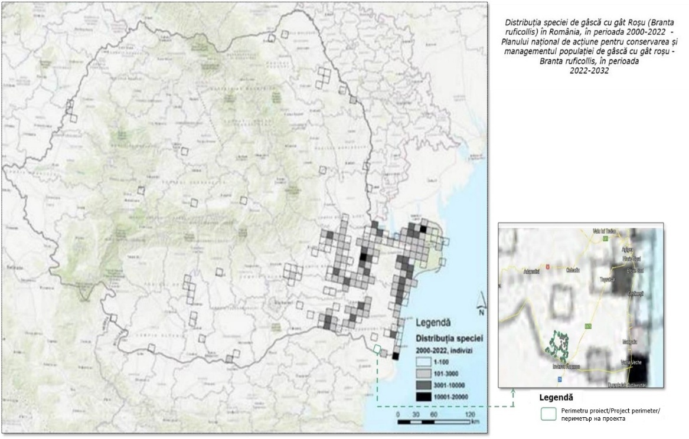

Figure 22 Map of the distribution of the red-breasted goose (Branta ruficollis) in Romania, between 2000 and 2022

Currently, there is no data in Romania on collisions between red-breasted geese and power lines and wind turbines. Research in Western and Northern Europe shows that wind turbines have a negative impact on goose populations. The main effect recorded is the abandonment of feeding areas, leading to the effective loss of key habitats (Larsen & Madsen, 2000; Larsen & Clausen, 2002, Madsen & Boertmann, 2008, etc.).
An analysis of the map showing the correlation between areas important for the red-breasted goose (Branta ruficollis) in Dobrogea and wind farms reveals that the perimeter of the energy park under analysis is located in an area of low importance (low sensitivity).

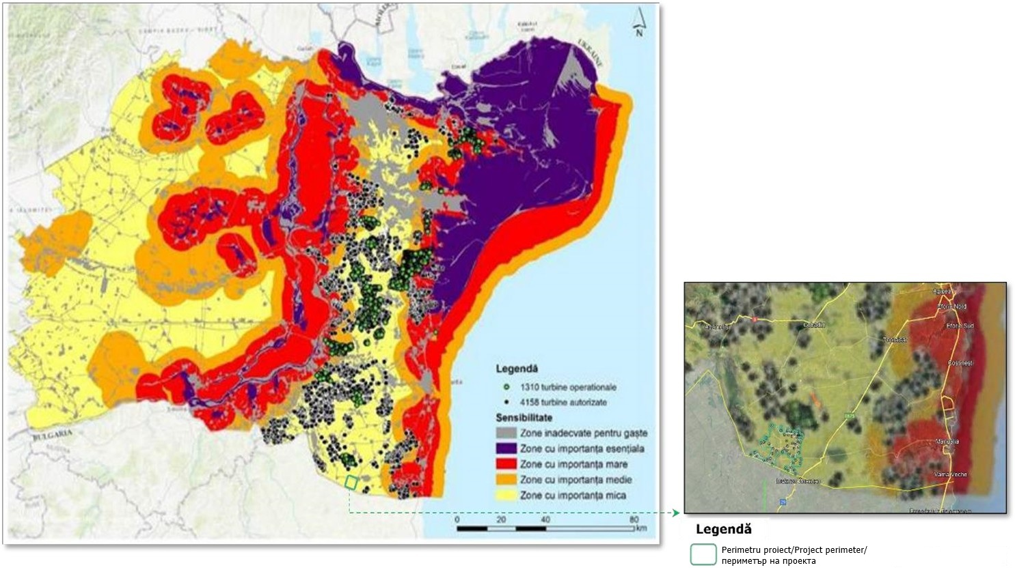

Figure 23 Correlation between areas important for the red-breasted goose (Branta ruficollis) in Dobrogea and wind farms. Authorized (black) and operational (green) wind turbines in Dobrogea and Bărăgan approved in Romania between 2000 and 2022¹³

The species' movements to wintering areas, which were carried out as part of the National Action Plan for
conservation and management of the Branta ruficollis population.

13 Annex to Order No. 2.480/2022 of the Minister of Environment, Water, and Forests approving the National Action Plan for the conservation and management of the red-breasted goose population - Branta ruficollis, during the period

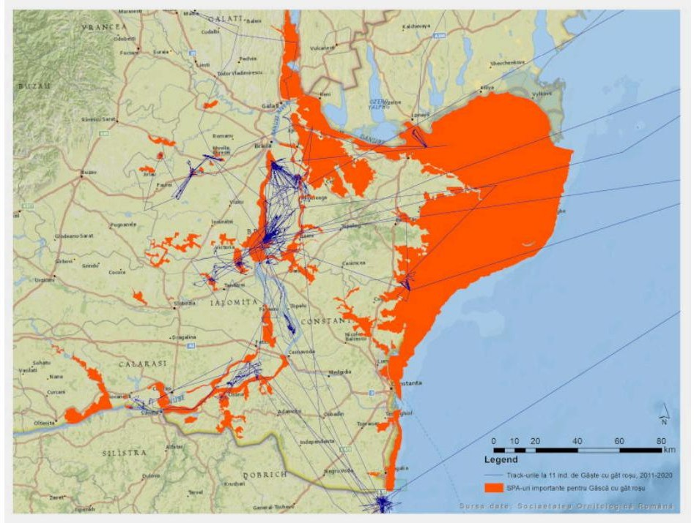

Figure 24 Movements of the species in wintering areas, based on data obtained from satellite transmitters in
the southeast of the country, during the period 2011-2020

The following table shows the migration routes of bird species identified in the project area according to information available on Bird Migration Map14 and the results of projects studying birds using satellite transmitters in central and southeastern Europe15 .
Table 10 Migration routes for migratory bird species analyzed in this study
No. | Species | Species (Romanian) | Ind. no.  Reported in  the  studied | Migration route | Data source
1 | Accipiter gentilis | Goshawk | 2 | - | -
2 | Sparrowhawk | Sparrowhawk | 5 | Northern Europe - Southern  Europe | Migrationatlas - https://migrationatlas  .org/node/1830
3 | Alauda arvensis | Skylark | 550 | - | -
4 | Anthus campestris | Meadow pipit | 10 | - | -
5 | Sunset sunset | Black Drepnea | 99 | Northern Europe -  South  Eastern Europe | Migrationatlas - https://migrationatlas  .org/node/1830
6 | Aquila pomarina | Lesser spotted eagle | 19 | Northern Europe - Central Africa | Birdtrackingmap - https://bbecquet.gith  ub.io/birdtracking/
7 | Buteo buteo | Common buzzard | 162 | Northern Europe -  South | Migrationatlas -

- Birdmap (5dvision.ee)

- SATELLITETRACKING.EU

No. | Species | Species (Romanian) | Index no.  Reported in  the  studied | Migration route | Data source
 |  |  |  | Europe | https://migrationatlas  .org/node/1830
8 | Buteo rufinus | Long-legged buzzard | 19
9 | Caprimulgus europaeus | Nightjar | 1 | Northern Europe -  South  Eastern Europe | Migrationatlas - https://migrationatlas  .org/node/1830
10 | Carduelis carduelis | Goldfinch | 10 | - | -
11 | Greenfinch | Florinte | 46 | - | -
12 | Ciconia ciconia | White stork | 93 | Southeast Europe - East Africa | Satellite tracking - https://satellitetracki ng.eu/inds/show map/?check_273=27 3
13 | Ciconia nigra | Black stork | 1 | East Africa -Northern Europe | Birdmap - https://birdmap.5dvis ion.ee/EN/202 3/autumn/?line=1&tr  ack=0&speed=1
14 | Circaetus gallicus | Short-toed snake eagle | 1 | Northern Europe - Southern Europe | Migrationatlas - https://migrationatlas  .org/node/1830
15 | Circus aeruginosus | Reed warbler | 37 | - | -
16 | Circus cyaneus | Blue-winged teal | 7 | - | -
17 | Circus pygargus | Erete sur | 8 | - | -
18 | Columba palumbus | Ring-necked pigeon | 2 | - | -
19 | Coracias garrulus | Dumbrăveancă | 26 | Southeastern Europe - Southern Africa | Satellite tracking - https://satellitetracki ng.eu/inds/show map/?check_273=27 3
20 | Corvus corax | Raven | 1 | - | -
21 | Corvus frugilegus | Raven | 28 | Southeastern Europe | Migrationatlas - https://migrationatlas  .org/node/1830
22 | Coturnix coturnix | Quail | 4 | Central Europe - South  Eastern Europe | Migrationatlas - https://migrationatlas  .org/node/1830
23 | Cuculus canorus | Cuckoo | 6 | Northern Europe -  South  Eastern Europe | Migrationatlas - https://migrationatlas  .org/node/1830
24 | House Martin | House Martin | 50 | Northern Europe - Southern Africa | Migrationatlas - https://migrationatlas  .org/node/1830
25 | Emberiza calandra | Yellowhammer | 200 | - | -
26 | Emberiza hortulana | Garden bunting | 3 | - | -
27 | European robin | Robin | 3 | Northern Europe - Southern Europe | Migrationatlas - https://migrationatlas  .org/node/1830
2 | Falco columbarius | Peregrine falcon | 2 | Northern Europe - Southern Europe | Migrationatlas - https://migrationatlas  .org/node/1830
29 | Falco subbuteo | Swallow hawk | 2 | Northern Europe - Southern Africa | Migrationatlas - https://migrationatlas  .org/node/1830
30 | Falco tinnunculus | Red Kestrel | 5 | Northern Europe - Northern Africa | Migrationatlas - https://migrationatlas  .org/node/1830
31 | Fringilla coelebs | Chaffinch | 4 | - | -
32 | Crested Bunting | Ciocârlan | 26 | Southern Europe - Southeastern Europe | Migrationatlas - https://migrationatlas  .org/node/1830

No. | Species | Species (Romanian) | Index no.  Reported in  the  studied | Migration route | Data source
33 | Common snipe | Common snipe | 1 | - | -
3 | Garrulus glandarius | Magpie | 4 | - | -
35 | Hieraaetus pennatus | Small eagle | 2 | - | -
36 | Barn swallow | Barn swallow | 219 | Northern Europe - Southern Africa | Migrationatlas - https://migrationatlas  .org/node/1830
37 | Lanius collurio | Red-backed shrike | 58 | Northern Europe - Southern Africa | Migrationatlas - https://migrationatlas  .org/node/1830
38 | Lanius minor | Black-fronted Shrike | 3 | - | -
39 | Black-headed Gull | Black-headed gull | 88 | - | -
40 | Luscinia luscinia | Nightingale  glade | 1 | Northern Europe - Eastern  Africa | Migrationatlas - https://migrationatlas  .org/node/1830
41 | Luscinia megarhynchos | Red-throated Nightingale | 4 | Southeastern Europe - Northern Africa | Migrationatlas - https://migrationatlas  .org/node/1830
42 | Calandra lark | Bărăgan lark | 55 | - | -
43 | Merops apiaster | Prigorie | 147 | Central Europe - Southern Europe | Migrationatlas - https://migrationatlas  .org/node/1830
44 | Motacilla alba | White wagtail | 56 | - | -
45 | Yellow wagtail | Yellow wagtail | 233 | - | -
46 | Oenanthe oenanthe | Stonechat | 15 | - | -
47 | Great tit | Great tit | 3 | - | -
4 | House sparrow | House sparrow | 70 | - | -
49 | Perdix perdix | Partridge | 30 | - | -
50 | Honey buzzard | Viespar | 2 | - | -
51 | Phasianus colchicus | Pheasant | 12 | - | -
52 | Phoenicurus phoenicurus | Forest redstart | 4 | - | -
53 | Pica pica | Magpie | 69 | - | -
54 | Sand martin | Marsh marigold | 1 | - | -
55 | Whinchat | Whinchat | 10 | - | -
56 | Eurasian collared dove | Guguştiuc | 29 | - | -
57 | Turtle Dove | Turturică | 5 | Northern Europe -  South  Eastern Europe | Migrationatlas - https://migrationatlas  .org/node/1830
58 | Sturnus vulgaris | Common starling | 982 | Eastern Europe - Southern Europe | Migrationatlas - https://migrationatlas  .org/node/1830
59 | Sylvia atricapilla | Blackcap | 3 | Northern Europe - Western Asia | Migrationatlas - https://migrationatlas  .org/node/1830
60 | Turdus merula | Blackbird | 18 | - | -
61 | Turdus philomelos | Song thrush | 7 | Southern Europe - Central Asia | Migrationatlas - https://migrationatlas  .org/node/1830
62 | Turdus pilaris | Fieldfare | 38 | Northern Europe - Southern Europe | Migrationatlas - https://migrationatlas  .org/node/1830
63 | Hoopoe | Hoopoe | 51 | Central Europe - Southern Europe | Migrationatlas - https://migrationatlas  .org/node/1830

Migration routes for bat species
The study area is not located in protected natural areas within the Natura 2000 network, but species with European and national protection status within this network are present in the study area (all bats are protected).
The following bat species have been identified in the project area: Eptesicus serotinus, Miniopterus schreibersii, Myotis daubentonii, Myotis mystacinus/brandtii, Nyctalus leisleri, Nyctalus noctula, Pipistrellus nathusii/kuhlii, Pipistrellus pipistrellus, Pipistrellus pygmaeus, Plecotus auritus, Vespertilio murinus.

The most abundant taxon recorded in the 2022 monitoring campaign was Pipistrellus nathusii/kuhlii, followed by Nyctalus noctula. All groups/species recorded in the study area are very common in the open areas of southern Romania.

The Pipistrellus pipistrellus species is among the regional migratory species, with seasonal migrations ranging from several hundred kilometers to dispersal or migration distances of up to 800 km. Pipistrellus nathusii can migrate over slightly longer distances (over 2,000 km).
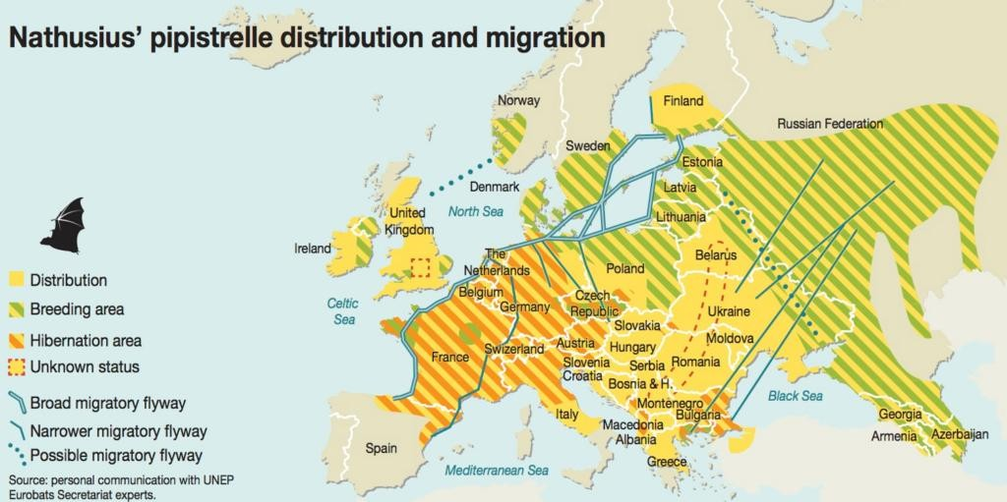
A project has been developed for these species with the aim of identifying migration routes and providing operational maps to guide the planning of wind farm projects17.

Figure 25 Migration routes of the Pipistrellus nathusi species

Nyctalus noctula is a species that migrates long distances, regularly flying 3,000-4,000 km in a round trip from its summer breeding grounds to its winter habitat and back.

Information about local flora and fauna

To identify and characterize the biodiversity components in the project site area " Wind Farm 48 (46) wind turbines approx. 316.8 MW (303.6 MW), substations, Transformer stations, Electrical connection networks, Construction and modernization of communication and access routes, Cerchezu, Constanta County" field trips were conducted repeated in the field, with observations/monitoring of habitats and vegetation, invertebrates, herpetofauna (amphibians and reptiles), avifauna, mammals, and chiroptera. Field activities were carried out over a period of 12 months (April 2022 – March 2023), covering a complete biological cycle, and included 24 trips, with data collected by an independent team of specialists by taxonomic groups; The investigations extended beyond the project's direct area of influence, according to the resulting distribution maps.
Additionally, specific methods were applied for bats (nocturnal transects with ultrasonic detectors, fixed points in transects, and static detectors placed at several points), with recordings made throughout the activity season (according to the monitoring program), and the identification and processing of acoustic data was performed with dedicated software; spatial data were processed in ArcGIS ESRI 2023.

16 According to Hutterer, 2005
17 Bat migration routes in Europe, 2021

Plants and habitats

It was found that the largest share in the Cerchezu UAT is represented by agricultural areas, which occupy about 88% of the total. A smaller share is represented by pastures (approximately 4.5%) and localities (approximately 5%). The smallest shares are held by industrial or commercial areas (less than 1%) and agricultural land with significant areas of natural vegetation (approximately 1.4%).

The grassland area in the south of Cerchezu
Predominantly herbaceous vegetation, with rare shrubs, visibly affected by grazing, as it is surrounded by agricultural land. Due to this limitation, the vegetation is overgrazed, with less than 100% ground cover. The vegetation consists mainly of herbaceous species, native species, with the most represented families being Asteraceae and Poaceae:
Artemisia austriaca, Artemisia absinthium, Botriochloa ischaemum, Marrubium peregrinum, Hordeum murinum, Xeranthemum annuum, Daucus carota, Chondrilla juncaea, Euphorbia glareosa nicaeensis, Eryngium campestre, Achillea setacea, Agropyron cristatum, Cichorium intybus, Plantago lanceolata, Sisymbrium orientale, Teucrium polium subsp. capitatum, Salvia aethiopis, Linaria genistifolia, Sideritis montana, Tunica prolifera, Bupleurum commutatum subsp. glaucocarpum, Festuca valesiaca, Poa bulbosa, Cynodon dactylon (herbaceous base; shows slight soil salinity, specific), Aegylops cylindrica, Galium humifusum, Asperula tenella, Bromus cf. tectorum, Allium rotundum, Potentilla sp., Vulpia myuros, Trifolium sp., Medicago lupulina, Sambucus ebulus, Carduus acanthoides, Cannabis ruderalis, Prunus spinosa, Verbascum thapsus, Urtica dioica, Torilis nodosa, Onopordum acanthium, Rosa canina, Consolida regalis, Centaurea diffusa, Cephalaria transsilvanica, Elymus repens, Lolium perenne, Convolvulus arvensis.

The landscape is typical of Dobrogea, with limestone deposits of the canara type, where rare species typical of Dobrogea, calcifers, can still be found. The meadow is also bordered and covered on one side by an acacia plantation (Robinia pseudoacacia, an invasive alien species).

The distribution of vegetation is heterogeneous, alternating areas with abundant vegetation in good condition with areas with sparse vegetation, reduced in size and coverage and affected by the presence of ruderal and some segetal species.

The grassland area north of the village of Viroaga

Characterized by herbaceous species, predominantly species with no conservation value, with a predominance of
taxa from the Poaceae family:

Carduus acanthoides (almost monodominant over large areas), Lolium perenne, Festuca valesiaca, Poa angustifolia, Achillea setacea, Papaver dubium, Daucus carota, Tunica prolifera, Berteroa incana, Plantago lanceolata, Vulpia myuros, Bromus cf. tectorum, Stellaria media, Centaurea diffusa, Reseda lutea, Cannabis ruderalis, Artemisia austriaca, Marrubium peregrinum, Onopordom acanthium, Galium humifusum, Galum verum, Stachys germanica, Medicago falcata, Aegylops cylindrica, Potentilla argentea, Bromus tectorum (predominant species over large areas), Phragmites australis, Poa prratensis (predominant species over large areas), Bupleurum commutatum subsp. glaucocarpum.
The plant associations that characterize the plant communities in the analyzed areas are Cynodonti-Poëtum angustifoliae Rapaics ex Soó 1957 and Artemsio austriacae-Poëtum bulbosae Pop 1970, which form the steppe grassland vegetation. Cynodonti-Poëtum angustifoliae is a secondary association, its composition being heterogeneous depending on location, type, and degree of use, thus being "enriched" with numerous ruderal elements, species resistant to these pressures. Today, located between agricultural lands, these areas constitute pastures and areas where sheepfolds are set up. However, the vegetation still retains some elements of the Dobrogea steppe vegetation, such as Teucrium polium subsp. capitatum, Festuca valesiaca, Sideritis montana, Asperula tenella, Allium rotundum, etc. Ruderalisation is caused by the degradation of the initial communities, the reduction of soil cover and the presence of species that form real thickets, such as Carduus acanthoides, Onopordon acanthium, Urtica dioica, Sambucus ebulus, Cannabis ruderalis, etc. The two associations belong to the habitat in the national classification (Doniţă et al. 2005) R3420 West Pontic grasslands with Poa bulbosa, Artemisia austriaca, Cynodon dactylon, and Poa angustifolia (lands covered, prior to anthropization, with vegetation specific to the Natura 2000 priority habitat 62C0* Ponto-Sarmatic steppes).
Habitat R8702 Anthropogenic communities with Onopordum acanthium, Carduus nutans and Centaurea calcitrapa (Doniţă et al. 2005) occurs in areas where Carduus and Onopordon species are highly distributed, with 70-80% coverage, where they form thickets of brambles that prevent the development of natural native vegetation. However, they are a source of food at the end of the summer and in the autumn for migratory or sedentary species of the order Passeriformes.

The grassland area west of the village of Căscioarele

The analyzed meadow is predominantly covered with herbaceous vegetation, with rare shrubs, heavily affected by grazing, and bordered by agricultural land and inhabited areas. The vegetation is mosaic-like, alternating between grazed and overgrazed areas, with plant communities featuring grass species characteristic of steppe vegetation (e.g., Stipa capillata, Chrysopogon gryllus) observed in some places. The vegetation consists mainly of native species, with the most represented families being Asteraceae and Poaceae:

Berteroa incana, Plantago lanceolata, Galium humifusum, Achillea setacea, Torilis arvensis, Allium rotundum, Eryngium campestre, Daucus carota, Lolium perenne, Dicanthium ischaemum (predominant species over large areas), Cynodon dactylon (predominant species over large areas), Tunica prolifera, Festuca valesiaca, Bromus cf. tectorum (predominant species over large areas), Sisymbrium orientale, Poa bulbosa, Centaurea diffusa, Artemisia austriaca, Nigella arvensis, Consolida regalis, Xeranthemum annuum, Chondrilla juncaea, Euphorbia glareosa nicaeensis, Asperula tenella, Dactylis glomerata, Crataegus monogyna, Cephalaria transsilvnica, Cichorium intybus, Stipa capillata, Marrubium peregrinum, Chaiturus marrubiastrum, Oenothera sp., Echiunm vulgare, Heliotropium suaveolens, Sanguisorba minor, Malva neglecta, Sedum sp., Agropyron cristatum, Chrysopogon gryllus, Carduus acanthoides (predominant species over large areas), Onopordum acanthium (predominant species over large areas), C. lanceolatum, Verbascum thapsus, V. nigrum, Sambucus ebulus, Urtica dioica, Xanthium spinosum (invasive alien species, characteristic of fallow areas).

Characteristic Dobrogea landscape with large open areas covered with herbaceous vegetation with xerophilous elements resistant to periods without precipitation during the summer, secondary to steppe vegetation, and calcareous deposits of the canara type, where rare calcifuge species usually grow. Woody species are rare (e.g., Crataegus monogyna).

The distribution of vegetation is heterogeneous, alternating between areas with abundant vegetation and areas with sparse vegetation, with reduced size and coverage and affected by the presence of ruderal species (e.g. Carduus acanthoides, C. lanceolatum, Verbascum thapsus, Sambucus ebulus, Urtica dioica, Xanthium spinosum), and some segetal species (e.g., Consolida regalis).

The grassland is a mosaic of plant communities, among which the most prominent are the plant associations Cynodonti-Poëtum angustifoliae Rapaics ex Soó 1957, Artemsio austriacae-Poëtum bulbosae Pop 1970 and Botriochloetum ischaemi (Kristinsen 1937) Pop 1977, which form the secondary steppe grassland vegetation. All three associations represent secondary vegetation successions, with a fairly heterogeneous phytocenotic composition depending on location, soil type, exposure, type and degree of use, thus being
"enriched" with numerous species that denote ruderalization. However, the vegetation still retains some elements of the Dobrujan steppe vegetation, such as Chrysopogon gryllus, Stipa capillata, Festuca valesiaca, Eryngium campestre, Plantago lanceolata, Sanguisorba minor, Asperula tenella, Allium rotundum, etc. Ruderalisation is caused by the degradation of the initial communities, the reduction of soil cover and the presence of species that form real thickets, such as Carduus acanthoides, Onopordon acanthium, Urtica dioica, Sambucus ebulus, etc. The first two associations belong to the habitat in the national classification (Doniţă et al. 2005) R3420 West Pontic grasslands with Poa bulbosa, Artemisia austriaca, Cynodon dactylon, and Poa angustifolia, and the Botriochloetum ischaemi association defines the habitat R3415 Ponto-Balkan grasslands-Balkan grasslands with Botriochloa ischaemum and Festuca valesiaca, both habitats with a compositional structure strongly affected by grazing (land probably covered, prior to anthropization, with vegetation characteristic of the Natura 2000 habitat 62C0* Ponto-Sarmatian steppes).

In some places, there are plant communities with Chrysopogon gryllus (ass. veg. Thymio pannonici-Chrysopogonetum grylli Doniţă et al. 1992, syn.: Chrysopogonetum grylli Soó), with limited distribution on the limestone slopes bordering the flat area of the meadow, clearly degraded by grazing.

The limestone rocks of the canara type still preserve elements of characteristic vegetation with Agropyron cristatum, Satureja coerulea, Thymus sp., these areas, apparently unattractive to domestic animals, are affected by the passage of animals, vectors of dispersion and for alien plant species, such as Xanthium spinosum – an invasive alien species in our country, characteristic of degraded areas.

The meadow is crossed by a drainage canal that is mostly devoid of vegetation, with certain areas where excess moisture remains, allowing meso-hygrophilous species such as Chaiturus marrubiastrum to grow, as well as some allochthonous species such as Oenothera sp. (a taxon of South American origin).

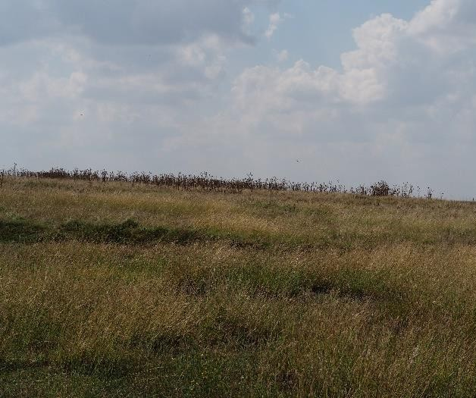 | 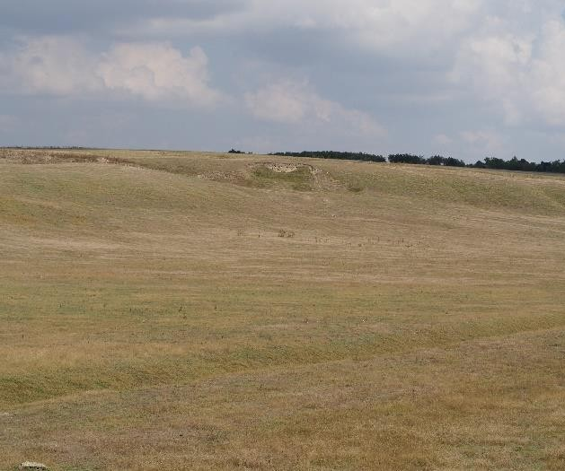
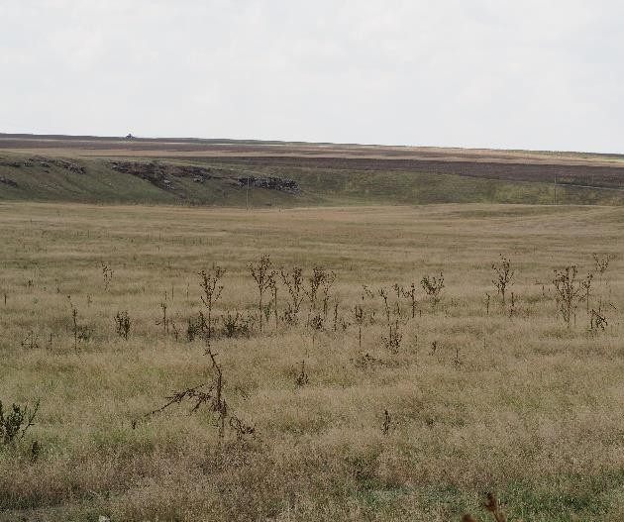 | 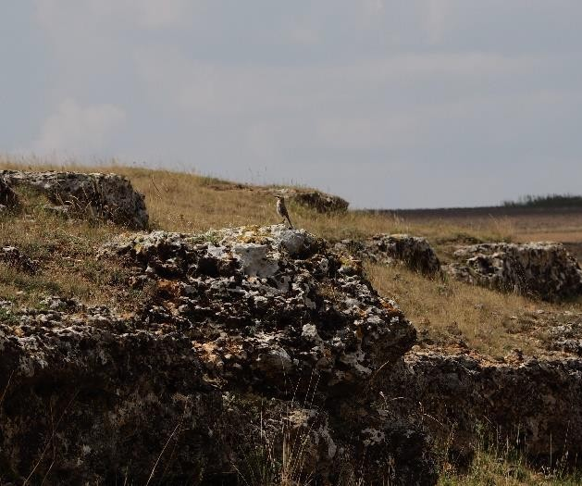
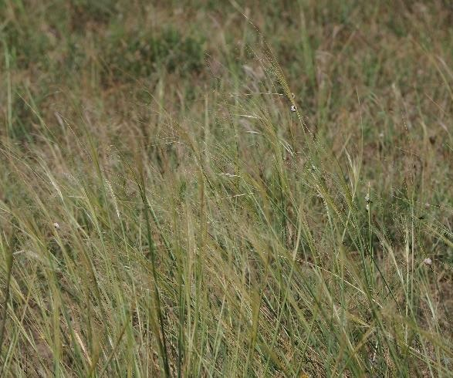 | 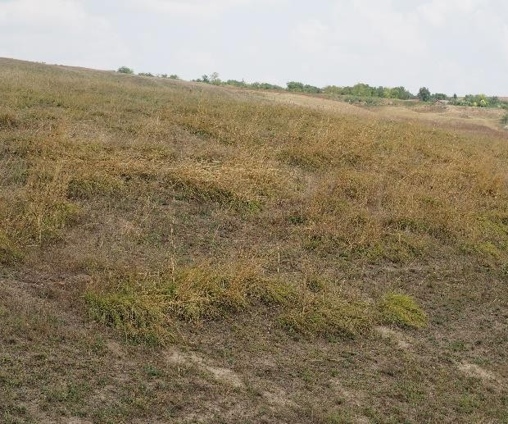

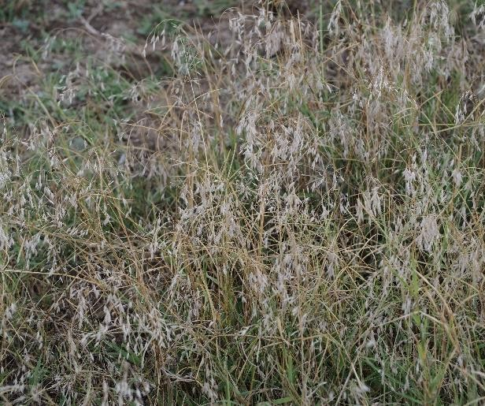 | 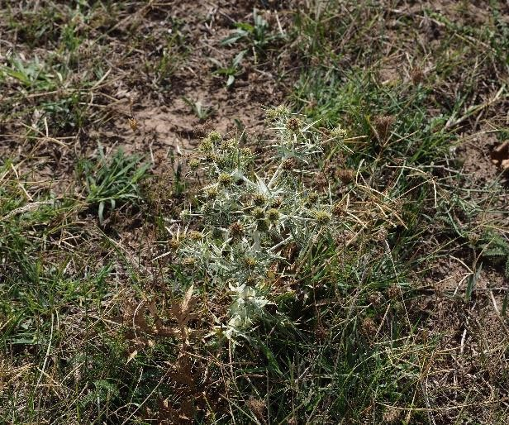
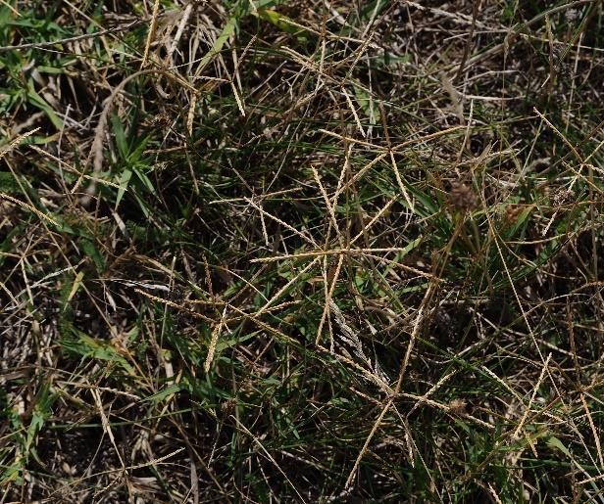 | 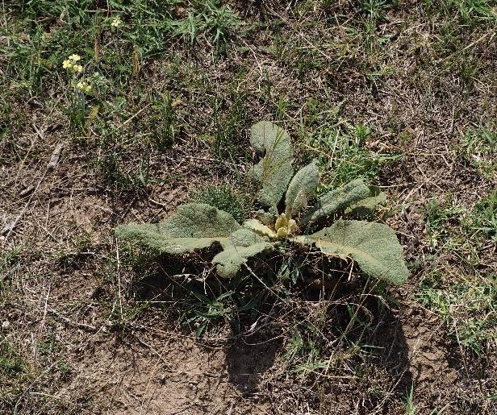
Figure 26 Aspects of the analyzed areas regarding meadow vegetation

An obvious effect of the degree of use and degradation of the grassland is the presence of habitat R8702 Anthropogenic communities with Onopordum acanthium, Carduus nutans, and Centaurea calcitrapa (Doniţă et al. 2005). This is defined by areas where Carduus and Onopordon species are highly distributed (observed especially near localities), has high coverage of 70-80% forming thickets (brambles) that prevent the development of natural native vegetation It is a source of food at the end of the summer season and in the autumn season for species of the order Passeriformes, migratory or sedentary.

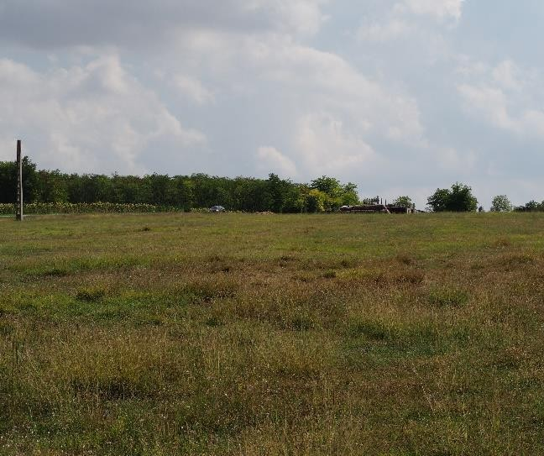 | 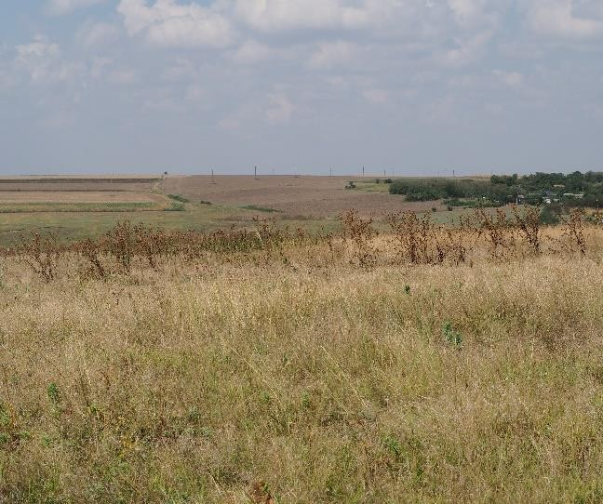
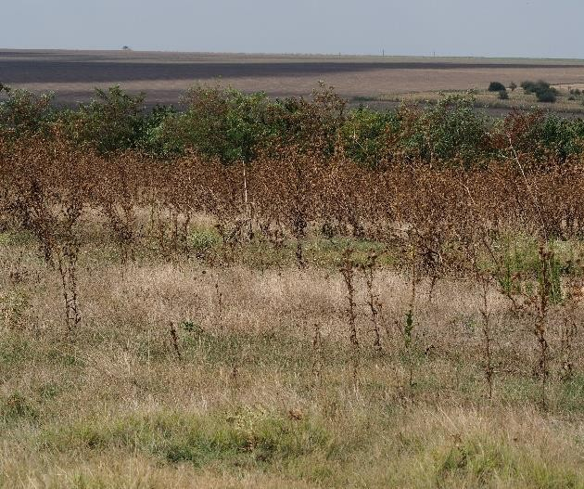 | 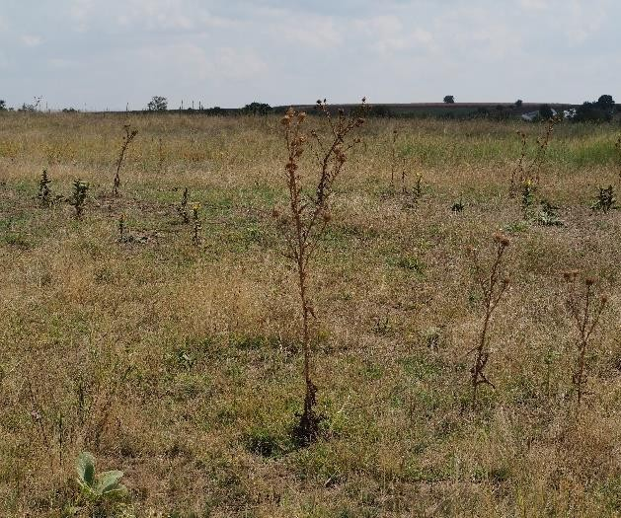
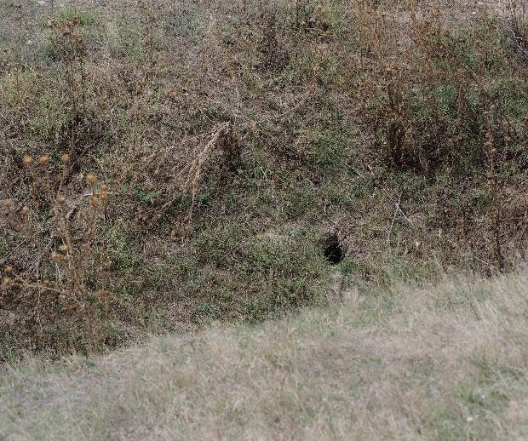 | 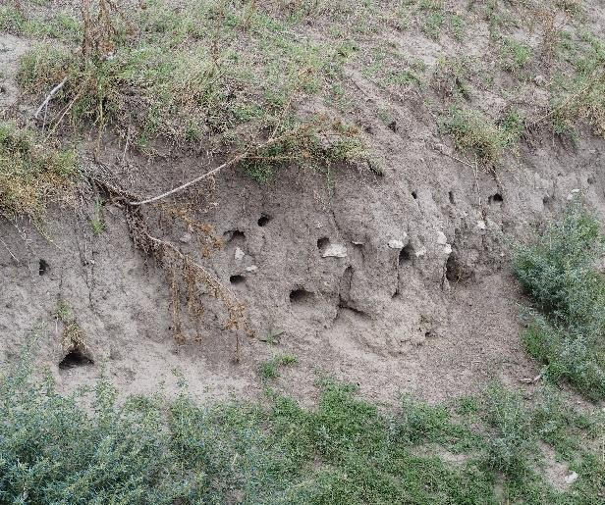
Figure 27 Aspects of areas affected by grazing, where ruderal species predominate and invasive alien species (e.g., Xanthium spinosum) grow in places.
Although the main use of the grassland is as pasture, it is also a refuge for numerous species of wildlife, some of which are protected (e.g. Spermophilus citellus), due to the plant species that form the trophic base, but also due to its role as a breeding habitat. The vegetation of the grassland

is clearly affected by grazing, with the land being heavily ruderalized due to its use as common grazing land, which reduces its conservation value, with the presence of alien taxa contributing to this situation.

The grassland area east of the village of Căscioarele (not identified by CLC2018)

This grassland area is used as pasture for sheep, with a sheepfold located nearby. In this grassland area, the vegetation is predominantly segetal and ruderal (with rare elements of spontaneous xerophilous steppe vegetation), consisting of the following 41 taxa. Spring annuals are replaced by vegetation specific to the summer season. The highest proportion is held by representatives of the Poaceae (grasses), Fabaceae (legumes), and Caryophyllaceae (carnation family) families:

Achillea setacea | Trifolium repens | Cynodon dactylon
Poa bulbosa | Marrubium peregrinum | Veronica verna
Plantago lanceolata | Bentgrass | Holosteum umbellatum
Cerastium semidecandrum | Anchusa sp. | Filago arvensis
Stellaria media | Scleranthus annuus | Chenopodium album
Galium humifusum | Androsace elongata | Geranium sp.
Erodium cicutarium | Xeranthemum annuum | Silver cinquefoil
Bromus tectorum | Barley | Centaurea sp.
Bromus hordeaceus | Lepidium draba | Matricaria sp.
Medicago minima | Veronica polita | Thymus sp.
Lathyrus tuberosus | Malva neglecta | Alyssum desertorum
Dandelion | Carduus nutans | Mullein
Eryngium campestre | Sysimbrium loeselii | Daucus carota
Chondrilla juncacea | Draba verna

The vegetation forms a meadow, but this is a grazed meadow, a secondary meadow established on former habitats with specific steppe vegetation, on which anthropogenic factors have intervened in the past (most likely areas used for agriculture). This type of vegetation can often be found on the edges of roads or agricultural crops, which are better maintained. It can be observed that some species such as Achillea setacea, Thymus sp., Medicago minima, Veronica verna, Centaurea sp., Xeranthemum annuum, etc. are species that indicate secondary pasture quality, some of which are found in the phytocenotic composition of xerophilous vegetation.

The meadow is a large, expansive area covered mainly with Poa pratensis, a mesophilic species that indicates sandy-loamy soils, probably with excess water in the spring. The vegetation of this meadow can be classified in the Poëtum pratensis association (Răvăruţ et al. 1956).

There are no alien species (at least so far), which can be considered a positive aspect, but given the proximity of agricultural land, the presence of alien species cannot be ruled out.

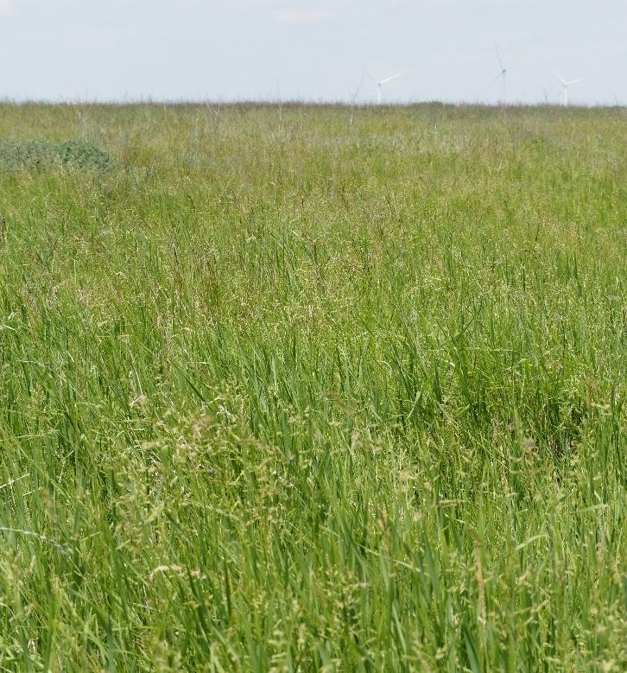 | 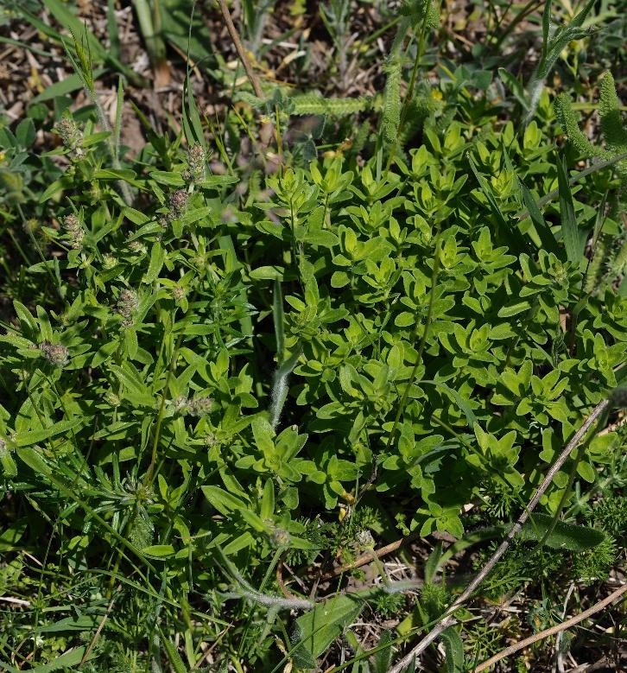
The meadow area is mainly covered with  Poa pratensis | The grassland area covered mainly with  Thymus sp.
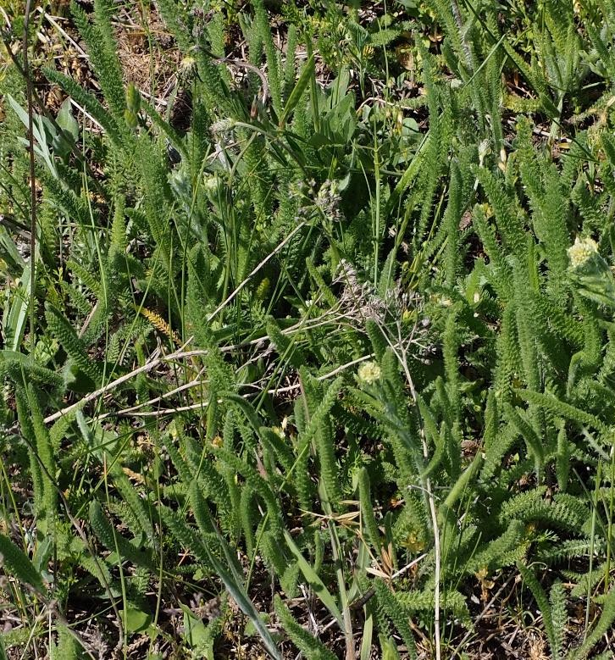 | 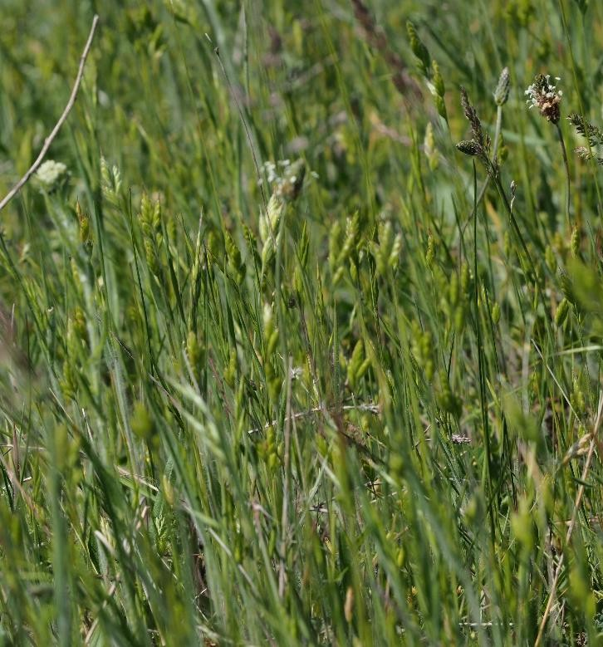
Grassland area mainly covered with  Achillea setacea | Grassland area mainly covered with  Hordeum vulgare

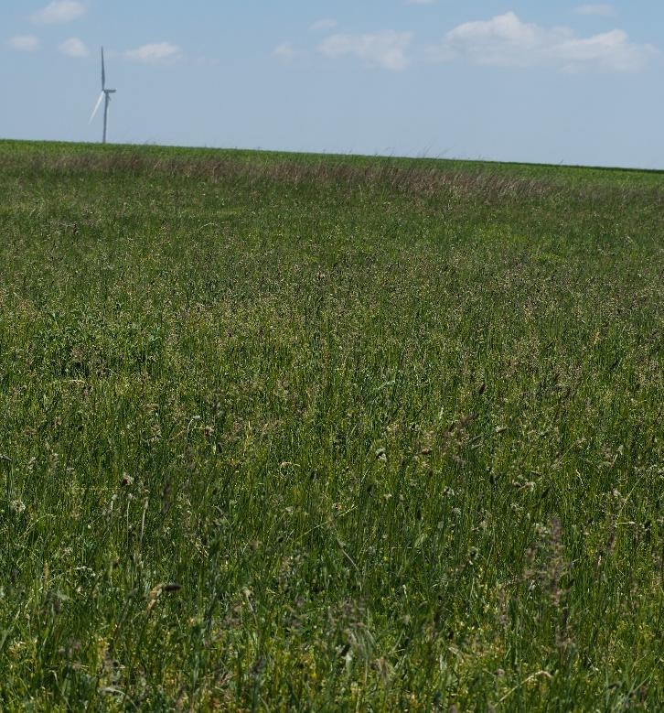 | 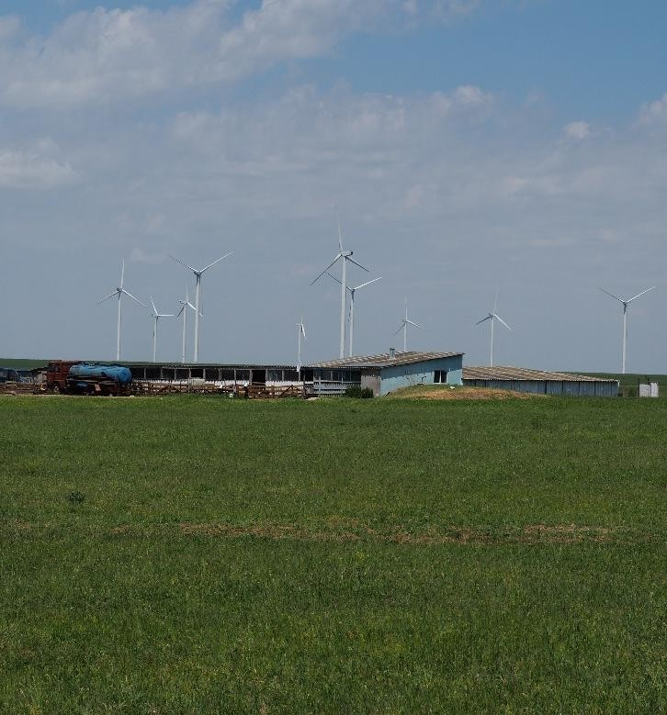
Aspects of the analyzed grassland area and identified pressure (sheepfold)
Figure no. 28 Aspects of vegetation in the project area

Mammals

During the monitoring period, 14 mammal species were identified in the study area (which includes both the project site and the southern end of the Natura 2000 site ROSCI0071 Dumbrăveni - Valea Urluia - Lacul Vederoasa), as shown in the table below.
Table 11 Identified mammal species
Species | Species (ro) | No. ind.  reported | Observations  Activity  species | IUCN* | Habitats Directive* | Priority species  priority | Government Emergency Ordinance 57/2007* | Red Book of Vertebrates in  Romania
Apodemus agrarius | Field mouse | 19 | The species was observed during the summer  and winter | LC | - | No | - | -
Apodemus sylvaticus | Wood mouse | 1 | The species does not nest on the site, but uses it for  transit | LC | - | No | - | -
Canis aureus | Jackal | 26 | The species uses the site area  for transit | NT | - | No | Annex 5A | Vulnerable species
Capreolus capreolus | Roe deer | 14 | The species was observed during the summer-winter period, using the site  for transit | LC | - | No | Annex 5B | Vulnerable species
Crocidura leucodon | Field shrew  field | 2 | The species does not inhabit the site, but uses its surface for  transit | LC | - | No | - | Vulnerable species
Erinaceus roumanicus | Eastern  Eastern | 6 | The species was observed during the  spring - summer | LC | - | No | - | -

Species | Species (en) | Ind.  reported | Observations species activity | IUCN | Habitats Directive* | Priority  Priority | Government Emergency Ordinance 57/2007* | Red Book of Vertebrates in Romania
The species uses the site area
for transit
Lepus europaeus | Hare | 26 | The species was observed throughout the year The species uses the site area for transit | LC | - | No | Annex 5B | -
Meles meles | Badger/Marten | 15 | The species was observed throughout the year The species uses the site area  for transit | LC | - | No | Annex 5B | -
Mustela eversmanii | Steppe ferret | 1 | The species was observed throughout the year The species uses the site area  for transit | EN | Annex II, Annex IV | No | Annex 3, Annex 4A | Vulnerable species
Rattus norvegicus | Rat  brown | 1 | The species was observed during winter  The species uses the surface of the site  for transit | LC | - | No | - | -
Spalax leucodon | Small blind mole | 9 | The species was observed during winter  The species uses the surface of the site  for transit | LC | - | No | Annex 4B | -
Spermophilus citellus | Ground squirrel | 39 | The species uses the site for nesting, feeding, and  transit | VU | Annex II, Annex IV | No | Annex 3, Annex 4A | Vulnerable species
Talpa europaea | Mole | 8 | The species was observed during spring and summer The species uses the site for feeding and transit, with mounds also present within  site | LC | - | No | - | -
Vulpes vulpes | Fox | 55 | The species has been observed throughout the year The species uses the site area  for transit | LC | - | No | Annex 5B | -
IUCN: LC – Least Concern; VU – Vulnerable; NT – Near Threatened, EN (Endangered) – endangered species.

Habitats Directive: Annex II – animal and plant species of Community interest whose conservation requires the designation of special areas of conservation; Annex IV – animal and plant species of Community importance requiring strict protection;

OUG57/2007 on the regime of protected natural areas, conservation of natural habitats, wild flora and fauna: Annex 3 - Plant and animal species whose conservation requires the designation of special conservation areas and special bird protection areas; Annex 4A - Species of Community interest. Animal and plant species requiring strict protection; Annex 4B - Species of national interest Animal and plant species requiring strict protection Annex 5A - Species of Community interest. Plant and animal species of Community interest, except for bird species, whose removal from the wild and exploitation are subject to management measures; Annex 5B - Animal species of national interest whose removal from the wild and exploitation are subject to management measures.

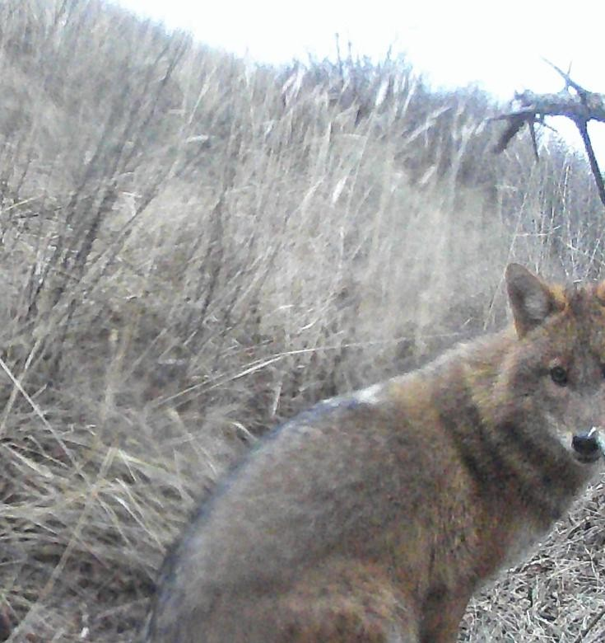 | 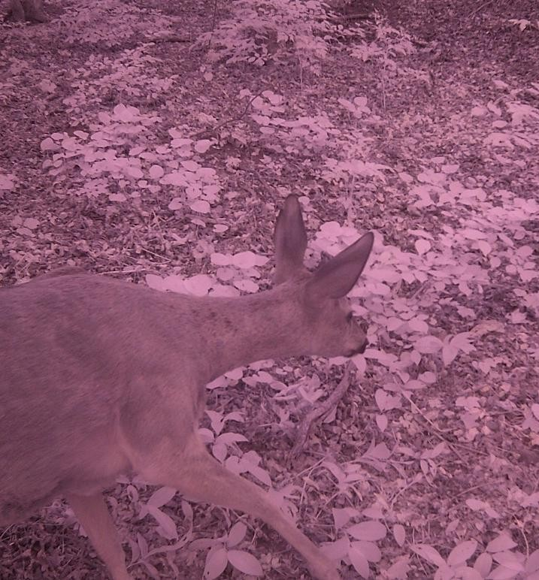
Jackal (Canis aureus) in the area of the wind farm site | Roe deer (Capreolus capreolus) in the Natura 2000 site ROSCI0071
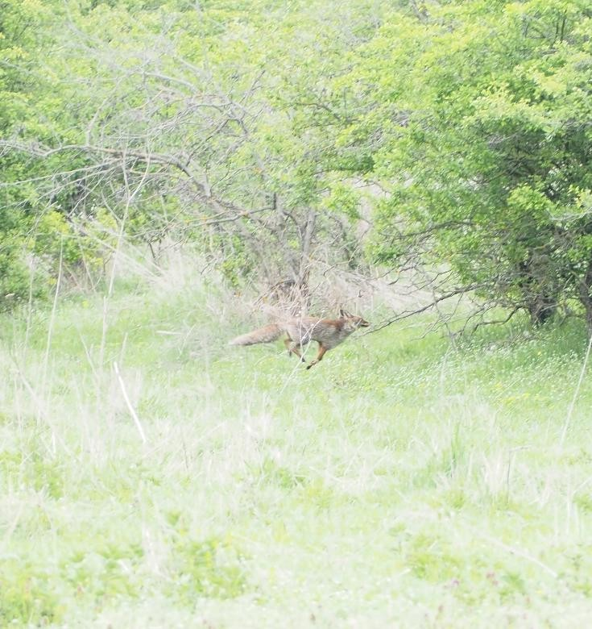 | 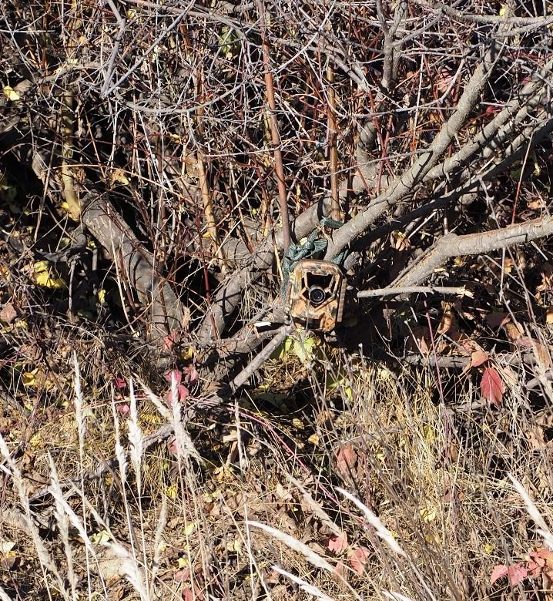
Fox (Vulpes vulpes) in the Natura site ROSCI0071 | Motion sensor-triggered photo-video camera located in the wind farm site area

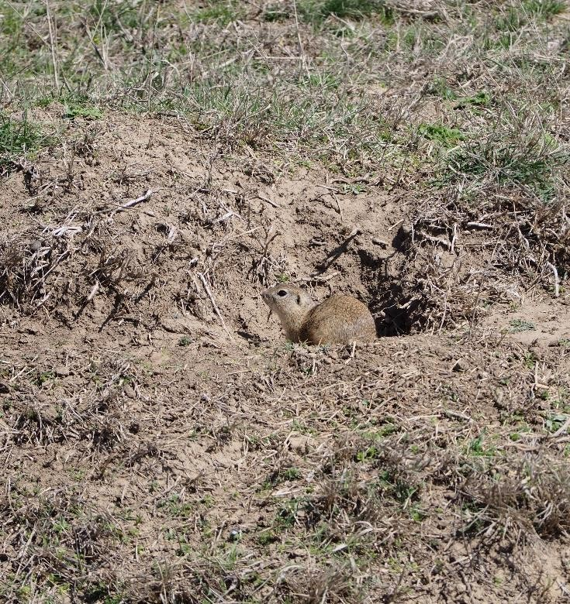 | 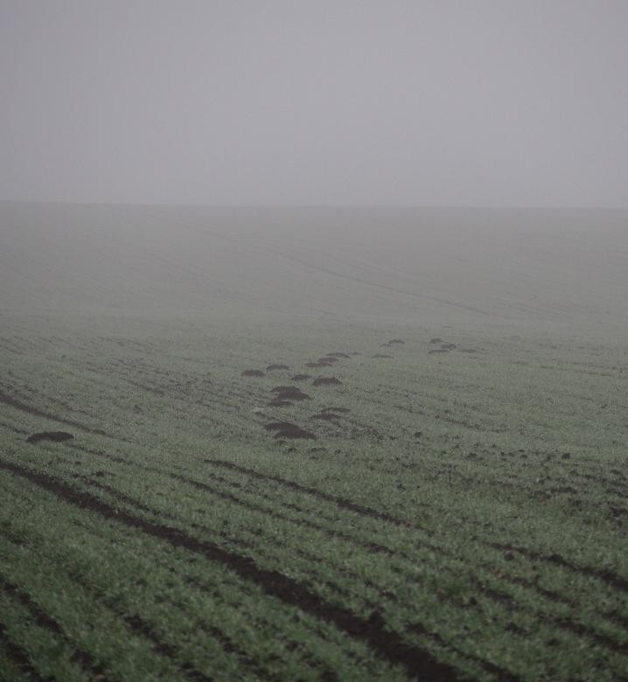
Ground squirrel (Spermophilus citellus) in the area of the wind farm site | Mounds of small blind mole (Spalax leucodon) in the area of the wind farm site
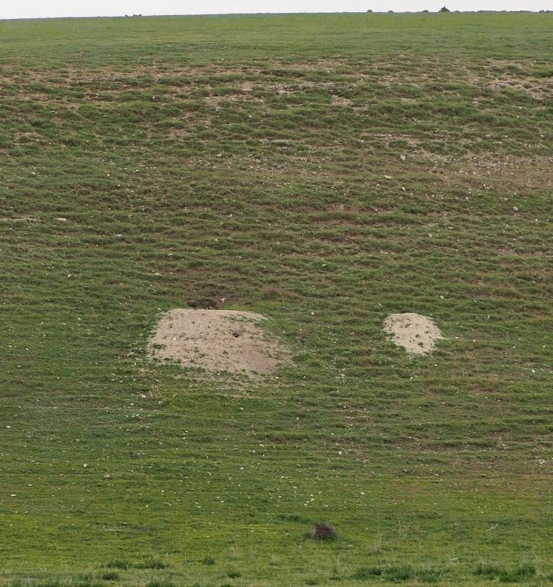 | 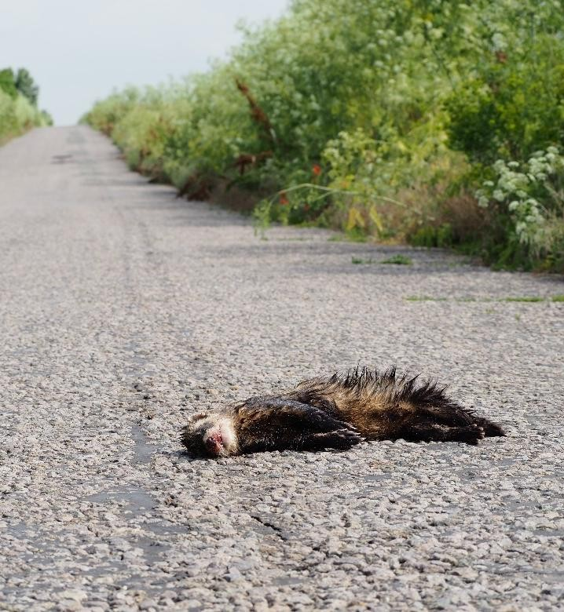
Badger (Meles meles) burrow in the area of the wind farm site | Steppe polecat (Mustela eversmanii) roadkill in the wind farm site area

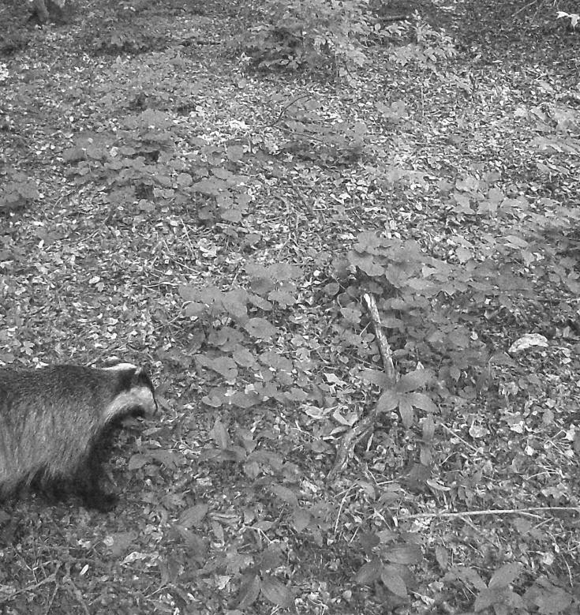 | 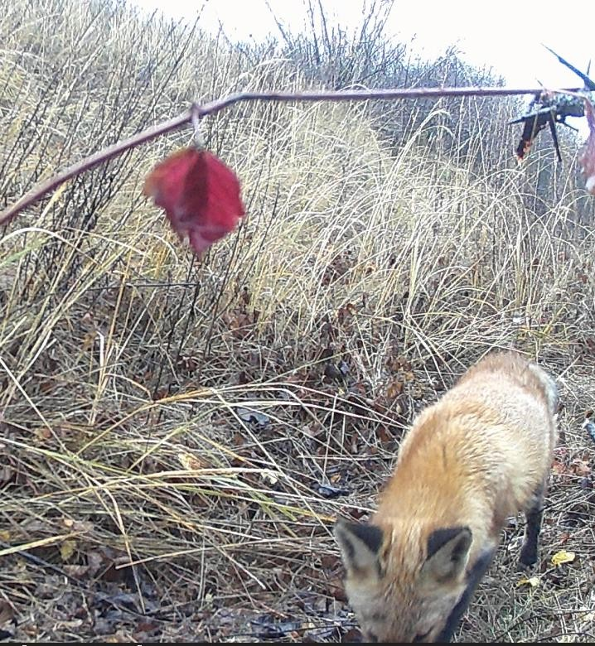
Badger (Meles meles) in ROSCI0071 Dumbrăveni - Valea Urluia - Lacul Vederoasa | Fox (Vulpes vulpes) in the area of the wind farm site
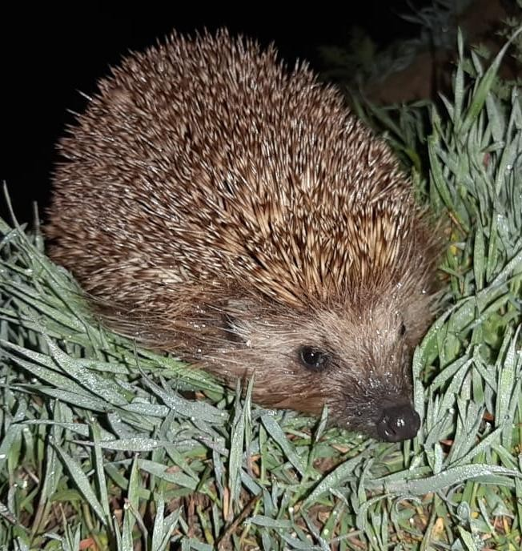 | 
Hedgehog (Erinaceus roumanicus) in the area of the wind farm site | Hare (Lepus europaeus) in the area of the wind farm site

Figure 29 Distribution of locations where mammal species are present

Amphibians and reptiles

During the monitoring period, transects were carried out on the surface of the future Cerchezu wind farm and all signs of presence (visual observation of individuals, regardless of their stage of development: egg, larva or adult, or their condition: alive, dead) of amphibian and reptile species were noted. This

method was also applied in the southern sector of the Natura2000 site ROSCI0071 Dumbrăveni - Valea Urluia -
Lacul Vederoasa, which borders the project area.

Table 12 Identified mammal species
Species | Species (ro) | No. ind.  reported | IUCN | Habitats Directive* | Priority species  Priority | Government Emergency Ordinance 57/2007* | Red Book of Vertebrates  in Romania
Bufo viridis | Green toad  green | 4 | LC | Annex IV | No | Annex 4A | Near threatened species  endangered
Dolicophis  caspius | The evil snake | 3 | LC | Annex IV | No | Annex 4A,  Annex 4B | Vulnerable  vulnerable
Lacerta viridis | Gușter | 11 | LC | Annex IV | No | Annex 4A | -
Podarcis muralis | Wall lizard | 2 | LC | Annex IV | No | Annex 4A | Vulnerable species  vulnerable
Podarcis taurica | Steppe lizard | 14 | LC | Annex IV | No | Annex 4A | Near threatened species  endangered
Testudo graeca | Dobrogea tortoise  Dobrogea | 6 | VU | Annex II,  Annex IV | No | Annex 3,  Annex 4A | Species  Endangered
IUCN: LC – Least Concern; VU – Vulnerable
Habitats Directive: Annex II – animal and plant species of Community interest whose conservation requires the designation of special areas of conservation; Annex IV – animal and plant species of Community importance requiring strict protection;
OUG57/2007 on the regime of protected natural areas, conservation of natural habitats, wild flora and fauna: Annex 3 - Plant and animal species whose conservation requires the designation of special conservation areas and special bird protection areas; Annex 4A - Species of Community interest. Animal and plant species requiring strict protection; Annex 4B - Species of national interest. Animal and plant species requiring strict protection.

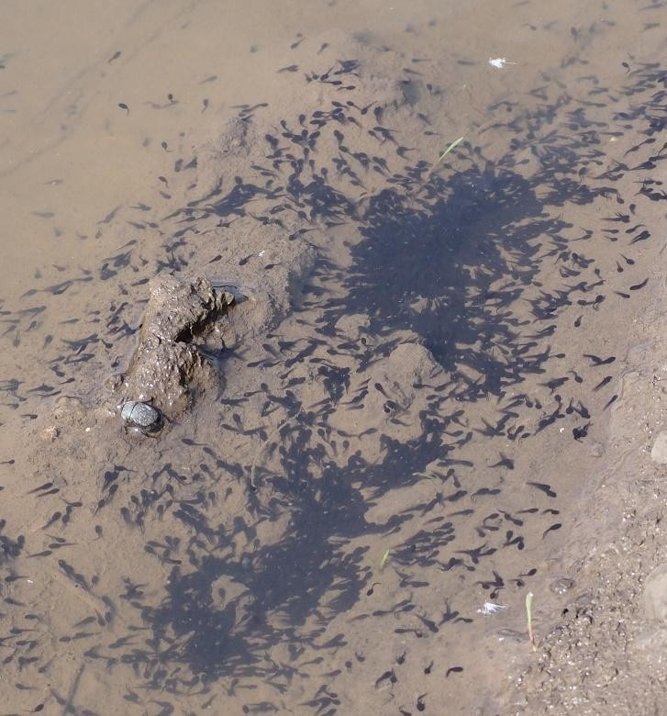 | 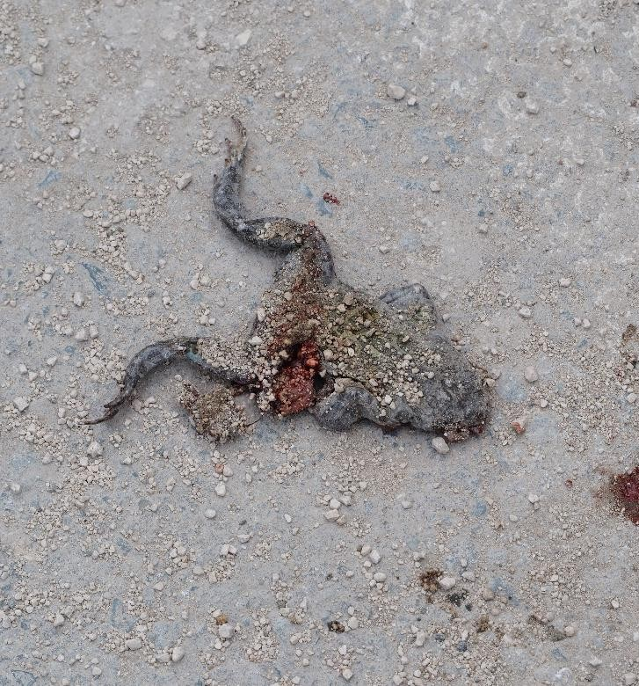
Green toad (Bufo viridis) larvae in a temporary puddle on a farm road | Green toad (Bufo viridis) victim of road traffic, in the Natura 2000 site ROSCI0071 Dumbrăveni - Valea Urluia - Lacul Vederoasa

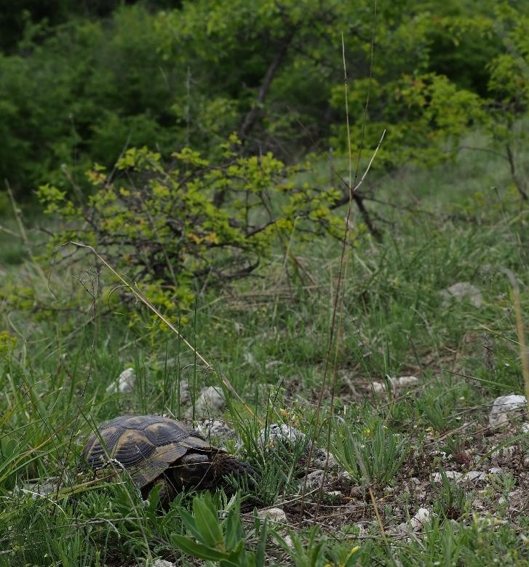 | 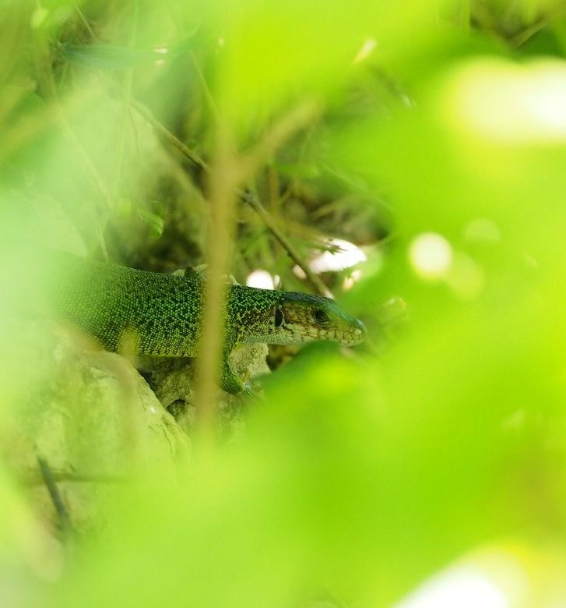
Dobrogea tortoise (Testudo graeca) observed inside ROSCI0071 Dumbrăveni - Valea Urluia - Lacul Vederoasa | Green lizard (Lacerta viridis) observed in the area of the wind farm site
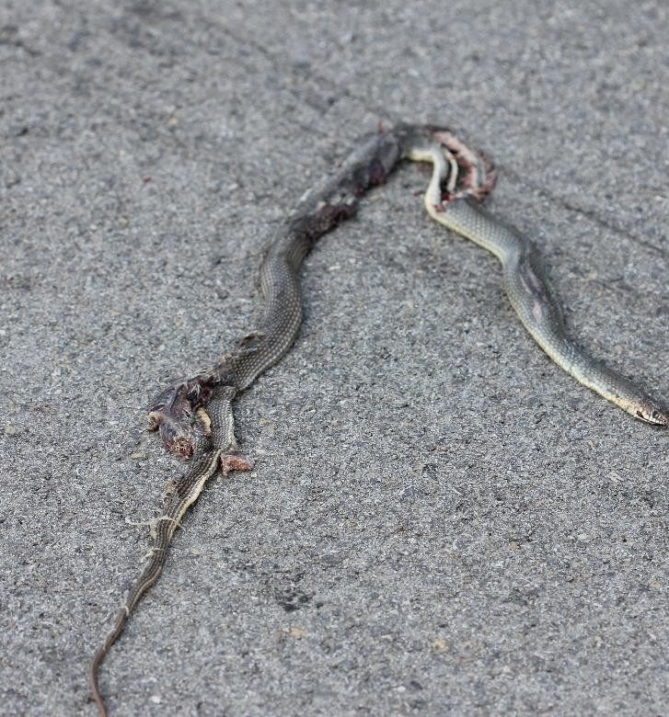 | 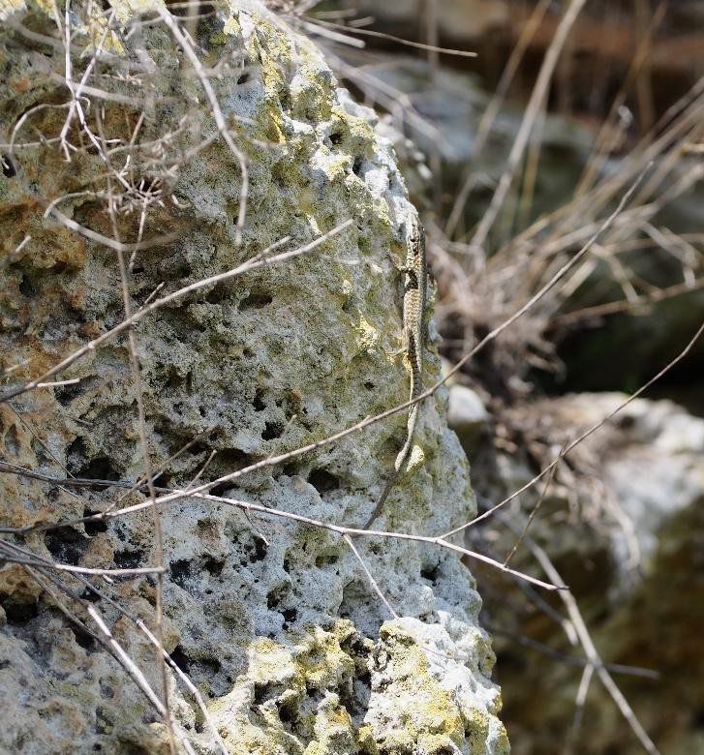
Caspian whipsnake (Dolicophis caspius) roadkill in the area of the wind farm site | Wall lizard (Podarcis muralis) observed in  the wind farm area

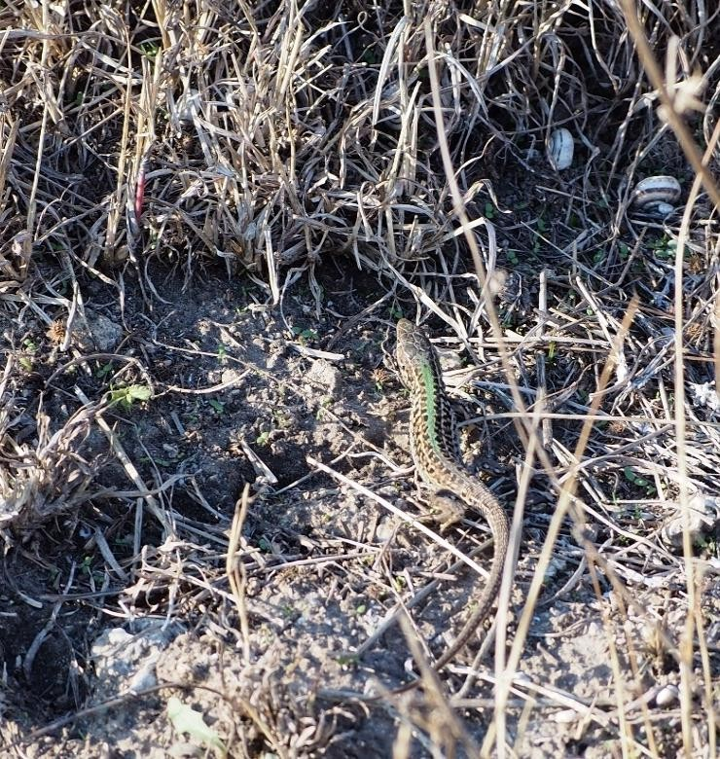
Steppe lizard (Podarcis taurica) observed in the wind farm area

Figure no. 30 Relevant photographs of mammals

Avifauna

During the monitoring period, transects were carried out on the surface of the future Cerchezu wind farm and all signs of presence (visual observation of individuals, auditory signals) of bird species were noted. This method was also applied in the southern sector of the Natura2000 site ROSCI0071 Dumbrăveni - Valea Urluia - Lacul Vederoasa, which borders the project area.
During the monitoring period, in the studied area (which includes both the project site and the southern end of the Natura2000 site ROSCI0071 Dumbrăveni - Valea Urluia - Lacul Vederoasa) the presence of 63 bird species (totaling almost 3,800 individuals) was established, as shown in the table below.

Table 13 Bird species identified in the study area
No. | Species | Species (Romanian) | No.  reported | IUCN | Directive  Birds* | Government Emergency Ordinance 57/2007* | Red Book of Vertebrates | Convention  Convention* | Convention  of Bonn*
1 | Accipiter gentilis | Goshawk | 2 | LC | - | - | - | - | -
2 | Sparrowhawk | Sparrowhawk | 5 | LC | - | - | - | - | -
3 | Alauda arvensis | Skylark | 550 | LC | Annex II B | Annex 5C | - | - | -
4 | Anthus campestris | Meadow pipit | 10 | LC | Annex I | Annex 3 | - | - | -
5 | Sunset sunset | Black Drepnea | 99 | LC | - | - | - | - | -
6 | Aquila pomarina | Lesser spotted eagle | 19 | LC | Annex I | Annex 3 | Vulnerable species | - | -
7 | Buteo buteo | Common buzzard | 162 | LC | - | - | - | - | -
8 | Buteo rufinus | Long-legged buzzard | 19 | LC | Annex I | Annex 3 | Vulnerable species | - | -
9 | Caprimulgus europaeus | Nightjar | 1 | LC | Annex I | Annex 3 | - | - | -
10 | Goldfinch | Goldfinch | 100 | LC | - | Annex 4B | - | Annex II | -
11 | Greenfinch | Florinte | 46 | LC | - | Annex 4B | - | Annex II | -
12 | Ciconia ciconia | White stork | 93 | LC | Annex I | Annex 3 | Vulnerable species | - | Annex II
13 | Ciconia nigra | Black stork | 1 | LC | Annex I | Annex 3 | Vulnerable species | - | Annex II
14 | Short-toed snake eagle | Snake eagle | 1 | LC | Annex I | Annex 3 | Vulnerable species | - | -
15 | Circus aeruginosus | Marsh harrier | 37 | LC | Annex I | Annex 3 | - | - | -
16 | Circus cyaneus | Blue-winged teal | 7 | LC | Annex I | Annex 3 | - | - | -
17 | Circus pygargus | Erete sur | 8 | LC | Annex I | Annex 3 | Endangered species | - | -
18 | Columba palumbus | Ring-necked pigeon | 2 | LC | Annex II A,  Annex III A | Annex 5C | - | Annex III | -
19 | Coracias garrulus | European roller | 26 | LC | Annex I | Annex 3 | - | Annex II | Annex II
20 | Corvus corax | The raven | 1 | LC | - | Annex 4B | Endangered species | - | -
21 | Corvus frugilegus | Raven | 28 | LC | Annex II B | Annex 5C | - | Annex III | -
22 | Coturnix coturnix | Quail | 4 | LC | Annex II B | Annex 5C | - | - | Annex II
23 | Cuculus canorus | Cuckoo | 6 | LC | - | - | - | - | -
24 | House Martin | House Martin | 50 | LC | - | - | - | - | -
25 | Calandra Bunting | Sour press | 200 | LC | - | Annex 4B | - | - | -
26 | Emberiza hortulana | Garden bunting | 3 | LC | Annex | Annex 3 | - | - | -

No. | Species | Species (Romanian) | Ind. no.  reported | IUCN | Directive  Birds* | Government Emergency Ordinance 57/2007* | Red Book of Vertebrates | Convention of  Convention | Convention  of Bonn*
27 | Erithacus rubecula | Redstart | 3 | LC | - | Annex 4B | - | Annex II | -
28 | Falco columbarius | Merlin | 2 | LC | - | - | - | - | -
29 | Falco subbuteo | Swallow hawk | 2 | LC | - | Annex 4B | - | - | Annex II
30 | Falco tinnunculus | Red Kestrel | 55 | LC | - | Annex 4B | - | - | Annex II
31 | Chaenomeles sinensis | Chaffinch | 4 | LC | - | - | - | - | -
32 | Crested Bunting | Ciocârlan | 26 | LC | - | - | - | - | -
33 | Common snipe | Common snipe | 1 | LC | Annex II A, Annex III B | Annex 5C, Annex 5E | - | - | -
34 | Garrulus glandarius | Magpie | 4 | LC | Annex II B | Annex 5C | - | Annex III | -
35 | Hieraaetus pennatus | Small eagle | 2 | LC | Annex I | Annex 3 | Critically endangered species  Endangered | - | -
36 | Hirundo rustica | Swallow | 219 | LC | - | - | - | - | -
37 | Lanius collurio | Red-backed shrike | 58 | LC | Annex I | Annex 3 | - | - | -
38 | Lanius minor | Black-fronted shrike  black | 3 | LC | Annex I | Annex 3 | - | - | -
39 | Larus cachinnans | Black-headed Gull | 88 | LC | - | - | - | - | -
40 | Luscinia luscinia | Nightingale of the grove | 1 | LC | - | - | - | - | -
41 | Luscinia megarhynchos | Red-throated Nightingale | 4 | LC | - | - | - | - | -
42 | Calandra Lark | Bărăgan lark | 55 | VU | Annex | Annex 3 | - | Annex II | -
43 | Merops apiaster | Prigorie | 147 | LC | - | Annex 4B | - | Annex II | Annex II
44 | Motacilla alba | White wagtail | 56 | LC | - | Annex 4B | - | - | -
45 | Motacilla flava | Yellow wagtail | 233 | LC | - | Annex 4B | - | - | -
46 | Oenanthe oenanthe | Stonechat | 15 | LC | - | - | - | Annex II | -
47 | Great tit | Great tit | 3 | LC | - | - | - | - | -
48 | Passer domesticus | House sparrow | 70 | LC | - | - | - | Annex III | -
49 | Perdix perdix | Partridge | 30 | LC | Annex II A, Annex III A | Annex 5C | - | - | -
50 | Pernis apivorus | Viespar | 2 | LC | Annex I | Annex 3 | Vulnerable species | - | -
51 | Phasianus colchicus | Pheasant | 12 | LC | Annex II A, Annex III A | Annex 5C | - | - | -
52 | Phoenicurus phoenicurus | Forest redstart | 4 | LC | - | Annex 4B | - | Annex II | -

No. | Species | Species (Romanian) | Index no.  reported | IUCN | Directive  Birds* | OUG 57/2007* | Red Book of Vertebrates | Convention  Convention | The  of Bonn*
53 | Pica pica | Magpie | 69 | LC | Annex II B | Annex 5C | - | Annex III | -
54 | Riparia riparia | Sand martin | 1 | LC | - | - | - | - | -
55 | Whinchat | Great Reed Warbler | 10 | LC | - | - | - | Annex II | -
56 | Streptopelia decaocto | Guguştiuc | 29 | LC | Annex II B | Annex 5C | - | - | -
57 | Turtle Dove | Turturică | 5 | NT | Annex II B | Annex 5C | Vulnerable species | - | -
58 | Sturnus vulgaris | Common starling | 982 | LC | Annex II B | Annex 5C | - | Annex III | -
59 | Blackcap | Blackcap | 3 | LC | - | - | - | - | -
60 | Blackbird | Blackbird | 18 | LC | - | - | - | - | -
61 | Turdus philomelos | Song thrush | 7 | LC | Annex II B | Annex 5C | - | - | -
62 | Turdus pilaris | Redwing | 38 | VU | Annex II B | Annex 5C | - | - | -
63 | Hoopoe | Hoopoe | 51 | LC | - | Annex 4B | Vulnerable species | - | -
IUCN: LC – Least Concern; NT – Near Threatened; VU – Vulnerable;
Birds Directive: Annex I - Species subject to special conservation measures for their habitats in order to ensure their survival and reproduction in their area of distribution; Annex II A - Species that may be hunted in the geographical sea and land area to which this Directive applies; Annex II B - Species which may be hunted only in certain Member States specified in the Directive; Annex II B - Species which may be hunted only in certain Member States specified in the Directive; Annex III A - Species for which the sale, transport for sale, keeping for sale, and offering for sale of live or dead birds and any readily recognizable parts of birds or bird products are not prohibited, provided that the birds have been killed or captured by legal means or have been obtained by legal means; Annex III B - Species of birds for which some Member States may permit on their territory the sale, transport for sale, keeping for sale, and offering for sale of live or dead birds and any easily recognizable parts of birds or bird products, subject to certain restrictions, provided that the birds have been killed or captured by legal means or obtained by legal means.
OUG57/2007 on the regime of protected natural areas, conservation of natural habitats, wild flora and fauna: Annex 3 - Plant and animal species whose conservation requires the designation of special conservation areas and special bird protection areas; Annex 4B - Species of national interest. Animal and plant species requiring strict protection; Annex 5C - Species of Community interest whose hunting is permitted; Annex 5E - Bird species of Community interest whose trade is permitted under special conditions.
Bern Convention: Annex II - Strictly protected fauna species; Annex III - Protected fauna species.
Bonn Convention: Annex II - Migratory species to be covered by agreements

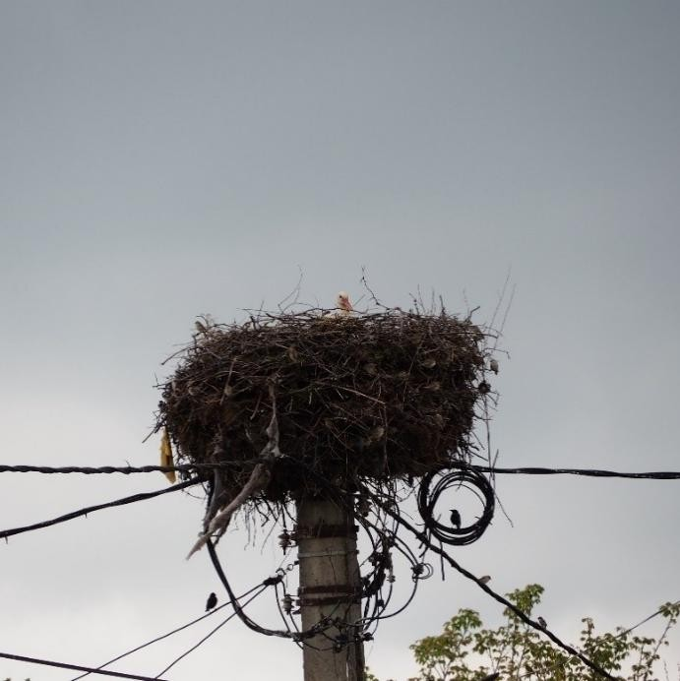 | 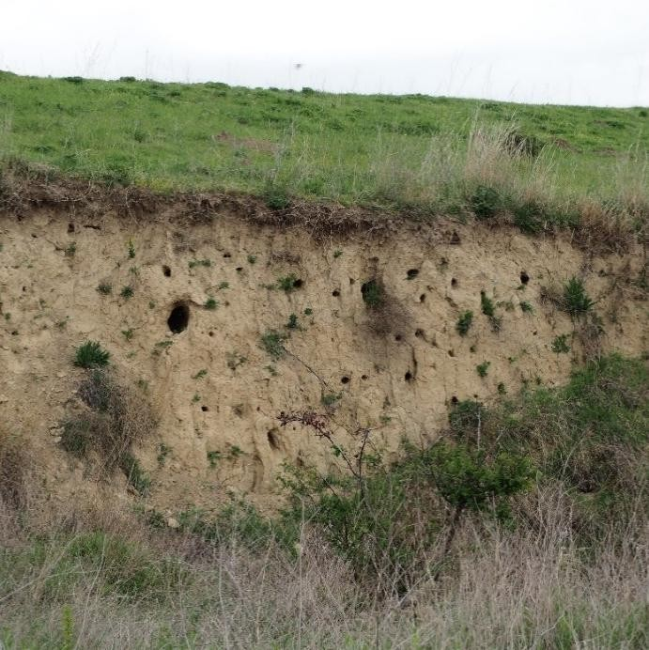
White stork (Ciconia ciconia) nest in Olteni | Mixed nesting colony (Merops apiaster, Sturnus vulgaris) near the future wind farm
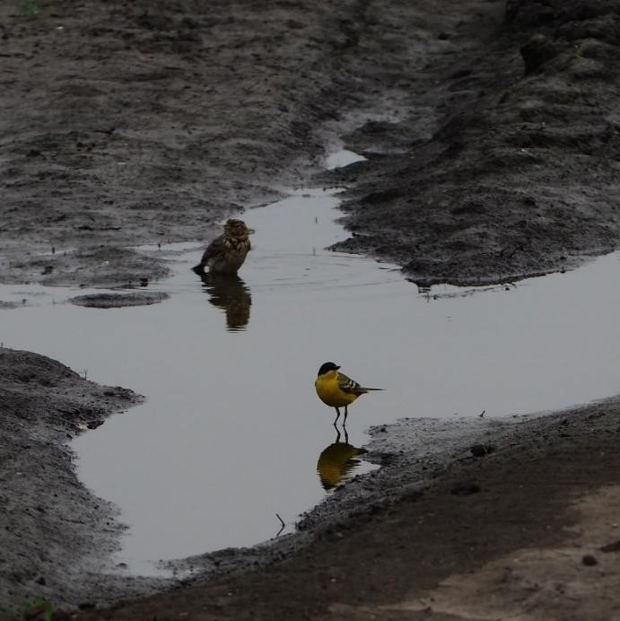 | 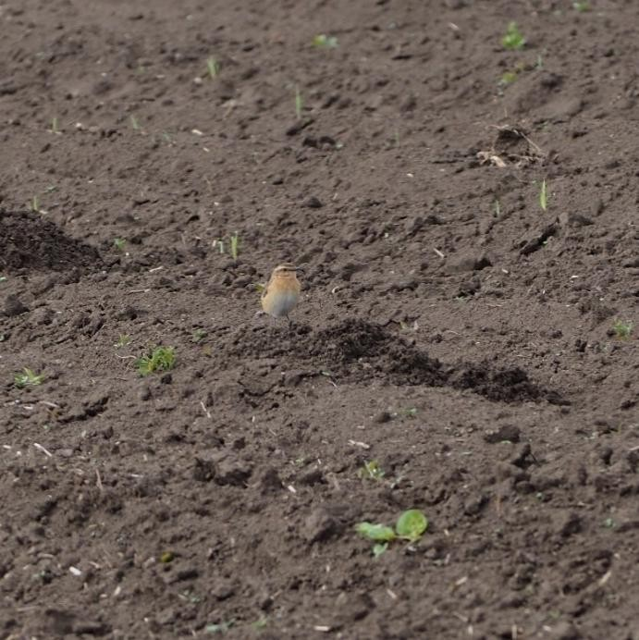
Corn bunting (Emberiza calandra) and yellow wagtail (Motacilla flava) at a temporary pond | Whinchat (Saxicola rubetra)

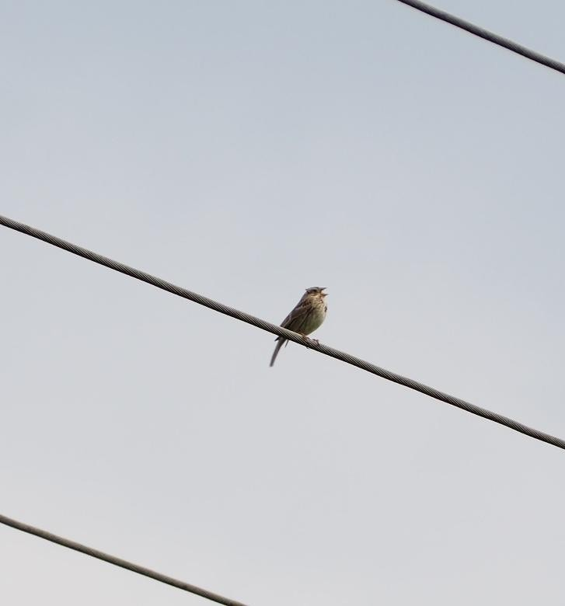 | 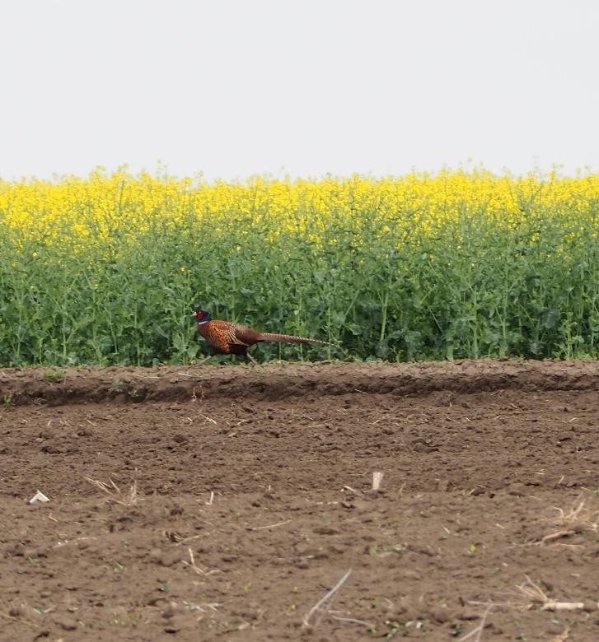
Corn bunting (Emberiza calandra) singing | Pheasant (Phasianus colchicus)
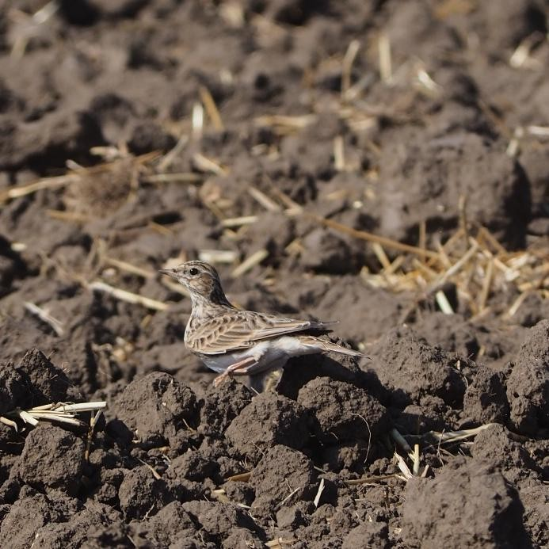 | 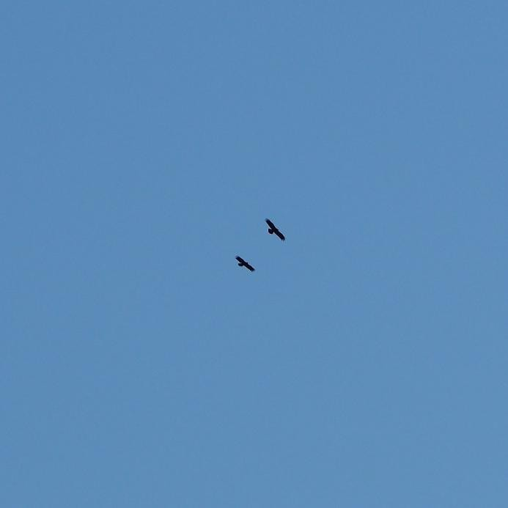
Skylark (Alauda arvensis) | Lesser spotted eagles (Aquila pomarina)

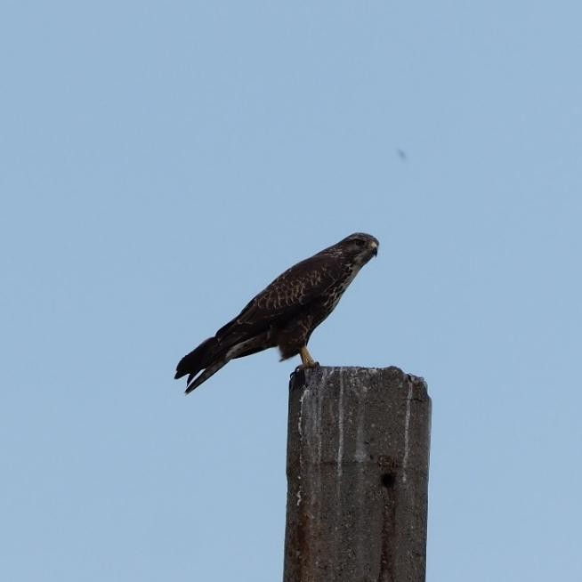 | 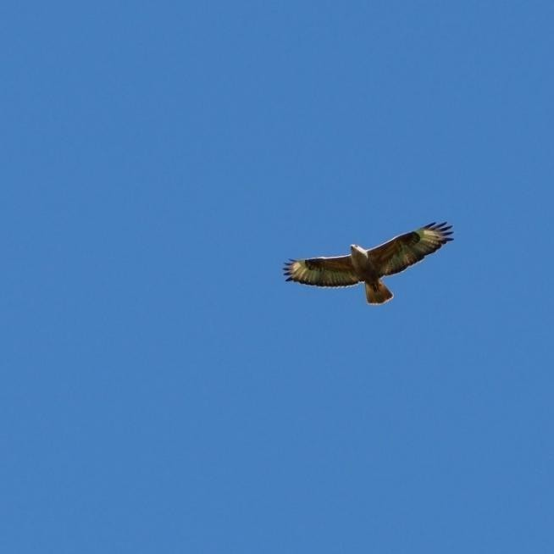
Common buzzard (Buteo buteo) | Long-legged buzzard (Buteo rufinus)
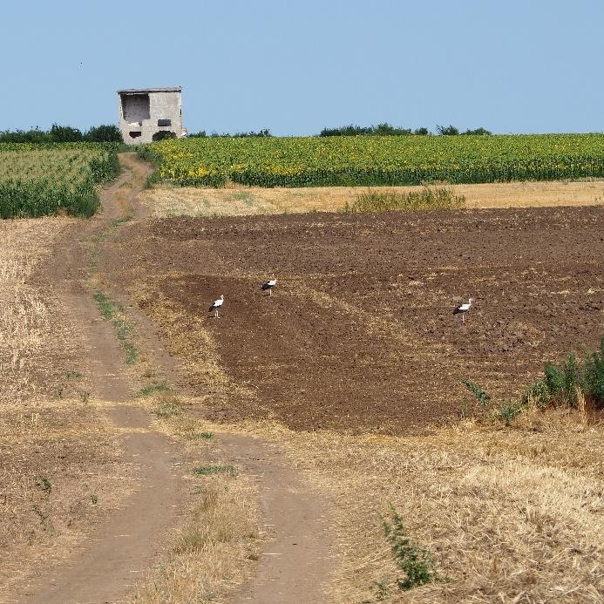 | 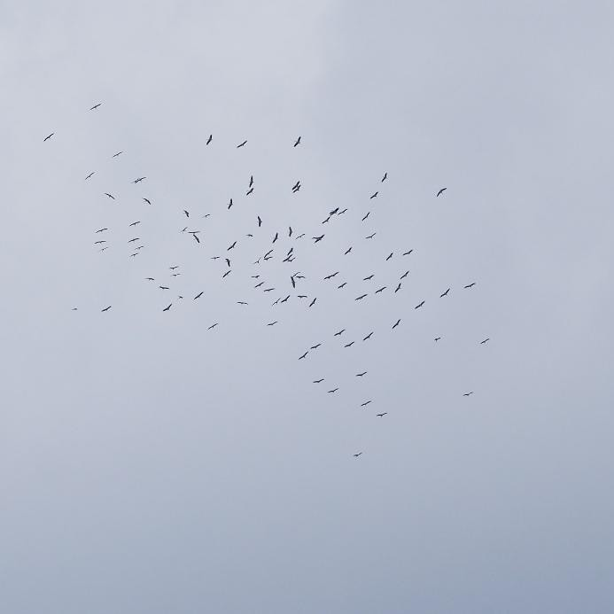
White storks (Ciconia ciconia) feeding on the project site | White storks (Ciconia ciconia) migrating over the project site
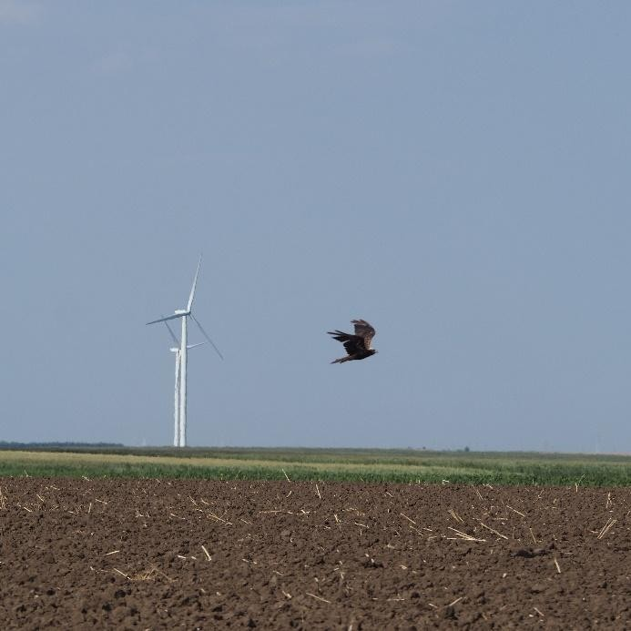 | 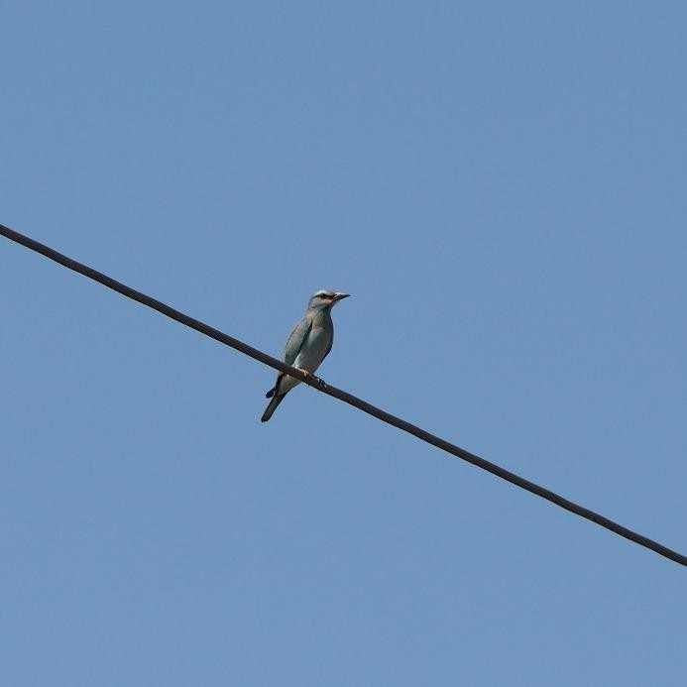
Marsh harriers (Circus aeruginosus) | European roller (Coracias garrulus)

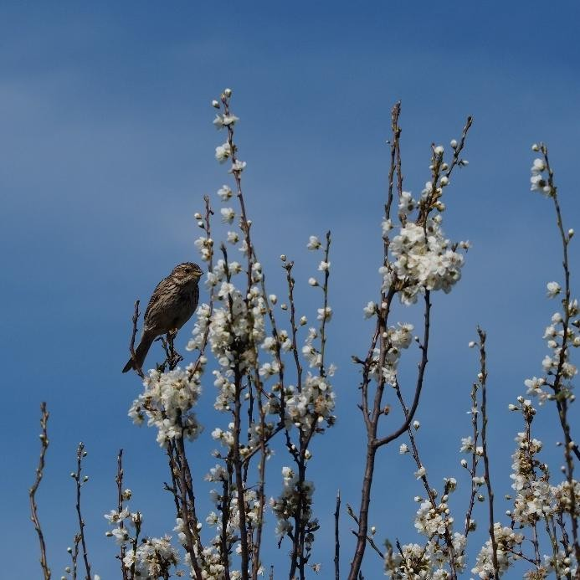 | 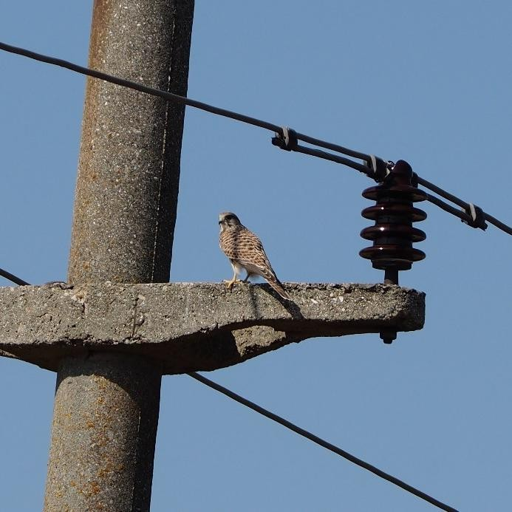
Corn Bunting (Emberiza calandra) | Kestrel (Falco tinnunculus)
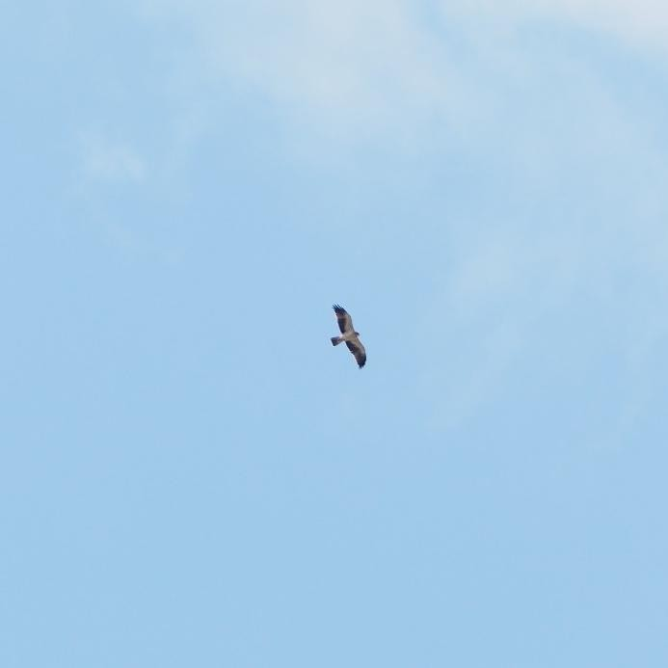 | 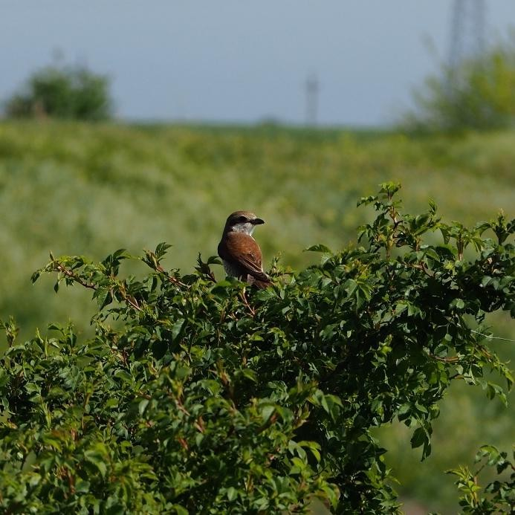
Booted eagle (Hieraaetus pennatus) | Red-backed Shrike (Lanius collurio)
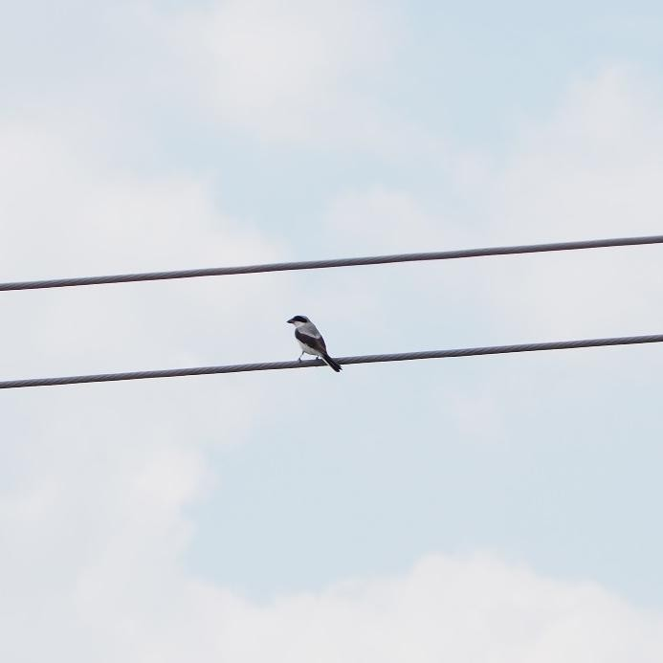 | 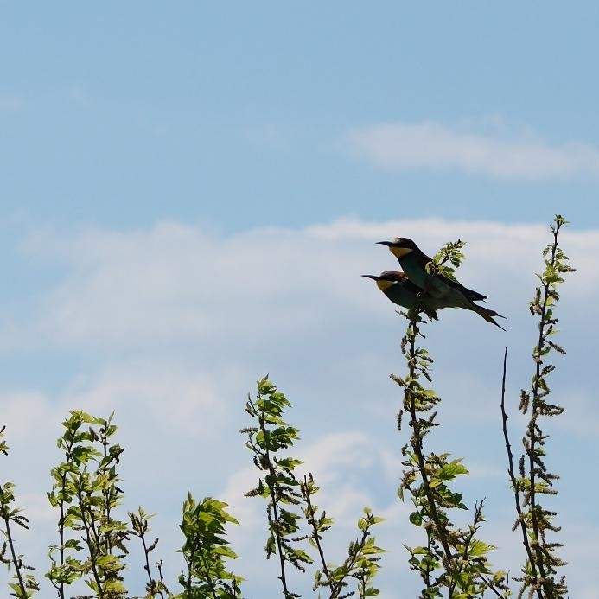
Lesser Grey Shrike (Lanius minor) | Bee-eaters (Merops apiaster)

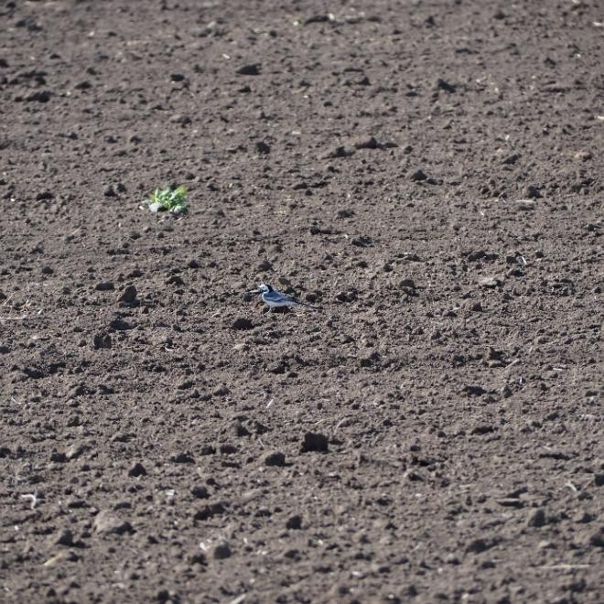 | 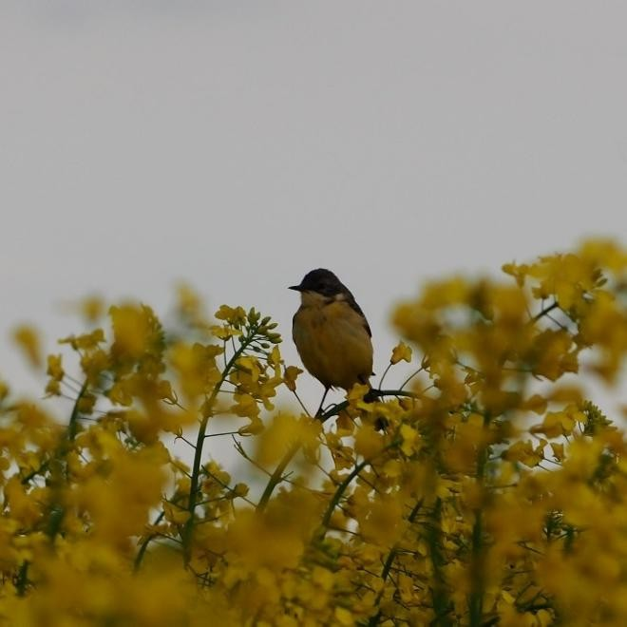
White wagtail (Motacilla alba) | Yellow Wagtail (Motacilla flava)
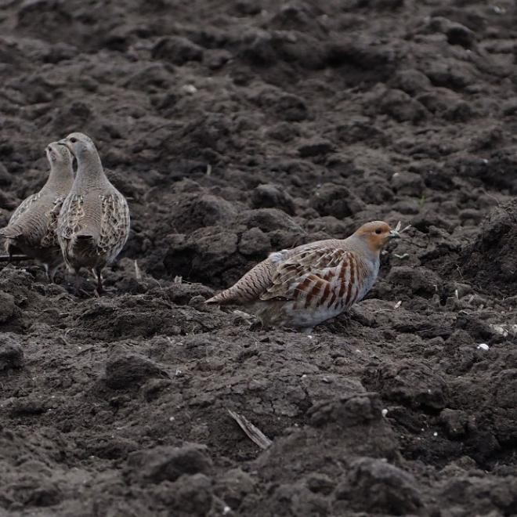 | 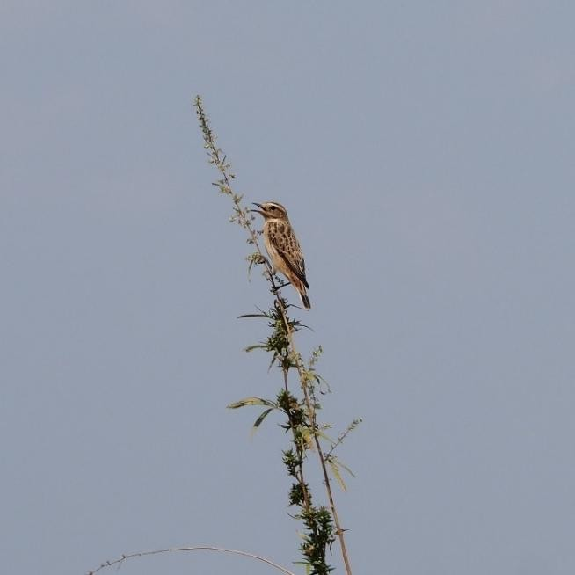
Grey partridge (Perdix perdix) | Whinchat (Saxicola rubetra)
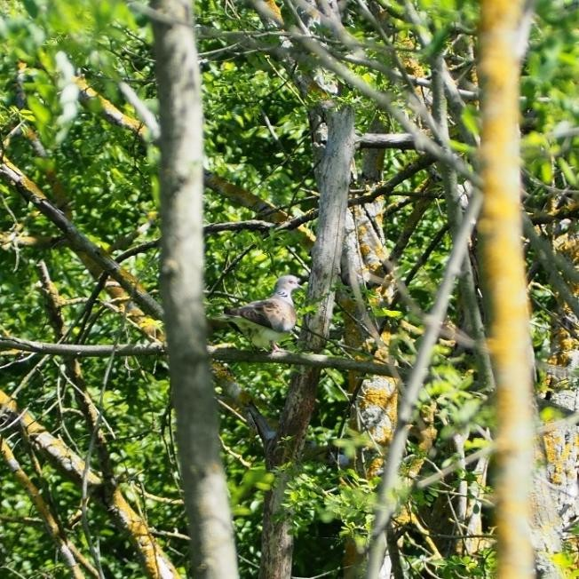 | 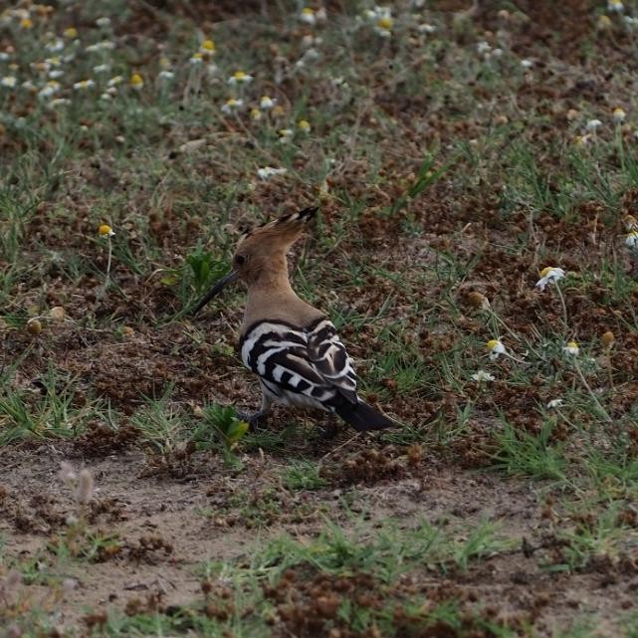
Turtle Dove (Streptopelia turtur) | Hoopoe (Upupa epops)

Figure no. 31 Photos relevant to bird species

Chiroptera

In order to observe the activity of chiroptera in the site, best practices in the field were implemented,
using state-of-the-art equipment.

Detecting bats at night is difficult, so a method was chosen that is both non-invasive and highly effective: recording the ultrasonic sounds emitted by the animals at night.
Three monitoring methods were used:

- Qualitative

- Quantitative – transect

- Quantitative – passive detection

The qualitative method involved driving along ultrasound transects in a vehicle on a pre-established route within the proposed site. The transects were carried out half an hour before sunset until 3:00 a.m. the following day in order to record the entire optimal spectrum for the bat species in the site. An Anabat Walkabout device with GPS was used. The data were processed using Anabat Insight software and identification guides for bat ultrasounds (Pocora & Pocora, 2012). Monthly trips were made, as far as possible during periods with optimal weather conditions for animal flight (no rain, temperatures close to the monthly average at night). The total length of the transects for each night was 60.7 km.
Qualitative methods included: 1 - recording bat activity at fixed points in transects (10 points), where bat activity was monitored for 10 minutes, 2 - automatic recording of bats using static detectors placed in various positions in the field (stratified radomic sampling method), of the Anabat Chorus type, with a frequency of one full night of activity per month, at 5 points in the proposed location. The data recorded using static detectors were identified manually using Kaleidoscope Pro – Wildlife Acoustics software.
For any ultrasound analysis, the number of contacts is not equal to the number of individuals, as an animal can be detected several times in the same place (especially for quantitative monitoring). The number of contacts is directly proportional to the number of individuals.
The Bat Activity Index (BAI) was calculated for the quantitative method, providing a less subjective perspective in quantifying the potential impact (no. of contacts/nights of activity).
All spatial data were processed using ArcGIS ESRI 2023 software.

Qualitative method

Climatic conditions during monitoring were generally optimal (one sub-optimal case) for the year 2022.

During the monitoring period, 285 records were captured.

Five potentially six species/groups of bats were identified. Certain species cannot be directly identified through ultrasound analysis due to the similarity of their echolocation, so groupings such as Pipistrellus nathusii/Pipistrellus kuhlii or Myotis sp. (with various grouping variations) are accepted. The species identifications from the qualitative method can be found in the sonograms presented below.

The most abundant taxon recorded in the 2022 monitoring campaign was Pipistrellus nathusii/kuhlii, followed by Nyctalus noctula. All groups/species recorded in the study area are very common in the open areas of southern Romania.
The evolution of chiropteran activity per monitoring month indicates a peak in May 2022, which may coincide with late migrations of some species or with the beginning of the maternity period for species of the genus Pipistrellus sp.
Activity gradually decreased starting in May 2022, and diversity remained roughly similar, with few species identified during transects (maximum 5). The data indicate the possibility of using the site as a migration area in the spring season, but also as a maternity area in the summer.
Table 14 Number of ultrasound contacts per species or group and conservation status – qualitative method – ultrasound transects
No. | Species | O.U.G. 57/2007 | Habitats Directive | No. of contacts
1 | Pipistrellus nathusii/kuhlii | Annex IV A | Annex IV | 239
2 | Pipistrellus pipistrellus | Annex IV A | Annex IV | 7
3 | Nyctalus leisleri | Annex IV A | Annex IV | 10
4 | Nyctalus noctula | Annex IV A | Annex IV | 26
5 | Eptesicus serotinus | Annex IV A | Annex IV | 3

Quantitative method

The static points collected during the transect recorded variable results, with relatively uniform values across the site in terms of species diversity. The highest values in terms of contact abundance were recorded at T2 in the northern part of the site. In general, the highest values were recorded along linear vegetation elements (shrub alignments, roads, and irrigation channels).
The static detectors were placed near former irrigation channels (MS1, MS2, MS3, MS5), but also in open agricultural land (MS4). The five static detectors recorded a total of 31,060 raw contacts, with a maximum abundance for MS2 (9,986 raw contacts). The sonograms of the identified species (minus those common in the qualitative analysis) can be seen in. The BAI activity index had the highest value for point MS2, located in the central eastern area of the project, near an abandoned irrigation canal. The species with the highest abundance was Pipistrellus nathusii/kuhlii, but also with the highest BAI index. The evolution of ultrasound contacts per month indicates a maximum during the autumn migration period (August) and a high level during the spring migration period. The species Miniopterus schreibersii was more active during migration periods.

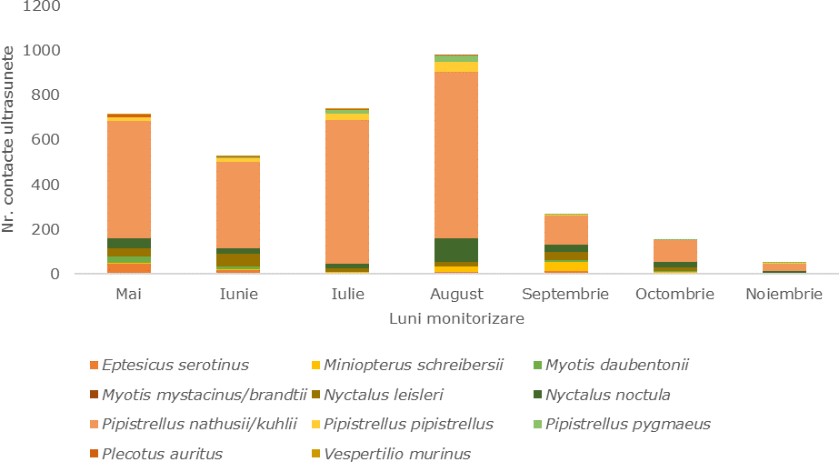

Figure no. 32 Evolution of ultrasonic contacts in static detection per monitoring month

Soil/subsoil and land use

Study area

The analyzed area is located in the administrative territory of Cerchezu commune, Constanța county, with agriculture as the main function of the studied area, the agricultural land currently being used for arable farming.
The land on which the proposed investment is to be made is privately owned by individuals/legal entities with whom the beneficiary of the investment, SOUTH WIND SRL, has concluded transfer and surface rights agreements.
The area studied for the implementation of the project includes agricultural land intended for arable use and land for special purposes—service roads in the public domain of the administrative-territorial unit of Cerchezu commune, administered by the Local Council of Cerchezu commune and the public domain of county interest.
From a geological point of view, the analyzed territory belongs to the geological unit of southern Dobrogea (according to the geological map of Romania - sheet 1:200,000 Mangalia), located between the Central Dobrogea Massif, the Wallachian Platform, and the state border with Bulgaria. This sector, which contains a section of the Moesian platform, consists of Mesozoic and Tertiary epicontinental deposits, slightly folded or unfolded, characterized by small thicknesses and many sedimentary gaps. They are arranged on a folded Paleozoic foundation from which relatively slightly folded Silurian and Devonian deposits have been highlighted. The territory that makes up the southeastern tip of Dobrogea has the appearance of a plateau with low elevations, whose altitude decreases slowly from west to east and from south to north. Thus, the highest elevations are located near the border, south of Olteni. Looking eastward, the altitude of the plateau reaches approximately 80 m near the town of Cotu Văii and 20-30 m near Mangalia. From south to north, there is also a decrease in altitude. Near the border, south of Negru Vodă, elevations of 160-154 m are recorded.
The plateau is crossed by canyon-like valleys, generally narrow, with steep and symmetrical sides. These valleys belong to two distinct hydrographic basins: the Danube to the west and the Black Sea to the east.

General information about the soil/subsoil

The formation and geographical distribution of soils in the Cerchezu commune have been influenced by physical and natural factors
physical and natural factors, relief, lithology, and climate.

The numerous soil classes and types are distinctly different in terms of their properties, productive capacity, and measures to maintain and increase fertility.
The main soil types in the analyzed area are chernozems, fertile black soils characteristic of agricultural land in this area, rich in humus and nutrients, which makes them suitable for agriculture, especially for cereal crops.
The following figure shows the soil map of the proposed project area:
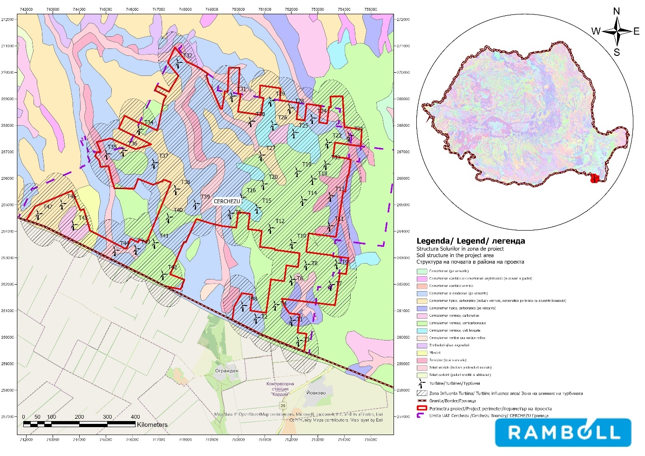

Figure 33 Soil map of the proposed project area

Analyzing the soil map, it can be seen that in the project implementation area, the predominant soil class is chernozems (black earth), accounting for approximately 90% of the total area.
From a geological point of view, the region is predominantly covered with sedimentary rocks including sand, clay, and marl, due to the marine and fluvial deposits that characterize the Dobrogea platform.
More specifically, the analyzed territory is located in Southern Dobrogea, which, from a tectonic point of view, represents a sector of the Moesian Platform, delimited by the major Capidava-Ovidiu faults to the north, and the intramoesic (Călărași-Fierbinți-Sabla) fault to the south, which continues to northern Bulgaria, the Danube to the west, and the Black Sea to the east. This region covers an area of approximately 5000 km2. Above the Archean and Proterozoic crystalline bedrock, there are discordant sedimentary deposits belonging to the Paleozoic, Mesozoic, and Neogene sedimentary cycles.
In Southern Dobrogea, a carbonate platform developed from the Mesozoic (Upper Jurassic and Cretaceous) and continued through the Paleogene to the Miocene. The Pliocene developed mainly along the right bank of the Danube, in areas with low topography, and is represented by the sedimentation of continental red clay sequences.
The commune of Cerchezu, located in Constanța County, has a specific geographical and pedological environment that can influence both agricultural activities and the sustainable development of the area.
In the analyzed area, the commune of Cerchezu and its surroundings, no areas of particular geological, paleontological, and speleological importance have been identified.

Current state of the soil/subsoil in the site area

Currently, the soil quality in the administrative territory of the Cerchezu commune is not affected by industrial activities. According to available public sources, there are no historically contaminated sites or potentially contaminated sites in the administrative territory of the Cerchezu commune.
Areas with a potential risk of soil pollution are represented by agricultural activities. Improper use of fertilizers can lead to excessive nitrogen and phosphate levels, with effects on the soil microflora and their accumulation in vegetation.
According to the County Report on the State of the Environment, 2022, for Constanța County, out of a total area of 707,129 ha, recorded in the land registry according to data provided by DAJ Constanța, almost 80% is agricultural land (558,204 ha), with the remaining 20% being non-agricultural land.
The map showing the distribution of land use categories in the project coverage area is shown in the figure below.

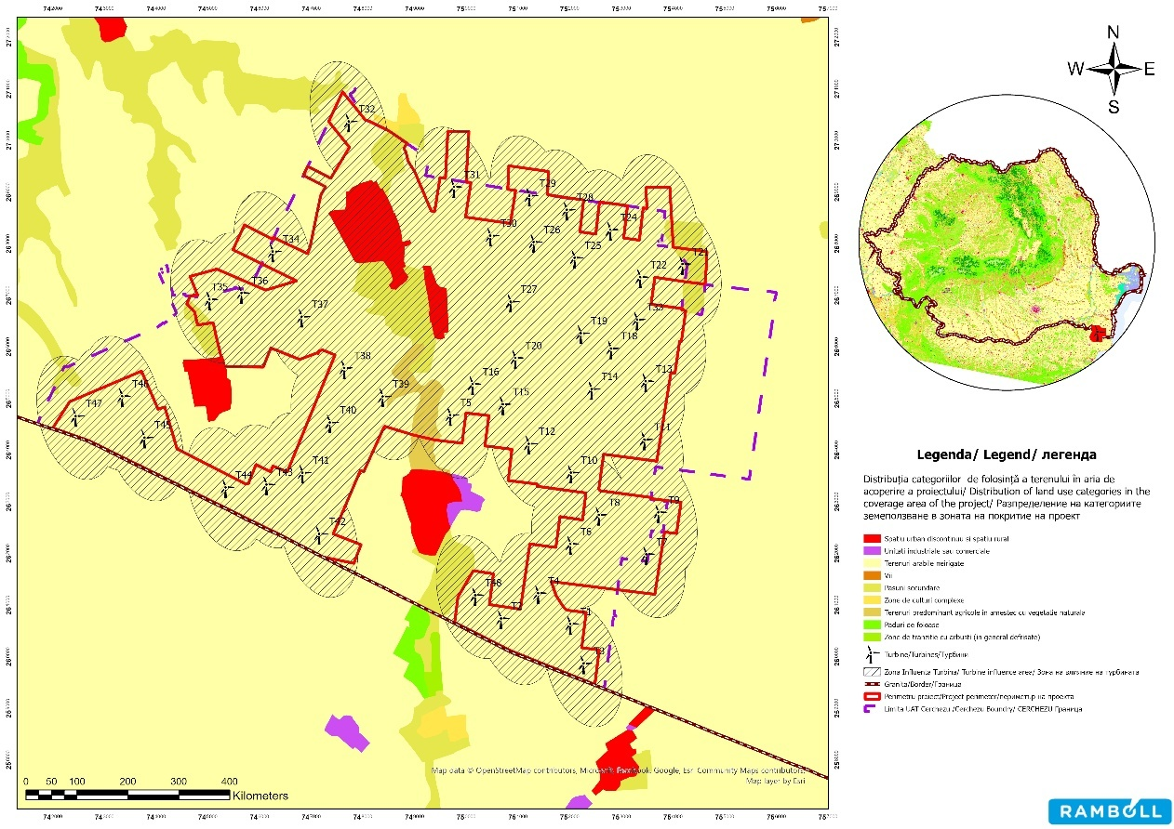

Source: CORINE Land Cover, 2018, Version 2020_20u1mDate of publication: Jun 14, 2019 Revision date: May 13, 2020
Figure no. 34 Distribution of land use categories in the project coverage area

In terms of land use categories, the study area consists of arable land (90%), secondary pastures, predominantly agricultural land mixed with natural vegetation, discontinuous urban areas, and industrial or commercial units.
The Convention on Biological Diversity (CBD) has defined soil biodiversity as "the variation of soil life, from genes to communities and the ecological complexes of which they are part." In other words, soil biodiversity represents the diversity of underground life.
A recent article published by the JRC (Joint Research Centre) presents a map of potential threats to three categories of soil biodiversity (microorganisms, fauna, and biological functions of the soil) in the EU and provides guidance for identifying soils that may be at risk. According to the JRC's conclusions, intensive human use/exploitation poses the greatest potential threat, while genetically modified organisms (GMOs) pose the least threat.
The maps show that high-risk soils exist in most European countries, with the risk being higher in agricultural areas and the Danube floodplains than in other forested areas.
The biological potential of the soil was assessed and mapped using critical thresholds for certain factors that influence the soil, such as climate change, land use change, habitat fragmentation, intensive anthropogenic exploitation, decline in soil organic matter, industrial pollution, soil compaction, soil erosion, soil sealing, soil salinization, the use of GMOs in

agriculture, and invasive species. These can affect the biological condition of soils and indirectly the levels of
soil biodiversity levels.

Analyzing the data presented in the JRC study on the potential risks threatening the biological functions of the soil, it was observed that in the project implementation area, the vast majority of soils present a high risk in Romania, decreasing to a moderate risk in Bulgaria, , thus making biological functions susceptible to being affected by soil degradation processes.
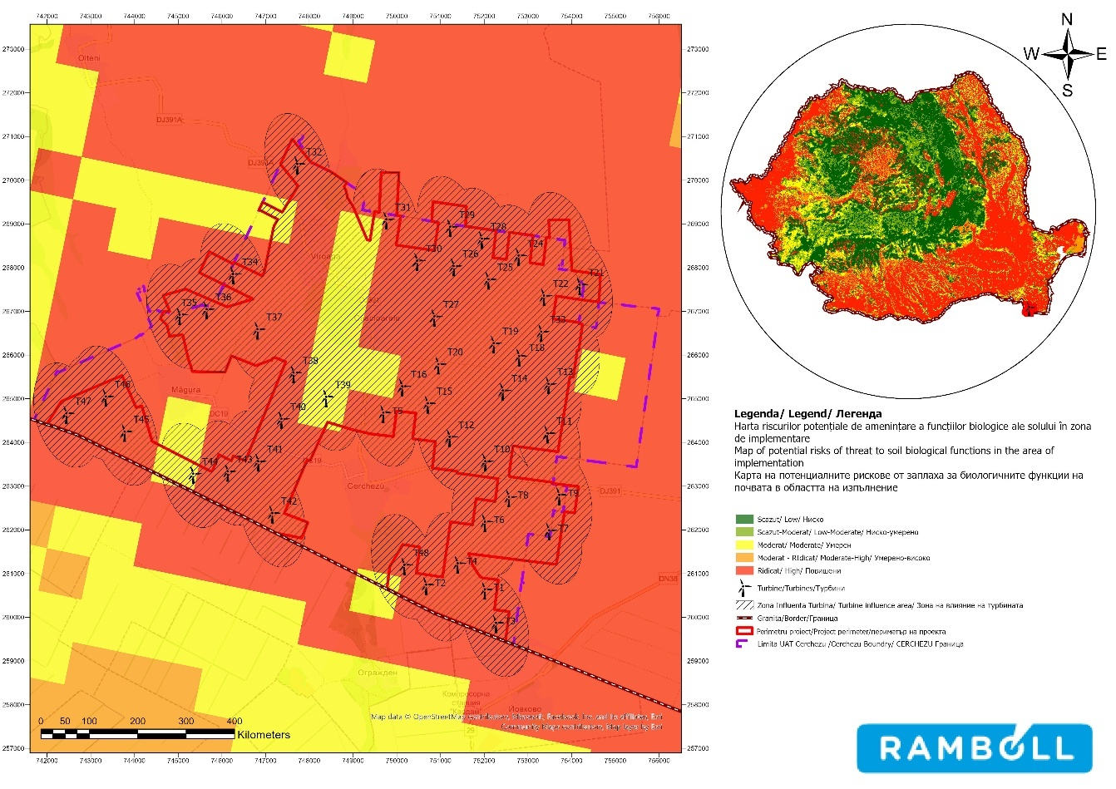
Source: Joint Research Centre-European Soil Data Centre- Soil Biodiversity; A knowledge-based approach to estimating the magnitude and spatial patterns of potential threats to soil biodiversity
Figure 35 Map of potential threats to soil biological functions in the project implementation area
project implementation area

    - Land use

The land on which the proposed investment is to be carried out is privately owned by individuals/legal entities with whom the beneficiary of the investment, SOUTH WIND SRL, has concluded surface rights contracts.
The total area of the proposed project is 40 ha.

The land on which the investment covered by this documentation is to be developed is represented by the plots shown in the following table:

Table 15 Territorial balance

Components | Total ha
Foundations | 3.25
Technology platforms | 22
Transformer stations | 3.03
Internal access road network, overlapping existing agricultural roads, 5.5 m wide, to be paved | 49.0
Site organization | 3.6
Total area | 80.95

The construction of the energy park will lead to the permanent occupation of land areas:

- approximately 25 ha for the location of wind turbines and complementary constructions and
transformer stations
- 49.06 ha permanently occupied by service roads and paved roads.
The energy park will lead to the permanent removal of an area of approximately 30 ha from agricultural use.

The area studied for the implementation of the objective includes agricultural land intended for arable land and land for special purposes - service roads in the public domain of the administrative-territorial unit of Cerchezu commune, administered by the Local Council of Cerchezu commune.
The main function of the studied area is agriculture, with agricultural land currently used for arable farming covering an area of 2,908.24 ha, representing 96.05% of the total studied area. The categories of land use are presented in the following table and figure.
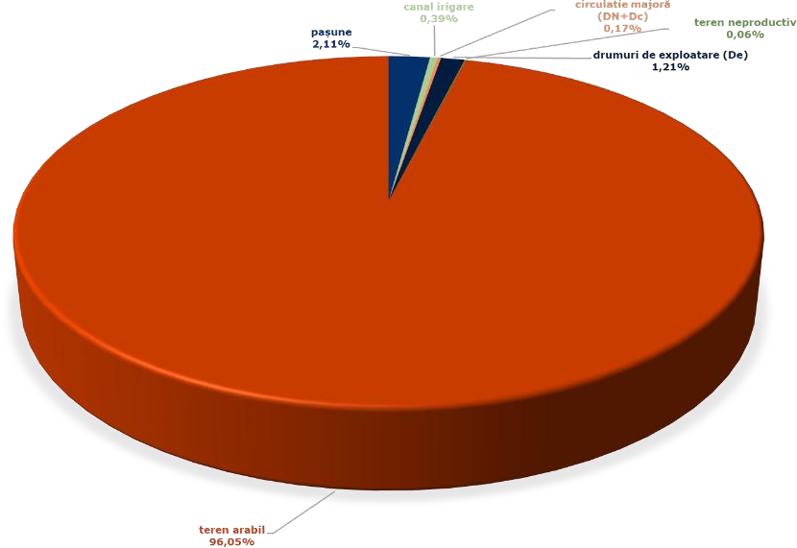
Land use categories | ha
Pasture | 64
Irrigation canal | 11.77
Major traffic (DN+Dc) | 5.2
Service roads (De) | 36.65
Unproductive land | 1.87
Arable land | 2908.2
Total | 3027.77

Figure no. 36 Land use categories
The energy park will lead to the permanent removal of approximately 30 ha of land from agricultural use.

For the areas occupied by the component storage platforms and crane assembly, a request will be made for the temporary removal of the relevant areas from agricultural use.
The quality classes and fertility ratings of agricultural land are closely linked to the assessment of soil fertility and productivity. Thus, agricultural land is grouped into five quality classes, differentiated by average fertility rating (class I: 81-100 points, class V: 1-20 points).
The land on which the investments are to be developed outside the built-up area of the municipality of Cerchezu is classified as class III quality (on a scale from I to V), i.e. moderately fertile soil, moderately affected by degradation.

Water/Water bodies

Study area

The study area for assessing the water environmental factor was defined to include the project site and its area of direct and indirect influence, taking into account the type and extent of the proposed works, as well as potential interactions with surface or groundwater bodies and watercourses in the project area.
For the water environmental factor, the study area includes the area occupied by permanent and temporary works, as well as a proximity area around the site where indirect effects could occur (e.g., dust emissions, waste, chemicals/oils/lubricants/etc.).
The study area was defined based on information available from official databases on surface and groundwater bodies, existing technical documentation, and local characteristics of the territory, ensuring a proportional and adequate assessment of the potential risks associated with the project.

Surface water

From a hydrographic point of view, the project site is located in the Danube-Litoral Hydrographic Basin. The closest surface water bodies identified in the studied area on Romanian territory are located at distances greater than 28 km (Mangalia - code ROCT01_B2, at a distance of approx. 29 km, east of the site boundary, Eforie Nord-Vama Veche - ROCT02_B2, northeast of the site boundary, at a distance of approx. 35 km, there is also Lake Tatlageac - ROLW15-1_B9, and Lake Techirghiol dulce - ROLW15.1_B1).
The project elements do not intersect any surface water bodies.

The following table shows the ecological status and chemical status of surface water bodies in the wind farm location area, based on data provided by the updated Management Plan for the Danube River, Danube Delta, Dobrogea Hydrographic Area, and Coastal Waters (2022-2027):
Table 16 Ecological status of surface water bodies in the site area
Water body name | Water body category | Water body type | Surface water body code | Status/Potential  (S/P) | Ecological status/potential  ecological | Chemical status
Mangalia | CW | ROCT01CAP  M | ROCT01_B2 | P | 5 | 2
Eforie North-Vama  Veche | CW | ROCT02 | ROCT02_B2 | S | 5 | 2
Lake Bugeac | LW | ROLN02 | ROLW14-1-37_B1 | S | 2 | 2
Lake Iortmac | LW | ROLN01 | ROLW14-1-39_B1 | S | 2 | 2
Lake Oltina | LW | ROLN02 | ROLW14-1-39-  1_B1 | S | 2 | 2
Lake Dunăreni | LW | ROLN01 | ROLW14-1-  39A_B1 | S | 2 | 2
Lake Vederoasa | LW | ROLN02 | ROLW14-1-40_B1 | S | 2 | 2
Techirghiol freshwater lake | LW | ROLN05 | ROLW15.1_B1 | S | 2 | 2
Techirghiol Salt Lake | HMWB - LW | ROLNPM01T | ROLW15-1_B2 | - | - | 2
Lake Tatlageac | LW | ROLN02 | ROLW15-1_B9 | S | 2 | 2
Column "Water body category": RW - natural river/CAMP river/artificial river, LW - natural lake/storage lake/heavily modified natural lake/artificial lake, CW - natural/heavily modified coastal waters, HMWB = heavily modified water body
Column "Status/Potential": S - ecological status; P - ecological potential
Column "Water body type": ROCT02 - natural coastal waters,
Column "Ecological status/ecological potential": 1 - very good ecological status; 2 - good ecological status/maximum and good potential; 3 - moderate ecological status/moderate potential; 4 - poor ecological status/poor potential; 5 - bad ecological status/bad potential
Column "Chemical status": 2 = good

The closest surface water bodies identified in the project area on Bulgarian territory are located south of the site boundary: BG1DJ900R1015 at a distance of approx. 1 km south of the project site, BG2DO700L017 at a distance of approx. 34 km, and BG2BS000C001 at a distance of approx. 36 km, southeast of the site boundary.
The following figure shows the location of the project in relation to surface water bodies.
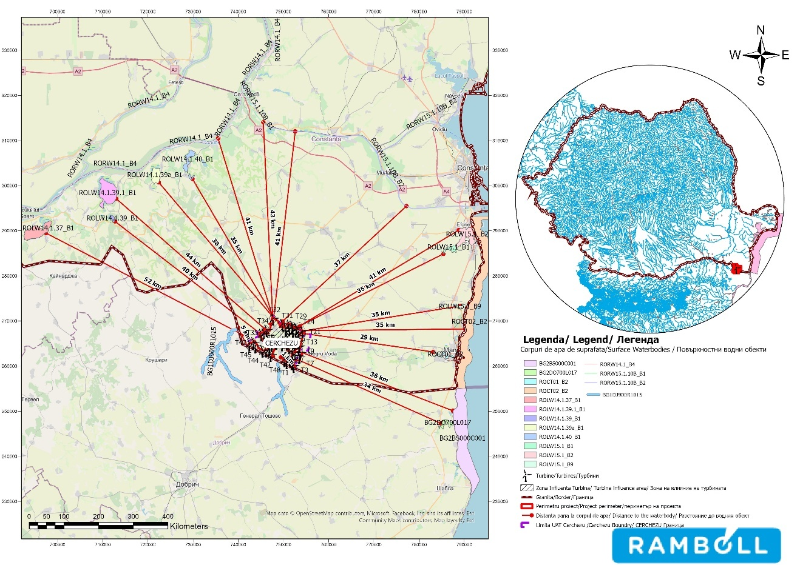
Figure no. 37 Surface water bodies in the project area

According to the Danube Littoral River Basin Management Plan, no interdependencies between watercourses (no surface water bodies have been delimited on these watercourses) have been identified at the river basin level in the wind farm project area.
Three watercourses were identified in the project area:


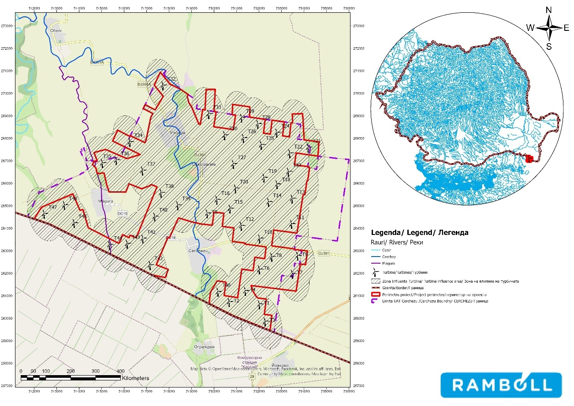

Figure no. 38 Surface watercourses in the project area

In order to carry out the project, it is necessary to build underpasses for the Cerchez (2 underpasses) and Măgura (2 underpasses) watercourses. The works will be carried out using horizontal drilling technology at a depth of 1 m between the upper generator of the protective pipe and the watercourse bed. Upon completion of the works, the affected areas will be restored to their original condition.

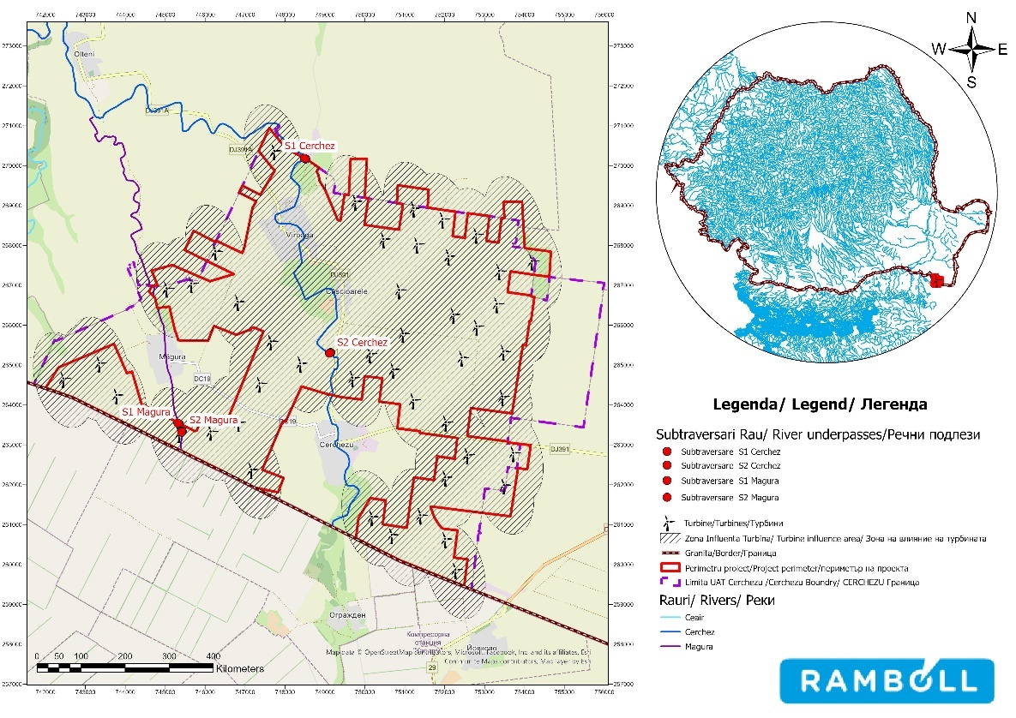
Figure no. 39 Location of watercourse underpass works

In the vicinity of wind farms T1, T4, T12, T26, T27, and T28, there are irrigation channels that are not in operation.
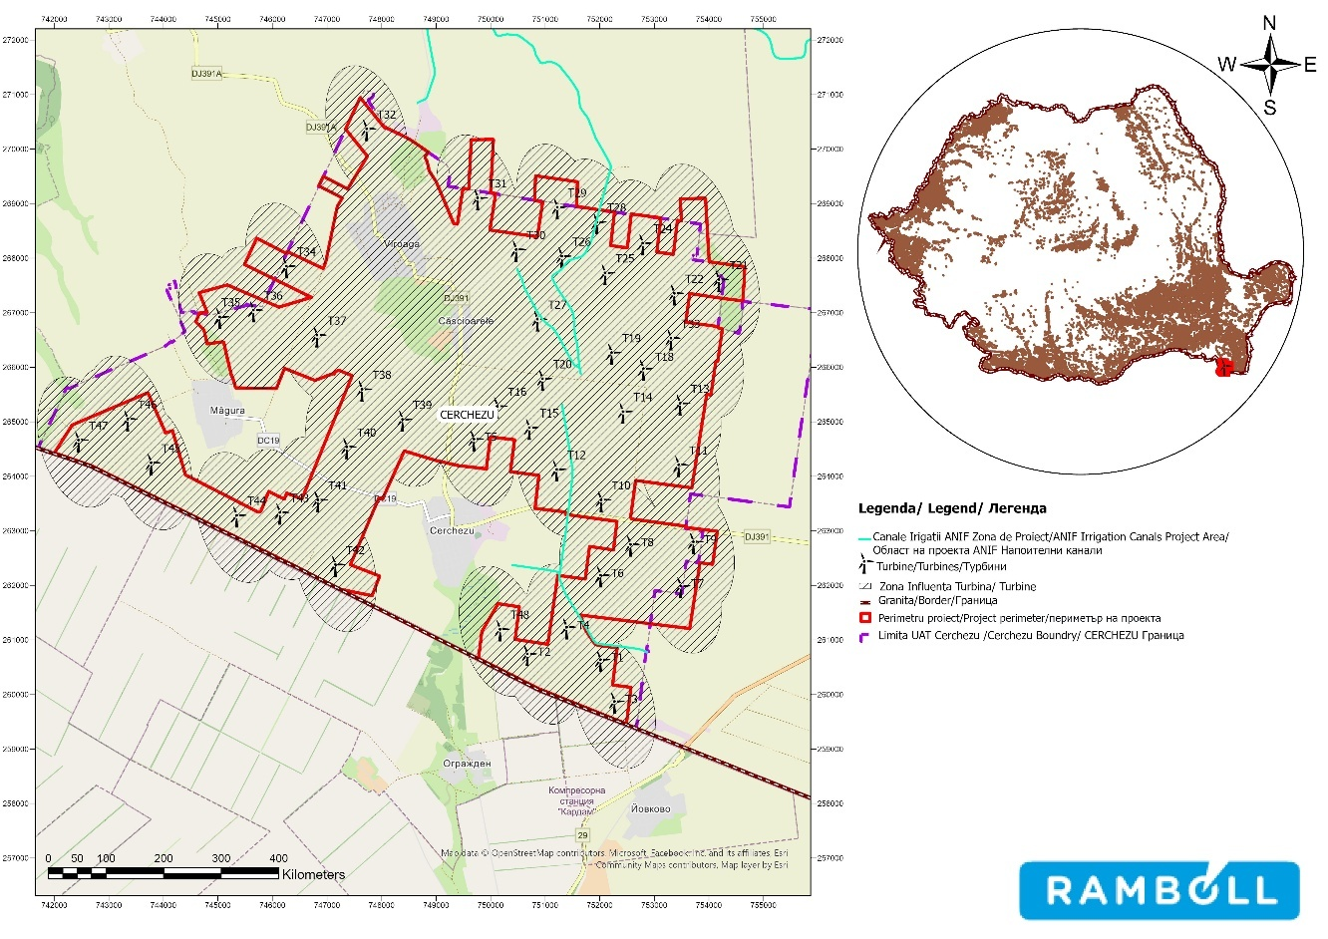
Figure no. 40 Irrigation channels in the project area

Groundwater

The project implementation area overlaps with three groundwater bodies in Romania and is located near two groundwater bodies in Bulgaria:
- 2 transboundary deep groundwater bodies (RODL04 Cobadin-Mangalia, RODL06 -
Platforma Valahă);
- 1 groundwater body (RODL10 Southern Dobrogea);
- 2 bodies groundwater bodies located on the territory of Bulgaria (BG1G000000N049 and BG1G0000J3K051).
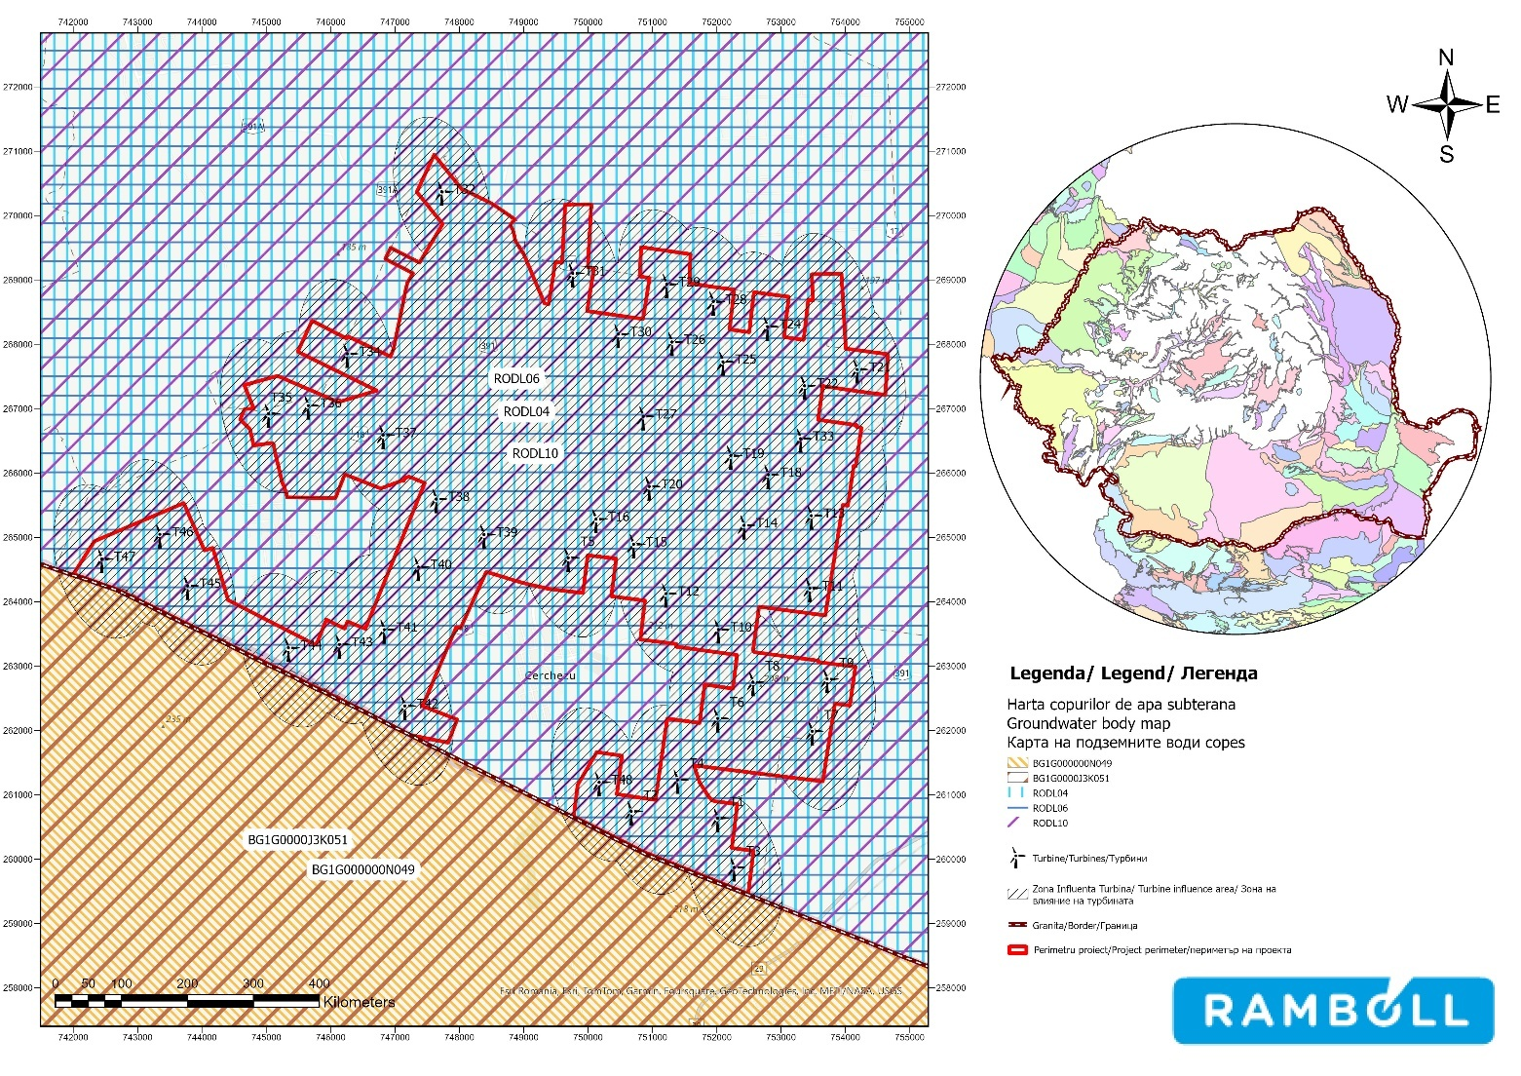

Figure no. 41 Groundwater bodies in the project area

Groundwater body RODL04 – Cobadin - Mangalia (transboundary water body)

The deep groundwater body is accumulated in oolitic and lumachelic Sarmatian (Kersonian) limestone deposits located in the southeastern tip of Dobrogea. The Sarmatian limestone deposits form a 10-150 m thick slab sloping slightly towards the east, which contains free-flowing water that is the main source of supply for the coast south of Eforie Nord.
At the base of the Sarmatian limestones there is a package of Senonian chalk representing the impermeable bed
of the aquifer.

At the top, the Sarmatian aquifer complex is generally covered by permeable Pleistocene loess deposits (middle and upper), but locally there are also impermeable clay layers from the lower Pleistocene.
The majority of the groundwater body (85%) is covered by arable land.

Groundwater body RODL06 - Valaha Platform (transboundary water body)

This deep underground water body has a large extent, partially covering the Wallachian Platform, and is described below in two areas, which present different degrees of knowledge and exploitation:
- Development area in Southern Dobrogea: The deep aquifer – but partially also with a free level (the sector adjacent to the Danube) – is confined to Jurassic and Barremian limestone and dolomite formations, sometimes fractured and karstified, with regional extension (approx. 4500 km2) throughout Southern Dobrogea. The Barremian-Jurassic aquifer, also known as the lower aquifer, is confined to fractured and karstified carbonate formations of Barremian and Upper Jurassic age (Tithonian, Kimmeridgian, Oxfordian). The Jurassic and Barremian formations are characterized by hydraulic communication through an aquitard.
- Giurgiu – Călăraşi area: A series of exploratory drillings were carried out in the area bordering the Danube, between Zimnicea to the west and Feteşti to the east, intercepted a series of carbonate rocks (compact or fissured limestone, whitish or grayish with frequent flint lenses) from the Lower Cretaceous and Jurassic periods, located at depths of 200–400 meters. This deep aquifer is strongly ascending, with the piezometric level located at depths between 4 and 12 m. The flow rates obtained by pumping are between 20 and 60 l/s, with specific flow rates of around 10 to 25 l/s/m. In the Giurgiu area, beneath the gravel and boulders of the low Danube terrace, at depths of between 15 and 25 m, there are a series of deposits consisting of gray, white, or greenish marl and sandstone, attributed to the Upper Cretaceous (Turonian-Senonian).
The RODL06 groundwater body is covered by agricultural land, and if chemical fertilizers are applied to this land, it may have a negative impact on the chemical status of the groundwater body.

Groundwater body RODL10 - Southern Dobrogea (transboundary water body)

The groundwater body is phreatic, porous-permeable or fissured, located in current and sub-current alluvium (attributed to the Holocene), in loess deposits (Upper Pleistocene-Holocene), in loess (Middle Pleistocene-Upper Pleistocene), as well as at the boundary between loess/loessoid/red clays (the latter being attributed to the Lower Pleistocene) and the terminal part of the Sarmatian deposits (Cotu Văii Formation), Upper Badenian (Seimeni Formation) or Lower Cretaceous. Due to its lithological constitution, geomorphological characteristics, and structural-tectonic conditions, the body shows great variations in quantity and quality, both horizontally and vertically.
Most of the surface area of the water body is covered by agricultural land (83%).

The environmental objectives for groundwater bodies, current quantitative and chemical status 18can be found in the following table:
19F

18 Updated Management Plan for the Danube River, Danube Delta, Dobrogea Hydrographic Area, and Coastal Waters, 2022-2027

Table 17 Environmental objectives for groundwater bodies, current quantitative and chemical status
Name of groundwater body | Groundwater body code | Environmental objective |  | Current quantitative status | Current chemical status | Deadline for achieving  the environmental objective
Name of groundwater body | Groundwater body code | Quantitative status  quantitative | Chemical  chemical | Current quantitative status | Current chemical status | Quantitative  quantitative | State  chemical
Cobadin -  Mangalia | RODL04 | B | B | B | S | 2020 | 2027
Platform  Valahă | RODL06 | B | B | B | B | 2020 | 2020
Southern  South | RODL10 | B | B | B | S | 2020 | 2027
Legend: B – good status S – poor status

In the project area, the quantitative status of groundwater bodies is good, while the chemical status is poor for groundwater bodies RODL04 Cobadin-Mangalia and RODL10 Southern Dobrogea, and good for water body RODL06 Valaha Platform.

Air

Study area

The study area for assessing the air environmental factor was defined to include the project site and its area of direct and indirect influence, taking into account the type and scale of the proposed works.
For the air environmental factor, the study area includes the area occupied by the project components, as well as a proximity area around the site where direct and indirect effects could occur (e.g., dust emissions, increased concentrations of pollutants associated with traffic and the operation of equipment involved in the works).
The definition of the study area was based on information available from official national and European databases on air quality and activities with an impact on air, existing specialist documentation, and the local characteristics of the area, ensuring a proportionate and adequate assessment of the potential risks associated with the project.

Brief description of existing sources of pollution in the project area

The main sources of air pollution in the Cerchezu commune are transport activities, construction/demolition activities, diffuse combustion sources, agricultural activities, and industrial activities.
Transport activities in the municipality of Cerchezu include only road traffic, as there are no railway lines in the area. Road traffic mainly takes place on:
- the DJ391 Mangalia – Negru Vodă – Cobadin – Tuzla county road, which crosses the Cerchezu commune and connects it with other localities at the county level;
- the municipal roads DC19 Măgura – Cerchezu, DC18 Viroaga – Măgura, DC17 Chirnogeni-Viroaga, DC16 DN38-Chimogeni-Plopeni-Negrești, DC13 DN38-Pelinu;
- on the internal streets of the commune connecting to the main roads.

Road traffic as a mobile source of pollution has the highest share in atmospheric pollution in the Cerchezu commune area, with transit traffic making the largest contribution.
The main specific pollutants resulting from road transport are: nitrogen oxides (NOx), sulfur dioxide (SO2), carbon oxides (COx), particulate matter (PM10, PM2.5), and volatile organic compounds (VOCs).
According to the latest traffic census conducted in 2022 19 by CESTRIN – the Center for Technical Road Studies and Informatics within CNAIR (the National Road Infrastructure Administration Company), on a 53.817 km section of the DN38 road (closest to the town of Cerchezu), the daily average number of vehicles is around 3,750 per day, of which: 2,740 are light vehicles (cars), 433 are trucks, 218 are vans and special vehicles, 98 are buses/coaches, and 98 are minibuses.
20F
24 trucks and derivatives, 18 tractors, 29 bicycles, and 14 motorcycles.

Areas along the road and at intersections, especially where there is heavy vehicle traffic, are most exposed to pollution. Other exposed areas are centers of general interest—transit points.
The level of atmospheric pollution generated by road transport varies over time and space. The level of pollution depends on the type of vehicle, the age of the vehicle, the volume of traffic, the type of fuel used, and the technical condition of the road and the vehicle. The greatest impact is felt in built-up areas and areas with congested traffic arteries. Concentrations of atmospheric pollutants are higher in areas with traffic arteries flanked by tall buildings (such as apartment blocks) in a compact form, which prevent the dispersion of pollutants into the atmosphere – a situation that is not specific to the municipality of Cerchezu.
Construction/demolition activities in the municipality of Cerchezu can be sources of air pollution through:
- earthmoving activities (topsoil removal, excavation, filling, levelling, loading, unloading, transport), construction materials and construction waste – stationary uncontrolled sources. The specific pollutants produced are: dust;
- vehicles and machinery involved in land development and the transport of materials and equipment necessary for construction works (excavators, compactors, cranes, electric generators) – non-road mobile sources. The main specific pollutants produced are: NOx, SOx, CO, dust.
According to local government data 20, between 2019 and 2023 , there are
21F
the following categories of works:

- Road infrastructure rehabilitation and modernization works;

- Modernization works on agricultural roads in the locality;

- School renovation works;

- Works for the establishment of natural gas distribution systems;

- Works for the development of sports infrastructure;

19https://www.cestrin.ro/assets/pdf/recensamant%202022.pdf
20https://www.graiuldobrogei.ro/page/1/?s=cerchezu

- Works for the construction of a kindergarten.

The impact generated by construction/demolition activities is usually temporary and local. The most affected areas are those in the vicinity of the work fronts and site organizations.

Diffuse sources of combustion

Residential and institutional heating represented by individual heating sources (boilers, stoves) that use solid fuels (wood) and are not equipped with appropriate chimneys to ensure the dispersion of pollutants into the air can be a source of air pollution.
To these can be added the unauthorized outdoor burning of household waste, used tires, plastics, and street waste within urban areas, the failure to maintain public sanitation, and the improper storage of household waste. These sources cumulatively constitute a global source of permanent pollution with particulate matter, various gaseous pollutants, unpleasant odors, which are particularly noticeable in unfavorable weather conditions (fog, atmospheric calm, thermal inversion).
The main pollutants from these sources are: CO, SO2, NO2, O3, PM10, PM 2.5, NO2.

Agriculture

Emissions to the atmosphere associated with the agricultural sector consist mainly of NH3, dust, NOx, and CH4 from
animal husbandry (manure management, enteric fermentation) and crop cultivation.

At the level of Constanța County, according to the 2022 Annual Report on the State of the Environment, no information is available on the quantification of agriculture's contribution to atmospheric emissions.
The commune of Cerchezu is part of the South-West Dobrogea Local Action Group (LAG) along with nine other communes. Agriculture 21is one of the main areas of activity in the LAG area, with cereal and industrial crops, fruit and vegetables, vines, beekeeping, and animal husbandry being characteristic. Agricultural activities are carried out either a) on large farms, consisting of large properties, but also of small plots of land leased together, and consisting of cereal cultivation, or b) at a semi-subsistence and subsistence level, on relatively small areas of up to approximately 10 ha. At this smaller scale, agricultural production can be more varied, including vegetables in greenhouses, seedling production for the local market and for own consumption.
22F
The lack of irrigation infrastructure limits production to crops that can cope with the low rainfall in the area.
No data on agricultural activities were available for the municipality of Cerchezu.

Industrial activities

According to data from the Local Development Strategy 2014-2020 22 , amended in 2023, many economic enterprises in the area face a lack of capital for investment. As a result, innovations – often associated with the risk of loss – are slow to catch on, whether they involve new cultivation technologies or methods of processing, promoting, or selling products.
23F

21https://galdobrogeasv.ro/modificari-ale-strategiei-de-dezvoltare-locala/
22https://galdobrogeasv.ro/modificari-ale-strategiei-de-dezvoltare-locala/

In the municipality of Cerchezu, registered companies operate in the field of cereal cultivation (excluding rice), legumes, and oilseed crops, retail trade in non-specialized stores, predominantly selling food, beverages, and tobacco, tourism, and sea fishing, which are not considered to cause significant air pollution.
Currently, there are no industrial facilities in the municipality of Cerchezu that are subject to the Industrial Emissions Directive
Industrial Emissions Directive (IED).

Current state of air quality

Air quality monitoring in Constanța County is carried out using the automatic air quality monitoring system included in the RNMCA, consisting of eight stations located in accordance with the specific criteria currently set out in Law 104/2011 on air quality. The structure of this network is as follows:
- CT-1 station - traffic station, located in Constanța, Casa de cultură, the location being representative in terms of traffic (maximum radius of representativeness 100m); the pollutants monitored are SO2, NO2, NOx, PM10 Pb, C6H6, CO, Ni, Cd;
- CT-2 station – urban background station located in the Fantazio – Parc Primărie area, less exposed to traffic and industry; monitored pollutants: SO2, NO2, NOx, CO, PM2.5, O3, benzene, toluene, o,m,pxylene, ethylbenzene, meteorological parameters;
- CT-3 station – suburban background station, located in a suburban environment, in the Năvodari Tabăra Victoria urban area (representative area 25-150 km), for assessing average pollution levels within a large urban area, due to phenomena occurring within the city, with possible significant contributions from transport phenomena originating outside the city; the pollutants monitored are SO2, NO2, NOx, CO, O3, Ni, Cd, benzene, toluene, o,m,pxylene, ethylbenzene, meteorological parameters;
- CT-4 station – traffic station, located in Mangalia, in an urban environment (representative area 10-100 km); monitored pollutants are SO2, NO2, NOx, CO, PM10 Pb, C6H6;
- CT-5 station – industrial station, located in Constanța, in an urban environment on Prelungirea Liliacului Street (representative area 1 km); monitored pollutants are SO2, NO2, NOx, PM10 Pb, C6H6, CO, O3, Ni, Cd, meteorological parameters;
- CT-6 station – industrial station, located in the town of Năvodari, in an urban environment, in the area of the Lazăr Edeleanu high school (representative area 1 km); monitored pollutants are SO2, NO2, NOx, CO, PM10, O3, benzene, meteorological parameters;
- CT-7 station – industrial station, located in an urban environment in the area of the Medgidia town hall (representative area 1 km); monitored pollutants are SO2, NO2, NOx, PM10 Pb, CO, O3, meteorological parameters;
- CT-8 station - urban background station, located in an urban environment in the municipality of Mangalia, Crișanei Street (representative area 1 km); the pollutants monitored are NO2, NOx, PM10, meteorological parameters;

The municipality of Cerchezu is not within the range of these monitoring stations, and there are no real-time air quality measurement stations (road transport) planned for the area.
At the time of writing this report, no information was available on air quality measurements
in the municipality of Cerchezu.

In order to establish the current air quality situation in the proposed project area, an analysis was carried out of the air quality maps for the indicators PM10, PM2.5, NO2, and O3, available at European level.
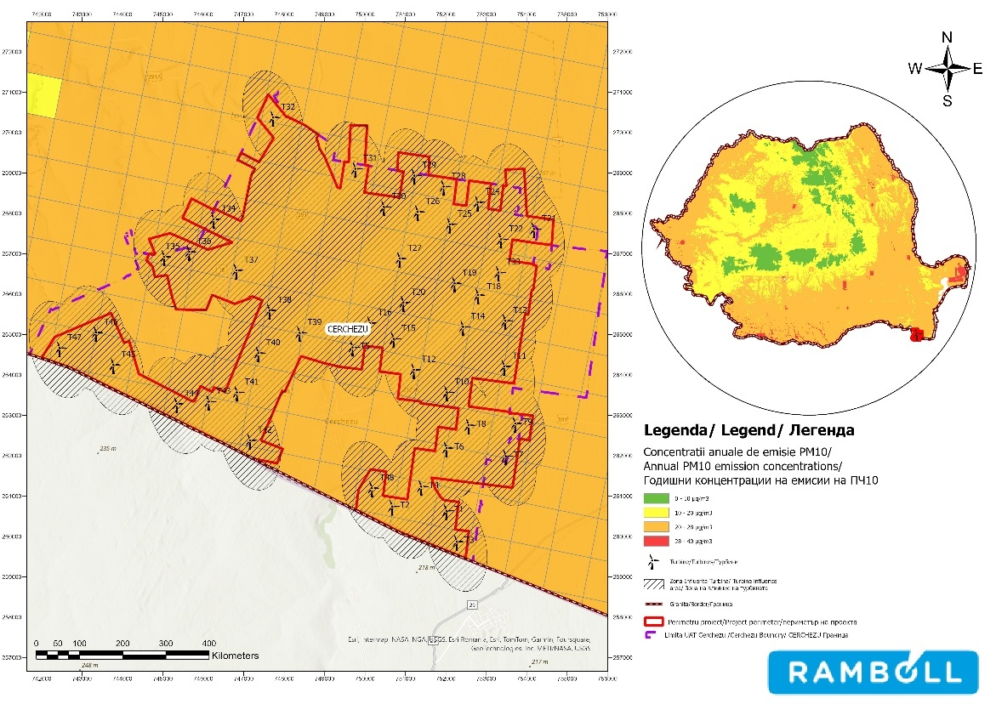
Source: processed by the European Environment Agency
Figure 42 Annual average for the PM10 indicator

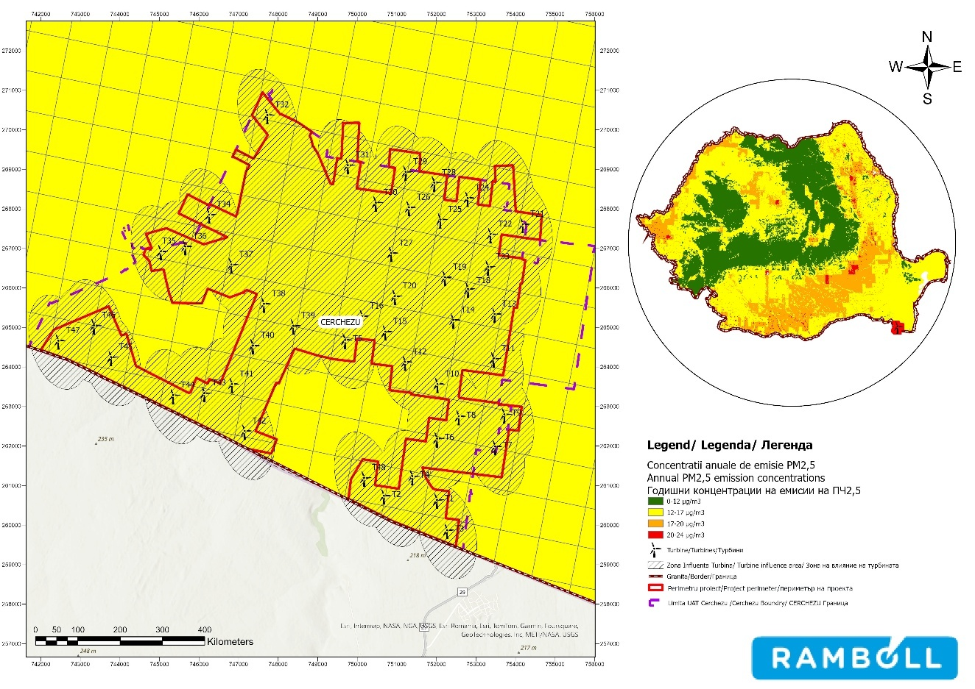
Source: processed data from the European Environment Agency
Figure no. 43 Annual average for the PM2.5 indicator
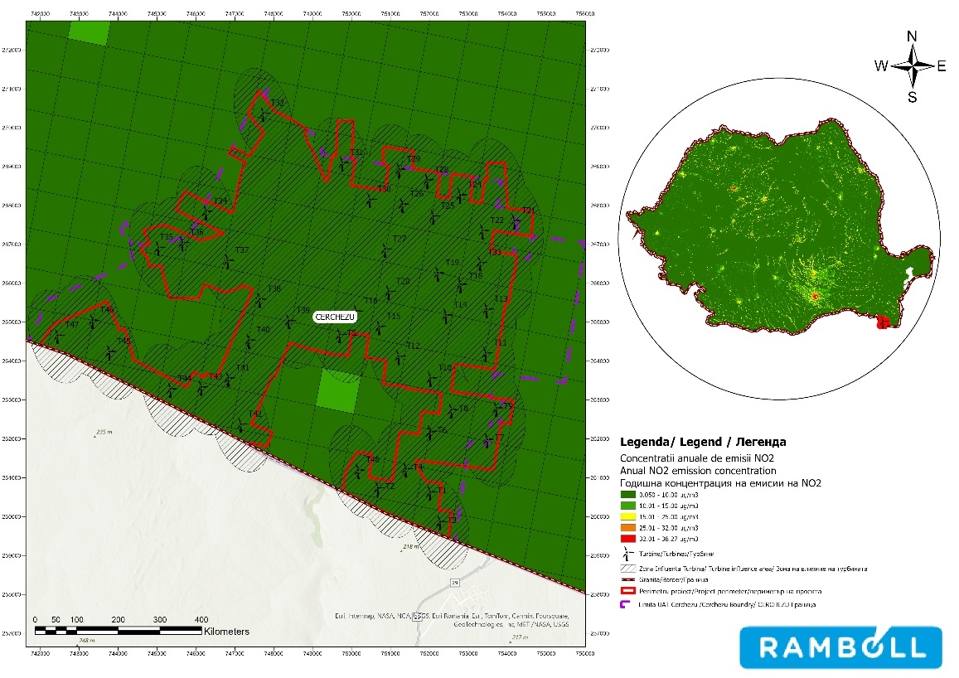
Source: processed data from the European Environment Agency
Figure 44 Annual average for NO2

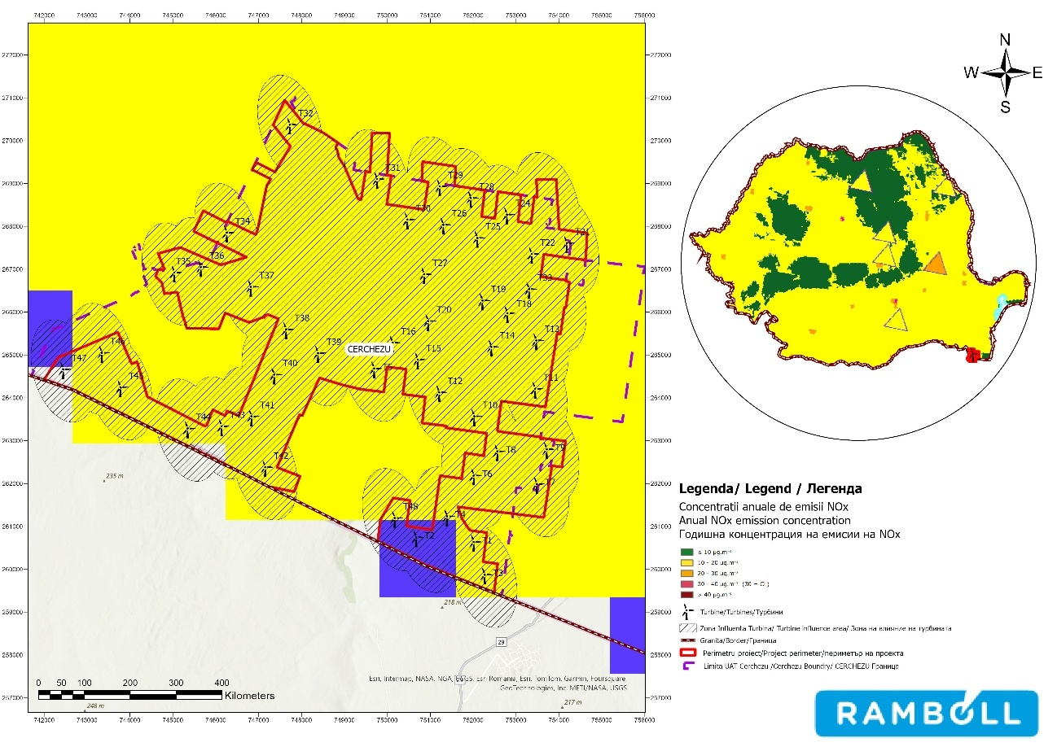
Source: processed data from the European Environment Agency
Figure no. 45 Annual average for the NOx indicator

As can be seen in the maps above, no exceedances of the limit values set by the legislation in force (Law No. 104/2011 on ambient air quality) were found in the project implementation area.
In the Cerchezu commune area, taking into account the activities currently carried out, air quality can be considered generally good, as it is an open rural area uncluttered by urban construction and without intense industrial activity.

Noise

Study area

The study area for noise assessment was defined to include the project site
and its area of direct and indirect influence, taking into account the type and scale of the proposed works.

For noise, the study area includes the area occupied by the project components, as well as a proximity area around the site where direct effects could occur (e.g., noise associated with construction/decommissioning works, or noise associated with the operation of the wind farm).
The study area was defined based on information available from official databases, existing technical documentation, and local characteristics of the area, ensuring a proportional and adequate assessment of the potential risks associated with the project.

Brief description of existing sources of pollution in the project area

The main sources of noise in the Cerchezu commune are road traffic on county road DJ391 and communal roads DC13, DC16, DC17, DC18, and DC19, as well as construction/demolition activities involving the operation of machinery used in land development/assembly/concrete pouring works and vehicles transporting materials.
Noise pollution causes a whole range of effects on the human body, from mild auditory fatigue to severe neurotic conditions and even trauma to the auditory organ. Higher-frequency sounds are more dangerous than lower-frequency ones.
The legal framework for avoiding, preventing, or reducing harmful effects, including discomfort, caused by the exposure of the population to environmental noise is represented by Law No. 121/2019 on the assessment and management of environmental noise, with subsequent amendments and additions, which provides for noise mapping to determine exposure to environmental noise and the adoption of action plans to prevent and reduce environmental noise, where appropriate, and for maintaining ambient noise levels below the limit values where these are not exceeded.
In Constanța County, noise mapping and the development of strategic noise maps and action plans were carried out between 2016 and 2024 as follows:
- The Constanța City Hall drew up strategic noise maps for the municipality of Constanța in 2016, which were redrawn in 2018 for the municipality of Constanța, the Palazu Mare neighborhood, and the Mamaia resort, and updated in 2024 for the municipality of Constanța.
- The National Company "Administrația Porturilor Maritime" S.A. Constanța drew up strategic noise maps for the Port of Constanța in 2019. The strategic noise maps were approved by Order of the Minister of Transport No. 1245/05.09.2019. The noise action plan was approved by Order of the Minister of Transport No. 1246/05.09.2019;
- The Ministry of Transport – National Railway Company "CFR" S.A., as administrator of the Palas – Saligny – 49 km railway section, drew up the strategic noise maps for 2016;
- In 2017, the National Road Infrastructure Administration Company drew up strategic noise maps for main roads with traffic exceeding 6,000,000 vehicles per year: motorways, national roads, and bypasses.
The coverage area of the strategic noise maps drawn up at county level does not include the area of the commune of
Cerchezu.

Considering the above and taking into account that the Cerchezu commune is an open rural area, uncluttered by urban buildings, without industrial activities and without heavy traffic on internal roads and roads connecting it to other localities, it can be concluded that the noise level in the commune is low.

Cultural conditions and cultural heritage

Study area

The study area for the assessment of cultural heritage was defined to include the project site and its area of direct and indirect influence, taking into account the type and scale of the proposed works, as well as potential interactions with elements of tangible and intangible cultural heritage.
For tangible cultural heritage, the study area includes the area occupied by permanent and temporary works, as well as a proximity area around the site where indirect effects (e.g., vibrations, landscape changes, access) could occur. For intangible cultural heritage, the analysis considered the entire local community in the commune of Cerchezu, given that these elements are linked to social practices, traditions, and community life.
The study area was defined based on information available from official cultural heritage databases, existing specialist documentation, and local characteristics of the territory, ensuring a proportional and adequate assessment of the potential risks associated with the project.

Description of the project in relation to cultural heritage elements

According to the 2015 List of Historical Monuments in Constanța County, approved by Order No. 2361/2010, the following site of historical interest has been identified in the proposed project area.
Table 18 Sites of interest in the project location area
LMI code | Location | Name | Date
CT-IV-m-B-02967 | VIROAGA village; commune  CERCHEZU | Obelisk in memory of the heroes of  World War I | 1936

Also, in the project area, there are precisely located archaeological sites that are not included in the List of Historical Monuments, but have been identified with the help of the National Archaeological Repertory.
of Historical Monuments, but have been identified with the help of the National Archaeological Repertory. These are:

  - Villa rustica in Viroaga - Viroaga village, CERCHEZU commune
  - The Tumulus at Căscioarele - Movila Bacu - village of Căscioarele, commune of CERCHEZU
  - Legionary fort at Căscioarele - Căscioarele village, CERCHEZU commune

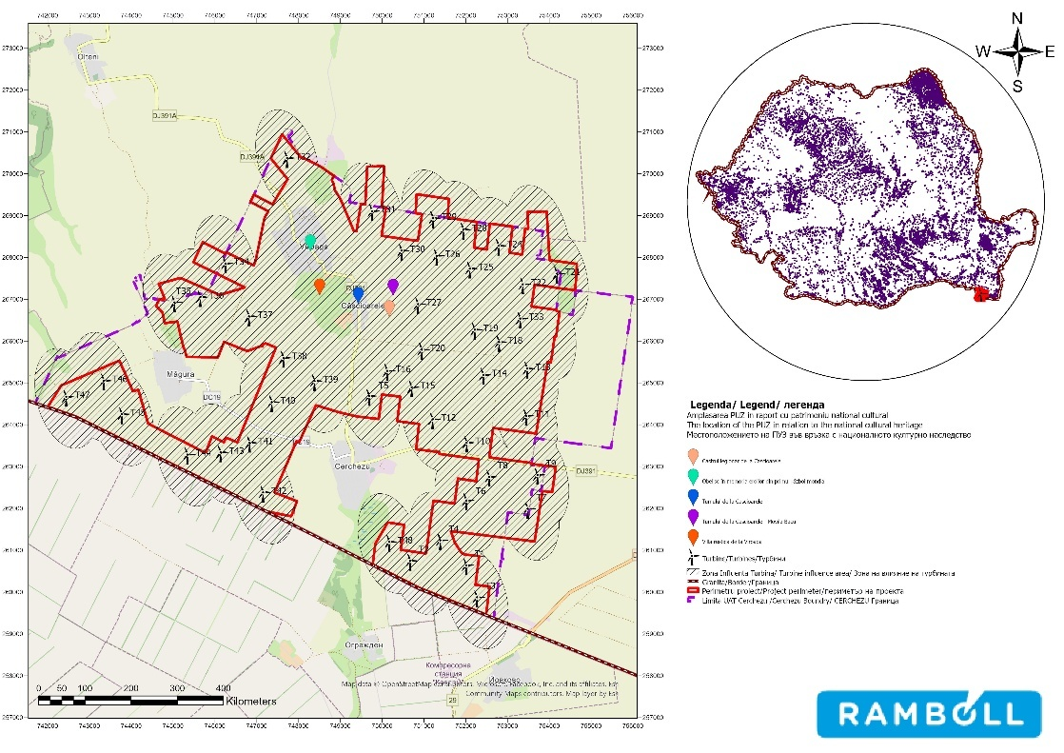

Figure no. 46 Map showing the location of the project in relation to sites of historical interest (Repertoriul National Archaeological Museum (cIMeC) and National Heritage Institute - eGISpat Romania)

Interventions on historical monuments are regulated by the provisions of Article 23 of Law No. 422/2001, republished, on the protection of historical monuments. In the protection zone of historical monuments (200.00 m within the built-up area and 500.00 m outside the built-up area), new constructions or interventions on existing constructions will only be authorized with the approval of the Ministry of Culture and National Identity, respectively the Constanța County Directorate for Culture and National Heritage.
The legal regime governing historic monuments is regulated by the provisions of Law No. 422/2001, published in the Official Gazette of Romania No. 938 of November 20, 2006, republished pursuant to Article V of Law No. 259/2006 amending and supplementing Law No. 422/2001 on the protection of historic monuments, published in the Official Gazette of Romania No. 100 of May 10, 2007. V of Law No. 259/2006 amending and supplementing Law No. 422/2001 on the protection of historical monuments, published in the Official Gazette of Romania, Part I, No. 573 of July 3, 2006, with the texts being renumbered.

Intangible cultural heritage

The intangible cultural heritage of the commune of Cerchezu is part of the broader context of the cultural heritage specific to Southern Dobrogea, a region characterized by ethnic and cultural diversity that has developed over time. Elements of intangible heritage are mainly associated with local traditions, customs, social practices, oral expressions, and traditional crafts, transmitted mainly informally within the community.
In the commune of Cerchezu, the intangible cultural heritage is linked to traditional rural life, agricultural and pastoral practices, as well as seasonal customs and events (religious holidays, community events, rituals associated with the agricultural cycle). There are also elements of local culinary tradition and expressions of oral culture (stories, customs, community practices) characteristic of communities in southern Dobrogea.
No elements of intangible cultural heritage listed in the National Register of Intangible Cultural Heritage or on UNESCO lists have been identified in the commune of Cerchezu, and existing practices are predominantly of local importance, being maintained through the participation of the community and older generations.

Landscape

Study area

The study area for assessing the impact on the landscape was defined to cover the project site and its area of visual influence, taking into account the topographical characteristics of the land, the height and typology of the project elements, as well as the potential perception from sensitive points in the surrounding area.
The study area includes:

- the area of direct influence, corresponding to the location of permanent and temporary works (turbines, access roads, platforms, electrical substation, power lines);
- extended visual impact area, defined on the basis of visibility analyses (Zone of Theoretical Visibility – ZTV), which may include territories located at a greater distance, from where the elements of the project can be visually perceived, depending on the relief, vegetation cover, and existing structures.
Within this area, sensitive landscape receptors such as human settlements, communication routes, recreational areas, and other points of public interest were taken into account, as well as the characteristics of the existing landscape, including its structure, coherence, and scenic value.
The study area was defined in a manner proportional to the scale of the project and its potential visual impact, ensuring an adequate assessment of both direct and cumulative effects on the landscape, in line with good practice in landscape impact assessment and visual perception.

Project location and landscape types

The study area is predominantly agricultural, with patches of natural grassland used for grazing domestic animals.
The landscape is typical of Dobrogea, with limestone deposits of the canara type, where rare species typical of Dobrogea, calcifers, can still be found. The pasture is also bordered and covered on one side by an acacia plantation (Robinia pseudoacacia, an invasive alien species).

The distribution of vegetation is heterogeneous, alternating areas with abundant vegetation in good condition with areas with sparse vegetation, reduced in size and coverage and affected by the presence of ruderal and some segetal species.
The existing European LANMAP3 database was used to identify the landscape types in the site area. Landscape types are determined based on criteria that take into account the following elements:
- The climate type of the area;
- The topography of the land;
- Parent material of the rock;
- Land use.

Our country has a variety of landscapes, with approximately 45 landscapes featuring mountains with gorges and canyons, hills and plateaus, plains and river plains, rivers and lakes.
According to the regional differentiation of landscapes in Bulgaria (Velchev, Todorov, Penin, 2003), the territory of Bulgaria falls within three major landscape provinces of Eurasia: Alpine, East Mediterranean, and Pontic.
The following figure shows the spatial distribution of the types of landscape existing in the analyzed area.
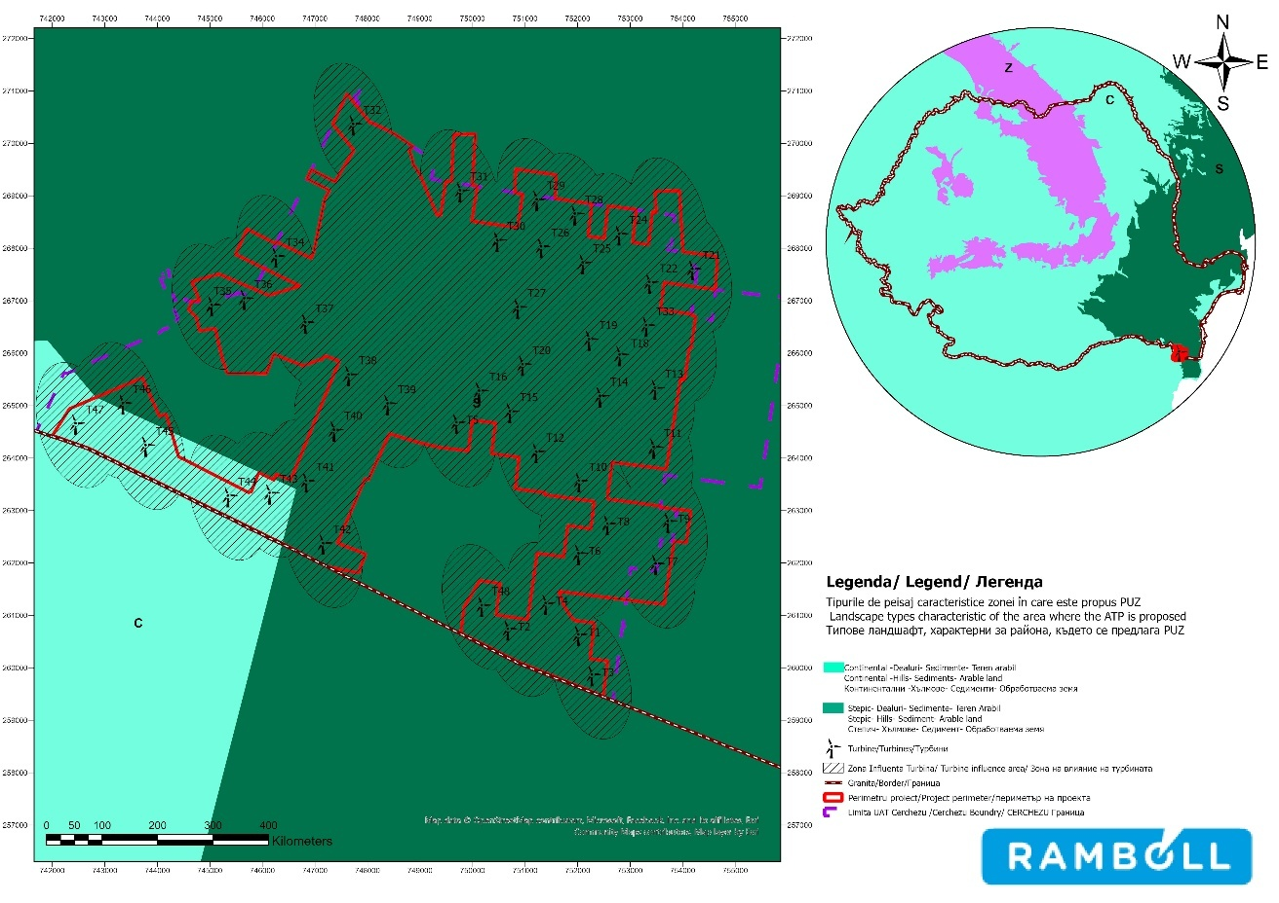

Figure no. 47 Landscape types characteristic of the project location

We can see from the figure above that the general appearance of the area is dominated by the following landscape types: continental-hills-sediments-arable land and steppe-hills-sediments-arable land.

In conclusion, it can be observed that the Cerchezu commune is dominated by a steppe-type landscape with a predominantly hilly relief and arable areas. No areas of high sensitivity in terms of landscape were identified in the entire project area.
The areas of moderate and high sensitivity identified in the study area are the natural areas associated with the protected natural areas located in the vicinity of the project.

Landscape fragmentation

Landscape fragmentation is assessed using the "effective mesh size" indicator (meff, km2), which suggests the probability that two random points in an area will be connected without encountering obstacles ("Landscape fragmentation in Europe"). This indicator is used in some European Union countries and Switzerland to assess the state of the environment, more specifically to understand ecological processes at the landscape level. The following figure shows the variability of landscape fragmentation in the municipality of Cerchezu, using data from the EEA. The lower the "effective mesh size" value, the more fragmented the landscape is and the lower its connectivity.
The indicator underlying the map takes into account "average and major anthropogenic fragmentation" (roads, railways, built-up areas, etc.) and excludes natural barriers. The figure below shows that the highest values of landscape fragmentation are found in the north-west of the site, in the area of turbine T32. Based on the landscape fragmentation analysis, we can conclude that the project implementation area (Cerchezu commune) is associated with a very low fragmentation value.
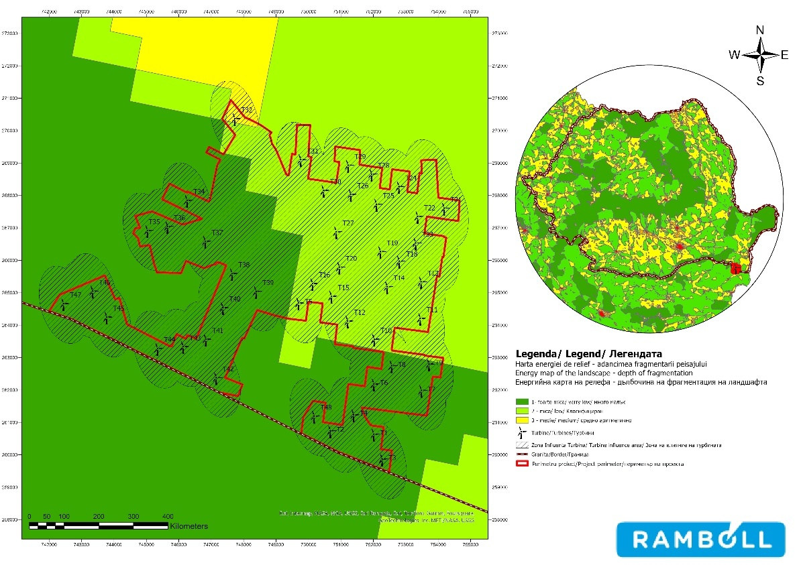

Source: European Environment Agency²³
Figure 48 Degree of landscape fragmentation in the project implementation area

23 Landscape fragmentation Effective Mesh Density time-series: major and medium anthropogenic fragmenting elements (FGA2-S) — European Environment Agency (europa.eu)

Topography

The territory of Cerchezu commune is located in the southwestern part of Constanța County, within the geomorphological unit of the Southern Dobrogea Plateau. The relief is characterized by plains and a slightly fragmented plateau, with low altitudes and small topographical variations, specific to the southern part of Dobrogea.
Altitudes generally range from 50 to 120 m, and slopes are gentle or very slight, with no major discontinuities in relief. The lack of steep slopes and large differences in elevation gives the area a stable topography, favorable for the location of linear and point infrastructures.
The relief is predominantly gently undulating, shaped by slow geomorphological processes, and the valley network is poorly developed, temporary in nature, and mainly active following heavy rainfall. There are no mountainous relief features, pronounced hills, or areas with potentially unstable geomorphology.
From a topographical point of view, the area does not present significant constraints for the development of infrastructure projects, being suitable for the implementation of wind farms.

Brief description of the likely evolution of the state of the environment if
the project is not implemented

The following table provides a brief description of the likely evolution of the state of the environment if the project is not implemented, to the extent that natural changes from the baseline scenario can be reasonably assessed based on available environmental information and scientific knowledge. The most important aspects relevant to the project under review have been retained in this section.

Table 19 Brief description of the likely evolution of the state of the environment if the project is not implemented
Component | Main characteristics of the current state of the environment | Likely evolution of the environmental situation if the project is not  is implemented | Overall assessment of the likely evolution of  environmental status
Population and human health | According to the latest census conducted in 2021, the total population of Cerchezu commune, as of July 1, was 1,360 people, of whom 645 were women and 711 were men.  The population density of Cerchezu commune was 16.25 ^{inhabitants/km²}in 2021, lower than the county density (108.^{6 inhabitants/km²}), regional density (71.2 inhabitants/km²),and national density (84.4 inhabitants/km²).  The population of Cerchezu commune shows a downward trend between 2011 and 2025, due to both natural movement (births and deaths) and migration. Compared to 2011, the population of Cerchezu commune decreased by 17% in 2025.  At the level of the Cerchezu commune, between 2010 and 2023, the number of unemployed people showed an upward trend. In 2023, the number of unemployed people reached 44, which is 54% higher than in 2013.  Cerchezu is not among the localities designated as socio-economically marginalized areas in urban and rural areas in  Romania. | As a general conclusion, the current situation in terms of population, human health, and economy is specific to rural communities in Romania. Without opportunities for socio-economic development, the future condition of the population in the studied area would worsen. If the project is not implemented, the adult population will seek other job opportunities in more developed areas. | Deterioration
Biodiversity | If the project is not implemented, the state of biodiversity in the site area would remain broadly similar to the current situation, with the predominantly agricultural/anthropized character of the land being maintained. There would be no additional pressures associated with the construction and operation of the turbines (localized land occupation, noise/traffic disturbance, collision risk and barotrauma for birds and bats). Biodiversity dynamics would continue to be determined mainly by existing pressures (agricultural practices, local traffic, existing fragmentation), without  significant changes induced by the project. | Maintenance (with possible occasional improvement for flying fauna by eliminating specific risks associated with turbine operation, but without relevant structural changes to habitats, assuming current agricultural pressures remain unchanged). | Maintenance
Soil/subsoil | The main soil types in the analyzed area are chernozems, fertile, black soils characteristic of agricultural land in this area, rich in humus and nutrients, which makes them suitable for agriculture, especially for cereal crops.  According to available public sources, there are no historically contaminated sites or potentially contaminated sites in the administrative territory of Cerchezu commune.  The land on which the investments are to be developed in the extra-urban area of the commune of Cerchezu falls within quality class III (on a scale from I to V), i.e., medium-fertile soil.  moderately affected by degradation. | Not doing the project won't change the quality and structure of the soil, and we expect the land use to stay the same, focused on farming, which is the main economic activity in rural communities in the study area. | Maintenance
Surface water | Given that the project area is located more than 28 km away from the water bodies for which their quality status is defined  and the project works involve undercrossing | If the project is not implemented, the quality of surface water bodies will not change, remaining at the current level. | Maintenance

Component | Main characteristics of the current state of the environment | Probable evolution of the state of the environment if the project is not  is implemented | Overall assessment of the likely evolution of the environmental status
 | of the Cerchezu and Măgura watercourses, which are unregistered and for which no data on their quality is available, a cautious approach was taken and they were considered to be in poor ecological and chemical condition
Groundwater | In the project area, the quantitative status of groundwater bodies is good, and the chemical status is poor for the RODL04 Cobadin-Mangalia and RODL10 South Dobrogea groundwater bodies, and good for the RODL06 Valaha Platform groundwater body. | Given that the environmental objectives for 2027 for groundwater bodies in the project area are good chemical status, the likely evolution of the quality of these bodies in the area is improvement. | Improvement
Air | In the Cerchezu commune area, taking into account the activities currently carried out, air quality can be considered generally good, as it is an open rural area uncluttered by urban construction and without intense industrial activity. | In the absence of changes in existing sources of pollution or the emergence of additional sources of pollution, the non-implementation of the project will not directly lead to a deterioration in air quality in the site area.  Given the project's objective of creating a renewable energy source to replace conventional sources of electricity generation, it can be concluded that the non-implementation of the project  will indirectly lead to a deterioration in air quality. | Worsening
Cultural conditions and cultural heritage | In the area of the proposed project, the Obelisk in memory of the heroes of World War I, belonging to the 2015 List of Historical Monuments in Constanța County, approved by Order No. 2361/2010, and archaeological sites identified with the help of the National Archaeological Repertory, have been identified: Villa rustica in Viroaga - Viroaga village, CERCHEZU commune, the Tumulus at Căscioarele - Movila Bacu - Căscioarele village, CERCHEZU commune, the Legionary Camp at  Căscioarele - village of Căscioarele, commune of CERCHEZU. | The non-implementation of the project is not expected to cause any changes to the location or content of the archaeological sites or heritage objects in the project area. | Maintenance
Landscape | The study area is predominantly agricultural, with existing anthropogenic uses (agricultural land, pastures, agricultural and communal roads), without historical monuments, archaeological sites, or sites of particular landscape value. | If the project is not implemented, there will be no changes in terms of landscape. | Maintenance

Probable evolution compared to the existing situation:

Class | Description of changes
Improvement | The trend is positive
Maintenance | The trend is negative
Worsening | No major changes are expected compared to the current situation

Transformation, electrical connection networks, construction and modernization of communication and access routes

DESCRIPTION OF ENVIRONMENTAL FACTORS LIKELY TO BE SIGNIFICANTLY AFFECTED BY THE PROJECT
This chapter will assess the potential effects that investments made through this project may have on the environment, regardless of the likelihood of significant negative effects occurring.
The following environmental factors were assessed: the socio-economic environment and population health, biodiversity, soil/subsoil, water, air, noise, climate change, cultural heritage, landscape, and resource use.
In order to identify the environmental factors likely to be affected by the project, the following were analysed:
- all activities necessary for the implementation of the project;
- all components of the receiving environment, i.e., the environment that will bear the effects of the project;
- the current state of the receiving environmental factor (quality of the environmental factor);
- all possible interactions between activities and environmental components.
Significant impairment means a permanent change in the quality of the environmental factor or temporary (reversible) changes with medium- and long-term effects on the quality of the environmental factor, for example (5-10 years). Significant impairment of an environmental factor is determined by the occurrence of a number of situations in which the magnitude of the environmental impact resulting from the implementation of the measures proposed by this project falls within the category of high/very high negative impact, and the sensitivity of the environmental component undergoing change as a result of the project falls within the category of high/very high.
Significant impact consequences are understood to mean all direct, indirect, isolated, or synergistic effects in the medium and long term as a result of the effect.
Both during the execution/decommissioning period and during the project's operation, no activities involving the use of chemicals that could potentially cause major accidents will be carried out.
The table below presents theoretical situations in which the environmental factor could be significantly affected and is not based on the results of the impact assessment presented in Chapter 7. These situations are also valid for the demobilization/decommissioning stage.

Table 20 Environmental factors potentially affected by the project
Environmental factor | Cause of such situations | Situations that could have led or could lead to  significant negative impacts | The area where they have occurred or could occur, depending on the location of the works
Social and economic environment (including public health) | Location of construction sites in the vicinity of residential areas. Use of public roads crossing localities.  Proximity of the work front to inhabited areas  Malfunctions of machinery and/or means of transport.  Failure to ensure regular technical inspection of machinery/means of transport.  Use of outdated machinery/means of transport | Long-term damage to the environment with effects on public health (increased concentrations of pollutants in the air, water, soil, noise, intermittent shading above the maximum limits permitted by current legislation, increased noise and vibration levels). | In the vicinity of the work front and site organization
Social and economic environment (including public health) | Non-compliance with the technical design. | Affection on natural resources (in the sense of a considerable reduction in quantity and deterioration in quality) on on which local communities depend. | Natural resources were procured from authorized local suppliers.  The construction of the wind farm in the Cerchezu area does not involve significant consumption of natural resources,  as the communities in the project area are not dependent on these resources and there are alternatives in the area
Biodiversity | Failure to comply with the technical design and the location established for the works.  Removal of fertile soil and vegetation – stripping works | Uncontrolled expansion of the footprint of the works, additional land occupation and habitat loss/alteration beyond estimates; local fragmentation and degradation of microhabitats through stripping/excavation outside the approved corridor. | In the direct footprint of the works: turbine platforms/foundations, stations, new/modernized roads, site organization, storage and borrow/fill areas (if any).
Biodiversity | Construction site traffic during the execution/decommissioning period.  Traffic during the period of maintenance or repair work. | Disturbance through noise/vibrations and presence; accidental mortality (crushing/collisions) for amphibians, reptiles, and small mammals; resuspension of dust that may reduce the quality of local habitats.  Recurring local disturbance due to traffic and maintenance activities; increased likelihood of accidental mortality of terrestrial fauna on roads; increased disturbance during biologically sensitive periods (nesting, migration, nocturnal activity). | On access roads (existing/modernized) and internal transport routes, especially at entrances/exits, intersections, and areas with reduced visibility.  Internal roads and turbine/station areas where interventions are carried out; occasionally in equipment parking/storage areas.
Biodiversity | Changes in air, water, and soil quality | Powder deposits on vegetation and soil; accidental pollution (fuels/oils/fluids) affecting soil and microhabitats; temporary changes in local conditions  for invertebrates and spontaneous vegetation | In the vicinity of work fronts and equipment handling/maintenance areas; in supply and storage areas and on work platforms, as well as along heavily used roads.
Biodiversity | Disruption of wildlife activity due to human presence, air emissions, and noise resulting from construction work and maintenance and repair interventions during the operational period  Changes to the shelter or feeding places of wildlife species whose habitats are located in the area where the works are carried out | Disturbance and avoidance (reduction in habitat use), temporary displacement of wildlife; possible functional loss of habitat; during operation, for birds/bats: risk of collision/barotrauma and avoidance/barrier effect in relation to the turbine area. | Around the work fronts (construction) and, during operation, in the vicinity of the turbines (rotor area) and associated infrastructure; potentially also in the area of influence towards neighboring Natura 2000 areas (including cross-border).
Biodiversity | Voluntary or unintentional introduction of species  Soil removal, excavation, and filling works - quantities of soil that may contain seeds or tubers of invasive or alien plant species. They may also be introduced through the machinery and vehicles used to carry out the works | Introduction/spread of opportunistic/invasive species through excavated soil, transport of materials and machinery; competition with local flora and changes in the structure of plant communities in the affected areas. | Especially on newly constructed platforms and roads, in areas of temporary storage of soil/materials, and along transport routes, where seeds/plant fragments can be dispersed.
Soil/subsoil | Failure to comply with the technical design/human errors that could have led to the occupation of additional areas | Permanent occupation of land areas | The construction of the energy park will lead to the permanent occupation of land areas:  - 58.79 ha for the location of wind turbines and ancillary structures and transformer stations  - 49.06 ha permanently occupied by service roads and paved roads.
Soil/subsoil | Malfunctions of machinery and/or means of transport.  Failure to ensure periodic technical inspection of machinery/means of transport.  Use of outdated machinery/means of transport.  Improper management of waste generated during the execution period  Improper management of wastewater from the construction site | Soil contamination | In the wind farm site, in the work front area.  In the area proposed for the organization of the construction site.
Soil/subsoil | Failure to comply with the technical design or measures to prevent  impact  Soil isolation – creation of storage platforms site organization  Compaction works  Accidental leaks from machinery/vehicles used to carry out  the works. | Physical degradation and loss of soil productivity in the work front/site organization area | In the work front and site organization areas during the construction/decommissioning period.
Use of resources | Non-compliance with the technical design/human error | High resource consumption and reduction of the support capacity of the areas from which the materials necessary for the implementation of these measures were supplied. | No areas were identified where communities are dependent on a specific natural resource necessary for the implementation of the measures proposed by the project.  Resources used:  - soil, stone, sand, gravel for filling and foundations;  - wood (lumber) for formwork;  - non-renewable natural resources - fuels (derived from petroleum) used to operate machinery and  vehicles that transported the necessary materials.

Environmental factor | Cause of such situations | Situations that could have led or could lead to  significant negative impacts | The area where they occurred or could occur – depending on the location of the works
Climate  climate | Failure to take climate change adaptation into account at the design stage | Effects of climate change on wind farms that may lead to their total or partial deterioration | The town of Cerchezu is not explicitly listed in Annex 3 of Law No. 575 of October 22, 2001, on the approval of the National Spatial Planning Plan - Section V Natural Risk Areas, but localities in the southeast (including Constanța County) are generally classified as areas with seismic intensity of approximately VII MSK for general zoning and design purposes.
Climate  climate | Machinery and/or transport equipment malfunctions  Failure to ensure regular technical inspection of machinery/means of transport  Use of outdated machinery/means of transport. | Generation of high levels of greenhouse gas emissions, failing to meet the Europe 2020 Strategy target of reducing greenhouse gas emissions by 20% | In the work front and site organization area
Water | Non-compliance with the technical design/human error.  Accidental fuel leaks from the machinery used to carry out the work and the penetration of pollutants into the water table or their direct discharge into surface waters  Storage of materials/waste  Direct discharge of domestic wastewater from the site organization without pre-treatment. | Deterioration of the condition of surface watercourses and groundwater bodies in the project area, which could lead to the environmental objectives set for them not being achieved | Surface and underground watercourses in the project area, areas where construction work was carried out near watercourses:  The water bodies identified in the Cerchezu wind farm site area are located at distances greater than 28 km, so there is no impact on them. The project works require the Cerchez (2) and Măgura (2) watercourses to be crossed, but this will be done using horizontal drilling technology at a depth of 1 m between the upper generator of the protective pipe and the watercourse bed.
Water | Failure to comply with the technical design/human error.  Accidental fuel leaks from the machinery used to carry out the work and their direct discharge into surface water | Degradation of bank stability | The project works require crossing the Cerchez (2) and Măgura (2) watercourses, but this will be done using horizontal drilling technology at a depth of 1 m between the upper generator of the protective pipe and the watercourse bed
Water | Failure to comply with the technical design.  Non-compliance with the method of constructing the crossings.  Improper management of material resulting from  underpasses (horizontal drilling). | Reduction or obstruction of the flow section of watercourses by entraining soil or dislodging rocks in the river or stream bed. | The works for crossing the Cerchezu and Măgura watercourses will be carried out using horizontal drilling technology at a depth of 1 m between the upper generator of the protective pipe and the watercourse bed
Air | Execution and operation:  Increased traffic volume on public roads and failure to provide a traffic management plan.  Continuous operation of machinery.  Malfunctions of machinery and/or means of transport.  Failure to ensure regular technical inspections of machinery/means of transport.  Use of outdated machinery and means of transport  Soil stripping – storage and handling of soil | Exceeding, in the medium and long term, the maximum concentrations established for the quality indicators NO2, SO2, CO, PM10, PM2.5 and the assessment thresholds for the health of the population and vegetation (cf. Law No. 104/2010 on air quality) and creation of impediments to the implementation of the measures provided for in the Air Quality Maintenance Plans in Constanța County | The most sensitive areas would be those where the maximum permissible concentrations for several atmospheric pollutants relevant to the proposed project are already periodically exceeded.  During the execution period, air pollutant emissions resulted from the machinery used to carry out the works and the vehicles that transported the raw materials in the work front areas and the site organization areas.
Noise and vibrations | During the execution/decommissioning period:  Site traffic and operation of machinery.  Malfunctions of machinery and/or means of transport.  Failure to ensure regular technical inspections of machinery/means of transport.  Use of outdated machinery/means of transport Failure to comply with the population's rest schedule.  During the operating period:  Traffic and operation of machinery for repair of breakdowns and  maintenance. | Increase in the equivalent noise level during the day above the permissible limits for residential areas. | In the vicinity of the work front and site organization.  In the vicinity of the objectives that will generate noise during operation.
Landscape | Site traffic  The presence of trenches and materials used for construction. Permanent occupation  of certain areas of land. | Alteration of the natural and built landscape with high aesthetic and conservation value. | No areas of high landscape value or forest areas that could be affected were identified in the vicinity of the worksites.
Cultural heritage | Failure to comply with the technical design and the location established for the works  Road traffic and the operation of machinery.  Excavations in archaeological site protection areas. | Partial or total alteration of historical monuments, places of worship, or archaeological sites | No historical monuments/places of worship/archaeological sites have been identified in the vicinity of the proposed works

- POTENTIAL IMPACT, INCLUDING THE CROSS-BORDER,ON ENVIRONMENTAL COMPONENTS – each responsible for which factor

Identification of effects and forms of impact

Project construction and operation

The effects were identified by correlating the project interventions (wind turbines, platforms, access roads, transformer stations, underground electrical networks, site organization, and maintenance activities) with environmental receptors, particularly biodiversity components, based on spatial analyses (GIS) and field observations/monitoring, resulting in a classification of impacts by mechanism (direct/indirect), duration (temporary/permanent), extent (local/neighborhood), and probability (certain/possible/accidental).
During the construction phase, the effects are mainly generated by earthworks, foundations, assembly, and site traffic, which produce noise, vibrations, and intense human presence, causing temporary disturbance to wildlife and reducing the use of habitats in the vicinity of the work fronts. Also during this stage, temporary land occupation for organisation, storage and the execution of cable trenches, as well as the construction of structural elements (platforms, roads, foundations, stations) can lead to habitat loss/alteration and local fragmentation, which is mainly temporary, but with permanent point impacts associated with the final infrastructure. Construction involves dust and pollutant emissions from transport and machinery, with local and reversible effects, and the use of equipment and handling of materials may, in accidental scenarios, cause point source pollution of soil or water through fuel/oil spills and improper waste management. In addition, vehicle traffic and machinery operation increase the risk of accidental mortality for terrestrial fauna (especially amphibians, reptiles, and small mammals) through collisions or crushing on access roads and within the perimeter of the works.
During operation, the relevant effects are mainly associated with the functioning of the turbines, through the risk of direct mortality of birds and bats as a result of collision with the rotor, as well as through barotrauma specific to bats, a mechanism that can also occur in the absence of collision. The operation of the wind farm may also induce an avoidance or behavioral barrier effect, whereby some species change their flight routes or reduce their use of the area, which may result in functional habitat loss and indirect effects in the medium to long term. During operation, local noise effects (turbine background noise) and temporary effects associated with maintenance activities and related traffic are maintained, and night-time signage/lighting and the presence of infrastructure may occasionally influence the behaviour of some species (attraction/avoidance), usually with a low impact when appropriate design and operating solutions are applied.
Overall, construction is characterized by predominantly direct, temporary, and local impacts, while operation is characterized by potentially dominant impacts on flying fauna (collision, barotrauma, and behavioral effects), with a possible cumulative component in the context of anthropogenic pressures in the area.

Use of natural resources

The natural resources used for the implementation of the project are mainly water and mineral aggregates (especially crushed stone and sand), to which is added the land/soil resource related to the works (stripping, excavation, and filling). During the construction phase, water is used in different ways: bottled drinking water is provided for staff, water for sanitary purposes is provided by the contractor (usually via cisterns), and process water is used in small quantities to spray the work fronts (to limit dust) and to moisten/maintain the foundations during the drying period, being brought to the site as needed, without the need for new dedicated water catchments. The concrete required for the foundations is provided by authorized local concrete plants and transported to the site by concrete mixer truck.
Crushed stone fill is required for the construction of foundations, technological platforms, and the development/modernization of access roads, with the quantity estimated in the documentation being approximately 114,250 m³, while sand is used to connect the turbines. The soil resulting from excavations is managed so that it can be reused, as far as possible, for filling and restoring the sites after completion of the works, in order to return the land to its original state. The implementation of the project does not involve the exploitation of natural resources within protected natural areas.
During the operational phase, the only natural resource used for electricity production is wind energy, a renewable resource; consumption associated with exploitation is limited to maintenance materials (such as oils/lubricants and greases) used occasionally in maintenance operations.

Technologies and substances used

During the execution and operation of the project, common chemicals specific to construction, assembly, and wind turbine operation will be used (such as fuels, oils/lubricants, greases, hydraulic fluids, maintenance products, and technical consumables). Detailed information on the types and quantities of substances used is presented in the technical documentation, in the section dedicated to substances/materials and in the chapters describing the works and maintenance operations.
In assessing the potential effects on environmental factors, both the technologies used and the management of substances were integrated for both stages (execution and operation), with reference to the relevant impact mechanisms (in particular the risk of accidental soil/water pollution and the generation of hazardous waste). Under normal working conditions, the substances used do not have a significant impact on the environment; the impact may only occur in accidental situations (e.g., leaks, spills, equipment failure, or improper handling).
To prevent/eliminate risks, management measures are applied: storage of substances in designated and secure areas (waterproof platforms, retention trays/containers), labeling and keeping safety data sheets (SDS), refueling and maintenance operations in controlled areas, provision of absorbent materials and intervention kits, as well as staff training and handling exclusively in accordance with the requirements of the safety data sheets and internal procedures.

Emissions of pollutants, noise, vibrations, light, heat, and radiation, creation of discomfort, waste disposal and recovery
A presentation of the sources of physical and chemical pollutant emissions, as well as the types and quantities of waste generated during the implementation of the project (construction and operation), including prevention, selective collection, recovery/recycling, and disposal measures, is included in the technical chapters of the documentation (sections dedicated to emissions and waste management).
From the perspective of the project under review, the following are particularly relevant: air emissions during the construction phase (dust and combustion gases resulting from earthworks and machinery/transport traffic), noise and vibrations associated with the works and turbine operation, the intermittent shadow flicker effect generated by the rotation of the blades under certain lighting conditions, as well as waste generated both during the construction phase (including construction and packaging waste) and during the operation phase (maintenance waste, including potentially hazardous fractions such as oils/filters/absorbents).

Risks to human health, cultural or environmental heritage
the environment (e.g. due to accidents or disasters)

These aspects (emission sources, physical and chemical pollutants, and the types/quantities of waste generated, including prevention, collection, recovery, and disposal measures) are presented and analyzed in this study.

Climate change

Details on climate change are presented in Chapter VII.11. Climate change and
VIII. Description of forecasting methods.

Social and economic environment

Sensitivity class and magnitude classes for assessing the potential impact on the social and economic environment, including public health
For the component "Social and economic environment, population health, and material goods," the following sensitivity classes have been defined:
Table 21 Sensitivity classes
Sensitivity | Elements for classification | Areas identified in the implementation area implementation of  project
SOCIAL AND ECONOMIC ENVIRONMENT
Small | Are there water or other resources in the area affected, with the community having access to other affected, proposed investments through this may indirectly cause minor negative impacts. Areas where there is no skilled or relevant experience. Concerns from stakeholders regarding concerns the emergence of forms of impact on the local community. Areas where the proposed development may affect indigenous ethnic minorities. | The entire area where are proposed investments through this project characterizes by a sensitivity class small in terms of social and economic environment  given that the project located in a area predominantly agricultural in which communities that use affected resources have access to nearby alternatives.

Sensitivity | Elements for classification | Areas identified in the implementation area of  project
Moderate | There are affected water resources in the area, the community has no access to other alternative sources nearby, Areas with a workforce with little experience  The community believes that the development of the project will affect their quality of life for an acceptable period (<1 year)  Some stakeholders express concerns about certain forms of impact on some communities  The area is characterized by the presence of communities made up of mainly from minorities ethnic  indigenous communities that may be affected by the proposed development | -
Large | There is a community in the area that is dependent on certain natural resources for which there are no alternatives nearby.  The community believes that the development of the project will affect their quality of life for a significant period (>1 year) but they are not forced to leave the area.  A high level of concern is expressed by NGOs and/or stakeholders regarding the impact of the proposed developments.  The area is characterized by the presence of declining indigenous ethnic minority communities that may  be affected by the proposed development. | -
Very high | There are many communities in the area that are dependent on certain affected natural resources and for which there are no alternatives  There is no skilled and experienced workforce in the area  The local community perceives that the changes brought about by the project significantly affect their quality of life and that they may be forced to leave the area.  Stakeholders are extremely concerned  the impact of the proposed developments. Communities predominantly made up of declining indigenous ethnic minorities that may be affected by the proposed development | -
No sensitivity/Very low sensitivity | In the project area, local communities that use the affected resources have access to other nearby alternatives, the use of which cannot cause negative impacts.  There is a skilled and experienced workforce available in the area  There are no concerns among stakeholders regarding possible impacts on communities There are no indigenous ethnic minorities in the area that may be affected by the proposed development. | -
POPULATION HEALTH
Low | Mixed urban residential areas (residential and industrial) with significant sources of air pollution and high noise levels | -
Moderate | Urban residential areas with sources of air pollution and high noise levels, which occasionally exceed the permitted limits | The project site is located outside the built-up area of Cerchezu, more than 1 km from the nearest inhabited areas, with no sensitive targets in the immediate vicinity. Potential sources of impact on public health are limited, temporary, and controllable, being mainly associated with road traffic and activities  phase execution, and the level of noise generated during the operational phase, in compliance with the limit values provided by the legislation in force.

Sensitivity | Classification elements | Areas identified in theimplementation of  project
Large | Urban/rural residential areas where there are no significant sources of air pollution or high noise levels | -
Very high | Urban/rural residential areas with high housing density, areas near kindergartens, schools, hospitals | -
No sensitivity/Very low sensitivity | residential areas heavily warehouses or with  temporary/seasonal housing. | -
MATERIAL GOODS
Low | The goods and benefits that people obtain from nature in the form of goods and services  provided by natural and semi-natural ecosystems are reduced or of very low importance or no importance.  Buildings and transport infrastructure of minor importance at the local level | -
Moderate | The goods and benefits that people obtain from nature in the form of goods and services provided by natural and semi-natural ecosystems are of low importance but with few alternatives for replacement.  Buildings and transport infrastructure of local importance. | -
High | The goods and benefits that people obtain from nature in the form of goods and services provided by natural and semi-natural ecosystems are of moderate importance and have numerous substitutes.  Buildings and transportation infrastructure of county importance  county level. | -
Very high | The goods and benefits that people obtain from nature in the form of goods and services provided by natural and semi-natural ecosystems are of high importance and highly substitutable.  Buildings and transport infrastructure of high importance / elements of cultural value, cultural protection or energy security areas / buildings at high risk  to earthquakes and vibrations. | -
No sensitivity/Very low sensitivity | Existing goods and ecosystem services are of low importance or have no local importance.  Buildings and infrastructure elements of no significance, without vibration-sensitive structural components. | The project site is located outside the city limits, on agricultural land, without buildings or infrastructure elements of local, county, or national importance. Access to the project objectives is via municipal roads and existing agricultural roads, without affecting their structure or functionality. No vibration-sensitive material assets, elements heritage elements or infrastructure of strategic value, and the impact on material assets  is negligible.

The following magnitude classes for the social and economic environment were used to assess the magnitude of the impact:
Table 22 Magnitude classes for the social and economic environment
Magnitude  Magnitude | Description | Magnitude identified in the case of the project
Negative magnitude
Small | Temporary disruption (≤1 year) to quality of life, disruption to local household and economic activities. | The implementation of the wind farm does not generate effects that significantly influence the local population in terms of living conditions or economic opportunities. The project does not involve the elimination of existing jobs, does not cause a decrease in the population's income, and does not interfere with the current activities carried out by communities in the area.
Moderate | Relocation population or abandonment of households in the number of inhabitants of the locality (≤5).  Reduction in the number of local jobs (5-10%) and temporary reduction in income, affecting business opportunities in the medium term (1-5 years) | -
High | Displacement of the or abandonment of households in the number of inhabitants of the locality or reduction in income (5-20% of the existing population)  Changes with negative effects on quality of life, loss of opportunities to improve living standards and economic conditions; changes that could lead to increased migration to other areas or threaten the integrity and viability of communities. | -
Positive magnitude
Small | The proposed investments contribute in the short term to improving the quality of life and lead to the maintenance/increase in the number of jobs. | In terms of the construction and operation of the wind farm, the project may have specific favorable effects through the temporary creation of jobs and indirect contributions to improving local socio-economic conditions local socio-economic conditions. These benefits are limited in scope, but may be relevant in the short and medium term for communities in the area of  influence
Moderate | The proposed investments contribute to improving the quality of life in the medium term and lead to maintaining (≤5% of the local population) leads to an increase in the number of jobs, improvement of economic activities | -
High | The proposed investments contribute to a significant improvement in the quality of life (5-20% of the local population), improved conditions for the development of economic activities, and an increase in the number of jobs. | -
Neutral
 | Changes that do not affect the local population and opportunities de afaceri locale sau activităţi  household | -

To assess the magnitude of the impact, the following magnitude classes have been defined for

population health:
Table 23 Magnitude classes for population health
Class  Magnitude | Description | Magnitude identified in the  the project
Negative magnitude
Small | Discomfort caused to the population by noise, dust, odors, without risks to human health and not leading to increased morbidity.  Occurrence of short-term complaints related to discomfort caused by noise, dust, or odors. | During the execution phase, the implementation of the interventions proposed by the project falls within the low negative magnitude class, given that the works will be carried out at a minimum distance of approx. 1 km from the residential area of the  Cerchezu.
Moderate | Exceeding the maximum permissible values of pollutants in the atmosphere and noise levels, which may lead to risks to human health  . | -
High | Exceeding the maximum permissible levels of atmospheric pollutants and noise levels, with long-term effects, which may lead to risks to human health and increased morbidity.  Occurrence of effects with major risks to the health of the population (fires, explosions, emissions of radiation and chemical or biological pollutants in concentrations well above the permitted limits, contamination of water resources, etc.). | -
Positive magnitude
Low | The proposed changes contribute to improving quality of life and reducing risk factors that cause short-term discomfort. | During the operational phase for the human health component, a low magnitude was also considered, determined by a low and controllable acoustic impact, limited in space and time, with the noise level remaining below the permissible limits in inhabited areas on throughout the duration of operation of  wind farm.
Moderate | The proposed changes contribute to improving the quality of life and reducing risk factors that can lead to the onset of diseases and affect the health of the population in the medium and long term. | -
High | The proposed changes lead to the elimination of significant risk factors for human health. | -
Neutral
 | changes that do not have effects on human health  . | -

To assess the magnitude of the impact, the following magnitude classes have been defined for material goods:
Table 24 Magnitude classes for tangible assets
Class  Magnitude | Description | Magnitude identified in the  the project
Negative magnitude
Small | The proposed changes affect ecosystem, social, and economic goods and services to a small extent (≤1%). | During the execution phase, the implementation of the wind farm may cause temporary and limited damage to material assets, consisting of the temporary occupation of land areas and the use of existing local road infrastructure  These interventions are

Magnitude class | Description | Magnitude identified in the case of the project
 |  | reversible, small-scale and do not lead to the deterioration of ecosystem, social or economic goods or services in a significant proportion.
Moderate | The proposed changes affect ecosystem, social, and economic goods and services to a  moderate (1–5%). | -
High | The proposed changes affect ecosystem, social, and economic goods and services to a significant extent (≥5%). | -
Positive magnitude
Small | The proposed changes improve ecosystem, social, and economic goods and services to a small extent (≤1%). | -
Moderate | The proposed changes improve ecosystem, social, and economic goods and services to a moderate extent (1–5%). | -
High | The proposed changes improve ecosystem, social, and economic goods and services to a significant extent (≥5%).
Neutral
 | The proposed changes do not affect/influence material goods and ecosystem, social, and economic services. | Interventions specific to the operational phase will not lead to changes in material goods.

Impact forecast

When assessing the impact on the social and economic environment, the health of the population, and material goods, the following aspects were taken into account:

Forms of impact considered:
- Change in living conditions
- Change in quality of life
- Material and financial losses
- Positive impact on the social environment, human health, and material assets (properly treated water supply, reduction of losses, reduction of loads)
- Negative impact: pollutant emissions, accidental spills, increased noise levels, odors, traffic disruption
Nature of the impact
- Direct - for the social and economic environment, the proposed interventions may lead to potential immediate changes for the population and the economic environment.

Extension of the impact
- Local: for specific works at the level of the local administrative unit
- Regional: for linear works that can be carried out across several local administrative units.
Frequency of occurrence of effects
- Temporary/one-time – The impact occurs only once during one of the project stages. Most often associated with a short duration.
- permanent – The impact occurs continuously after the moment of occurrence
- discontinuous – for emissions of pollutants into the atmosphere, odors, noise levels, the impact occurs repeatedly/discontinuously, with an unknown frequency
- Accidental – for accidental spills of hazardous chemicals
Probability of occurrence
- Probable – for situations encountered in practice and from the consultant's experience, for all interventions carried out
- Unlikely or unlikely – for effects occurring when certain polluting substances are emitted, causing material losses and affecting quality of life

Irreversibility: The impact does not allow a return to the initial conditions of the affected environmental component.
Reversible: After the impact disappears, the affected component can return to its initial conditions.

The following tables present the matrix for assessing the impact on the social and economic environment, including on public health, for the implementation and operation phases.

Table 25 Assessment of the project's impact on the socio-economic environment, including public health (overall assessment, execution phase)
Stage | Interventions/activities | Effects | Impact | Form of impact | Nature of impact | Potential  Duration | Duration | Frequency of occurrence | Extension of | Probability | Reversibility | Assessment of impact significance | Justification
Execution | Site organization and operation (land preparation, temporary platforms) | Temporary occupation of land, presence of machinery | Temporary inconvenience  for the population | Negative | Direct | Yes | Short | Temporary | Local | Probable | Reversible | Insignificant | Three temporary construction sites are planned for the investments, located within the project perimeter, on plots that have already been demarcated and will be used exclusively for the duration of the works. Land occupation is limited in terms of area and duration, without affecting neighboring uses or material assets. The activities carried out within the construction sites (temporary facilities, machinery traffic, waste management, lighting) may cause minor local discomfort, temporary, reversible and without extending  impact outside the site area.
Execution | Construction site traffic (equipment, materials, components) | Increased traffic, dust and noise emissions | Temporary impact of the comfort  of the population | Negative | Direct | Yes | Average | Intermittent | Local | Probable | Reversible | Insignificant | Traffic associated with the execution may lead to temporary increases in noise and atmospheric emissions, with local and short-term effects, without exceeding the limits allowed in inhabited areas.
Execution | Excavation, foundation, and  technological platforms | Noise, vibrations, dust emissions  dust | Discomfort to the population | Negative | Direct | Yes | Average | Intermittent | Local | Probable | Reversible | Insignificant | The impact is specific to construction works, temporary and localized, with no significant effects on public health.
Execution | Use of existing roads | Temporary increase in infrastructure use | Temporary disruption  temporary of  local traffic | Negative | Indirect | Yes | Short | Occasional | Local | Unlikely | Reversible | Insignificant | Existing municipal and agricultural roads will be used without structural changes; any disruptions are temporary and limited.
Execution | Generation and management of construction waste (non-hazardous waste, packaging, household waste)  household waste) | Waste generation Waste generation, temporary storage | Local discomfort / potential pollution risk | Negative | Indirect | Yes | Short | Intermittent | Local | Unlikely | Reversible | Insignificant | The waste generated during the execution phase is predominantly non-hazardous and will be selectively collected, temporarily stored in designated areas, and disposed of by authorized operators in accordance with the legislation in force.
Execution | Construction and assembly activities | Creation of temporary workplaces  xml-ph-0002@deepl.internal | Benefits socio-  economic | Positive | Direct | Yes | Short | Temporary | Local | Probable | Reversible | Insignificant | The execution phase may generate an insignificant positive impact through the use of local labor and auxiliary services.

Conclusions regarding the impact on the socio-economic environment, including public health during the execution phase:
The impact generated by the project will be felt mainly at the local level, in the area where the turbines, technological platforms, and construction sites are located, and along the access roads used during the construction period.
Execution. The proposed activities do not have the potential to affect existing uses or material assets in the vicinity, as there is no risk of the impact extending beyond the project's area of influence.
The magnitude and complexity of the negative impact are reduced and limited to the execution stage of the works, manifesting themselves temporarily and sporadically in the areas targeted by the project or in their immediate vicinity. Through the technical solutions adopted, the proper organisation of the construction site and the application of prevention and control measures (waste management, use of existing roads, noise monitoring), the likelihood of significant negative effects on the population and human health is minimised.
During the execution period, the risk of negative impacts on land use and material assets in the areas where the wind farm components are located is low, given the temporary and reversible nature of the interventions, as well as the restoration of the temporarily used areas after completion of the works.
Thanks to the measures provided for in the project, the specific works carried out for the wind farm will have an insignificant, local, and reversible negative impact on the health of the population, strictly limited to the period of execution of the activities.
Given the specific nature of the project and the type of work carried out, it is estimated that, during the decommissioning phase, the impact will be of the same nature, magnitude, extent, and significance as that estimated during the execution phase.

Table 26 Assessment of the project's impact on the socio-economic environment, including public health (overall assessment, operational phase)
Stage | Interventions/activities | Effects | Impact | Form of impact | Nature of impact | Potential  Duration | Duration | Frequency of occurrence | Extension of | Probability | Reversibility | Assessment of impact significance | Justification
Operation | Operation of wind turbines  wind turbines | noise background noise specific  operation | Acoustic discomfort acoustic  Potential | Negative | Direct | Yes | Long | Continuous | Local | Unlikely | Reversible | Insignificant | The noise level generated during operation remains below the permissible limits in residential areas, given the distance from receptors sensitive and continuous monitoring of acoustic parameters  acoustic parameters.
Operation | Operation of wind turbines  wind turbines | Effect of shadow  (shadow flicker) | Temporary temporary of  visual comfort | Negative | Direct | Yes | Long | Occasional | Local | Unlikely | Reversible | Insignificant | The shadow effect is limited in duration and intensity, being controlled by operational management measures, with no significant impact  on the quality of life of the population.
Operation | Actual activity of the  wind farm | Visual presence of turbines | Landscape modification | Negative | Indirect | Yes | Long | Permanent | Local | Probable | Irreversible | Reduced | The visual impact is subjective and does not directly affect the health of the population or socio-economic activities , being considered of  low importance.
Operation | Traffic for operation and maintenance | Low road traffic | Minor discomfort | Negative | Indirect | Yes | Long | Occasional | Local | Unlikely | Reversible | Insignificant | Maintenance-related traffic is low in intensity and frequency, using existing roads without significantly disrupting  local traffic.
Operation | Operation of the  wind | Maintenance of jobs  work | socio-economic benefits  Local | Positive | Direct | Yes | Long | Permanent | Local | Probable | Reversible | Insignificant | 's activity operation ensures places of work permanent and  local economic contributions, with limited positive effects in terms of scale.
Operation | Operation of auxiliary facilities | Waste generation Waste (maintenance) | impact potential on  tangible assets | Negative | Indirect | Yes | Long | Occasional | Local | Unlikely | Reversible | Insignificant | The waste generated during the operational phase is small in quantity and will be managed in accordance with the law, with no impact on the population or  material goods.

Conclusions on the impact on the socio-economic environment, including public health during the operational phase:

The impact during the operational phase will be felt mainly locally, in the area of the wind farm site and its vicinity, without extending the area of influence to inhabited areas. Given the location
of the project outside the built-up area and the distances to the nearest settlements (≥1 km), the operation of the turbines is not likely to cause significant changes to the quality of life and socio-economic opportunities of the population.
The potential relevant effect on human health during operation is mainly associated with the noise specific to turbine operation and, occasionally, possible visual discomfort. During operation, in terms of noise levels, the maximum noise level is most likely to be recorded in the turbine area, without being able to propagate to sensitive receptors at levels above the permissible limit, both during the day and at night. Under these conditions, the impact on the health of the population is considered to be low, local, and controllable.
In terms of material assets, the operational phase does not involve interventions that affect the existing infrastructure or neighboring uses, and maintenance-related traffic is low and occasional. At the same time, the project may generate positive local effects through economic contributions (payments to landowners, taxes/duties) and the maintenance of a limited number of jobs for exploitation activities. Overall, the socio-economic impact, including on the health of the population, during the operational phase is considered to be insignificant, local, and reversible.

Measures to avoid and reduce the impact

During the execution of the works, no additional measures are necessary to avoid or reduce the impact, given the temporary, local, and reversible nature of the interventions.
During operation, preventive measures and best practices specific to wind farm operation will be applied to mitigate the potential impact on the social and economic environment, including on public health. The facilities will be operated in accordance with the manufacturer's technical requirements and the provisions of the legislation in force, so that noise levels, vibrations, and other effects associated with operation are kept within the permitted limits. Operation and maintenance activities will be organised in such a way as to limit potential discomfort to the population, and the traffic associated with them will be reduced and used mainly on the existing road infrastructure. The operation of the equipment will be monitored periodically in order to prevent situations that could cause discomfort or risks to neighbouring communities.
The same measures will be implemented during the decommissioning phase as during the execution phase.

Biodiversity

The general methodological guidelines applied in the project assessment are presented in the methodological chapter of the documentation, and the specific elements of the biodiversity impact assessment are detailed in the sections dedicated to each component analysed (habitats, flora, invertebrates, herpetofauna, avifauna, mammals/chiroptera), including in the context of neighbouring Natura 2000 sites and the cross-border component.
The assessment of the significance of the impact was based on two main criteria: the sensitivity of the receptors (the value and vulnerability of habitats/species and protected areas in the study area and the area of influence) and the magnitude of the changes induced by the project (the type, extent, duration, frequency, and reversibility of the interventions related to the construction and operation phases).

    - Sensitivity classes and magnitude classes for assessing nimpact on biodiversity
- Sensitivity classes
The sensitivity classes used to assess the significance of impacts on biodiversity components in the project assessment are summarized in the table below.
Table 27 Sensitivity classes used in assessing the impact on biodiversity components
Sensitivity | Classification elements |  | Identified areas in the project implementation area
Small | Anthropized habitats (e.g., plantations, agricultural crops, abandoned agricultural land, ruderal plant communities, etc.) without management objectives and without the presence of species of conservation interest. | Non-irrigated agricultural/arable land (turbine location area), existing/modernized communal and farm roads, intensively used agricultural land in  outside built-up areas.
Moderate | Sustainable development areas within protected natural areas of national interest;  Habitats favorable to species of Community and national interest, located outside protected natural areas (species are abundant/ new | Agricultural mosaic with significant areas of natural vegetation (strips/islands of ruderal grassland vegetation and sparse scrub at the edges of plots), meadows/pastures  degraded/overgrazed at the level

Sensitivity | Classification elements | Areas identified in the project implementation area
 | recorded; main migration routes identified);  High nature value (HNV) grasslands, grasslands important for birds, grasslands important for butterflies, traditional orchards with hay meadows in hilly and mountainous areas;  Semi-natural ecosystems which are not subject to conservation (e.g.: reserves xml-ph-0002@deepl.com)  conservation (e.g., seed reserves, parks  dendrological parks, urban parks and gardens, etc.). | local (there are grasslands in the UAT, but the turbines are located in areas used for agriculture), linear elements with ecological potential: irrigation canals and local valleys/watercourses in the area.
Large | Natura 2000 habitats and habitats of Natura 2000 species within the boundaries of Natura 2000 sites;  Nature reserves;  Natural monuments;  Protected natural areas of county and local interest; Buffer zones (sustainable conservation areas, sustainable management areas) within protected natural areas of national interest;  Wetlands of international importance; Important bird areas (IBA); Ecological corridors;  Critical habitats of species of Community and national interest;  Critical habitats of vulnerable and near-threatened species  threatened species. | Not identified in the implementation area: the project does not intersect with Natura 2000 sites, nature reserves/monuments or other protected areas.
Very high | Scientific reserves;  Strict protection zones and integral protection zones within protected natural areas of national interest;  Virgin forests; Wilderness areas; Priority habitats;  Habitats of priority, endangered, critically endangered species  endangered | Not identified in the implementation area: there are no scientific reserves, strictly protected/integrally protected areas, virgin forests, or priority habitats within protected areas.
No sensitivity/Very low sensitivity | Habitats located within human communities, strongly influenced by their activities (e.g., lawns, vacant lots, etc.). | Technical/anthropized surfaces and areas heavily influenced by human activities : technological platforms and turbine foundations ( ), platforms/areas stations , site organization, paved roads and LES routes in the technical corridor (linear works  ).

The sensitivity analysis of biodiversity components in the project implementation area indicates that the site is dominated by predominantly agricultural and anthropized land, where the conservation value of habitats is generally low. Most of the areas related to the location of turbines, platforms, access roads, and technical corridors for electrical networks fall into the low sensitivity class, due to their association with arable land and existing/modernized infrastructure, with simplified vegetation structures and constant anthropogenic pressure.
Areas classified as moderately sensitive are limited and occur sporadically in the form of an agricultural mosaic with semi-natural elements (strips of ruderal grassland vegetation, field margins, sparse scrub) and linear elements with potential ecological value (canals, local valleys/watercourses in the area). These can function as microhabitats or local corridors for some fauna groups, but they have limited continuity and are influenced by agricultural activities and traffic, which diminishes their ecological function and capacity to support sensitive species.
No areas of high or very high sensitivity have been identified in the implementation area, as the project
does not overlap with Natura 2000 sites or other protected natural areas and does not involve priority habitats,
strict/integral protection areas, scientific reserves, or virgin forests. Consequently, from the perspective of the habitat structure at the site, the project does not directly affect receptors with high conservation value.
The areas classified as very low sensitivity/no sensitivity correspond to technical areas created or used by the project (technological platforms, foundations, station areas, site organization, paved roads, and the LES corridor), where anthropogenic pressure is highest and biodiversity is already low or heavily dependent on the use regime.
Overall, the distribution of sensitivity classes supports the conclusion that the potential effects on biodiversity at the site habitat level are predominantly local, isolated, and manageable through standard avoidance/mitigation measures (limiting temporarily occupied areas, restoring land after works, managing traffic and accidental pollution). However, although the sensitivity of the habitats at the site is low, it remains relevant to assess the indirect effects associated with the operation of the turbines on flying fauna (birds and bats) and, where appropriate, local connectivity, particularly in relation to nearby Natura 2000 sites and the cross-border component.

Magnitude of the proposed changes
In order to assess the impact on biodiversity, sensitive elements potentially exposed to the effects of the project (receptors and spatially delimited areas) were identified and analysed, by reporting on the magnitude of the changes induced by the proposed interventions, both negative and positive, for the biodiversity components considered relevant. The analysis covered, as appropriate, Natura 2000 sites in the area of influence, habitats and species of Community interest, habitats and species of national interest, as well as other relevant biological/landscape elements (including dendrological components, where present).
The magnitude of the changes directly expresses the potential for generating the impact associated with a type of intervention or activity (e.g., land occupation, construction works, traffic, turbine operation) and is used as a basic parameter in determining the significance of the impact. The following table presents the magnitude classes, differentiated into five levels for negative effects and five levels for positive effects, also providing for the situation where the intervention/activity does not cause changes to the analyzed biodiversity component.
Table 28 Magnitude classes used in assessing the impact on biodiversity components
Class  Magnitude | Description | Magnitude identified for the project
Negative magnitude
Low | Actions which, together with other pressures and threats, lead to the biological component being affected by 10-25% of the threshold value established for maintaining good conservation status (in the absence of thresholds, 2.5-5% of the biological component is affected) | Applicable (dominant) for biodiversity components at the site: isolated losses/alterations of habitat by platforms/foundations/roads/ditches LES, temporary disturbances by human presence, noise and traffic during construction, and local effects during operation (noise, maintenance). No changes are anticipated that would affect the conservation status of receptors at the  population level.
Moderate | Actions which, together with other pressures and threats, lead to damage to the biological component of 25-50% of the threshold value set for maintaining good conservation status (in the absence of thresholds, damage to 5-10% of the biological component) | Applicable on a case-by-case basis, especially as a potential for birds and bats during the operational phase (risk of collision/barotrauma and avoidance/barrier effect), during certain sensitive periods (migration, dispersal, nocturnal activity) and under favorable weather conditions. The magnitude remains controllable through operational measures and monitoring, being assessed as  not reaching critical thresholds at the population level.

Magnitude class | Description | Magnitude identified in the case of the project
High | Actions which, together with other pressures and threats, lead to damage to the biological component exceeding 50% of the threshold value set for maintaining good conservation status (in the absence of thresholds, damage to 10-20% of the biological component) | Not applicable: the project does not intersect Natura 2000 sites/protected areas and does not involve extensive transformations of habitats of high conservation value; no damage >50% of relevant biological components is anticipated, nor are there any regional mechanisms that would lead to the degradation of the conservation status.
Positive magnitude
Small | Actions leading to an improvement in the biological component of 10-25% of the threshold value set for maintaining good conservation status (in the absence of thresholds, an improvement of 2.5-5% of the biological component) | Applicable to a limited extent/indirectly, through land restoration measures after execution (reprofiling, restoring the topsoil layer, local grass planting where appropriate) and by reducing specific pressures (waste management, dust control) – local effects, without significant increases in conservation value.
Moderate | Actions leading to an improvement in the biological component of 25-50% of the threshold value set for maintaining good conservation status (in the absence of thresholds, an improvement of 5-10% in the biological component) | Not applicable: the project does not include ecological improvement measures on a relevant scale (habitat restoration, ecological reconstruction, corridor expansion, renaturation works) that would produce a visible improvement in biological components.
High | Actions leading to an improvement in the biological component of ≥50% of the threshold value set for maintaining good conservation status (in the absence of thresholds, improvement of 10-20% of the biological component) | Not applicable: no interventions with a major positive effect on biodiversity are planned (extensive restoration/creation of priority habitats, significant increases in populations/habitat structure).
Neutral
 | Actions that do not influence biodiversity components or changes are not detectable. | Applicable to components on which interventions do not produce detectable changes or there is no causal relationship (e.g., biological elements not present/conditions at the site, or receptors located outside the relevant area of influence).

The classification by magnitude class shows that, for the proposed project, the magnitude of negative changes is, overall, low, and the anticipated effects are predominantly local, isolated, and manageable, especially since the site is characterized by agricultural use and the intervention does not cause extensive transformations of habitats with high conservation value or overlaps with protected natural areas. In this logic, the low negative magnitude class is considered dominant and best describes the effects associated with the physical footprint of the infrastructure (platforms, foundations, roads, stations, LES corridors), as well as temporary disturbances during the execution phase (noise, vibrations, traffic, human presence), which occur for limited periods and over relatively small areas.
At the same time, the table highlights that the moderate negative magnitude is applicable on a case-by-case basis, mainly for highly mobile biological receptors, namely birds and bats, during the operational phase, through mechanisms specific to wind farms (collision risk, barotrauma, and avoidance/barrier behavioral effects). This classification reflects the fact that, although the intervention does not cause major structural degradation of the habitats on the site, the potential effects on flying fauna may become relevant during certain biologically sensitive periods (migration, dispersal, nocturnal activity), requiring appropriate operational management and monitoring to keep the effects within acceptable limits.
High negative magnitude classes are considered inapplicable in the context of the project, as there are no identified premises for large-scale impacts (such as exceeding population thresholds or extensive habitat transformations) or mechanisms that would lead to deterioration of the conservation status at regional level. This result is consistent with the location context and with the fact that the assessment referred to nearby Natura 2000 sites, without identifying any overlaps or direct losses of protected areas.

In terms of positive magnitude, the results indicate the existence of at most a small positive magnitude, local and indirect in nature, associated mainly with the restoration of temporarily affected areas after execution (return of land to use, re-profiling, restoration of topsoil where appropriate) and the application of good practice measures (dust emission control, waste management, and prevention of accidental pollution). The moderate/high positive magnitude classes are considered inapplicable, as the project does not include ecological restoration interventions or habitat improvement measures on a significant scale.
Overall, the conclusion derived from the table is that the project has a predominantly low potential impact, with moderate specific risks concentrated on flying fauna in exploitation, and the significance of the impact depends mainly on how avoidance/mitigation measures are implemented and on the post-implementation monitoring program, so that the effects remain within limits compatible with maintaining the conservation status of the relevant receptors in the area of influence.

Conclusions of the Appropriate Assessment Study

In the Adequacy Assessment Study prepared at the PUZ stage for the "Zonal Urban Plan – Wind Farm 48 (46) wind turbines approx. 316.8 MW (303.6 MW), transformer stations, electrical connection networks, construction and modernization of communication and access routes," located outside the town of Cerchezu, Constanța County, the potential effects that the implementation of the plan may have on protected natural areas of community interest in the area of influence (including in a cross-border context) were analyzed.
The study was developed with a view to completing the environmental procedure for the PUZ and integrating the conclusions into the Environmental Report, in compliance with the requirements of the methodological guidelines applicable to the appropriate assessment (including Order No. 1682/2023, as amended, and the specific guide for the field of "Energy Production").
During the scoping stage, the competent authority established the need for an environmental assessment, an appropriate assessment, and a transboundary assessment, given the proximity of the plan to protected areas in Bulgaria (≈410 m from BG0000569 Kardam and ≈3.64 km from BG0000570 Izvorovo–Kraishte) and the requirement for a detailed analysis of the potential impact on their conservation objectives; in this regard, correspondence was also conducted with the Bulgarian environmental authorities to complete the data necessary for the assessment
From the perspective of the relationship with the Natura 2000 network, the study notes that the plan does not overlap with the boundaries of Natura 2000 sites, but includes in the analysis the relevant sites in the area of influence: ROSCI0071/ROSAC0071 Dumbrăveni – Valea Urluia – Lacul Vederoasa, ROSCI0157/ROSAC0157 Pădurea Hagieni – Cotul Văii, ROSPA0036 Dumbrăveni, ROSPA0166 Plopeni–Chirnogeni, ROSPA0094 Hagieni Forest, as well as the Bulgarian sites BG0000569 Kardam and BG0000570 Izvorovo–Kraishte.
The assessment of the impact on potentially affected Natura 2000 sites was carried out by reference to specific conservation objectives and quantitative and qualitative significance parameters (including conservation status, location of the impact, ecological functions/connectivity, type and duration of impact), taking into account cumulative impacts (in relation to other pressures/activities and similar projects in the area).
With regard to the main forms of impact, the study highlights as particularly relevant the effects on birds and bats during the operational phase (risk of collision and, for bats, barotrauma and avoidance behavior), as well as temporary effects during the construction phase (disturbance from noise, traffic, human presence; isolated habitat loss/alteration and accidental risks). To reduce the risk of mortality and residual impact, operational and technical measures are planned from the first year of operation, such as limiting the entry into production of certain turbines by increasing the start-up/cut-in speed (e.g., 6.5 m/s during sensitive periods, at night), the use of acoustic deterrent systems for bats, as well as shutdown-on-demand systems, video cameras/radar for collision detection and prevention.
Following risk quantification (including through the use of risk zones and specific calculations for residual impact assessment) and considering the set of proposed measures, the study concludes that no significant residual impact is identified for the species analyzed in the protected natural areas potentially affected by the implementation of the PUZ, and the integrity of the analyzed Natura 2000 sites can be maintained under the conditions of implementation of the measures and the associated monitoring program.

Impact forecasting

This chapter presents the forecast of the potential impact of the implementation and operation of the project on environmental factors, achieved by correlating the technical characteristics and the execution/operation stages with the sensitive receptors identified in the study area and in the area of influence, including in relation to the relevant protected natural areas.

Table 29 Identification and quantification of impacts

Intervention |  | Effects | Direct impacts | Indirect impacts | Secondary impacts | Cumulative impacts | Short- and long-term impacts |  | Species/habitat | Parameter /  target affected | Impact quantification | Quantification method
ROSCI0071/ROSAC0071 Dumbrăveni - Valea Urluia - Lacul Vederoasa
Construction | Organisation and operation of the construction site (including construction site traffic) | Removal of topsoil and vegetation | AH/PH | No indirect impacts were identified | No secondary impacts identified | No No cumulative impacts identified | Direct impact Short term | on | Spermophilus citellus | Habitat area  of the species | 0 ha of protected area  Areas temporarily occupied by the project outside the boundaries of protected areas where the presence of the species has been reported: | Spatial analysis of inventory results in the field
Construction |  |  |  |  |  | No No cumulative impacts identified |  |  |  |  | 0.9 ha temporarily occupied by the construction site + area temporarily occupied by trenches for cable installation 309.24 ha of areas permanently occupied by the structural elements of the energy park
Construction | Construction of access roads | Temporary/permanent occupation of  of land areas | FH | No indirect impacts were identified | No secondary impacts identified | No No cumulative impacts identified | Direct impact Short term | on |  | Habitat area  of the species | Possible disturbance of the activity of a maximum of 2 to 3 individuals  The effects will be felt locally, at distances that are not likely to affect sensitive receptors in the area  The 30 dB noise contour will be felt at distances of up to 1.5 km around the work area | Estimates level  noise
Construction | works earthworks  (leveling of the terrain,  excavations, excavations,  backfilling) | Increased noise levels | PAS | No indirect impacts identified | No secondary impacts identified | No No cumulative impacts were identified | Direct impact Short term | on |  | Population size |  | Estimates level  noise
Construction |  |  |  |  |  | No No cumulative impacts were identified |  |  |  |  | The impact will be felt outside the protected area, within the boundaries of the wind farm, within the boundaries/vicinity of the work front  Results of noise level modelling study
Construction | Foundation construction works | Collision of wildlife with vehicle traffic on access roads/machinery in the work front area | REP | No indirect impacts were identified | No secondary impacts identified | No No cumulative impacts identified | Direct impact Short term | on |  | Population size | 1/individual (accidental)  (outside the protected area, within the wind farm) | Analysis of species mortality risk
Construction | Works Installation Installation of facilities/equipment | Emissions of pollutants into the atmosphere (operation of vehicles and machinery) | AH | No indirect impacts have been identified | No secondary impacts identified | No No cumulative impacts identified | Direct impact Short term | on | Agricultural land outside the protected natural area | Habitat area  of the species | 0 ha within the protected area  Areas temporarily occupied by the project outside the boundaries of protected areas where the presence of the species has been reported: | Spatial analysis of inventory results in the field
Construction |  |  |  |  |  | No No cumulative impacts identified |  |  | Agricultural land outside the protected natural area |  | 0.9 ha temporarily occupied by the construction site + area temporarily occupied by trenches for cable installation  309.24 ha of areas permanently occupied by  the construction elements of the energy park
Construction | Construction of the electrical network for discharging the energy produced by the  to the transformer station and the telecommunications network (fiber optics), transformer stations  Transformers | Accidental spills of petroleum products from equipment—penetration of pollutants into the soil | AH | No indirect impacts were identified | No secondary impacts were identified | No No cumulative impacts were identified | Direct impact Short term | on | Agricultural land outside the protected natural area | Habitat area  of the species | 0 ha of the protected area  30-40 sq m in the working area, land outside the protected area (agricultural land). | Spatial analysis of inventory results in the field
Construction | Land rehabilitation works upon completion of construction | Introduction of invasive species | AH | No indirect impacts identified | No secondary impacts identified | No No cumulative impacts identified | Direct impact Long term | on | Agricultural land outside the protected natural area | Habitat area  of the species | 0 ha within the protected area  Maximum 500 m from the working front boundary. The distance over which the effects are felt is between 5 m (in the case of rhizomes/root fragments) and 200-500 m (in the case of seeds).  the habitat is located at 200-700 m from the area | Spatial analysis of the results of the field inventories in the field

Intervention |  | Effects | Direct impacts | Indirect impacts | Secondary impacts | Cumulative impacts | Short- and long-term impacts | Species/habitat | Target parameter/  affected target | Impact quantification | Quantification method
 |  |  |  |  |  |  |  |  |  | where excavation work is carried out. Taking into account the precautionary principle, it was considered that this could generate a potential impact
Operation | Carrying out energy production activities | Increased noise levels | PAS | No indirect impacts were identified | No secondary impacts identified | No No cumulative impacts identified | Direct impact Long term | Spermophilus citellus | The size population  (distribution pattern) | Possible disruption of the activity of a maximum of 2 to 3 individuals  The effects will be felt locally, at distances that are not likely to affect sensitive receptors in the area  The 30 dB noise contour will be felt at distances of up to 1.5 km around the work area  The impact will be felt outside the protected area boundary wind farm vicinity  wind turbines | Estimates level  noise
Operation | Carrying out energy production activities | Night-time lighting | PAS/PH | No impacts identified  indirect | No secondary impacts identified  secondary | No No cumulative impacts  Cumulative | No | No have No potentially affected species have been identified | Not applicable | Not applicable | Not applicable
Operation | Carrying out energy production activities | Waste generation | AH/PAS | No indirect impacts have been identified | No secondary impacts identified | No No cumulative impacts identified | None identified | No have identified | Not applicable | Not applicable | Not applicable
Operation | Maintenance and repair work | Collision of wildlife with vehicle traffic on access roads/machinery in the repair front area | REP | No indirect impacts identified | No secondary impacts identified | No No cumulative impacts identified | Direct impact Short term | Spermophilus citellus | Population size | 1/individual (accidental)  (outside the protected area, within the wind farm) | Analysis of mortality risk for the species
Operation | Maintenance and repair work | Collision with turbine blades | REP | No indirect impacts were identified | No secondary impacts identified | Cumulative impact with: Chirnogeni Wind Farm (existing) 14 CE-  92.4 MW,  transformer station, electrical networks connection networks, construction and modernization of and  and  access -  outside the built-up area of Fântana Mare, com.  Independența, Constanța County (proposed)  Wind farm 17 CE-  112.2 MW,  transformer station, electrical networks connection networks, construction and modernization of of  and  access -  outside the built-up area of  Independența  and commune | Direct impact Long term | Miniopterus schreibersii Rhinolophus mehelyi | Population size | Miniopterus schreibersii  - maximum one individual every 5 years | The precautionary principle And data from  literature and  Eurobats Eurobats 2023

Intervention |  | Effects | Direct impacts | Indirect impacts | Secondary impacts | Cumulative impacts | Short- and long-term impacts | Species/habitat | Target parameter/  affected target | Impact quantification | Quantification method
Cerchezu, Constanța County (proposed) Comana Wind Farm - Pecineaga, Tătaru built-up area
and outside the built-up area of Comana (proposed
Wind Karnobat
(existing)
 |  | Sudden change in pressure within the range of the turbine blades, but also below this (approx. 5 m) - barotrauma | REP | No indirect impacts identified | No secondary impacts identified | Cumulative impact with: Wind farm Chirnogeni (existing) Wind farm 14 CE-  92.4 MW,  transformer station, electrical networks connection networks, construction and modernization of of  communication and  access -  outside the built-up area of Fântana Mare, commune of  Independența, Constanța County (proposed)  Wind farm 17 CE-  112.2 MW,  transformer station, electrical networks connection networks, construction and modernization of of  and  access -  outside the built-up area of  Independența and municipality  Cerchezu, Constanța County (proposed) Comana Wind Farm - Pecineaga, built-up area of Tătaru  and outside the built-up area of Comana (proposed  Wind Karnobat  (existing | Direct impact Long term | Miniopterus schreibersii | Population size | Miniopterus schreibersii  - maximum one individual every 5 years | Precautionary principle And data from  literature specialist  Eurobats Eurobats 2023

Intervention |  | Effects | Direct impacts | Indirect impacts | Secondary impacts | Cumulative impacts | Short- and long-term impacts | Species/habitat | Parameter/  affected target | Impact quantification | Method of quantification
 |  | Introduction of invasive species | AH | Not applicable | Not applicable | Not applicable | Not applicable | Not applicable | Not applicable | Not applicable | Not applicable
Decommissioning | Organization and operation of the construction site (including site traffic) | Removal of topsoil and vegetation | AH/PH | No indirect impacts were identified | No secondary impacts identified | No No cumulative impacts identified | Direct impact Short term | Spermophilus citellus | Habitat area  of the species | 0 ha of protected area  Areas occupied outside the protected area where presence was reported following monitoring:  0.9 ha temporarily occupied, area used for construction site organization | Spatial analysis and data received from the beneficiary
Decommissioning |  | Temporary occupation of land areas | FH | No indirect impacts were identified | No secondary impacts identified | No No cumulative impacts identified | Direct impact Short term | Spermophilus citellus | Habitat area  of the species |  | Spatial analysis and data received from the beneficiary
Decommissioning |  | Increase in noise levels | PAS | No indirect impacts identified | No secondary impacts identified | No No cumulative impacts identified | Direct impact Short term | Spermophilus citellus | Size of the population  (pattern of  distribution) | Possible disruption of the activity of a maximum of 2 to 3 individuals  The effects will be felt locally, at distances that are not capable of affecting sensitive receptors in the area  The 30 dB noise contour will be felt at distances of up to 1.5 km around the work area  The impact will be felt outside the protected area of the wind farm, in the vicinity of the wind turbines | Results study  modeling noise level
Decommissioning | Decommissioning/demolition works Land restoration/rehabilitation works at the end of the project's life cycle | Collision of wildlife with vehicle traffic on access roads/machinery in the work area | REP | No indirect impacts were identified | No secondary impacts identified | No No cumulative impacts identified | Direct impact Short term | Spermophilus citellus | Population size | 1/individual (accidental)  outside the protected area, within the wind farm) | Analysis of mortality risk for the species
Decommissioning |  | Pollutant emissions into the atmosphere (vehicle operation) vehicles and machinery) | AH | No indirect impacts have been identified | No secondary impacts identified | No No cumulative impacts identified | Direct impact Short term | Agricultural land outside the protected natural area | Habitat area  of the species | 0 ha within the protected area  Areas temporarily occupied by the project outside the boundaries of protected areas where the presence of the species has been reported:  0.9 ha temporarily occupied by the construction site + area temporarily occupied by trenches for cable installation  309.24 ha of areas permanently occupied by the construction elements of the energy park The impact will be felt outside the protected area, within the limits/vicinity of the wind farm, within the limits/vicinity of the  the work front | Spatial analysis of the results of the field inventories in the field
Decommissioning |  | Accidental spills of petroleum products from machinery—penetration of pollutants into the soil | AH | No indirect impacts identified  indirect | No secondary impacts identified  secondary | No No cumulative impacts  Cumulative | Direct impact in the  term | Agricultural land outside the protected natural area | Habitat area  of the species | 0 ha within the protected area  30-40 sq m in the working area, agricultural land outside the protected area | Spatial analysis of inventory results from  land
Decommissioning |  | Introduction of invasive species | AH | No indirect impacts were identified | No secondary impacts identified | No No cumulative impacts identified | Direct impact Short term | Agricultural land outside the protected natural area | Habitat area  of the species | 0 ha within the protected area  Maximum 500 m from the edge of the work front. The distance over which the effects are felt is between 5 m (in the case of rhizomes/root fragments) and 200-500 m (in the case of seeds). The habitat is located 200-700 m from the area where the excavation works are carried out. Taking into account the precautionary principle, it was considered that this could generate a  potential impact | Spatial analysis of inventory results in the field
ROSCI0157/ROSAC157 Hagieni Forest - Cotul Văii

Intervention |  | Effects | Direct impacts | Indirect impacts | Secondary impacts | Cumulative impacts | Short- and long-term impacts | Species/habitat | Target parameter/  affected target | Impact quantification | Quantification method
Construction | Organization and operation of the construction site (including site traffic) | Removal of topsoil and vegetation | AH/PH | No indirect impacts were identified | No secondary impacts identified | No No cumulative impacts identified | Direct impact Short term | Spermophilus citellus, Mustela eversmanii | Habitat area  of the species | 0 ha within the protected area  Areas occupied outside the protected area where the presence of the species was reported following monitoring:  0.9 ha temporarily occupied, area of the construction site + area temporarily occupied by trenches for cable installation  309.24 ha of areas permanently occupied by the construction elements of the energy park | Spatial analysis and data received from the beneficiary
Construction | Construction of access roads | e temporary/permanent occupation of  of land areas | FH | No indirect impacts were identified | No secondary impacts identified | No No cumulative impacts have been identified | Direct impact Short term | Spermophilus citellus, Mustela eversmanii | Habitat area  of the species |  | Spatial analysis and data received from the beneficiary
Construction | works by  (land levelling of the terrain,  excavations, excavations,  backfilling) | Increased noise levels | PAS | No indirect impacts identified | No secondary impacts identified | No No cumulative impacts identified | Direct impact Short term | Spermophilus citellus, Mustela eversmanii | Habitat area  of the species |  | Spatial analysis and data received from the beneficiary
Construction | Foundation construction works | Collision of wildlife with vehicle traffic on access roads access roads/machinery in the work area | REP | No indirect impacts were identified | No secondary impacts identified | No No cumulative impacts identified | Direct impact Short term | Spermophilus citellus, Mustela eversmanii | Population size | 1/individual (accidental)  (outside the protected area, within the wind farm) | Analysis of mortality risk for the species
Construction | Works Installation Installation of facilities/equipment | Emissions of pollutants into the atmosphere (operation of vehicles and machinery) | AH | No indirect impacts have been identified | No secondary impacts identified | No No cumulative impacts identified | Direct impact Short term | Agricultural land outside the protected natural area | Habitat area  of the species | 0 ha within the protected area  Areas temporarily occupied by the project outside the boundaries of protected areas where the presence of the species has been reported:  0.9 ha temporarily occupied by the construction site + area temporarily occupied by trenches for cable installation  309.24 ha of areas permanently occupied by the construction elements of the energy park The impact will be felt outside the protected area, within the limits/vicinity of the wind farm  the work front | Spatial analysis of the results of the field inventories in the field
Construction | Construction of the electrical network for discharging the energy produced by the  to the transformer station and the telecommunications network (fiber optic), transformer stations  Transformers | Accidental spills of petroleum products from equipment—penetration of pollutants into the soil | AH | No indirect impacts were identified | No secondary impacts identified | No No cumulative impacts identified | Direct impact Short term | Agricultural land outside the protected natural area | Habitat area  of the species | 0 ha within the protected area  30-40 sq m in the working area, land outside the protected area (agricultural land). | Spatial analysis of inventory results in the field
Construction | Land rehabilitation works upon completion of construction | Introduction of invasive species | AH | No indirect impacts were identified | No secondary impacts were identified | No No cumulative impacts were identified | Direct impact in the long term | Agricultural land outside the protected natural area | Habitat area  of the species | 0 ha within the protected area  Maximum 500 m from the working front boundary. The distance over which the effects are felt is between 5 m (in the case of rhizomes/root fragments) and 200-500 m (in the case of seeds). The habitat is located 200-700 m from the area where the excavation works are carried out. Taking into account the precautionary principle, it was considered that this could generate a  potential impact | Spatial analysis of inventory results in the field
Operation | Carrying out energy production activities | Increased noise levels | PAS | No indirect impacts identified | No secondary impacts identified | No No cumulative impacts identified | Direct impact in the long term | Spermophilus citellus, Mustela eversmanii | Population size | Possible disturbance of the activity of a maximum of 2 to 3 individuals  The effects will be felt locally, at distances that are not likely to affect sensitive receptors in the area  The 30 dB noise isoline will be felt at distances of up to 1.5 km around the work area.  The impact will be felt outside the protected area, within the boundaries of the wind farm, in the vicinity of the  wind turbines | Results study  modeling noise level
Operation | Carrying out energy production activities | Night-time lighting | PAS/PH | None identified | Not identified | No identified | Direct impact on | No have identified potentially affected species | Not applicable | Not applicable | Not applicable

Intervention |  | Effects | Direct impacts | Indirect impacts | Secondary impacts | Cumulative impacts | Short- and long-term impacts | Species/habitat | Parameter/  affected target | Impact quantification | Quantification method
 |  |  |  | indirect impacts | secondary impacts | Cumulative impacts | Long term
 |  | Waste generation | AH/PAS | No indirect impacts have been identified | No secondary impacts identified | No No cumulative impacts identified | None identified | No have identified | Not applicable | Not applicable | Not applicable
 |  | Collision with turbine blades | REP | No indirect impacts were identified | No secondary impacts were identified | Cumulative impact with: Chirnogeni Wind Farm (existing) 14 CE-  92.4 MW,  transformer station, electrical networks connection networks, construction and modernization of and  and  access -  outside the built-up area of Fântana Mare, com.  Independența, Constanța County (proposed)  Wind farm 17 CE-  112.2 MW,  transformer station, electrical networks connection networks, construction and modernization of of  and  access -  outside the built-up area of  Independența and municipality  Cerchezu, Constanța County (proposed) Comana Wind Farm - Pecineaga, built-up area of Tătaru  and outside the built-up area of Comana (proposed  Wind Karnobat  (existing | Direct impact Long term | Miniopterus schreibersii, Rhinolophus ferrumequinum | Population size | Rhinolophus ferrumequinum Miniopterus schreibersii  approx. 1-2 individuals/year (accidental) | Data from the literature Report Eurobats 2023
 |  | Sudden change in pressure within the range of the turbine blades, but also below it (approx. 5 m) - barotrauma | REP | No indirect impacts identified | No secondary impacts identified | Cumulative impact with: Wind farm Chirnogeni (existing) Wind farm 14 CE-  92.4 MW,  power station | Direct impact Long-term | Miniopterus schreibersii, Rhinolophus ferrumequinum | Population size | Rhinolophus ferrumequinum Miniopterus schreibersii  - maximum one individual every 5 years | Data from the literature Report Eurobats 2023

Intervention |  | Effects | Direct impacts | Indirect impacts | Secondary impacts | Cumulative impacts | Short- and long-term impacts | Species/habitat | Parameter/  affected target | Impact quantification | Quantification method
transformation, electrical networks connection, construction and modernization of roads of
and
access -
outside the built-up area of Fântana Mare, com.
Independența, Constanța County (proposed)
Wind farm 17 CE-
112.2 MW,
transformer station, electrical networks connection networks, construction and modernization of of
and
access -
outside the built-up area of
Independența and municipality
Cerchezu, Constanța County (proposed) Comana Wind Farm - Pecineaga, built-up area of Tătaru
and outside the built-up area of Comana (proposed
Wind Karnobat
(existing
 | Maintenance and repair works | Collision of wildlife with vehicle traffic on access roads/machinery in the repair front area | REP | No indirect impacts identified | No secondary impacts were identified | No No cumulative impacts were identified | Direct impact Short term | Spermophilus citellus, Mustela eversmanii | Population size | 1/individual (accidental) | Analysis of species mortality risk
 | Maintenance and repair works | Introduction of invasive species | AH | Not applicable | Not applicable | Not applicable | Not applicable | Not applicable | Not applicable | Not applicable | Not applicable
Decommissioning | Organization and operation of the construction site (including site traffic) | Removal of topsoil and vegetation | AH/PH | No indirect impacts were identified | No secondary impacts identified | No No cumulative impacts identified | Direct impact Short term | Spermophilus citellus, Mustela eversmanii | Habitat area  of the species | 0 ha of the protected area  Areas occupied outside the protected area where presence was reported following monitoring:  0.9 ha temporarily occupied, area of the construction site + area temporarily occupied by trenches for cable installation  309.24 ha of areas permanently occupied by  structural structural of the  energy | Spatial analysis and data received from the beneficiary
Decommissioning |  | Temporary occupation of land areas | FH | No indirect impacts were identified | No secondary impacts identified | No No cumulative impacts identified | Direct impact Short term | Spermophilus citellus, Mustela eversmanii | Habitat area  of the species |  | Spatial analysis and data received from the beneficiary
Decommissioning |  | Increased noise levels | PAS | None identified | Not identified | No identified | Direct impact on | Spermophilus citellus, | Size population  (pattern of  distribution pattern) | Possible disruption of the activity of a maximum of 2 to 3 individuals | Results study  Modeling level  noise

Intervention |  | Effects | Direct impacts | Indirect impacts | Secondary impacts | Cumulative impacts | Short- and long-term impacts | Species/habitat | Parameter/  affected target | Impact quantification | Quantification method
 |  |  |  | indirect impacts | secondary impacts | Cumulative impacts | Short term | Mustela eversmanii |  | The effects will be felt locally, at distances that are not likely to affect sensitive receptors in the area  The 30 dB noise isoline will be felt at distances of up to 1.5 km around the work area  The impact will be felt outside the protected area of the wind farm, in the vicinity of the wind turbines  1/individual (accidental)  (outside the protected area, within the  wind farm)
 | Decommissioning/demolition works Land restoration/rehabilitation works at the end of the project's life cycle | Collision of wildlife with vehicle traffic on access roads/machinery in the work area | REP | No indirect impacts were identified | No secondary impacts identified | No No cumulative impacts identified | Direct impact Short term | Spermophilus citellus, Mustela eversmanii | Population size |  | Analysis of species mortality risk
 |  | Emissions of pollutants into the atmosphere (operation of vehicles and machinery) | AH | No indirect impacts have been identified | No secondary impacts identified | No No cumulative impacts identified | Direct impact Short term | Agricultural land outside the protected natural area | Habitat area  of the species | 0 ha within the protected area  Areas temporarily occupied by the project outside the boundaries of protected areas where the presence of the species has been reported:  0.9 ha temporarily occupied by the construction site + area temporarily occupied by trenches for cable installation  309.24 ha of areas permanently occupied by the construction elements of the energy park The impact will be felt outside the protected area of the wind farm, within the limits/vicinity of the  the work front | Spatial analysis of the results of the field inventories in the field
 |  | Accidental spills of petroleum products from machinery - penetration of pollutants into the soil | AH | No indirect impacts were identified | No secondary impacts identified | No No cumulative impacts identified | Direct impact Short term | Agricultural land outside the protected natural area | Habitat area  of the species | 0 ha within the protected area  30-40 m² in the working area, agricultural land outside the protected area | Spatial analysis of inventory results in the field
 |  | Introduction of invasive species | AH | No indirect impacts were identified | No secondary impacts were identified | No No cumulative impacts were identified | Direct impact Short term | Agricultural land outside the protected natural area | Habitat area  of the species | 0 ha of the protected area  Maximum 500 m from the working front boundary. The distance over which the effects are felt is between 5 m (in the case of rhizomes/root fragments) and 200-500 m (in the case of seeds). The habitat is located 200-700 m from the area where the excavation works are carried out. Taking into account the precautionary principle, it was considered that this could generate a  potential impact | Spatial analysis of inventory results in the field
ROSPA0166 Plopeni - Chirnogeni
Construction | Organization and operation of the construction site (including site traffic) | Removal of topsoil and vegetation | AH/PH | No indirect impacts were identified | No secondary impacts identified | No No cumulative impacts identified | Direct impact Short term | Anthus campestris Buteo rufinus  Circus cyaneus Falco columbarius Falco vespertinus Lanius minor | Trend of population size  Population size | 0 individuals  The impact will be felt outside the protected area, in the work front area, resulting in the temporary removal of specimens that use these areas for feeding/resting, with the species moving to neighboring areas with similar conditions. The effect will be insignificant and  temporary, as the work will be carried out in stages. | Analysis of inventories and monitoring carried out in the field with the the behavior of the observed species. GIS analysis
Construction | Construction of access roads | e temporary/permanent occupation of  of land areas | FH | No indirect impacts were identified | No secondary impacts identified | No No cumulative impacts were identified | Direct impact Short term |  | Trend of population size  Population size | The impact will be felt outside the protected area, in the work front area, resulting in the temporary removal of specimens that use these areas for feeding/resting, with the species moving to neighboring areas with similar conditions. The effect will be insignificant and  temporary, as the work will be carried out in stages. | Analysis of inventories and monitoring carried out in the field with the the behavior of the observed species.  GIS analysis
Construction | works by earthworks  (leveling of the terrain,  excavations, excavations,  backfilling) | Increased noise levels | PAS | No indirect impacts identified | No secondary impacts identified | No No cumulative impacts identified | Direct impact Short term |  | Trend of population size  Population size | Possible disruption of the activity of a maximum of 2 to 3 individuals  The effects will be felt locally, at distances that are not likely to affect sensitive receptors in the area  The 30 dB noise contour will be felt at distances of up to 1.5 km around the work area  work area | Analysis of inventories and monitoring carried out in the field with the the behavior of the observed species. GIS analysis

Intervention |  | Effects | Direct impacts | Indirect impacts | Secondary impacts | Cumulative impacts | Short- and long-term impacts | Species/habitat | Target parameter/  affected target | Impact quantification | Method of quantification
 |  |  |  |  |  |  |  |  |  | The impact occurs outside the boundaries of the protected area | Modeling Noise level
 | works by completion of  foundations | Collision of wildlife with vehicle traffic on access roads access roads/machinery in the work area | REP | No indirect impacts were identified | No secondary impacts identified | No No cumulative impacts identified | Not applicable | Not applicable | Not applicable | Not applicable | Not applicable
 | Works of installation of facilities/equipment | Emissions of pollutants into the atmosphere (operation vehicles and machinery) | AH | No indirect impacts were identified | No secondary impacts were identified | No No cumulative impacts were identified | Not applicable | Not applicable | Not applicable | Not applicable | Not applicable
 | Construction of the electrical network for discharging the energy produced by the  wind power plant to the transformer station and the telecommunications network (fiber optics), transformer stations  Transformers | Accidental spills of petroleum products from equipment—penetration of pollutants into the soil | AH | No indirect impacts were identified | No secondary impacts identified | No No cumulative impacts identified | Not applicable | Not applicable | Not applicable | Not applicable | Not applicable
 | Land rehabilitation works upon completion of construction | Introduction of invasive species | AH | No indirect impacts identified | No secondary impacts identified | No No cumulative impacts identified | Not applicable | Not applicable | Not applicable | Not applicable | Not applicable
Operation | Carrying out energy production activities | Increase in noise levels | PAS | No indirect impacts have been identified | No secondary impacts identified | No No cumulative impacts identified | Direct impact Long-term | Anthus campestris Buteo rufinus  Circus cyaneus Falco columbarius Falco vespertinus Lanius minor | Trend of population size | Possible disturbance of the activity of a maximum of 2 to 3 individuals  The effects will be felt locally, at distances that are not capable of affecting sensitive receptors in the area  The 30 dB noise contour will be felt at distances of up to 1.5 km around the work area  The impact will be felt outside the protected area, within the wind farm, in the vicinity of the wind turbines | Study Noise level modeling
Operation | Carrying out energy production activities | Night-time lighting | PAS/PH | No indirect impacts were identified | No secondary impacts identified | No No cumulative impacts identified | Not applicable | Not applicable | Not applicable | Not applicable | Not applicable
Operation | Carrying out energy production activities | Waste generation | AH/PAS | No indirect impacts have been identified | No secondary impacts identified | No No cumulative impacts identified | Not applicable | Not applicable | Not applicable | Not applicable | Not applicable
Operation | Carrying out energy production activities | Collision with turbine blades | REP | No indirect impacts identified | No secondary impacts identified | Cumulative impact with: Chirnogeni (existing) Wind farm 14 CE-  92.4 MW,  transformer station, electrical networks connection networks, construction and modernization of and  and  access -  outside the built-up area of Fântana Mare,  com. | Direct impact Long term | Anthus campestris Buteo rufinus  Circus cyaneus Falco columbarius Falco vespertinus Lanius minor | Population size | Anthus campestris - insignificant Buteo rufinus - 0.193 individuals/year (1 individual at approx. 5 years), Circus cyaneus - 0.012 individuals/year (1 individual approx. approx. 83 years) Falco columbarius insignificant Falco vespertinus insignificant Lanius minor – insignificant, it is a small species,  the effects on these species are considered to be rarely significant at the population level  due to (in most cases) relatively large populations  size | Scottish National Heritage  guide: "Wind farms and Birds:  Calculating a theoretical collision risk assuming no avoiding action"

Intervention |  | Effects | Direct impacts | Indirect impacts | Secondary impacts | Cumulative impacts | Short- and long-term impacts | Species/habitat | Parameter/  affected target | Impact quantification | Quantification method
Independența, Constanța County (proposed)
Wind farm 17 CE-
112.2 MW,
transformer station, electrical networks connection networks, construction and modernization of and
and
access -
outside the built-up area of
Independența and municipality
Cerchezu, Constanța County (proposed) Comana Wind Farm - Pecineaga, built-up area of Tătaru
and outside the built-up area of Comana (proposed
Wind Karnobat
(existing
 |  | Sudden change in pressure within the range of the turbine blades, but also below this (approx. 5 m) -  barotrauma | REP | No indirect impacts were identified  indirect | No secondary impacts were identified  secondary | No No cumulative impacts  Cumulative | Not applicable | Not applicable | Not applicable | Not applicable | Not applicable
 | Maintenance and servicing | Collision of wildlife with vehicle traffic on access roads/machinery in the repair front area | REP | No indirect impacts identified | No secondary impacts identified | No No cumulative impacts identified | Not applicable | Not applicable | Not applicable | Not applicable | Not applicable
 | Maintenance and servicing | Introduction of invasive species | AH | No indirect impacts have been identified | No secondary impacts identified | No No cumulative impacts identified | Not applicable | Not applicable | Not applicable | Not applicable | Not applicable
Decommissioning | Organization and operation of the construction site (including site traffic) | Removal of topsoil and vegetation | AH/PH | No indirect impacts were identified | No secondary impacts were identified | No No cumulative impacts were identified | Direct impact Short term | Anthus campestris Buteo rufinus  Circus cyaneus Falco columbarius Falco vespertinus Lanius minor | Trend of population size | Insignificant. The impact will be felt outside the protected area, in the work front areas, resulting in the temporary removal of fauna specimens that use these areas for feeding or resting. These species will move to neighboring areas with similar habitat conditions. The effect will be temporary and insignificant, concentrated on specific work periods. The works will be carried out in stages, and impact monitoring and prevention measures will be implemented to ensure the protection of fauna in these areas. The works will also comply with the prohibition periods for interventions during sensitive periods for vulnerable species.  0 ha of the protected area  Areas outside the protected area that could constitute feeding habitats: 0.9 ha temporarily occupied, site organization area + occupied area | Analysis of inventories and monitoring carried out in the field with based the behavior of the observed species GIS analysis.

Intervention |  | Effects | Direct impacts | Indirect impacts | Secondary impacts | Cumulative impacts | Short- and long-term impacts | Species/habitat | Parameter/  affected target | Impact quantification | Method of quantification
cables
309.24 ha of land permanently occupied by the construction elements of the energy park
 |  | Temporary occupation of land areas | FH | No indirect impacts were identified | No secondary impacts identified | No No cumulative impacts identified | Direct impact Short term | Anthus campestris Buteo rufinus  Circus cyaneus Falco columbarius Falco vespertinus Lanius minor | Trend of population size | Insignificant. The impact will be felt outside the protected area in the work front zone, resulting in the temporary removal of specimens that use these areas for feeding/resting, with the species moving to neighboring areas with similar conditions. The effect will be insignificant and temporary, as the works will be carried out in stages. 0 ha of the protected area  Areas outside the protected area that could constitute feeding habitats: 0.9 ha temporarily occupied, the area of the construction site + the area temporarily occupied by the trenches for cable installation | Analysis of inventories and monitoring carried out in the field with based on the behavior of the observed species GIS analysis.
 |  | Increase in noise levels | PAS | No indirect impacts were identified | No secondary impacts identified | No No cumulative impacts identified | Direct impact Short term | Anthus campestris Buteo rufinus  Circus cyaneus Falco columbarius Falco vespertinus Lanius minor | Trend of population size | Insignificant, given the results of estimates regarding the possible noise level recorded in the work area, within the park's boundaries, during the construction period, which will be similar during the decommissioning period  The impact will be felt outside the protected area, within the wind farm, in the vicinity of the wind turbines | Modeling results Noise level
 | Decommissioning/demolition works Land restoration/rehabilitation works at the end of the project's life cycle | Collision of wildlife with vehicle traffic on access roads/machinery in the work area | REP | No indirect impacts were identified | No secondary impacts identified | No No cumulative impacts identified | Direct impact Short term | Anthus campestris Buteo rufinus  Circus cyaneus Falco columbarius Falco vespertinus Lanius minor | Trend of population size | Insignificant. The impact will be felt outside the protected area, in the work front zone, resulting in the temporary removal of specimens that use these areas for feeding/resting, with the species moving to neighboring areas with similar conditions. The effect will be insignificant and temporary, as the work will be carried out in stages.  Maximum 1 individual of the species Anthus campestris at this stage | Analysis of inventories and monitoring carried out in the field based the behavior of the species observed GIS analysis.
 |  | Emissions of pollutants into the atmosphere (operation of vehicles and machinery) | AH | No indirect impacts have been identified | No secondary impacts identified | No No cumulative impacts identified | Not applicable | Not applicable | Not applicable | Not applicable | Not applicable
 |  | Accidental spills of petroleum products from machinery—penetration of pollutants into the soil | AH | No indirect impacts identified  Indirect | No secondary impacts identified  secondary | No No cumulative impacts  Cumulative | Not applicable | Not applicable | Not applicable | Not applicable | Not applicable
 |  | Introduction of invasive species | AH | No indirect impacts have been identified  indirect | No impacts identified  secondary | No No cumulative impacts  No | Not applicable | Not applicable | Not applicable | Not applicable | Not applicable
BG0000569 Kardam
Construction | Organization and operation of the construction site (including site traffic) | Removal of topsoil and vegetation | AH/PH | No indirect impacts were identified | No secondary impacts identified | No No cumulative impacts identified | Direct impact Short term | Spermophilus citellus, Mesocricetus newtoni, Mustela eversmanii, Vormela peregusna  Lynx lynx (only if presence is confirmed) | Habitat area  of the species | 0 ha within the protected area  Areas occupied outside the protected area where presence has been reported following monitoring:  0.9 ha temporarily occupied by the construction site + area temporarily occupied by trenches for cable installation 309.24 ha permanently occupied by | Spatial analysis and data provided by the Bulgarian Ministry of Environment to  the request of the beneficiary
Construction | Construction of access roads | e temporary/permanent occupation of  of land areas | FH | No indirect impacts were identified | No secondary impacts identified | No No cumulative impacts were identified | Direct impact Short term |  | Habitat area  of the species

Intervention |  | Effects | Direct impacts | Indirect impacts | Secondary impacts | Cumulative impacts | Short- and long-term impacts | Species/habitat | Parameter/  affected target | Impact quantification | Quantification method
 |  |  |  |  |  |  |  |  |  | structural elements of the energy park  Possible disruption of the activity of a maximum of 2 to 3 individuals  The effects will be felt locally, at distances that are not likely to affect sensitive receptors in the area  The 30 dB noise isoline will be felt at distances of up to 1.5 km around the work area  The impact will be felt outside the protected area of the wind farm, in the vicinity of the wind turbines | Estimates level  noise
 | works earthworks  (leveling of the terrain,  excavations, excavations,  backfilling) | Increased noise levels | PAS | No indirect impacts identified | No secondary impacts identified | No No cumulative impacts identified | Direct impact Short term |  | Size population (type of distribution) |  | Estimates level  noise
 | Foundation construction works | Wildlife collisions with vehicles on access roads/machinery in the work area access roads/machinery in the work area | REP | No indirect impacts were identified | No secondary impacts identified | No No cumulative impacts identified | Direct impact Short term |  | Population size | 1 individual (accidental)  (outside the protected area, within the wind farm) | Data from the literature Precautionary principle Risk analysis of mortality of  species
 | Works Installation installation of facilities/equipment | Emissions of pollutants into the atmosphere (operation vehicles and machinery) | AH | No indirect impacts have been identified | No secondary impacts identified | No No cumulative impacts identified | Not applicable | Not applicable | Not applicable | Not applicable | Not applicable
 | Construction of the electrical network for discharging the energy produced by the  to the transformer station and the telecommunications network (fiber optics), transformer stations  Transformers | Accidental spills of petroleum products from equipment—penetration of pollutants into the soil | AH | No indirect impacts were identified | No secondary impacts identified | No No cumulative impacts identified | Not applicable | Not applicable | Not applicable | Not applicable | Not applicable
 | Land restoration works upon completion of construction | Introduction of invasive species | AH | No indirect impacts identified | No secondary impacts identified | No No cumulative impacts identified | Direct impact in the long term | Agricultural land outside the protected natural area | Habitat area  of the species | During the construction phase of the project, a potential risk of damage was identified due to the introduction of invasive plant species (Ailanthus altissima, Ambrosia artemisiifolia, Xanthium orientale, Conyza canadensis may be present in the vicinity of roads) into the habitat, mainly by wind dispersal, during the construction phase (during excavation works through the excavated soil and through transport activities - on construction machinery or vehicles).  Given that the project does not involve any work on the site itself, but only in its vicinity, the spread of invasive species is possible only at the edge of the habitat. According to the results of specialized studies (Management of invasive species in Romania, beneficiary: Ministry of the Environment), the abundance of invasive species in the project area is very low (1-3 species), and the hotspots of invasive species distribution are insignificant. 0 ha of the protected area  Maximum 500 m from the working front boundary. The distance over which the effects are felt is between 5 m (in the case of rhizomes/root fragments) and 200-500 m (in the case of seeds), the habitat is located 200-700 m from the area where the excavation works are carried out. Taking into account the precautionary principle, it was considered that this could generate a  potential impact | Spatial analysis of inventory results in the field

Intervention |  | Effects | Direct impacts | Indirect impacts | Secondary impacts | Cumulative impacts | Short- and long-term impacts | Species/habitat | Target parameter/  affected target | Impact quantification | Method of quantification
Operation | Carrying out energy production activities | Increase in noise levels | PAS | No indirect impacts have been identified | No secondary impacts identified | No No cumulative impacts have been identified | Direct impact in the long term | Spermophilus citellus, Mesocricetus newtoni, Mustela eversmanii, Vormela peregusna | Population size | Possible disturbance of the activity of a maximum of 2 to 3 individuals  The effects will be felt locally, at distances that are not likely to affect sensitive receptors in the area  The 30 dB noise isoline will be felt at distances of up to 1.5 km around the work area  The impact will be felt outside the protected area of the wind farm, in the vicinity of the wind turbines | Noise modeling
Operation | Carrying out energy production activities | Night-time lighting | PAS/PH | No indirect impacts have been identified | No secondary impacts have been identified | No No cumulative impacts identified | Not applicable | Not applicable | Not applicable | Not applicable | Not applicable
Operation | Carrying out energy production activities | Waste generation | AH/PAS | No indirect impacts have been identified  Indirect | No secondary impacts identified  secondary | No No cumulative impacts  Cumulative | Not applicable | Not applicable | Not applicable | Not applicable | Not applicable
Operation | Maintenance and repair work | Collision of wildlife with vehicle traffic on access roads/machinery in the repair front area | REP | No indirect impacts identified | No secondary impacts identified | No No cumulative impacts identified | Direct impact Short term | Spermophilus citellus, Mesocricetus newtoni, Mustela eversmanii, Vormela peregusna | Population size | 1 individual (accidental)  (outside the protected area, within the wind farm) | Specialized literature data Risk analysis  species mortality
Operation | Maintenance and repair work | Collision with turbine blades | REP | No indirect impacts identified | No secondary impacts identified | Cumulative impact with: Wind farm Chirnogeni (existing) Wind farm 14 CE-  92.4 MW,  transformer station, electrical networks connection networks, construction and modernization of and  and  access -  outside the built-up area of Fântana Mare, com.  Independența, Constanța County (proposed)  Wind farm 17 CE-  112.2 MW,  transformer station, electrical networks connection networks, construction and modernization of of  and  access -  outside the built-up area of  Independența  and commune | Direct impact Long term | Rhinolophus mehelyi Rhinolophus hipposideros Rhinolophus ferrumequinum Rhinolophus euryale Rhinolophus blasii Miniopterus schreibersii  Myotis myotis Myotis emarginatus Myotis capaccinii Myotis blythii Myotis bechsteinii Barbastella barbastellus | Population size | Rhinolophus mehelyi - maximum one individual at a time of 10 years Rhinolophus hipposideros - maximum one individual per one interval of 10 years Rhinolophus ferrumequinum - maximum two individuals at an interval of 10 years Rhinolophus euryale - maximum one individual at an interval of 10 years Rhinolophus blasii - maximum one individual at an interval of of 10 years Miniopterus schreibersii - maximum two individuals at one interval of 10 years Myotis myotis - maximum two individuals at an interval of 10 years Myotis emarginatus - maximum one individual at an interval of of 10 years Myotis capaccinii - maximum one individual at an interval of of 10 years Myotis blythii - maximum two individuals at an interval of of 10 years Myotis bechsteinii - maximum one individual at an interval 10 years Barbastella barbastellus - maximum two individuals at an interval of 10 years | data from the literature

Intervention |  | Effects | Direct impacts | Indirect impacts | Secondary impacts | Cumulative impacts | Short- and long-term impacts | Species/habitat | Parameter/  affected target | Impact quantification | Quantification method
Cerchezu, Constanța County (proposed) Comana Wind Farm - Pecineaga, Tătaru built-up area
and outside the built-up area of Comana (proposed
Karnobat Wind Farm Karnobat Wind Farm (existing
 |  | Sudden change in pressure within the range of the turbine blades, but also below this (approx. 5 m) - barotrauma | REP | No indirect impacts identified | No secondary impacts identified | Cumulative impact with: Chirnogeni (existing) Wind farm 14 CE-  92.4 MW,  transformer station, electrical networks connection networks, construction and modernization of and  and  access -  outside the town limits of Fântana Mare, commune of  Constanța County (proposed) Wind farm 17 CE-1100, Constanța County  Wind farm 17 CE-  112.2 MW,  transformer station, electrical networks connection networks, construction and modernization of of  and  access -  outside the built-up area of  Independența and commune  Cerchezu county  Constanța |  | Rhinolophus mehelyi Rhinolophus hipposideros Rhinolophus ferrumequinum Rhinolophus euryale Rhinolophus blasii Miniopterus schreibersii  Myotis Myotis Myotis emarginatus Myotis capaccinii Myotis blythii Myotis bechsteinii Barbastella barbastellus | Population size | Rhinolophus mehelyi - maximum one individual at a time of 10 years Rhinolophus hipposideros - maximum one individual per one interval of 10 years Rhinolophus ferrumequinum - maximum two individuals at an interval of 10 years Rhinolophus euryale - maximum one individual at an interval of 10 years Rhinolophus blasii - maximum one individual at an interval of of 10 years Miniopterus schreibersii - maximum two individuals at one interval of 10 years Myotis myotis - maximum two individuals at an interval of 10 years Myotis emarginatus - maximum one individual at an interval of of 10 years Myotis capaccinii - maximum one individual at an interval of of 10 years Myotis blythii - maximum two individuals at an interval of of 10 years Myotis bechsteinii - maximum one individual at an interval 10 years Barbastella barbastellus - maximum two individuals at an interval of 10 years | data from the literature

Intervention |  | Effects | Direct impacts | Indirect impacts | Secondary impacts | Cumulative impacts | Short- and long-term impacts | Species/habitat | Parameter/  affected target | Impact quantification | Quantification method
(proposed) Comana Wind Farm - Pecineaga, Tătaru built-up area
and outside the built-up area of Comana (proposed
Karnobat Wind Farm Karnobat Wind Farm (existing
 |  | Introduction of invasive species | AH | No indirect impacts identified | No secondary impacts identified | No No cumulative impacts identified | Not applicable | Not applicable | Not applicable | Not applicable | Not applicable
Decommissioning | Organization and operation of the construction site (including site traffic) | Removal of topsoil and vegetation | AH/PH | No indirect impacts identified | No secondary impacts were identified | No No cumulative impacts were identified | Direct impact Short term | Spermophilus citellus, Mesocricetus newtoni, Mustela eversmanii, Vormela peregusna  Lynx lynx (only if presence is confirmed) | Habitat area  of the species | 0 ha within the protected area  Areas occupied outside the protected area where presence was reported following monitoring:  0.9 ha temporarily occupied by the construction site + area temporarily occupied by trenches for cable installation  309.24 ha of areas permanently occupied by  structural structural of the  energy | Spatial analysis and data received from the beneficiary Spatial analysis and data transmitted by the Bulgarian Ministry of Environment to  the beneficiary's request
Decommissioning |  | Temporary occupation of land areas | FH | No indirect impacts were identified | No secondary impacts identified | No No cumulative impacts identified | Direct impact Short term | Spermophilus citellus, Mesocricetus newtoni, Mustela eversmanii, Vormela peregusna  Lynx lynx (only if presence is confirmed) | Population size | 0 ha fragmented habitats in the protected area  Areas occupied outside the protected area where presence has been reported following monitoring:  0.9 ha temporarily occupied by the construction site + area temporarily occupied by trenches for cable installation  309.24 ha of areas permanently occupied by  structural structural of the  energy | Spatial analysis and data received from the beneficiary Spatial analysis and data transmitted by the Bulgarian Ministry of Environment to  the beneficiary's request
Decommissioning |  | Increase in noise levels | PAS | No indirect impacts identified | No secondary impacts identified | No No cumulative impacts identified | Direct impact Short term | Spermophilus citellus, Mesocricetus newtoni, Mustela eversmanii, Vormela peregusna  Lynx lynx (only if  presence is confirmed) | Population size (distribution pattern) | Possible disturbance of the activity of a maximum of 2 to 3 individuals  The effects will be felt locally, at distances that are not likely to affect sensitive receptors in the area  The 30 dB noise isoline will be felt at distances of up to 1.5 km around the work area | Spatial analysis and data received from the beneficiary Spatial analysis and data transmitted by the Bulgarian Ministry of the Environment to  the beneficiary's request Estimates level  level

Intervention |  | Effects | Direct impacts | Indirect impacts | Secondary impacts | Cumulative impacts | Short- and long-term impacts | Species/habitat | Parameter/  affected target | Impact quantification | Method of quantification
 | Decommissioning/demolition works Land restoration/rehabilitation works at the end of the project's life cycle | Collision of wildlife with vehicle traffic on access roads/machinery in the work area | REP | No indirect impacts were identified | No secondary impacts identified | No No cumulative impacts identified | Direct impact Short term | Spermophilus citellus, Mesocricetus newtoni, Mustela eversmanii, Vormela peregusna  Lynx lynx (only if  presence is confirmed) | Population size | 1/individual (accidental)  (outside the protected area, within the wind farm) | Precautionary principle and data from specialist literature  Analysis of the species' mortality risk
 |  | Pollutant emissions into the atmosphere (operation of vehicles and machinery) | AH | No indirect impacts have been identified | No secondary impacts identified | No No cumulative impacts identified | Direct impact Short term | Agricultural land outside the protected natural area | Habitat area  of the species | 0 ha of the protected area  0.9 ha temporarily occupied by the construction site + area temporarily occupied by trenches for cable installation  309.24 ha of areas permanently occupied by the construction elements of the energy park The impact will be felt outside the protected area at the edge of the wind farm, within the limits/vicinity of the  the work front | Spatial analysis of the results of the field inventories in the field
 |  | Accidental spills of petroleum products from machinery - penetration of pollutants into the soil | AH | No indirect impacts were identified | No secondary impacts identified | No No cumulative impacts identified | Direct impact in the short term | Agricultural land outside the protected natural area | Habitat area  of the species | 0 ha within the protected area  30-40 square meters in the working area, agricultural land outside the protected area | Spatial analysis of inventory results in the field
 |  | Introduction of invasive species | AH | No indirect impacts identified | No secondary impacts identified | No No cumulative impacts identified | Direct impact Short term | Agricultural land outside the protected natural area | Habitat area of the species | 0 ha within the protected area  Maximum 500 m from the working front boundary. The distance over which the effects are felt is between 5 m (in the case of rhizomes/root fragments) and 200-500 m (in the case of seeds), the habitat is located 200-700 m from the area where the excavation works are carried out. Taking into account the precautionary principle, it was considered that this could generate a  potential impact | Spatial analysis of inventory results in the field
BG0000570 Izvorovo - Kraishte
Construction | Organisation and operation of the construction site (including site traffic) | Removal of topsoil and vegetation | AH/PH | No indirect impacts were identified | No secondary impacts identified | No No cumulative impacts identified | Direct impact Short term | Spermophilus citellus, Mesocricetus newtoni, Mustela eversmanii, Vormela peregusna  Canis lupus (only if presence is confirmed)  Lynx lynx (only if presence is confirmed) | Habitat area  of the species | 0 ha within the protected area  Areas occupied outside the protected area where presence was reported following monitoring:  0.9 ha temporarily occupied by the construction site + area temporarily occupied by trenches for cable installation  309.24 ha of areas permanently occupied by the construction elements of the energy park | Spatial analysis and data received from the beneficiary Spatial analysis and data transmitted by the Bulgarian Ministry of Environment to  the beneficiary's request
Construction | Construction of access roads | e temporary/permanent occupation of  of land areas | FH | No indirect impacts were identified | No secondary impacts identified | No No cumulative impacts identified | Direct impact Short term |  | Habitat area  of the species
Construction | works by  (land levelling of the terrain,  excavations, excavations,  backfilling) | Increased noise levels | PAS | No indirect impacts identified | No secondary impacts identified | No No cumulative impacts identified | Direct impact Short term |  | Habitat area  of the species
Construction | Foundation construction works | Collision of wildlife with vehicle traffic on access roads access roads/machinery in the work area | REP | No indirect impacts were identified | No secondary impacts identified | No No cumulative impacts identified | Direct impact Short term |  | Population size | 1/individual (accidental)  (outside the protected area, within the wind farm) | The precautionary principle and data from literature literature  Risk analysis risk of mortality of  species
Construction | Works Installation installation of facilities/equipment | Emissions of pollutants into the atmosphere (operation vehicles and machinery) | AH | No indirect impacts have been identified | No secondary impacts identified | No No cumulative impacts identified | Direct impact Short term | Agricultural land outside the protected natural area | Habitat area of the species | 0 ha within the protected area  Areas temporarily occupied by the project outside the boundaries of protected areas where the presence of the species has been reported:  0.9 ha temporarily occupied by the construction site + area temporarily occupied by trenches for cable installation  309.24 ha of areas permanently occupied by  the construction elements of the energy park | Spatial analysis of inventory results in the field

Intervention |  | Effects | Direct impacts | Indirect impacts | Secondary impacts | Cumulative impacts | Short- and long-term impacts | Species/habitat | Target parameter/  affected target | Impact quantification | Method of quantification
 | Construction of the electrical network for discharging the energy produced by the  wind power plant to the transformer station and the telecommunications network (fiber optics), transformer stations  Transformers | Accidental spills of petroleum products from equipment—penetration of pollutants into the soil | AH | No indirect impacts were identified | No secondary impacts identified | No No cumulative impacts identified | Direct impact Short term | Agricultural land outside the protected natural area | Habitat area  of the species | 0 ha within the protected area  30-40 square meters in the work area, land outside the protected area (agricultural land). | Spatial analysis of inventory results in the field
 | Land rehabilitation works upon completion of construction | Introduction of invasive species | AH | No indirect impacts identified | No secondary impacts identified | No No cumulative impacts identified | Direct impact in the long term | Agricultural land outside the protected natural area | Habitat area  of the species | 0 ha within the protected area  Maximum 500 m from the working front boundary. The distance over which the effects are felt is between 5 m (in the case of rhizomes/root fragments) and 200-500 m (in the case of seeds), the habitat is located 200-700 m from the area where the excavation works are carried out. Taking into account the precautionary principle, it was considered that this could generate a  potential impact | Spatial analysis of inventory results in the field
Operation | Carrying out energy production activities | Increased noise levels | PAS | No indirect impacts have been identified | No secondary impacts identified | No No cumulative impacts identified | Direct impact in the long term | Spermophilus citellus, Mesocricetus newtoni, Mustela eversmanii, Vormela peregusna  Canis lupus (only if presence is confirmed)  Lynx lynx (only if  presence is confirmed) | Population size (distribution pattern)  (distribution pattern) | Possible disturbance of the activity of a maximum of 2 to 3 individuals  The effects will be felt locally, at distances that are not likely to affect sensitive receptors in the area  The 30 dB noise isoline will be felt at distances of up to 1.5 km around the work area  The impact will be felt outside the protected area of the wind farm, in the vicinity of the wind turbines | Spatial analysis and data received from the beneficiary Spatial analysis and data transmitted by the Bulgarian Ministry of the Environment to  the beneficiary's request  Modeling wind farm noise level
Operation | Carrying out energy production activities | Night-time lighting | PAS/PH | No indirect impacts were identified  indirect | No secondary impacts were identified  secondary | No No cumulative impacts  cumulative | Direct impact term  term | No have No potentially affected species identified | Not applicable | Not applicable | Not applicable
Operation | Carrying out energy production activities | Waste generation | AH/PAS | No indirect impacts identified | No secondary impacts identified | No No cumulative impacts identified | None identified | No have identified | Not applicable | Not applicable | Not applicable
Operation | Carrying out energy production activities | Collision with turbine blades | REP | No indirect impacts identified | No secondary impacts identified | No No cumulative impacts identified | Direct impact in the long term | Rhinolophus mehelyi Rhinolophus hipposideros Rhinolophus ferrumequinum Rhinolophus euryale Rhinolophus blasii Miniopterus schreibersii  Myotis myotis Myotis emarginatus Myotis capaccinii Myotis blythii Myotis bechsteinii Barbastella barbastellus | Population size | Rhinolophus mehelyi - maximum one individual at a time of 10 years Rhinolophus hipposideros - maximum one individual per one interval of 10 years Rhinolophus ferrumequinum - maximum two individuals at an interval of 10 years Rhinolophus euryale - maximum one individual at an interval of 10 years Rhinolophus blasii - maximum one individual at an interval of of 10 years Miniopterus schreibersii - maximum two individuals at one interval of 10 years Myotis myotis - maximum two individuals at an interval of 10 years Myotis emarginatus - maximum one individual at an interval of of 10 years Myotis capaccinii - maximum one individual at an interval of of 10 years Myotis blythii - maximum two individuals at an interval of of 10 years Myotis bechsteinii - maximum one individual at an interval 10 years Barbastella barbastellus - maximum two individuals  at 10-year intervals | The precautionary principle and data from specialist literature specialist literature  Eurobats Eurobats 2023
Operation | Carrying out energy production activities | Sudden change bruscă de pressure in  the turbine blade range, | REP | None identified | None identified | No were identified | Direct impact on | Rhinolophus mehelyi Rhinolophus | Population size | Rhinolophus mehelyi - maximum one individual at a time of 10 years Rhinolophus hipposideros - maximum one individual | Precautionary principle and data

Intervention |  | Effects | Direct impacts | Indirect impacts | Secondary impacts | Cumulative impacts | Short- and long-term impacts | Species/habitat | Parameter/  affected target | Impact quantification | Method of quantification
 |  | but also below this (approx. 5 m) - barotrauma |  | indirect impacts | secondary impacts | cumulative impacts | long term | hipposideros Rhinolophus ferrumequinum Rhinolophus euryale Rhinolophus blasii Miniopterus schreibersii  Myotis myotis Myotis emarginatus Myotis capaccinii Myotis blythii Myotis bechsteinii Barbastella barbastellus |  | at one interval of 10 years Rhinolophus ferrumequinum - maximum two individuals at an interval of 10 years Rhinolophus euryale - maximum one individual at an interval of 10 years Rhinolophus blasii - maximum one individual at an interval of of 10 years Miniopterus schreibersii - maximum two individuals at one interval of 10 years Myotis myotis - maximum two individuals at an interval of 10 years Myotis emarginatus - maximum one individual at an interval of of 10 years Myotis capaccinii - maximum one individual at an interval of of 10 years Myotis blythii - maximum two individuals at an interval of of 10 years Myotis bechsteinii - maximum one individual at an interval of of 10 years Barbastella barbastellus - maximum two individuals  at 10-year intervals | from specialized of  Eurobats Eurobats 2023
 | Maintenance and repair works | Collision of wildlife with vehicle traffic on access roads/machinery in the repair front area | REP | No indirect impacts identified | No secondary impacts identified | No No cumulative impacts identified | Direct impact Short term | Spermophilus citellus, Mesocricetus newtoni, Mustela eversmanii, Vormela peregusna  Canis lupus (only if presence is confirmed)  Lynx lynx (only if  confirmed) | Population size | 1/individual (accidental)  (outside the protected area, within the wind farm) | Precautionary principle and data from specialist literature  Analysis of mortality risk for the species
 | Maintenance and repair works | Introduction of invasive species | AH | Not applicable | Not applicable | Not applicable | Not applicable | Not applicable | Not applicable | Not applicable | Not applicable
Decommissioning | Organization and operation of the construction site (including site traffic) | Removal of topsoil and vegetation | AH/PH | No indirect impacts were identified | No secondary impacts identified | No No cumulative impacts identified | Direct impact Short term | Spermophilus citellus, Mesocricetus newtoni, Mustela eversmanii, Vormela peregusna  Canis lupus (only if presence is confirmed)  Lynx lynx (only if  confirmed) | Habitat area  of the species | 0 ha in the protected area  Areas occupied outside the protected area where presence was reported following monitoring:  0.9 ha temporarily occupied by the construction site + area temporarily occupied by trenches for cable installation  309.24 ha permanently occupied by the structural elements of the energy park | Spatial analysis and data provided by the Bulgarian Ministry of Environment at the request of the project beneficiary  GIS GIS land data
Decommissioning |  | Temporary occupation of land areas | FH | No indirect impacts were identified | No secondary impacts identified | No No cumulative impacts identified | Direct impact Short term | Spermophilus citellus, Mesocricetus newtoni, Mustela eversmanii, Vormela peregusna  Canis lupus (only if presence is confirmed)  Lynx lynx (only if  confirmed) | Population size | 0 ha fragmented habitats in the protected area  Areas occupied outside the protected area where presence was reported following monitoring:  0.9 ha temporarily occupied by the construction site + area temporarily occupied by trenches for cable installation  309.24 ha permanently occupied by the structural elements of the energy park | Spatial analysis and data provided by the Bulgarian Ministry of Environment at the request of the project beneficiary  GIS GIS land data

Intervention |  | Effects | Direct impacts | Indirect impacts | Secondary impacts | Cumulative impacts | Short- and long-term impacts | Species/habitat | Parameter/  affected target | Impact quantification | Quantification method
 |  | Increase in noise level | PAS | No indirect impacts identified | No secondary impacts identified | No No cumulative impacts identified | Direct impact Short term | Spermophilus citellus, Mesocricetus newtoni, Mustela eversmanii, Vormela peregusna  Canis lupus (only if presence is confirmed)  Lynx lynx (only if  presence is confirmed) | Population size | Possible disturbance of the activity of a maximum of 2 to 3 individuals  The effects will be felt locally, at distances that are not likely to affect sensitive receptors in the area  The 30 dB noise isoline will be felt at distances of up to 1.5 km around the work area | Spatial analysis and data provided by the Bulgarian Ministry of Environment at the request of the project beneficiary  Analysis GIS of land data  Modeling Noise level
 | Decommissioning/demolition works Land restoration/rehabilitation works at the end of the project's life cycle | Collision of wildlife with vehicle traffic on access roads/machinery in the work area | REP | No indirect impacts were identified | No secondary impacts identified | No No cumulative impacts have been identified | Direct impact in the short term | Spermophilus citellus, Mesocricetus newtoni, Mustela eversmanii, Vormela peregusna  Canis lupus (only if presence is confirmed)  Lynx lynx (only if  confirmed) | Population size | 1/individual (accidental) | Analysis of species mortality risk
 |  | Pollutant emissions into the atmosphere (operation of vehicles and machinery) | AH | No indirect impacts have been identified | No secondary impacts identified | No No cumulative impacts identified | Direct impact Short term | Agricultural land outside the protected natural area | Habitat area of the species | 0 ha within the protected area  Areas temporarily occupied by the project outside the boundaries of protected areas where the presence of the species has been reported:  0.9 ha temporarily occupied by the construction site + area temporarily occupied by trenches for cable installation  309.24 ha of land permanently occupied by the structural elements of the energy park The impact will be felt outside the protected area of the wind farm, within the limits/vicinity of the  the work front | Spatial analysis of the results of the field inventories in the field
 |  | Accidental spills of petroleum products from machinery - penetration of pollutants into the soil | AH | No indirect impacts were identified | No secondary impacts identified | No No cumulative impacts identified | Direct impact in the short term | Agricultural land outside the protected natural area | Habitat area  of the species | 0 ha within the protected area  30-40 sq m in the working area, agricultural land outside the protected area | Spatial analysis of inventory results in the field
 |  | Introduction of invasive species | AH | No indirect impacts identified | No secondary impacts identified | No No cumulative impacts have been identified | Direct impact in the short term | Agricultural land outside the protected natural area | Habitat area  of the species | 0 ha within the protected area  Maximum 500 m from the work front boundary. The distance over which the effects are felt is between 5 m (in the case of rhizomes/root fragments) and 200-500 m (in the case of seeds). The habitat is located 200-700 m from the area where the excavation works are carried out. Taking into account the precautionary principle, it was considered that this could generate a  potential impact | Spatial analysis of inventory results in the field

Table 30 Identification and quantification of impacts (continued)

Intervention |  | Effects | Direct impacts | Indirect impacts | Secondary impacts | Cumulative impacts | Short- and long-term impacts | Species |  |  |  |  | Parameter/target  affected | Impact quantification | Quantification method
ROSPA0036 Dumbrăveni
Construction | Organization and operation of the construction site (including site traffic) | Removal of topsoil and vegetation | AH/PH | No indirect impacts were identified | No secondary impacts identified | No cumulative impacts identified | Short-term direct impact | Accipiter brevipes, Anthus campestris, Aquila pomarina, Bubo bubo, Buteo rufinus, Caprimulgus europaeus, Circus cyaneus, Circus macrourus, Circus pygargus, Coracias garrulus, Falco peregrinus, Hieraaetus pennatus, Lanius collurio, Lanius minor, Melanocorypha calandra, Milvus migrans, Pernis apivorus | Species with regular migration/Species associated with extensively used agricultural land Alauda arvensis, Carduelis cannabina, Carduelis carduelis, Coturnix coturnix, Emberiza melanocephal a, Falco tinnunculus, Fringilla montifringilla, Galerida cristata, Lanius excubitor, Lanius senator, Merops apiaster, Miliaria calandra, Motacilla alba, Motacilla flava, Oenanthe isabellina, Oenanthe oenanthe, Saxicola torquata, Streptopelia turtur, Sturnus roseus (alternative name Pastor roseus), Turdus iliacus, Upupa epops | Species associated with forest habitats Carduelis chloris, Carduelis spinus, Coccothraustes coccothraustes, Falco subbuteo, Ficedula hypoleuca, Fringilla coelebs, Jynx torquilla, Muscicapa striata, Oriolus oriolus, Phylloscopus collybita, Phylloscopus sibilatrix, Phylloscopus trochilus, Pyrrhula pyrrhula, Regulus ignicapillus, Regulus regulus, Serinus serinus, Sturnus vulgaris, Sylvia atricapilla, Sylvia curruca, Turdus merula, Turdus philomelos, Turdus pilaris, Turdus viscivorus | Species associated with reedbed habitats Acrocephalus arundinaceus, Acrocephalus palustris, Acrocephalus schoenobaenus, Acrocephalus scirpaceus, Locustella fluviatilis, Locustella luscinioides, Riparia riparia | Species associated with rocky habitats and urban areas Monticola saxatilis, Hirundo daurica, Hirundo rustica | Population size trend | 0 ha of the protected area  Areas outside the protected area that could constitute feeding habitats:  0.9 ha temporarily occupied, construction site area + area temporarily occupied by trenches for cable installation 309.24 ha permanently occupied by the structural elements of the energy park | Analysis of inventories and monitoring carried out in the field based on the behavior of the species observed GIS analysis.
Construction | Construction of access roads | Temporary/permanent occupation of land areas | FH | No indirect impacts were identified | No secondary impacts were identified | No cumulative impacts identified | Short-term direct impact |  |  |  |  |  | Population size trend | 0 ha of protected area  Areas outside the protected area that could constitute feeding habitats:  0.9 ha temporarily occupied, site organization area + area temporarily occupied by trenches  for cable installation | Analysis of inventories and monitoring carried out in the field based on the behavior of the species observed GIS analysis.
Construction | Earthworks (land levelling, digging, excavation, filling) | Increased noise levels | PAS | No indirect impacts were identified | No secondary impacts identified | No cumulative impacts identified | Short-term direct impact |  |  |  |  |  | Population size trend | Possible disruption of the activity of a maximum of 2 to 3 individuals The effects will be felt locally, at distances that are not likely to affect sensitive receptors in the area The 30 dB noise contour will be felt at distances of up to 1.5 km around  the work area | Analysis of inventories and field monitoring based on the behavior of observed species GIS analysis.
Construction | Foundation construction works | Collision of wildlife with vehicle traffic on access roads/machinery in the work area | REP | No indirect impacts were identified | No secondary impacts were identified | No cumulative impacts identified | Not applicable | Not applicable |  |  |  |  | Not applicable | Not applicable | Not applicable

Intervention |  | Effects | Direct impacts | Indirect impacts | Secondary impacts | Cumulative impacts | Short- and long-term impacts | Species |  |  |  |  | Target parameter  affected | Impact quantification | Quantification method
 | Installation of facilities/equipment | Emissions of pollutants into the atmosphere (operation of vehicles and machinery) | AH | No indirect impacts were identified | No secondary impacts were identified | No cumulative impacts were identified | Not applicable | Not applicable |  |  |  |  | Not applicable | Not applicable | Not applicable
 | Construction of the electrical network for discharging the energy produced by the wind power plant at the transformer station and the telecommunications network (fiber optics), transformer stations  Transformers | Accidental spills of petroleum products from equipment—penetration of pollutants into the soil | AH | No indirect impacts were identified | No secondary impacts were identified | No cumulative impacts identified | Not applicable | Not applicable |  |  |  |  | Not applicable | Not applicable | Not applicable
 | Land rehabilitation works upon completion of construction | Introduction of invasive species | AH | No indirect impacts were identified | No secondary impacts identified | No cumulative impacts have been identified | Not applicable | Not applicable |  |  |  |  | Not applicable | Not applicable | Not applicable
Operation | Conducting energy production activities | Increased noise levels | PAS | No indirect impacts have been identified | No secondary impacts identified | No cumulative impacts identified | Long-term direct impact | Accipiter brevipes, Anthus campestris, Aquila pomarina, Bubo bubo, Buteo rufinus, Caprimulgus europaeus, Circus cyaneus, Circus macrourus, Circus pygargus, Coracias garrulus, Falco peregrinus, Hieraaetus pennatus, Lanius collurio, Lanius minor, Melanocorypha calandra, Milvus migrans, Pernis apivorus | Species with regular migration/Species associated with extensively used agricultural land Alauda arvensis, Carduelis cannabina, Carduelis carduelis, Coturnix coturnix, Emberiza melanocephal a, Falco tinnunculus, Fringilla montifringilla, Galerida cristata, Lanius excubitor, Lanius senator, Merops apiaster, Miliaria calandra, Motacilla alba, Motacilla flava, Oenanthe isabellina, Oenanthe oenanthe, Saxicola  torquata, | Species associated with forest habitats Carduelis chloris, Carduelis spinus, Coccothraustes coccothraustes, Falco subbuteo, Ficedula hypoleuca, Fringilla coelebs, Jynx torquilla, Muscicapa striata, Oriolus oriolus, Phylloscopus collybita, Phylloscopus sibilatrix, Phylloscopus trochilus, Pyrrhula pyrrhula, Regulus ignicapillus, Regulus regulus, Serinus serinus, Sturnus vulgaris, Sylvia  atricapilla, | Species associated with reedbed habitats Acrocephalus arundinaceus, Acrocephalus palustris, Acrocephalus schoenobaenus, Acrocephalus scirpaceus, Locustella fluviatilis, Locustella luscinioides, Riparia riparia | Species associated with rocky habitats and urban areas Monticola saxatilis, Hirundo daurica, Hirundo rustica | Population size trend | Possible disturbance of the activity of a maximum of 2 to 3 individuals The effects will be felt locally, at distances that are not likely to affect sensitive receptors in the area The 30 dB noise contour will be felt at distances of up to 1.5 km around the work area | Analysis of inventories and monitoring carried out in the field based on the behavior of the species observed GIS analysis.

Intervention |  | Effects | Direct impacts | Indirect impacts | Secondary impacts | Cumulative impacts | Short- and long-term impacts | Species |  |  |  |  | Target parameter  affected | Impact quantification | Quantification method
 |  |  |  |  |  |  |  |  | Streptopelia turtur, Sturnus roseus (alternative name Pastor roseus), Turdus iliacus, Upupa epops | Sylvia curruca, Turdus merula, Turdus philomelos, Turdus pilaris, Turdus viscivorus
 |  | Night lighting | PAS/PH | No indirect impacts were identified  e | No secondary impacts were identified | No cumulative impacts were identified | Not applicable | Not applicable |  |  |  |  | Not applicable | Not applicable | Not applicable
 |  | Generation  of waste | AH/PAS | No indirect impacts were identified  e | No secondary impacts were identified | No cumulative impacts were identified | Not applicable | Not applicable |  |  |  |  | Not applicable | Not applicable | Not applicable
 |  | Collision with turbine blades | REP | No indirect impacts were identified | No secondary impacts identified | Cumulative impact with  :  Chirnogeni wind farm (existing) 14 CE-  92.4 MW,  Transformer station, electrical connection networks, construction and modernization of communication and access routes - outside the town of Fântana Mare, commune of Independența.  Independența  , Constanța County (proposed) 17 CE-112.2 MW wind farm  112.2 MW,  transformer station, electrical connection networks, construction and modernisation of communication and access routes - outside the built-up area of Independența commune  Independența | Long-term direct impact | Accipiter brevipes, Anthus campestris, Aquila pomarina, Bubo bubo, Buteo rufinus, Caprimulgus europaeus, Circus cyaneus, Circus macrourus, Circus pygargus, Coracias garrulus, Falco peregrinus, Hieraaetus pennatus, Lanius collurio, Lanius minor, Melanocorypha calandra, Milvus migrans, Pernis apivorus | Species with regular migration/Species associated with extensively used agricultural land Alauda arvensis, Carduelis cannabina, Carduelis carduelis, Coturnix coturnix, Emberiza melanocephal a, Falco tinnunculus, Fringilla montifringilla, Galerida cristata, Lanius excubitor, Lanius senator, Merops apiaster, Miliaria calandra, Motacilla alba, Motacilla flava, Oenanthe isabellina, Oenanthe oenanthe, Saxicola torquata, Streptopelia turtur,  Sturnus | Species associated with forest habitats Carduelis chloris, Carduelis spinus, Coccothraustes coccothraustes, Falco subbuteo, Ficedula hypoleuca, Fringilla coelebs, Jynx torquilla, Muscicapa striata, Oriolus oriolus, Phylloscopus collybita, Phylloscopus sibilatrix, Phylloscopus trochilus, Pyrrhula pyrrhula, Regulus ignicapillus, Regulus regulus, Serinus serinus, Sturnus vulgaris, Sylvia atricapilla, Sylvia curruca,  Turdus | Species associated with reedbed habitats Acrocephalus arundinaceus, Acrocephalus palustris, Acrocephalus schoenobaenus  , Acrocephalus scirpaceus, Locustella fluviatilis, Locustella luscinioides, Riparia riparia | Species associated with rocky habitats and urban areas Monticola saxatilis, Hirundo daurica, Hirundo rustica | Population size | Alauda arvensis - 0.083 individuals/year (1 individual approx. every 12 years)  Buteo rufinus - 0.193 individuals/year (1 individual approx. every 5 years)  Circus cyaneus - 0.012 individuals/year (1 individual approx. every 83 years)  Coracias garrulus - 0.009 individuals/year (1 individual approx. every 111 years)  Falco tinnunculus - 0.964 individuals/year (1 individual approx. every 1 year)  Falco subbuteo - 0.154 individuals/year (1 individual in approx. 7 years)  Galerida cristata - 0.006 individuals/year (1 individual in approx. 167 years)  Hirundo rustica - 0.019 individuals/year (1 individual in approx. 53 years) Melanocorypha calandra - 0.005 individuals/year (1 individual in approx. 200 years)  Merops apiaster - 0.019 individuals/year (1 individual approx. every 53 years)  Miliaria calandra - 0.014 individuals/year (1 individual approx. every 71 years)  Motacilla alba - 0.006 individuals/year (1 individual approx. every 167 years) Motacilla flava - 0.003 individuals/year (1 individual approx. every 333 years)  Pernis apivorus - 0.028 individuals/year (1 individual in approx. 36 years) Streptopelia turtur - 0.004  individuals/year (1 individual in | Scottish National Heritage guide: "Wind farms and Birds: Calculating a theoretical collision risk assuming no  avoiding action"

Intervention |  | Effects | Direct impacts | Indirect impacts | Secondary impacts | Cumulative impacts | Short- and long-term impacts | Species |  |  |  |  | Target parameter  affected | Impact quantification | Method of quantification
 |  |  |  |  |  | and Cerchezu commune, Constanța county (proposed) Comana - Pecineaga Wind Farm, Tătaru built-up area  and outside the built-up area of Comana (proposed Karnobat Wind Farm  (existing |  |  | roseus (alternative name Pastor roseus), Turdus iliacus, Upupa epops | merula, Turdus philomelos, Turdus pilaris, Turdus viscivorus |  |  |  | approx. 250 years)  Upupa epops - 0.005 individuals/year (1 individual in approx. 20 years)
 |  | Sudden pressure change within the range of the turbine blades, but also below it (approx. 5 m) -  barotrauma | REP | No indirect impacts were identified | No secondary impacts were identified | No cumulative impacts were identified | Not applicable | Not applicable |  |  |  |  | Not applicable | Not applicable | Not applicable
 | Maintenance and repair work | Collision of wildlife with vehicle traffic on access roads/machinery in the repair front area | REP | No indirect impacts were identified | No secondary impacts were identified | No cumulative impacts were identified | Not applicable | Not applicable |  |  |  |  | Not applicable | Not applicable | Not applicable
 | Maintenance and repair work | Introduction of invasive species | AH | No indirect impacts were identified | No secondary impacts identified | No cumulative impacts identified | Not applicable | Not applicable |  |  |  |  | Not applicable | Not applicable | Not applicable
Decommissioning | Organization and operation of the construction site (including site traffic) | Removal of topsoil and vegetation | AH/PH | No indirect impacts were identified | No secondary impacts identified | No cumulative impacts identified | Short-term direct impact | Accipiter brevipes, Anthus campestris, Aquila pomarina, Bubo bubo, Buteo rufinus, Caprimulgus europaeus, Circus cyaneus, Circus macrourus, Circus pygargus, Coracias garrulus, Falco peregrinus, Hieraaetus pennatus, Lanius collurio,  Lanius minor, | Species with regular migration/Species associated with extensively used agricultural land Alauda arvensis, Carduelis cannabina, Carduelis carduelis, Coturnix coturnix, Emberiza melanocephal a, Falco tinnunculus, Fringilla montifringilla, Galerida cristata,  Lanius | Species associated with forest habitats Carduelis chloris, Carduelis spinus, Coccothraustes coccothraustes, Falco subbuteo, Ficedula hypoleuca, Fringilla coelebs, Jynx torquilla, Muscicapa striata, Oriolus oriolus, Phylloscopus  collybita, | Species associated with reedbed habitats Acrocephalus arundinaceus, Acrocephalus palustris, Acrocephalus schoenobaenu s, Acrocephalus scirpaceus, Locustella fluviatilis, Locustella luscinioides, Riparia riparia | Species associated with rocky habitats and urban areas Monticola saxatilis, Hirundo daurica, Hirundo rustica | Population size trend | 0 ha of the protected area  Areas outside the protected area that could constitute feeding habitats:  0.9 ha temporarily occupied, area of the construction site + area temporarily occupied by trenches for cable installation 309.24 ha permanently occupied by the structural elements of the  energy park | Analysis of inventories and monitoring carried out in the field based on the behavior of the species observed GIS analysis.
Decommissioning |  | Temporary occupation of land areas | FH | No indirect impacts were identified | No secondary impacts identified | No cumulative impacts identified | Short-term direct impact |  |  |  |  |  | Population size trend | 0 ha of the protected area  Areas outside the protected area that could constitute feeding habitats:  0.9 ha temporarily occupied, site organization area + occupied area | Analysis of field inventories and monitoring based on the behavior of the species observed GIS analysis.

Intervention |  | Effects | Direct impacts | Indirect impacts | Secondary impacts | Cumulative impacts | Short- and long-term impacts | Species |  |  |  |  | Target parameter  affected | Impact quantification | Method of quantification
 |  |  |  |  |  |  |  | Melanocorypha calandra, Milvus migrans, Pernis apivorus | Great Grey Shrike, Lanius senator, European Bee-eater, Merops apiaster, Corn Bunting, Calandra Lark, Miliaria calandra, White Wagtail, Motacilla alba, Yellow Wagtail, Motacilla flava, Isabelline Wheatear, Oenanthe isabellina, Black Wheatear, Oenanthe oenanthe, Stonechat, Saxicola torquata, Turtle Dove, Streptopelia turtur, Rosy Starling (alternative name Pastor roseus), Redwing, Turdus iliacus, Hoopoe, Upupa epops | Phylloscopus sibilatrix, Phylloscopus trochilus, Pyrrhula pyrrhula, Regulus ignicapillus, Regulus regulus, Serinus serinus, Sturnus vulgaris, Sylvia atricapilla, Sylvia curruca, Turdus merula, Turdus philomelos, Turdus pilaris, Turdus viscivorus |  |  |  | temporary ditches for cable installation
 |  | Increased noise levels | PAS | No indirect impacts were identified | No secondary impacts identified | No cumulative impacts identified | Short-term direct impact |  |  |  |  |  | Population size trend | Possible disruption of the activity of a maximum of 2 to 3 individuals The effects will be felt locally, at distances that are not likely to affect sensitive receptors in the area The 30 dB noise contour will be felt at distances of up to 1.5 km around the work area | Analysis of inventories and monitoring carried out in the field based on the behavior of the species observed GIS analysis.
 | Decommissioning/demolition works Land restoration/rehabilitation works at the end of the project's life cycle | Collision of wildlife with vehicle traffic on access roads/machinery in the work area | REP | No indirect impacts were identified | No secondary impacts identified | No cumulative impacts identified | Short-term direct impact |  |  |  |  |  | Population size trend | The population trend will be stable, 0% change The impact will be felt in the work areas, resulting in the temporary removal of specimens that use these areas for feeding/resting, with the species moving to neighboring areas with similar conditions.  The effect will be insignificant and temporary, as the work will be carried out in stages | Analysis of inventories and monitoring carried out in the field based on the behavior of the species observed GIS analysis.
 |  | Emissions of pollutants into the atmosphere (operation of vehicles and machinery) | AH | No indirect impacts have been identified  e | No secondary impacts were identified | No cumulative impacts have been identified | Not applicable | Not applicable |  |  |  |  | Not applicable | Not applicable | Not applicable
 |  | Accidental spills of petroleum products from machinery—penetration of pollutants into the soil | AH | No indirect impacts were identified | No secondary impacts identified | No cumulative impacts identified | Not applicable | Not applicable |  |  |  |  | Not applicable | Not applicable | Not applicable
 |  | Introduction of invasive species | AH | No indirect impacts were identified | No secondary impacts identified | No cumulative impacts identified | Not applicable | Not applicable |  |  |  |  | Not applicable | Not applicable | Not applicable

Table 31 Identification and quantification of impacts (continued)

Intervention |  | Effects | Direct impacts | Indirect impacts | Secondary impacts | Cumulative impacts | Short- and long-term impacts | Species |  |  |  |  |  |  |  | Parameter  /  Affected target | Impact quantification | Quantification method
ROSPA0094 Hagieni Forest
Construction | Organization and operation of the construction site (including site traffic) | Removal of topsoil and vegetation | AH/PH | No indirect impacts were identified | No impacts identified  No cumulative impacts identified | No cumulative impacts identified | Short-term direct impact | Accipiter brevipes, Alcedo atthis, Anthus campestris, Aquila heliaca, Aquila pomarina, Burhinus oedicnemus, Buteo rufinus, Caprimulgus europaeus,  Calandrella brachydactyla, Ciconia | Regularly migrating species Species associated with open land  / | Regularly migrating species Species associated with  with | Regularly migrating species Species associated  with | Species with regular migration Associated species  with | Species with regular migration Associated species  with | Species with regular migration Associated species  with | Species with regular migration Associated species  with | Population size trend | 0 ha of protected area  Areas occupied outside the area | Analysis of inventories and monitoring  carried out

Intervention |  | Effects | Direct impacts | Indirect impacts | Secondary impacts | Cumulative impacts | Short- and long-term impacts | Species |  |  |  |  |  |  |  | Parameter  /  Affected target | Impact quantification | Method of quantification
 |  |  |  |  | secundary |  |  | Ciconia, Circaetus gallicus, Circus aeruginosus, Circus cyaneus, Circus macrourus, Circus pygargus, Coracias garrulus, Falco cherrug, Falco columbarius, Falco peregrinus, Falco vespertinus, Hieraaetus pennatus, Lanius collurio, Lanius minor, Larus melanocephalus, Larus minutus, Lullula arborea, Melanocorypha calandra, Milvus migrans, Nycticorax nycticorax, Oenanthe pleschanka, Pelecanus crispus, Pernis apivorus, Philomachus pugnax, Porzana porzana/Calidris pugnax, Recurvirostra avosetta, Tadorna ferruginea | agricultural  Alauda arvensis, Buteo lagopus, Emberiza melanocephala, Lanius senator, Merops apiaster, Miliaria calandra, Motacilla alba, Oenanthe oenanthe, Streptopelia turtur, Upupa epops, Falco tinnunculus Anser albifrons, Galerida cristata, Coturnix coturnix | riparian and coastal habitats Gallinago gallinago, Hirundo rustica | urban habitats Hirundo rustica | mixed terrestrial habitats forests and open land Accipiter nisus, Falco subbuteo, Buteo buteo | reedbed habitats Motacilla flava | open aquatic habitats Anser albifrons, Anser anser, Cygnus olor, Larus cachinnans | forest habitats Sylvia atricapilla |  | protected areas that could constitute feeding habitats:  0.9 ha temporarily occupied, site organization area  +area temporarily occupied by trenches for cable installation 309.24 ha  areas permanently occupied by construction elements  of the energy park | in the field based on the observed behavior of the species  GIS analysis.
 | Construction of access roads | Temporary/permanent occupation of land areas | FH | No indirect impacts were identified | No secondary impacts identified | No cumulative impacts identified | Short-term direct impact |  |  |  |  |  |  |  |  | Population size trend | 0 ha of the protected area  Areas outside the protected area that could constitute feeding habitats:  0.9 ha temporarily occupied, site organization area  +area temporarily occupied by trenches for cable installation | Analysis of inventories and monitoring carried out in the field based on the behavior of the species observed  GIS analysis.
 | Earthworks (land levelling, digging, excavation, filling) | Increased noise levels | PAS | No indirect impacts were identified | No secondary impacts identified | No cumulative impacts identified | Short-term direct impact |  |  |  |  |  |  |  |  | Population size trend | Possible disruption of the activity of a maximum of 2 to  to 3 individuals The effects will be felt locally, at distances that are not likely to affect sensitive receptors in the area  The 30 dB noise isoline will be felt at distances of up to 1.5 km around  the work area | Analysis of inventories and monitoring carried out in the field based on the behavior of the species observed  GIS analysis.
 | Foundation construction works | Collision of wildlife with vehicle traffic on roads | REP | No indirect impacts were identified | No impacts were identified | No cumulative impacts were identified | Not applicable | Not applicable |  |  |  |  |  |  |  | Not applicable | Not applicable | Not applicable

Intervention |  | Effects | Direct impacts | Indirect impacts | Secondary impacts | Cumulative impacts | Short- and long-term impacts | Species |  |  |  |  | Parameter  /  Affected target | Impact quantification | Method of quantifying
 |  | access/equipment in the front line area  work |  |  | Secondary
 | Installation/equipment assembly works | Emissions of pollutants into the atmosphere (operation of vehicles and  machinery) | AH | No indirect impacts were identified | No secondary impacts were identified  No cumulative impacts were identified | No cumulative impacts were identified | Not applicable | Not applicable |  |  |  |  | Not applicable | Not applicable | Not applicable
 | Construction of the electrical network for discharging the energy produced by the wind power plant at the transformer station and the telecommunications network (fiber optics), transformer stations  Transformers | Accidental spills of petroleum products from equipment—penetration of pollutants into the soil | AH | No indirect impacts have been identified | No secondary impacts were identified | No cumulative impacts were identified | Not applicable | Not applicable |  |  |  |  | Not applicable | Not applicable | Not applicable
 | Land rehabilitation works upon completion of construction | Introduction of invasive species | AH | No indirect impacts identified | No secondary impacts identified  No | No cumulative impacts identified | Not applicable | Not applicable |  |  |  |  | Not applicable | Not applicable | Not applicable
Operation | Conducting energy production activities | Increased noise levels | PAS | No indirect impacts have been identified | No secondary impacts were identified | No cumulative impacts identified | Direct long-term impact | Accipiter brevipes, Anthus campestris, Aquila pomarina, Bubo bubo, Buteo rufinus, Caprimulgus europaeus, Circus cyaneus, Circus macrourus, Circus pygargus, Coracias garrulus,  Falco peregrinus, Hieraaetus pennatus, Lanius collurio, Lanius minor, Melanocorypha calandra, Milvus migrans, Pernis apivorus | Species with regular migration/Species associated with extensively used agricultural land  Alauda arvensis, Carduelis cannabina, Carduelis carduelis, Coturnix coturnix, Emberiza melanocephala, Falco tinnunculus, Fringilla montifringilla, Galerida cristata, Lanius excubitor, Lanius senator, Merops apiaster, Miliaria calandra, Motacilla alba, Motacilla flava, Oenanthe isabellina, Oenanthe oenanthe, Saxicola torquata, Streptopelia turtur, Sturnus roseus (alternative name Pastor roseus), Turdus iliacus, Upupa epops | Associated species forest habitats Carduelis chloris, Carduelis spinus, Coccothraus tes coccothraus tes, Falco subbuteo, Ficedula hypoleuca, Fringilla coelebs, Jynx torquilla, Muscicapa striata, Oriolus oriolus, Phylloscopu s collybita, Phylloscopu s sibilatrix, Phylloscopu s trochilus, Pyrrhula pyrrhula, Regulus ignicapillus, Regulus regulus, Serinus serinus, Sturnus vulgaris, Sylvia atricapilla, Sylvia curruca, Turdus merula, Turdus  philomelos, | Species associated with reedbed habitats Acrocephalus arundinaceus, Acrocephalus palustris, Acrocephalus schoenobaneus, Acrocephalus scirpaceus  ,  Locustella fluviatilis, Locustella luscinioides, Riparia riparia | Species associated with rocky habitats and urban areas  Monticola saxatilis, Hirundo daurica, Hirundo rustica | Population size trend | Possible disturbance of the activity of a maximum of 2 to  to 3 individuals The effects will be felt locally, at distances that are not likely to affect sensitive receptors in the area  The 30 dB noise isoline will be felt at distances of up to 1.5 km around the work area | Analysis of inventories and field monitoring based on the observed behavior of species

Intervention |  | Effects | Direct impacts | Indirect impacts | Secondary impacts | Cumulative impacts | Short- and long-term impacts | Species |  |  |  |  |  | Parameter  /  Affected target | Impact quantification | Quantification method
 |  |  |  |  |  |  |  |  |  | Turdus pilaris, Turdus viscivorus
 |  | Night lighting | PAS/PH | No indirect impacts identified | No secondary impacts identified | No cumulative impacts identified | Not applicable | Not applicable |  |  |  |  |  | Not applicable | Not applicable | Not applicable
 |  | Generation  of waste | AH/PAS | No indirect impacts have been identified | No secondary impacts were identified  No | No cumulative impacts identified | Not applicable | Not applicable |  |  |  |  |  | Not applicable | Not applicable | Not applicable
 |  | Collision with turbine blades | REP | No indirect impacts identified | No secondary impacts identified | Cumulative impact with:  Chirnogeni wind farm (existing) 14 CE-92.4 wind farm  MW, transformer station, electrical connection networks, construction and modernization of communication and access routes  -  outside the built-up area of Fântana Mare, Independența commune, Constanța county (proposed)  Constanța (proposed) Wind farm 17 CE-112.2 MW, transformer station, electrical connection networks, construction and modernization of communication and access roads  MW, transformer station, electrical connection networks, construction and modernization of communication and access roads  -  outside the built-up area of Independența commune  Independența and  Cerchezu | Direct long-term impact | Accipiter brevipes, Anthus campestris, Aquila pomarina, Bubo bubo, Buteo rufinus, Caprimulgus europaeus, Circus cyaneus, Circus macrourus, Circus pygargus, Coracias garrulus,  Falco peregrinus, Hieraaetus pennatus, Lanius collurio, Lanius minor, Melanocorypha calandra, Milvus migrans, Pernis apivorus | Species with regular migration/Species associated with extensively used agricultural land Alauda arvensis, Carduelis cannabina, Carduelis carduelis, Coturnix coturnix, Emberiza melanocephala, Falco tinnunculus, Fringilla montifringilla,  Galerida cristata,  Lanius excubitor, Lanius senator, Merops apiaster, Miliaria calandra, Motacilla alba, Motacilla flava, Oenanthe isabellina, Oenanthe oenanthe, Saxicola torquata, Streptopelia turtur, Sturnus roseus (alternative name Pastor roseus), Turdus iliacus, Upupa epops | Associated species forest habitats Carduelis chloris, Carduelis spinus, Coccothraus tes coccothraus tes, Falco subbuteo, Ficedula hypoleuca, Fringilla coelebs, Jynx torquilla, Muscicapa striata, Oriolus oriolus, Phylloscopu s collybita, Phylloscopu s sibilatrix, Phylloscopu s trochilus, Pyrrhula pyrrhula, Regulus ignicapillus, Regulus regulus, Serinus serinus, Sturnus vulgaris, Sylvia atricapilla, Sylvia curruca, Turdus merula, Turdus philomelos, Turdus pilaris, Turdus viscivorus | Species associated with reedbed habitats Acrocephalus arundinaceus, Acrocephalus palustris, Acrocephalus schoenobanus, Acrocephalus scirpaceus, Locustella fluviatilis, Locustella luscinioides, Riparia riparia |  | Species associated with rocky habitats and urban areas  Monticola saxatilis, Hirundo daurica, Hirundo rustica | Population size | Alauda arvensis - 0.083 individuals/  year (1 individual  in approx. 12 years)  Aquila pomarina - 0.197 individuals/  year (1 individual  approx. every 5 years)  Buteo buteo - 1.285 individuals/  year (1 individual  approx. 1 year)  Buteo rufinus  - 0.193  individuals/year (1 individual approx. every 5 years) Circaetus gallicus - 0.261 individuals/  year (2 individuals  in approx. 5 years)  Circus aeruginosus - 0.181 individuals/  year (1 individual  approx. every 6 years)  Circus cyaneus - 0.012 individuals/  year (1 individual  approx. 83 years) Coracias garrulus -  0.009 individuals/  year (1 individual  approx. 111 years)  Falco subbuteo - 0.077 individuals/  year (1 individual  approx. every 12 years)  Falco tinnunculus -  0.964 individuals/ | Scottish National Heritage guide: "Wind farms and Birds: Calculating a theoretical collision risk assuming no avoiding action"

Intervention |  | Effects | Direct impacts | Indirect impacts | Secondary impacts | Cumulative impacts | Short- and long-term impacts | Species |  |  |  |  | Parameter  /  Affected target | Impact quantification | Quantification method
 |  |  |  |  |  | Constanța County (proposed) Comana-Pecineaga Wind Farm, within the built-up area of Tătaru and outside the built-up area of Comana (proposed Karnobat Wind Farm (existing |  |  |  |  |  |  |  | year (1 individual  at approx. 1 years) Galerida cristata -  0.006 individuals/  year (1 individual  approx. 167 years)  Hirundo rustica - 0.019  individuals/year (1 individual at approx. 53 years) Melanocoryph a calandra - 0.005 individuals/  year (1 individual  per approx. 200 years)  Merops apiaster - 0.019 individuals/  year (1 individual  approx. 53 years)  Miliaria calandra - 0.014 individuals/  year (1 individual  approx. every 71 years)  Motacilla alba  - 0.006  individuals/year (1 individual in approx. 167 years)  Motacilla flava  - 0.003  individuals/year (1 individual approx. every 333 years)  Pernis apivorus - 0.028 individuals/  year (1 individual  at approx. 36 years) Streptopelia turtur - 0.004  individuals/year (1 individual at approx. 250 years)  Upupa epops - 0.005 individuals/  year (1 individual  per approx. 20  years)
 |  | Sudden pressure change within the range of the turbine blades, but also below it (approx. 5 m) -  barotrauma | REP | No indirect impacts were identified | No secondary impacts were identified | No cumulative impacts identified | Not applicable | Not applicable |  |  |  |  | Not applicable | Not applicable | Not applicable
 | Maintenance and repair work | Collision of wildlife with vehicle traffic on roads | REP | No indirect impacts identified | No secondary impacts have been identified | No cumulative impacts identified | Not applicable | Not applicable |  |  |  |  | Not applicable | Not applicable | Not applicable

Intervention |  | Effects | Direct impacts | Indirect impacts | Secondary impacts | Cumulative impacts | Short- and long-term impacts | Species |  |  |  |  | Parameter  /  Affected target | Impact quantification | Method of quantification
access/equipment for the front line
repair
 |  | Introduction of invasive species | AH | No indirect impacts identified | No secondary impacts identified | No cumulative impacts identified | Not applicable | Not applicable |  |  |  |  | Not applicable | Not applicable | Not applicable
Decommissioning | Organization and operation of the construction site (including site traffic) | Removal of topsoil and vegetation | AH/PH | No indirect impacts have been identified | No secondary impacts were identified | No cumulative impacts identified | Direct short-term impact | Accipiter brevipes, Anthus campestris, Aquila pomarina, Bubo bubo, Buteo rufinus, Caprimulgus europaeus, Circus cyaneus, Circus macrourus, Circus pygargus, Coracias garrulus,  Falco peregrinus, Hieraaetus pennatus, Lanius collurio, Lanius minor, Melanocorypha calandra, Milvus migrans, Pernis apivorus | Species with regular migration/Species associated with extensively used agricultural land  Alauda arvensis, Carduelis cannabina, Carduelis carduelis, Coturnix coturnix, Emberiza melanocephala, Falco tinnunculus, Fringilla montifringilla, Galerida cristata, Lanius excubitor, Lanius senator, Merops apiaster, Miliaria calandra, Motacilla alba, Motacilla flava, Oenanthe isabellina, Oenanthe oenanthe, Saxicola torquata, Streptopelia turtur, Sturnus roseus (alternative name Pastor roseus), Turdus iliacus, Upupa epops | Associated species forest habitats Carduelis chloris, Carduelis spinus, Coccothraus tes coccothraus tes, Falco subbuteo, Ficedula hypoleuca, Fringilla coelebs, Jynx torquilla, Muscicapa striata, Oriolus oriolus, Phylloscopu s collybita, Phylloscopu s sibilatrix, Phylloscopu s trochilus, Pyrrhula pyrrhula, Regulus ignicapillus, Regulus regulus, Serinus serinus, Sturnus vulgaris, Sylvia atricapilla, Sylvia curruca, Turdus merula, Turdus philomelos, Turdus pilaris, Turdus viscivorus | Species associated with reedbed habitats Acrocephalus arundinaceus, Acrocephalus palustris, Acrocephalus schoenoboei, Acrocephalus scirpaceus  ,  Locustella fluviatilis, Locustella luscinioides, Riparia riparia | Species associated with rocky habitats and urban areas  Monticola saxatilis, Hirundo daurica, Hirundo rustica | Population size trend | 0 ha of the protected area  Areas outside the protected area that could constitute feeding habitats:  0.9 ha temporarily occupied, area of the construction site  +area temporarily occupied by trenches for cable installation 309.24 ha  areas permanently occupied by the park's structural elements  energy | Analysis of inventories and monitoring carried out in the field based on the observed behavior of species  GIS analysis  GIS
Decommissioning |  | Temporary occupation of land areas | FH | No indirect impacts were identified | No secondary impacts were identified | No cumulative impacts identified | Short-term direct impact |  |  |  |  |  | Population size trend | 0 ha of the protected area  Areas outside the protected area that could constitute feeding habitats:  0.9 ha temporarily occupied, site organization area  +area temporarily occupied by trenches for cable installation  cables | Analysis of inventories and monitoring carried out in the field based on the behavior of the species observed  GIS analysis  GIS analysis.
Decommissioning |  | Increase in noise levels | PAS | No indirect impacts identified | No secondary impacts identified | No cumulative impacts identified | Short-term direct impact |  |  |  |  |  | Population size trend | Possible disruption of the activity of a maximum of 2 to  to 3 individuals The effects will be felt locally, at distances that are not  able to | Analysis of inventories and monitoring carried out in the field based on the behavior  ment

Intervention |  | Effects | Direct impacts | Indirect impacts | Secondary impacts | Cumulative impacts | Short- and long-term impacts | Species |  |  |  |  | Parameter  /  Affected target | Impact quantification | Method of quantification
 |  |  |  |  |  |  |  |  |  |  |  |  |  | affect sensitive receptors in the area The 30 dB noise contour  noise will be felt at distances of up to 1.5 km around  the work area | species observed  GIS analysis.
 | Decommissioning works  / demolition Land restoration/rehabilitation works at the end of the project's life cycle | Collision of wildlife with vehicle traffic on access roads/machinery in the work area | REP | No indirect impacts were identified | No secondary impacts were identified | No cumulative impacts identified | Short-term direct impact |  |  |  |  |  | Population size trend | The population trend will be stable, with 0% change. The impact will be felt in the work front areas, resulting in the temporary removal of specimens that use these areas for feeding/resting, with species moving to neighboring areas with similar conditions  . The effect will be  insignificant and temporary, the works will be carried out  in stages | Analysis of inventories and monitoring carried out in the field based on the observed behavior of the species  GIS analysis  GIS.
 |  | Emissions of pollutants into the atmosphere (operation of vehicles and  machinery) | AH | No indirect impacts were identified | No secondary impacts were identified  secondary | No cumulative impacts were identified | Not applicable | Not applicable |  |  |  |  | Not applicable | Not applicable | Not applicable
 |  | Accidental spills of petroleum products from machinery—penetration of pollutants  into the soil | AH | No indirect impacts identified | No secondary impacts have been identified | No cumulative impacts identified | Not applicable | Not applicable |  |  |  |  | Not applicable | Not applicable | Not applicable
 |  | Introduction of invasive species | AH | No indirect impacts have been identified | No secondary impacts have been identified  impact | No cumulative impacts identified | Not applicable | Not applicable |  |  |  |  | Not applicable | Not applicable | Not applicable

ROSCI0071/ROSAC0071 Dumbrăveni - Urluia Valley - Lake Vederoasa

  - Habitat loss

The proposed area does not intersect the site, and no interventions within the site are necessary for the construction of the project. There is no risk of losing areas of habitats favorable to species declared of Community interest within the site, but potential habitats of species present within the studied area and also declared at the area level may be affected.

Habitat alteration

The proposed area does not intersect the site, and no interventions within the site are necessary for the construction of the project. There is no risk of loss of areas of habitats favorable to species declared of Community interest within the site, but potential habitats of species present within the area studied by the project and also declared at the area level may be affected.

Fragmentation of specific habitats

The project is not likely to cause habitat fragmentation or disrupt connectivity for species characteristic of this site.

Disruption of fauna species activity

Both during construction and operation, there is a risk that the project will disturb species due to reduced food resources, noise and vibrations, or atmospheric emissions, particularly for Spermophilus citellus and Miniopterus schreibersii.

Reduction in population numbers

There is a possibility that the project will cause casualties during both the construction and operation phases. During the construction phase, possible casualties include the species Spermophilus citellus, and during the operation phase, individuals of the species Miniopterus schreibersii.

ROSCI0157/ROSAC157 Hagieni Forest - Cotul Văii

  - Habitat loss

The proposed area does not intersect the site, and no interventions within the site are necessary for the construction of the project. There is no risk of losing areas of habitats favorable to species declared of Community interest within the site, but potential habitats of species present within the studied area and also declared at the area level may be affected.

Habitat alteration

The proposed area does not intersect the site, and no interventions within the site are necessary for the construction of the project. There is no risk of loss of areas of habitats favorable to species declared of Community interest within the site, but potential habitats of species present within the studied area and also declared at the area level may be affected.

Fragmentation of specific habitats

The project is not likely to cause habitat fragmentation or disrupt connectivity for species characteristic of this site.

Disruption of fauna species activity

Both during construction and operation, there is a risk that the project will disturb species due to reduced food resources, noise and vibrations, or atmospheric emissions, particularly for Spermophilus citellus, Miniopterus schreibersii, and Rhinolophus ferrumequinum.

Reduction in population numbers

There is a possibility that the project will cause casualties both during the construction and operation phases. During the construction phase, possible casualties include Spermophilus citellus, and during the operation phase, individuals of the species Miniopterus schreibersii and Rhinolophus ferrumequinum.

ROSPA0166 Plopeni – Chirnogeni

  - Habitat loss

The proposed area does not intersect the site, and no interventions within the site are necessary for the construction of the project. There is no risk of loss of areas of habitats favorable to species declared of Community interest within the site, but potential habitats of species present within the studied area and also declared at the area level may be affected.

Alteration of habitats

The proposed area does not intersect the site, and no interventions within the site are necessary for the construction of the project. There is no risk of losing areas of habitats favorable to species declared of Community interest within the site, but potential habitats of species present within the studied area and also declared at the area level may be affected.

Fragmentation of specific habitats

The project is not likely to cause habitat fragmentation or disrupt connectivity for
species characteristic of this site.

Disturbance of fauna species activity

Both during construction and operation, there is a risk that the project will disrupt the activity of species due to a reduction in food resources, noise and vibrations, or atmospheric emissions, particularly for the species Buteo rufinus, Circus cyaneus, Falco columbarius, Falco vespertinus, and Lanius minor.

Reduction in population numbers

There is a possibility that the project will cause casualties during the operational phase. During the operational phase, possible
victims of the species Buteo rufinus, Circus cyaneus, Falco columbarius, Falco vespertinus, Lanius minor.

ROSPA0036 Dumbrăveni

  - Habitat loss

The proposed area does not intersect the site, and no interventions within the site are necessary for the construction of the project. There is no risk of losing areas of habitats favorable to species declared of Community interest within the site, but potential habitats of species present within the studied area and also declared at the area level may be affected.

Alteration of habitats

The proposed area does not intersect the site, and no interventions within the site are necessary for the construction of the project. There is no risk of losing areas of habitats favorable to species declared of Community interest within the site, but potential habitats of species present within the studied area and also declared at the area level may be affected.

Fragmentation of specific habitats

The project is not likely to cause habitat fragmentation or disrupt connectivity for species characteristic of this site.

Disturbance of fauna species

Both during construction and operation, there is a risk that the project will lead to disturbance of species activity due to reduced food resources, noise and vibrations, or atmospheric emissions, particularly for the species Buteo rufinus, Circus cyaneus, Circus pygargus, Falco tinnunculus, Falco subbuteo, and Jynx torquilla.

Reduction in population numbers

There is a possibility that the project will cause casualties during the operational phase. During the operational phase, possible casualties include the species Buteo rufinus, Circus cyaneus, Circus pygargus, Falco tinnunculus, Falco subbuteo, and Jynx torquilla.

ROSPA0094 Hagieni Forest

  - Habitat loss

The proposed area does not intersect the site, and no interventions within the site are necessary for the construction of the project. There is no risk of loss of areas of habitats favorable to species declared of Community interest within the site, but potential habitats of species present within the area studied by the project and also declared at the area level may be affected.

Alteration of habitats

The proposed area does not intersect the site, and no interventions within the site are necessary for the construction of the project. There is no risk of losing areas of habitats favorable to species declared of Community interest within the site, but potential habitats of species present within the studied area and also declared at the area level may be affected.

Fragmentation of specific habitats

The project is not likely to cause habitat fragmentation or disruption of connectivity for species characteristic of this site.

Disturbance of fauna species activity

Both during construction and operation, there is a risk that the project will disrupt the activity of species due to a reduction in food resources, noise and vibrations, or atmospheric emissions, particularly for the species Anser albifrons, Buteo rufinus, Circus cyaneus, Circus pygargus, Falco cherrug, Falco columbarius, Falco peregrinus, Falco subbuteo, Falco tinnunculus, Falco vespertinus, Hieraaetus pennatus, Melanocorypha calandra, and Pernis apivorus.

Reduction in population numbers

There is a possibility that the project may cause casualties during the operational phase. During the operational phase, possible casualties include the species Anser albifrons, Buteo rufinus, Circus cyaneus, Circus pygargus, Falco cherrug, Falco columbarius, Falco peregrinus, Falco subbuteo, Falco tinnunculus, Falco vespertinus, Hieraaetus pennatus, Melanocorypha calandra, Pernis apivorus.
For the project "Wind Energy Park 48 (46) wind turbines approx. 316.8MW (303.6MW), Transformer stations, Electrical connection networks, construction and modernisation of communication and access roads", located in the commune of Cerchezu, Constanța County, was issued by the National Agency for Environment and Protected Areas, as the competent authority responsible for the administration of the protected natural areas ROSAC0071 Dumbraveni -Valea Urluia – Lacul Vederoasa, ROSPA0166 Plopeni-Chirnogeni, ROSAC0157 Hagieni Cotul – Vaii Forest, ROSPA0094 Hagieni Forest, ROSPA0151 Ciobanita Osmancea, ROSPA0001 Aliman-Adamclisi, Favorable Opinion No. 81/17.12.2025.

BG0000569 Kardam

  - Habitat loss

The proposed area does not intersect the site, and no interventions within the site are necessary for the construction of the project. There is no risk of losing areas of habitats favorable to species declared of Community interest within the site, but potential habitats of species present within the studied area and also declared at the area level may be affected.

Alteration of habitats

The proposed area does not intersect the site, and no interventions within the site are necessary for the construction of the project. There is no risk of losing areas of habitats favorable to species declared of Community interest within the site, but potential habitats of species present within the studied area and also declared at the area level may be affected.

Fragmentation of specific habitats

The project is not likely to cause habitat fragmentation or disrupt connectivity for
species characteristic of this site.

Disturbance of fauna species activity

During construction, there is a risk that the project will disrupt the activity of species due to a reduction in food resources, noise and vibrations, or atmospheric emissions, particularly for the species Spermophilus citellus, Mesocricetus newtoni, Mustela eversmanii, and Vormela peregusna.

Reduction in population numbers

There is a possibility that the project will cause casualties during the execution phase. During the execution phase, possible
victims of the species Spermophilus citellus, Mesocricetus newtoni, Mustela eversmanii, Vormela peregusna.

BG0000570 Izvorovo – Kraishte

  - Habitat loss

The proposed area does not intersect the site, and no interventions within the site are necessary for the construction of the project. There is no risk of losing areas of habitats favorable to species declared of Community interest within the site, but potential habitats of species present within the studied area and also declared at the area level may be affected.

Habitat alteration

The proposed area does not intersect the site, and no interventions within the site are necessary for the construction of the project. There is no risk of loss of areas of habitats favorable to species declared of Community interest within the site, but potential habitats of species present within the studied area and also declared at the area level may be affected.

Fragmentation of specific habitats

The project is not likely to cause habitat fragmentation or disrupt connectivity for species characteristic of this site.

Disruption of fauna species activity

Both during construction and operation, there is a risk that the project will disturb species due to a reduction in food resources, noise and vibrations, or atmospheric emissions, particularly for Spermophilus citellus, Mesocricetus newtoni, Mustela eversmanii, Vormela peregusna, Canis lupus (only if their presence is confirmed), and Rhinolophus mehelyi.

Reduction in population numbers

The project may cause casualties during both the construction and operation phases. During the execution phase, possible casualties include Spermophilus citellus, Mesocricetus newtoni, Mustela eversmanii, Vormela peregusna, Canis lupus (only if their presence is confirmed), and during the operation phase, individuals of the species Rhinolophus mehelyi.

Measures to avoid and reduce the impact

The analysis of environmental components was carried out separately for each factor on which the implementation of the investment may have potential effects. The assessment took into account the impacts associated with the construction phase, the operation phase, and the decommissioning phase, where relevant, and identified those effects for which avoidance, reduction, and control measures are required.

The consistent application of the proposed measures (technical and operational preconditions) leads to a reduction in the intensity, duration, and/or extent of the initially estimated effects, resulting in a decrease in the level of impact.

assessed in the "no measures" scenario. The effects that may persist after the full implementation of avoidance and mitigation measures are expressed as residual impact; at the documentation stage analyzed, this can only be estimated based on operating scenarios, field data, and available modeling.
Verifying the effectiveness of the measures and confirming the level of residual impact are essential elements of the project's environmental management and require the implementation of an appropriate monitoring program, carried out both during the execution and postconstruction, with intensity and duration adapted to the components analyzed (especially for sensitive biological receptors, such as avifauna and chiroptera) and with clear mechanisms for adjusting measures if the monitoring results indicate the need for additional interventions.

Table 32 Proposed measures for biodiversity protection
Measure description |  | Type of measure (P/E/R) | Affected species/habitat | Parameter addressed by the measure | Impact addressed by the measure | Period of implementation of the measure | Location of implementation of the measure
GENERAL MEASURES
M | Conducting regular training for all personnel involved in construction/decommissioning works on general environmental issues, habitats and protected species, and measures to avoid and reduce impacts. Particular attention will be paid to issues related to the prohibition of collecting plants and animals or deliberately injuring/killing protected species. | E | All Natura 2000 components related to the protected natural areas ROSCI0071, ROSCI0157, ROSPA0166, ROSPA0036, ROSPA0094, BG0000569,  BG0000570 | Population size Population trends for each species Habitat area | All forms of impact | Construction/Decommissioning | Park implementation area
M2 | Implementation of low-attractiveness lighting systems without UV spectrum and with exclusive dispersion on the ground (exclusion of incandescent bodies that generate heat) | P | All bird species*  potentially affected and chiroptera** from ROSCI0071, ROSCI0157, ROSPA0166, ROSPA0036, ROSPA0094, BG0000569,  BG0000570 | Population trends for each species Habitat area | PAS, REP | Construction/Operation/Decommissioning | Park implementation area
M3 | Compliance with the proposed work schedule and the period proposed in this project. | P | All bird species*  potentially affected and bats** and mammals*** from ROSCI0071, ROSCI0157, ROSPA0166, ROSPA0036, ROSPA0094, BG0000569,  BG0000570 | Population trends for each species Habitat area | PAS | Construction/Decommissioning | Park implementation area
M | Compliance with the perimeter of the proposed construction site to be located in the immediate vicinity of the work area. | P | All bird species*  potentially affected and bats** and mammals*** from ROSCI0071, ROSCI0157, ROSPA0166, ROSPA0036, ROSPA0094, BG0000569,  BG0000570 | Population trends for each species Habitat area | PAS | Construction/Decommissioning | Park implementation area
M | Carrying out activities within the perimeter on the strictly necessary areas. | P | All bird species*  potentially affected and bats** and mammals*** from ROSCI0071, ROSCI0157, ROSPA0166, ROSPA0036, ROSPA0094, BG0000569,  BG0000570 | Population trends for each species Habitat area | AH,PAS | Construction/Decommissioning | Park implementation area
M | Construction materials shall be stored only in the areas specified in the project within the site organization and work areas, without affecting the surrounding areas. | P,E | All bird species*  potentially affected and bats** and mammals*** from ROSCI0071,  ROSCI0157, | Population trends for each species | AH, PAS | Construction/Decommissioning | Park implementation area

Measure description |  | Type of measure (P/E/R) | Affected species/habitat | Parameter addressed by the measure | Impact addressed by the measure | Period of implementation of the measure | Location of measure implementation
 |  |  | ROSPA0166, ROSPA0036, ROSPA0094, BG0000569, BG0000570 | Area  of the habitat
M7 | Avoid any spills of liquid fuels, oils, paints, etc. on the ground. In the event of accidental pollution, it will be eliminated by applying absorbent materials and removed from the site by contracting companies specialised in the management of these types of hazardous waste. | P,E | All bird species*  potentially affected and chiroptera** and mammals*** from ROSCI0071, ROSCI0157, ROSPA0166, ROSPA0036, ROSPA0094, BG0000569,  BG0000570 | Population trends for each species Habitat area | AH,PAS | Construction/Operation/Decommissioning | Park implementation area
M8 | Ensuring proper waste management with regular disposal without using intermediate and non-compliant landfills. It is prohibited to abandon waste in the immediate vicinity of the construction site and beyond. | P,E | All potentially affected bird species*  potentially affected and bats** and mammals*** in ROSCI0071, ROSCI0157, ROSPA0166, ROSPA0036, ROSPA0094, BG0000569,  BG0000570 | Population trends for each species Habitat area | AH,PAS | Construction/Operation/Decommissioning | Park implementation area
M9 | Access to work sites will be via existing access routes so as not to affect additional land areas. | P,E | All bird species*  potentially affected and chiroptera** and mammals*** from ROSCI0071, ROSCI0157, ROSPA0166, ROSPA0036, ROSPA0094, BG0000569,  BG0000570 | Population trends for each species Habitat area | AH,PAS | Construction/Operation/Decommissioning | Park implementation area
M10 | Use of machinery and equipment to carry out the work that produces a minimum level of noise and vibration, is efficient, low-polluting, and quiet, so that wildlife species are not affected. | P,E | All bird species*  potentially affected and chiroptera** and mammals*** in ROSCI0071, ROSCI0157, ROSPA0166, ROSPA0036, ROSPA0094, BG0000569,  BG0000570 | Population trends for each species Habitat area | PAS | Construction/Operation/Decommissioning | Park implementation area
M11 | Topsoil or fertile soil resulting from excavations will be properly stored and protected, then reused. Restoration of the vegetation layer in temporarily occupied areas. | P,E | All bird species*  potentially affected and bats** and mammals*** from ROSCI0071, ROSCI0157, ROSPA0166, ROSPA0036, ROSPA0094, BG0000569,  BG0000570 | Population trends for each species Habitat area | AH, PAS | Construction/Decommissioning | Park implementation area
SPECIFIC MEASURES

Measure description |  | Type of measure (P/E/R) | Affected species/habitat | Parameter addressed by the measure | Impact addressed by the measure | Period of implementation of the measure | Location of measure implementation
M12 | Construction and installation works must be planned so as to take place outside the breeding and rearing seasons of species of Community interest, regardless of the presence or absence of nests on site. The planning of activities must take into account the biological calendar of the species concerned in order to prevent any negative impact on them. | P,E | All Natura 2000 components related to the protected natural areas ROSCI0071, ROSCI0157, ROSPA0166, ROSPA0036, ROSPA0094, BG0000569, BG0000570 | Population size Population trends for each species | REP | Construction?Decommissioning | Park implementation area
M13 | Turbines must be marked at night with flashing lights, with long intervals between two consecutive flashes. These turbines are easier for birds to recognize when flashing lights are used instead of continuous lights. | P,E,R | All bird species*  potentially affected and bats** in ROSCI0071, ROSCI0157, ROSPA0166, ROSPA0036, ROSPA0094, BG0000569,  BG0000570 | Population size Population trends for each species | REP | Operation | Wind farm area
M14 | Regular mowing of vegetation around turbines to maintain low abundance of insect species that are a food source for both bat and bird species. | P,E | All bird species*  potentially affected and bats** in ROSCI0071, ROSCI0157, ROSPA0166, ROSPA0036, ROSPA0094, BG0000569,  BG0000570 | Population size Population trends for each species | REP | Operation | Areas around turbines
M15 | Installation of a conditional activation lighting system (Aircraft Detection Lighting System – ADLS) for turbines T47, T46, T35, T36, T34 to reduce the risk of mortality of species sensitive to artificial light (birds and bats). The measure will be applied from the first year of project operation. | P, E, R | All bird species*  potentially affected and chiroptera** in ROSCI0071, ROSCI0157, ROSPA0166, ROSPA0036, ROSPA0094, BG0000569,  BG0000570 | Population size Population trends for each species | REP | Operation | Turbine area T47, T46, T35, T36, T34
M16 | To reduce the risk of mortality, the following measures are proposed: limiting the entry into production of turbines (T47, T46, T35, T36, T34) at wind speeds of 6.5 m/s, during the sensitive period (migration), starting half an hour before sunset until sunrise, and bat protection systems that emit ultrasonic deterrent signals to remove bats from the rotor's wake. The measure will be applied from the first year of operation of the wind farm. | R | All bird species*  potentially affected and chiroptera** in ROSCI0071, ROSCI0157, ROSPA0166, ROSPA0036, ROSPA0094, BG0000569,  BG0000570 | Population size Population trends for each species | REP | Operation | Turbine area T47, T46, T35, T36, T34
M17 | The installation of collision risk prevention systems will be implemented from the first year of operation of the wind farm. An automatic control system for shutting down/reducing the operating speed of turbines (e.g., DTBird, IdentiFlight, Robin Radar Max, STRIX BirdTrack). The system will target bird species for which a significant potential impact has been identified and will be applied from the first year of operation. | R | All bird species*  potentially affected  in ROSPA0166, ROSPA0036, ROSPA0094 | Population size Population trends for each species | REP | Operation | Turbine area T8, T18, T29.  T32 and T37

Measurement description |  | Type of measure (P/E/R) | Affected species/habitat | Parameter addressed by the measure | Impact addressed by the measure | Period of implementation of the measure | Location of measure implementation
M18 | Installation of a video system for bird detection on turbines T8, T18, T29, T32, and T37. High-resolution camera systems will be installed. The signal emission system must be installed during the first year of operation of the wind farm.  The camera system detects birds from a distance of up to 600 m and emits repellent sounds. If the bird continues to approach the turbine, after 300 meters the blades begin to slow down to a speed of 3 rpm, which eliminates the risk of collision. | E,R | All bird species*  potentially affected  in ROSPA0166, ROSPA0036, ROSPA0094 | Population size Population trends for each species | REP | Operation | Turbine area T8, T18, T29.  T32 and T37
M19 | Installation of radar systems and day and night video cameras (on turbines T8, T18, T29, T32, and T37) to detect and prevent the risk of collision of bats with wind farm structures.  The diversion signal system must be installed during the first year of operation of the wind farm. | E,R | All potentially affected bat species* in  ROSCI0071, ROSCI0157, BG0000569,  BG0000570 | Population size Population trends for each species | REP | Operation | Turbine area T8, T18, T29.  T32 and T37
*Aquila pomarina, Falco peregrinus, Hieraaetus pennatus, Lanius minor, Milvus migrans, Accipiter brevipes, Accipiter nisus, Acrocephalus arundinaceus, Acrocephalus palustris, Acrocephalus schoenobaenus, Acrocephalus scirpaceus, Alauda arvensis, Alcedo atthis, Anser albifrons, Anser anser, Anthus campestris, Aquila heliaca, Aquila pomarina, Bubo bubo, Burhinus oedicnemus, Buteo buteo, Buteo lagopus, Buteo rufinus, Calandrella brachydactyla, Caprimulgus europaeus, Carduelis cannabina, Carduelis carduelis, Carduelis chloris, Carduelis spinus, Ciconia ciconia, Circaetus gallicus, Circus aeruginosus, Circus cyaneus, Circus macrourus, Circus pygargus, Coccothraustes coccothraustes, Coracias garrulus, Coturnix coturnix, Cygnus olor, Emberiza melanocephala, Falco cherrug, Falco columbarius, Falco peregrinus, Falco subbuteo, Falco tinnunculus, Falco vespertinus, Ficedula hypoleuca, Fringilla coelebs, Fringilla montifringilla, Galerida cristata, Gallinago gallinago, Hieraaetus pennatus, Hirundo daurica, Hirundo rustica, Jynx torquilla, Lanius collurio, Lanius excubitor, Lanius minor, Lanius senator, Larus cachinnans, Larus melanocephalus, Larus minutus, Locustella fluviatilis, Locustella luscinioides, Lullula arborea, Melanocorypha calandra, Merops apiaster, Miliaria calandra, Milvus migrans, Monticola saxatilis, Motacilla alba, Motacilla flava, Muscicapa striata, Nycticorax nycticorax, Oenanthe isabellina, Oenanthe oenanthe, Oenanthe pleschanka, Oriolus oriolus, Pelecanus crispus, Pernis apivorus, Philomachus pugnax, Phylloscopus collybita, Phylloscopus sibilatrix, Phylloscopus trochilus, Porzana porzana/Calidris pugnax, Pyrrhula pyrrhula, Recurvirostra avosetta, Regulus ignicapillus, Regulus regulus, Riparia riparia, Saxicola torquata, Serinus serinus, Streptopelia turtur, Sturnus roseus, Sturnus vulgaris, Sylvia atricapilla, Sylvia curruca, Tadorna ferruginea, Turdus iliacus, Turdus merula, Turdus philomelos, Turdus pilaris, Turdus viscivorus, Upupa epops

** Miniopterus schreibersii, Rhinolophus mehelyi, Rhinolophus ferrumequinum, Myotis capaccinii, Nyctalus noctula, Pipistrellus pipistrellus

*** Spermophilus citellus, Mustela eversmanii

Additional details on some proposed measures

M16 - To reduce the risk of mortality, the following measures are proposed: limiting the entry into production of turbines (T47, T46, T35, T36, T34) at wind speeds of 6.5 m/s, during the sensitive period (migration), starting half an hour before sunset until sunrise, and bat protection systems that emit ultrasonic acoustic deterrent signals to remove bats from the rotor wash area. The measure will apply from the first year of operation of the wind farm.
It is proposed to reduce the impact on the reduction of bat and bird populations. The study by Arnett et al. (2010) showed that increasing the parameter
"wind speed at which turbines start operating" (en: cut-in speed) to 5 m/s reduces mortality from 44% to 93%, with production losses of less than 1%.

The same effectiveness is similar for measures M15 and M17.

M18 - Installation of a video system for bird detection on turbines T8, T18, T29, T32, and T37. High-resolution camera systems will be installed.
The cameras will be installed and commissioned at the same time as the wind farm. This means that monitoring will start immediately, reducing the risk of collisions from the outset of turbine operation.
The camera system can detect birds from a distance of up to 2 km. This extended detection capability allows for early identification of approaching birds and avoidance of potential incidents.
Through real-time tracking, the system can provide instant data on bird movements, which is essential for taking quick and effective action when a collision risk is detected.
The system can track and detect nocturnal bird activity using thermal imaging cameras, allowing for round-the-clock monitoring.
The effectiveness of these systems is generally estimated at around 80%, but may vary depending on weather conditions, light levels, or the type of camera used by the system.
A case study in Norway indicates an effectiveness in detecting bird flights in the vicinity of turbines of between 76% and 96% within a radius of 300 m around the turbines on one of the camera-based systems. At shorter distances (150 m), the detection rate was estimated to be between 86% and 96% (May et al., 2012). Another case in Sweden indicates collision avoidance with turbine blades in 88% of cases (Litsgard et al., 2016).
In the case of another video system, the detection rate and collision risk reduction is between 77% and 85%, according to a case study in California (Duerr et al., 2023). Another study in the United States indicates an 82% reduction in the mortality rate for bird of prey species after implementing this system in a wind farm (McClure et al., 2021).

Similar effectiveness was observed for measure M19.

A detailed analysis of the project's impact on biodiversity components for the two areas in Bulgaria was carried out in the Appropriate Assessment Study prepared at the PUZ stage, as well as in the annexes to this study, and was submitted to the Bulgarian side as part of the cross-border environmental impact assessment procedure with Bulgaria for the PUZ stage. By letter No. 99-00-268-22/26.06.2025, the Ministry of Environment and Water of the Republic of Bulgaria communicated that, "The analysis of the project's impact

The construction of 46 turbines near the border with Bulgaria is objective, and the proposed measures are sufficient to minimize/eliminate the negative impact on biodiversity and, in particular, on Natura 2000 protected areas.
The cross-border environmental impact assessment procedure at the PUZ stage was completed after analyzing all studies and requests for clarification. The Ministry of Environment and Water of the Republic of Bulgaria, by letter no. 99.00.268-40/17.09.2025, communicated the mandatory conditions to be included in the regulatory act to be issued by the competent authorities in Romania for the investment in question, both in the planning and design phase and in the monitoring measures following the implementation of the investment proposal, i.e. after the construction of the proposed investment, namely:
,, 1. "Wind Farm 48 (46) wind turbines, transformer stations, electrical connection networks, construction and modernization of communication and access roads" – will be implemented in compliance with all measures provided for in the submitted Environmental Report, with a view to preventing, reducing, and eliminating adverse effects on the environment, the living environment, and the health of the population as a result of the project's implementation;
- Given that the energy park is located in the immediate vicinity of the border with the Republic of Bulgaria, an assessment of the impact of physical factors in a cross-border context, in particular light effects, will be carried out during the design phase. The assessment will be forwarded to the Republic of Bulgaria;
- The paint used for wind turbines (tower and rotor) must be of the "absorbent" type, so as not to create conditions for reflections of incident light;
- After implementation of the investment proposal, controlled monitoring of noise levels, non-ionising radiation and light effects at the border with the affected Bulgarian localities will be ensured. The results of the monitoring will be transmitted to the Republic of Bulgaria.
The conditions imposed by the Bulgarian state were included in Environmental Notice No. 8/20.11.2025, issued by the Constanța County Directorate for Environmental Protection, a document that was translated into Bulgarian and English and sent, in accordance with the procedures in force, to the Ministry of Environment and Water of the Republic of Bulgaria.
Also, for condition no. 2 mentioned above, the Shadow Study was submitted, whose conclusions indicate that the results show a negligible impact on the analyzed area, including in the case of cross-border roads and the evaluated receptors, a conclusion supported by the use of a conservative modeling scenario based on the largest turbine configuration and an extended analysis radius.

Soil/Subsoil

Classes of Sensitivity for assessment impact on the soil/subsoil
The following sensitivity classes have been established for this project:

Table 33 Sensitivity classes for soil/subsoil
Sensitivity | Classification elements
SOIL

Sensitivity | Classification elements
Low | Land used for grazing domestic animals Unproductive agricultural land
Moderate | Agricultural land with good productivity, used for cereal crops
High | Land used for horticulture, fruit growing, and other crops Value Arable land along watercourses
Very high | Soil-protected areas Areas belonging to household gardens Areas declared as green spaces
No sensitivity/very low | Industrial/heavily urbanized areas  Areas along roads, access roads
SUBSOIL
Low | Areas poor in mineral resources
Moderate | Areas with valuable geological features that can be declared geoparks Areas valuable from a geological exploitation point of view
Large | Areas designated as geoparks or geological and speleological reserves
Very large | Areas important for geological/speleological research
No sensitivity/very low | Areas where there are no materials of geological and paleontological interest

In terms of soil sensitivity class, the area where the works are located falls within a zone of moderate sensitivity (agricultural land used for crops).
In terms of sensitivity class for subsoils, no areas with moderate or high sensitivity were identified in the areas proposed for the works. The areas proposed for the works are considered to be of low geological sensitivity (areas poor in mineral resources).

Classes of magnitude for impact the on the ground/subsoil
The following classes were used to assess the magnitude of the impact:

Table 34 Magnitude classes for the soil/subsoil environmental factor
Class  Magnitude | Description | Magnitude identified  for the project
Negative magnitude
Small | Change in land use category through permanent occupation of land areas with new construction elements and change in their use category (e.g., occupation of less than 1% of the available free area at the level of local administrative units, occupation of 1% of the area of protected natural areas)  The concentrations of pollutants specific to this type of work in the soil fall between the normal value and the alert threshold for sensitive land use.  The soil has not lost its productive capacity.  Accidental spills of pollutants leading to soil contamination require rapid and short-term intervention works  duration (<1 month) to remedy the situation. | During the execution phase, the soil/subsoil may be temporarily affected, limited to the area where the wind turbines are being constructed.  The activities carried out within the project that could affect the soil and subsoil are closely related to the work areas and the footprint of the constructions related to the wind turbine foundations, the construction of access roads, the construction of the electrical station, and the laying of the underground electrical network (LES).  It should be noted that the areas of land permanently occupied by the project's construction elements are nevertheless small in relation to the total area of the park, and in terms of the areas  temporarily occupied by
Small | Alteration of the identified geological resource (1-5%)

Magnitude class | Description | Magnitude identified  for the project
 |  | construction period, they will be restored to their original state upon completion of the works.
Moderate | Change in land use category through permanent occupation of land areas with new construction elements and change in their use category (e.g., occupation of 10% of the available free area at the level of local administrative units, occupation of land in protected natural areas (1-5% of the area of protected natural areas) The concentrations of pollutants specific to this type of work in the soil/subsoil exceed the alert threshold for sensitive land use but are below the intervention threshold.  The soil lost its productive capacity for a period of 3 months. Accidental spills of pollutants leading to soil contamination require rapid and short-term intervention (1-3 months) to remedy the situation.  (1-3 months) to remedy the situation | -
Moderate | Alteration of identified geological resources (5-10%) | -
High | Change in land use category through the permanent occupation of large areas of land with new construction elements and change in their use category (e.g., occupation of more than 10% of the available free area at the level of local administrative units, occupation of more than 5% of the area of protected natural areas) The concentrations of pollutants specific to this type of work in the soil exceed the intervention threshold for sensitive land use.  The affected soil has not lost its productive capacity over a long period (> 5 years).  Accidental spills of pollutants that lead to soil contamination require rapid and short-term intervention  duration (>6 months) remediation works | -
High | Location in geoparks/geological reserves, alteration of the identified geological resource  identified (>10%) | -
Positive magnitude
Low | Interventions leading to improved soil quality, reduced concentrations of pollutants in the soil, with pollutant concentrations in the soil falling within the alert threshold for sensitive uses. | -
Low | Interventions leading to improvement the identified geological resource (1-5%) | -
Moderate | Interventions that improve soil quality and reduce pollutant concentrations in soil, with pollutant concentrations in soil falling between normal values and the alert threshold for sensitive uses. | -
Moderate | Interventions leading to the improvement of the identified geological resource (5-10%) | -
High | Interventions leading to improved soil quality, significantly reducing soil pollutant concentrations, with soil pollutant concentrations falling within normal values. | -
High | Interventions leading to improvement the identified geological resource (>10%) | -
Neutral
 | No change in soil quality or productive capacity | -

The magnitude for this project is small, no changes with high and/or moderate negative magnitude have been identified.

Impact forecasting

The following aspects were taken into account when assessing the impact on the soil/subsoil:

Form of impact
- change in soil quality and production capacity
- changes in land use
Nature of impact
- direct if the interventions and activities specific to the execution stage can
cause immediate changes in soil quality and the geological environment
- indirect if they may have a potential impact after a certain period of time after completion and on another environmental factor

Impact extension
- Local: for specific works at the UAT level
- Regional: for linear works that can be carried out on several local administrative units
.
Frequency of occurrence of effects
- Permanent – the impact is continuous after the moment of occurrence
- temporary/one-time – effects that occur during the execution period
- accidental – for effects that may occur occasionally as a result of damage/human error
- intermittent – for effects that may occur throughout the entire period of operation/execution but are limited in time
Probability of occurrence
- Probable and very probable – for situations encountered in practice and from the consultant's experience
- Unlikely or unlikely – for effects that occur when certain polluting substances are emitted and penetrate the soil/subsoil, affecting its quality

Irreversibility: The impact does not allow a return to the initial conditions of the affected environmental component.
Reversible: After the impact has disappeared, the affected component can
return to its initial conditions.

Table 35 Assessment of the project's impact on the soil/subsoil (execution phase)
Stage | Interventions/activities | Effects | Impact | Form of impact | Nature of impact | Potential  Cumulative | Duration | Frequency of occurrence | Extent | Probability | Reversibility | Assessment of impact significance | Justification
Execution | Site organization and operation (land preparation, topsoil removal, ballasting, compaction/leveling, temporary platforms) | Temporary occupation of soil/land, presence of machinery | Degradation of soil quality through topsoil removal, site preparation, equipment activities, handling of excavated material excavated material, occurrence/spread of erosion | Negative | Direct | Yes | Short | Temporary | Local | Probable | Reversible | Insignificant | When the soil is stripped and stored, a quantity of nutrients is removed from the natural cycle, which will be reintegrated into the cycle as the stored topsoil is used to ecologically restore the areas affected by the works. These soil changes are reversible in the case of temporarily occupied areas, as the soil can be restored to its original state after the completion of the works.  A potential source of soil and subsoil pollution is the activity of vehicles and machinery at the work sites. Upon completion of the works, these vehicles and machinery will be removed from the site, and the impact will  cease once they are removed from the site .
Execution |  | Temporary storage Temporary storage of materials, waste, wastewater | Impact soil quality, possible cases of accidental pollution | Negative | Direct | Yes | Short | Temporary | Local | Probable | Reversible | Insignificant | The soil and subsoil may be polluted by accidental spills/leaks of hazardous substances (oils, fuels, lubricants) and/or wastewater from the construction site, as well as by improper storage of raw materials, materials, and waste. Only technically verified vehicles shall be used , , not , , , , , and temporary storage shall not be carried out directly on the ground. The impact will cease upon completion of the works, by removing all vehicles, machinery, and temporary storage from the site  site.
Execution | Construction of access roads (clearing vegetation, stripping soil, ballasting, compacting) | Removal of vegetation,  soil stripping | Habitat loss, soil degradation | Negative | Direct | Yes | Short | Temporary | Local | Probable | Reversible | Insignificant | The impact will cease upon completion of the works, with the removal of all vehicles and machinery from the site and the restoration of the affected areas to their original condition by  restoring the topsoil layer.
Execution |  | Storage of from  excavations | Temporary of  land, soil damage | Negative | Direct | Yes | Short | Temporary | Local | Probable | Reversible | Insignificant | The impact will cease upon completion of the works, through the use of the stripped soil in activities to restore the areas affected by the works to their original condition and the restoration of  the topsoil layer.
Execution | Construction of technological platforms  and foundations | Artificialization/occupation  of the soil | Loss of soil  of soil | Negative | Direct | Yes | Long | Permanent | Local | Probable | Reversible | Insignificant | The areas occupied by the footprint of the wind turbine foundations, the construction of access roads, the construction of the electrical substation, and the laying of the underground electrical network (LES) will be smaller than the total area of the park and are reduced in relation to  the total area of the park.
Execution | Construction of technological platforms  and foundations | Excavations, filling, compaction | Impact on the  of the soil | Negative | Direct | Yes | Short | Temporary | Local | Probable | Reversible | Insignificant | Land areas temporarily occupied during the execution period will be restored to their original condition upon  completion of the execution works.
Execution | Making electrical connections and laying underground cables | Stripping, trench digging | Temporary loss of topsoil and soil productivity  of the soil | Negative | Direct | Yes | Short | Temporary | Local | Probable | Reversible | Insignificant | Land areas temporarily occupied during the execution period will be restored to their original condition upon completion of the execution works.
Execution | Making electrical connections and laying underground cables | Temporarily opened trenches | Impact on soil/subsoil | Negative | Direct | Yes | Short | Temporary | Local | Probable | Reversible | Insignificant | Land areas temporarily occupied during the execution period will be restored to their original condition upon  completion of the execution works.
Execution | Construction site traffic | Soil/subsoil damage | Impact soil  capacity | Negative | Direct | Yes | Short | Temporary | Local | Probable | Reversible | Insignificant | The areas of land temporarily occupied during the execution period will be restored to their original condition upon  completion of the execution works.
Execution | Construction of transformer stations | Permanent land occupation | Loss of of  of soil | Negative | Direct | Yes | Long | Permanent | Local | Probable | Reversible | Insignificant | The areas occupied by the footprint of the wind turbine foundations, the construction of access roads, the construction of the electrical substation, and the laying of the underground electrical network (LES) will be smaller than the total area of the park and are reduced in relation to  the total area of the park.
Execution | Construction of transformer stations | Excavations, soil storage | Contamination (accidental) | Negative | Direct | Yes | Short | Temporary | Local | Probable | Reversible | Insignificant | Only technically verified vehicles will be used, no fuel will be stored on site, and temporary storage will not be carried out directly on the ground. The impact will cease upon completion of the works, by removing all  vehicles, machinery, and temporary storage from the  site.
Execution | Land restoration works  at the end of execution | Reinstallation soil vegetation,  resowing | Impact of  / | Negative | Direct | Yes | Short | Temporary | Local | Probable | Reversible | Insignificant | The restoration works will ensure the landscaping of  areas temporarily affected by the works, but also reduce

Stage | Interventions/activities | Effects | Impact | Form of impact | Nature of impact | Potential  Cumulative | Duration | Frequency of occurrence | Extent | Probability | Reversibility | Assessment of impact significance | Justification
 |  |  | Spread of invasive species  of invasive |  |  |  |  |  |  |  |  |  | risk of invasive alien plant species entering and establishing themselves on the areas subject to the works, which could endanger the areas in the vicinity of the proposed project. Grass planting will only be carried out with plant species specific to the area under consideration.

Conclusions regarding the impact on the soil/subsoil during the execution phase:

The impact generated by the project will be felt mainly at the local level, in the area where the turbines, technological platforms, and construction sites are located, and along the access roads used during the execution period.
execution period. The proposed activities do not have the potential to affect the surrounding land and soil/subsoil, as there is no risk of the impact extending beyond the project's area of influence.
The magnitude and complexity of the negative impact are reduced and limited to the execution stage of the works, manifesting themselves temporarily and sporadically in the areas targeted by the project or in their immediate vicinity. Through the technical solutions adopted, the proper organisation of the construction site and the application of prevention and control measures (waste management, use of existing roads, execution of works only on the land areas included in the project), the likelihood of significant negative effects on the soil/subsoil is minimised.
During the execution period, the risk of negative impacts on the soil/subsoil in the areas where the wind farm components are located is low, given the temporary and reversible nature of the interventions, as well as the restoration of the temporarily used areas upon completion of the execution works.
Thanks to the good practice measures provided for in the project, the execution works necessary for the construction of the wind farm will have an insignificant, local, and reversible negative impact on the soil/subsoil, strictly limited to the period of execution of the works.
Given the specific nature of the project and the type of work carried out, it is estimated that, during the decommissioning phase, the impact will be of the same nature, magnitude, extent, and significance as that estimated during the execution phase.

Table 36 Assessment of the project's impact on the soil/subsoil (operational phase)
Stage | Interventions/activities | Effects | Potential forms of impact | Form of impact | Nature of impact | Cumulative potential | Duration | Frequency of occurrence | Extent | Probability | Reversibility | Significance  of impact | Justification
Operation | Maintenance and repairs | Waste generation, possible accidental spills on the ground | Soil/subsoil contamination (accidental) | Negative | Direct | Yes | Long | Occasional | Local | Unlikely | Reversible | Insignificant | The waste generated during the operation period will be in small quantities, generated only during maintenance and repairs, but adequate waste management will be ensured through separate collection in appropriate containers, temporary storage only in specially designated areas, and then recovery/disposal, as appropriate, by  authorized operators, by handing them over on the basis of contracts concluded for this purpose.
Operation | Maintenance and repairs | Occasional traffic of vehicles/machinery in  the project area | Emissions into the soil/subsoil | Negative | Direct | Yes | Long | Occasional | Local | Unlikely | Reversible | Insignificant | Maintenance and repair work will be brief and occasional, and vehicle/equipment access to the project area will be occasional. Thus, emissions generated by their access  in the park area will be greatly reduced.

Conclusions regarding the impact on the soil/subsoil during the operational phase:

The impact during the operational phase will be low and will be felt mainly locally, only in the area of the wind farm site, without extending the area of influence to the neighboring areas. During the operational phase
The impact is considered insignificant, local, and reversible.

Measures to avoid and reduce the impact

During the execution/decommissioning of the works, no additional measures are necessary to avoid or reduce the impact on the soil/subsoil environmental factor, given the temporary, local, and reversible nature of the interventions.
For this project, a series of best practice requirements for the protection of the "soil/subsoil" environmental factor will be adopted during the execution/decommissioning and operation period.

During the execution period:

Only technically verified vehicles and equipment in good working order will be used, and no fuel will be stored on the project site. Temporary storage of materials used and waste generated will not be carried out directly on the ground, but in places specifically designated for this purpose.
Implementation of a Plan for the prevention and control of accidental pollution related to the construction site, and in the event of accidental pollution, action will be taken in accordance with the procedures set out therein, and the construction site will be equipped with means to combat accidental pollution (absorbent materials).
Proper management of waste generated during the project implementation period will be ensured through separate collection in appropriate containers, temporary storage only on the park site in specially designated areas, without direct storage on the ground, and then recycling/disposal as appropriate by authorized economic operators, based on contracts concluded for this purpose.

During the operation period:

The waste generated during operation will be in small quantities, generated only during maintenance and repair activities, but proper waste management will be ensured through separate collection in appropriate containers, temporary storage only in specially designated areas, and then recovered/disposed of, as appropriate, by authorized economic operators, through contracts concluded for this purpose.
During the decommissioning phase: The same measures will be implemented as during the execution phase.

Water/water bodies

Sensitivity classes and magnitude classes for water

Depending on the condition of the water bodies in the project implementation area, the following sensitivity classes have been identified:
Table 37 Sensitivity classes for the environmental factor water
Sensitivity | Classification elements | Water bodies identified  in the project
Surface water
Very low/no sensitivity | Surface water bodies with poor ecological status/poor ecological potential and poor chemical status  Unregistered surface watercourses where water bodies have not been delimited  Artificial water bodies  No surface water bodies have been identified | Unregistered watercourses: Cerchezu and Măgura
Mică | Surface water bodies with poor ecological status/potential  poor ecological and chemical status | -

Sensitivity | Classification elements | Water bodies identified in the project
Surface water bodies with poor ecological status/ecological potential and good chemical status
Bodies of Water of with with ecological ecological
Moderate/moderate ecological potential but poor chemical status
Moderate | Water of water of surface with moderate moderate ecological status/moderate ecological potential and moderate chemical status Bodies of of of surface with moderate moderate ecological status/moderate ecological potential and good chemical status Surface water bodies with good ecological status/good ecological potential but poor chemical status  Surface water bodies with good ecological status/low ecological potential  poor ecological potential but good chemical status | -
Sea | Surface water bodies with good ecological status/good ecological potential and good chemical status | -
Very large | Surface water bodies with very good ecological status/ecological potential and good chemical status.  If protected areas have been identified in the area where the works are to be carried out:  - areas designated for water abstraction for drinking water purposes;  - areas designated for the protection of economically important species;  - water bodies designated as recreational waters, including areas designated as bathing waters;  - nutrient-sensitive areas, including areas designated as vulnerable areas  - areas designated for the protection of habitats or species where the maintenance or improvement of water status is an important factor for their protection, including areas important for Natura 2000. | -
Groundwater
Very low/no sensitivity | Groundwater bodies with poor quantitative and chemical status  No groundwater bodies identified | -
Low | Groundwater bodies with good quantitative status and poor chemical status  Groundwater bodies with poor quantitative status and good chemical status  good chemical status | RODL04 Cobadin -Mangalia RODL10 Southern Dobrogea
Moderate | Water bodies with generally good chemical status but exceeding the limit values for one quality indicator | -
High | Groundwater bodies with good quantitative status and good chemical status | RODL06 Valaha Platform
Very high | Areas designated as hydrogeological protection zones | -

In order to assess the impact on water caused by the investments proposed in this project, activities that may have a potential impact on water have been identified:
- Execution/decommissioning stage: setting up the construction site, building the technological platforms, building the foundations for the turbines and transformer stations, crossing watercourses, building access roads, and restoring temporarily affected land.
- Operation phase: maintenance work on the wind farm.

The following classes were used to assess the magnitude of the impact:

Table 38 Sensitivity classes for the environmental factor water
Class  Magnitude | Elements for clarification | Magnitude identified in the  project
Surface water
Negative magnitude
Small | The effects of the impact fall within the natural variability limits of the receptor. | It is specific to the execution/decommissioning stage of the objectives proposed by this project (date of storage improper of  waste, excavated soil in the area

Magnitude class | Elements for clarification | Magnitude identified in the  project
Surface water
work fronts, chemicals in site organization, accidental spills from machinery, works involving the crossing of watercourses).
Although the project execution phase includes underpasses of the Cerchezu and Măgura watercourses, these will be constructed underground using the horizontal directional drilling method, without affecting the riverbed or banks
watercourses
Moderate | Quantitative and qualitative changes in the water body, which are felt locally but do not lead to deterioration of the water body's condition. | -
High | Long-term changes in quality elements that lead to deterioration of the status of the water body and that contribute directly to the deterioration of the chemical status and/or ecological status/potential of the water body. | -
Neutral | No changes to water bodies, no sources of pollution identified | -
Positive magnitude
Small | The effects of the impact fall within the natural variability limits of the receptor. | -
Moderate | Quantitative and qualitative changes in the water body that are locally noticeable but cannot fully ensure the improvement of the water body's condition. | -
High | Long-term changes in quality elements that lead to an improvement in the qualitative and quantitative status of the water body and enable the environmental objectives set for the water body to be achieved | -
Groundwater
Negative magnitude
Small | The effects of the impact fall within the natural variability limits of the receptor. | The foundations for wind turbines and transformer stations will not exceed a depth of 5.00 m, and the possibility of direct interference with groundwater is low.
Moderate | Quantitative and qualitative changes in the body of water that are felt locally but do not lead to deterioration of the body of water | -
Large | Long-term changes in quality elements that lead to deterioration of the status of the body of water and that contribute directly to the deterioration of the chemical status and/or quantitative status. | -
Neutral | No changes to water bodies, no sources of pollution identified | -
Positive magnitude
Small | The effects of the impact fall within the natural variability limits of the receptor. | -
Moderate | Quantitative and qualitative changes in the water body, which are felt locally but cannot fully ensure the improvement of the water body's condition. | -
High | Long-term changes in quality elements leading to an improvement in the qualitative and quantitative status of the water body | -

Impact forecasting

The impact assessment took into account the aspects presented in the following diagram.
Given the specific nature of the project and the type of work carried out under it, it is estimated that during the decommissioning phase, the impact on water will be of the same nature, magnitude, extent, and significance as that estimated during the construction phase.
The results of the impact assessment on surface and groundwater for the execution/decommissioning and operation stages are presented below.

Form of impact
- change in the chemical status of surface water bodies and change in the ecological status of surface water bodies
- change in the quantitative status of groundwater bodies and change in the chemical status of groundwater bodies.
Nature of the impact
- direct if the interventions and activities specific to the execution stage can cause immediate changes in water quality
- indirect if they can produce/generate a potential impact after a certain period of time following the occurrence of the effect

Extension of impact
- Local: for specific works at the UAT level
- Regional: for linear works that can be carried out across several UATs.
Frequency of occurrence of effects
- Permanent – effects that occur during the operating period, for interventions that generate a positive impact or in the case of treated water discharges.
- Temporary/one-time – The impact occurs only once during one of the project stages. Most often associated with a short duration.
- Accidental – for effects that may occur occasionally as a result of damage/human error (e.g., accidental spills).
- intermittent – The impact occurs repeatedly/discontinuously, with an unknown frequency.
Probability of occurrence
- Probable and very probable – for situations encountered in practice and from the consultant's experience
- Unlikely or unlikely – for effects that occur when certain polluting substances are emitted and enter the water (e.g., accidental spills of petroleum products could have significant effects and lead to the alteration of water bodies only if large quantities, in the order of hundreds of kilograms, were spilled).

Reversibility
- For this project, the effects on surface water are considered reversible.

Table 39 Assessment of the project's impact on surface and groundwater quality (overall assessment, execution phase)
Stage | Interventions/activities | Effects | Potential forms  of impact | Form of impact | Nature of impact | Potential  cumulative | Duration | Frequency of occurrence | Extension | Probability | Reversibility | Significance  of impact | Justification
Execution | Site organization and operation (Storage of materials, waste, wastewater Wastewater from the social activities of site organizations) | Pollutant penetration into  groundwater | Alteration of groundwater quality  groundwater | Negative | Direct | Yes | Short | Accidental | Local | Unlikely | Reversible | Insignificant | Interventions for the arrangement of the construction site and its operation during the execution of the works do not constitute significant sources of impact on the quality of surface and groundwater.  Fuel leaks from machinery/vehicles used for transport may affect surface water quality; these leaks can only occur in the event of damage or improper maintenance.  In order to prevent soil and groundwater pollution, important attention must be paid to the proper management of materials and substances used during the execution period, but also to the Contractor's obligation to avoid direct storage on the ground of products that can be entrained in biogeochemical circuits and, especially, those of a liquid nature.  In such situations, in the event of accidental spills, rapid action shall be taken to collect the contaminated soil and remove the risks of pollution spreading and infiltrating the groundwater.  Domestic wastewater from the ecological toilets used on site will be transported periodically to a treatment plant. The pumping and transport of domestic wastewater will be carried out by an authorized company, on the basis of an order/contract.  Waste generated in construction site areas and work fronts will be temporarily collected in appropriate containers/bins in specially designated areas and will be periodically collected and transported by authorized companies, based on service contracts, for  final recovery/disposal in specially designated areas
Execution |  | Pollutant spills into water Pollutant discharges into water | Alteration of groundwater quality  groundwater | Negative | Direct | No | Short | Accidental | Local | Unlikely | Reversible | Insignificant
Execution | Access road construction (vegetation clearing, soil stripping, ballasting, compaction) | Storage of excavated soil | Dust emissions that may alter surface water quality Changes in water quality | Negative | Indirect | Yes | Short | Intermittent | Local | Probable | Reversible | Insignificant | Road construction works, which also involve the handling of earth and loose materials, can lead to the deposition of dust sediments on the surface water and can have an impact on surface water quality. This type of negative impact is estimated to be insignificant.  During periods of weather phenomena such as showers, winds, and rains, soil displacement resulting from construction work may occur, followed by its transport into surface waters, which may favor the occurrence of potential pollution. The impact generated by these phenomena is estimated to be insignificant, limited to the work fronts, with the impact  being felt over small areas.
Execution | Operation of machinery/vehicles necessary for the execution of | Petroleum product leaks from machinery - Pollutant emissions into water | Changes in water quality | Negative | Direct | Yes | Short | Accidental | Local | Unlikely | Reversible | Insignificant | The quality of surface waters could be affected during the execution period only in the event of accidental spills of fuel or oil from vehicles used to transport materials and machinery involved in carrying out works along the work fronts in the vicinity of watercourses (especially in areas where water crossings are proposed).  To avoid such situations, periodic technical checks of the operating condition of the machinery/vehicles will be ensured and measures and materials for  intervention measures and materials in the event of accidents.
Execution | Construction of technological platforms  and foundations | Construction of foundations for turbines | Physical changes to the geological substrate that may cause surface losses  groundwater aquifer | Negative | Indirect | No | Permanent | Single | Local | Unlikely | Irreversible | Insignificant | The foundation depth is a maximum of 5 m.  The excavation works will not affect the quality of groundwater in the area and will not cause quantitative changes, as they will be carried out at a shallow depth, where no interception with groundwater in the area is expected.  During periods of meteorological phenomena such as showers, winds, and rains, soil displacement resulting from construction works may occur, followed by  transportation to surface waters, which
Execution | Construction of technological platforms  and foundations | Excavations, fillings, compaction | Dust emissions that can alter the quality of surface water | Negative | Indirect | Yes | Short | Intermittent | Local | Probable | Reversible | Insignificant

Stage | Interventions/activities | Effects | Potential forms  impact | Form of impact | Nature of impact | Potential  Cumulative | Duration | Frequency of occurrence | Extent | Probability | Reversibility | Significance  of impact | Justification
 |  |  | Changes in water quality |  |  |  |  |  |  |  |  |  | may favor the occurrence of potential pollution. It is estimated that the impact generated by these phenomena will be insignificant, limited to the work fronts, with the impact being felt over small areas.
 | Underpass works | Removal of riparian vegetation  riparian | Changes in the ecological status of water bodies | Negative | Direct | Yes | Short | Temporary | Local | A little  Probable | Reversible | Insignificant | Watercourses will be crossed by horizontal drilling  .  Traffic related to construction activities will cross watercourses on existing bridges and roads.  The works to cross the watercourses will not affect the minor and major riverbeds of the watercourses crossed.  The impact of these works on water is insignificant.
 | Construction of transformer stations | Execution of foundations | Physical changes to the geological substrate that may cause losses from the surface  of the groundwater aquifer | Negative | Indirect | No | Permanent | Single | Local | Unlikely | Irreversible | Insignificant | The foundation depth is a maximum of 5 m.  The excavation works will not affect the quality of groundwater in the area and will not cause quantitative changes, as they will be carried out at a shallow depth, where no interception with groundwater in the area is expected.  During periods of weather phenomena such as showers, winds, and rain, soil displacement may occur as a result of construction work, followed by its transport into surface waters, which may lead to potential pollution. It is estimated that the impact of these phenomena will be insignificant, limited to the work fronts, with the impact  felt over small areas.
 | Construction of transformer stations | Storage of excavated soil | Dust emissions that may alter surface water quality Changes in water quality | Negative | Indirect | Yes | Short | Intermittent | Local | Probable | Reversible | Insignificant
 | Land restoration works at the end of execution | Reinstallation of topsoil, reseeding | Spread  of invasive species | Negative | Secondary | Yes | Medium | Occasional | Local | Unlikely | Reversible | Insignificant | Controlled restoration of affected areas

Conclusions – Impact assessment during the implementation period
During the execution period, the interventions for the proposed investments do not constitute significant sources of impact on groundwater and surface water quality.
The impact is insignificantly negative, localised (in the work area and on the construction site), temporary (felt throughout the execution period) and intermittent (the works will not all be carried out at the same time, as they are proposed to be carried out in stages).
During the execution of the works, the impact on the quantity and quality of surface and groundwater is insignificant, temporary, and limited to the area where the works are carried out.
The extent of the impact can be considered local to the wind farm site.
During the execution period, the magnitude of the impact is low, of low complexity, manifesting itself at most locally, limited to the work fronts and the immediate vicinity. The impact is insignificant.
The impact on the quality and quantity of water sources is limited to the areas where work is carried out, and is unlikely if measures to prevent and avoid impact are complied with.
The probability of a change in water quality can be considered unlikely in the event of accidental spills from machinery/vehicles or improper waste storage. In the event of accidental pollution, the negative impact will be temporary, as the Contractor is obliged to intervene immediately to stop the source of pollution and its spread outside the work area, as well as to notify the competent authorities.
The frequency of impact is low, provided that preventive measures are observed, and is more likely to be caused by accidental and unpredictable situations.
Given the specific nature of the project and the type of work carried out, it is estimated that, during the decommissioning phase, the impact generated will be of the same nature, magnitude, extent, and significance as that estimated during the execution phase.

Table 40 Assessment of the project's impact on surface and groundwater quality (overall assessment, operation phase)
Stage | Interventions/activities | Effects | Potential forms  of impact | Form of impact | Nature of impact | Cumulative potential | Duration | Frequency of occurrence | Extent | Probability | Reversibility | Significance  of impact | Justification
Operation | Maintenance and repairs | Leaks Accidents of pollutants from the equipment used for maintenance and repairs Improper storage of resulting waste | Changes in water quality | Negative | Direct | Yes | Short | Accidental | Local | Unlikely | Reversible | Insignificant | During the works, changes in water quality may occur only in accidental situations, following damage to the equipment/vehicles used in the execution of the works or due to non-compliance with waste storage conditions.  Waste generated during maintenance/repair work will be temporarily collected in appropriate containers/receptacles in specially designated areas and periodically picked up and transported by authorized companies, based on service contracts, for  final recovery/disposal in specially designated areas.

Conclusions impact assessment during the operational period

During the operational period, the impact generated by the operation of the Cerchezu wind farm on the quality of surface water bodies/courses and groundwater bodies is negative, unlikely to occur, with a frequency of
accidental occurrence, insignificant.

Measures to avoid and reduce the impact

During the execution/decommissioning of the works, no additional measures are required to avoid or reduce the impact, given the temporary, local, and reversible nature of the interventions.
For this project, a series of good practice requirements for the protection of the environmental factor "water" will be adopted during the execution/decommissioning and operation period. The good practice requirements adopted within the project during the execution/decommissioning period and the conditions for its implementation are:
- Waste generated from construction/demolition activities will be selectively collected and stored appropriately in specially designated containers and areas so as to avoid any risk of pollution generated by them, until final recovery/disposal by authorized companies.
- Abandoning or dumping waste in watercourses is prohibited.
- It is prohibited to discharge/dump wastewater, liquid or solid waste, fuels, or lubricants into surface water, groundwater, or land, as well as to store such substances and waste in water resource protection areas or sanitary protection areas.
- Materials used in the execution and waste generated shall not be stored near watercourses.
- The storage of materials and substances used during the execution period shall be carried out in specially designated areas, taking into account their condition and the risks they may pose to the environment. They shall not be located near watercourses.
- Work fronts and site organizations shall be equipped with intervention kits in case of accidental pollution.
- Excavation work shall not be carried out in extreme weather conditions (rain, strong wind).
- The technical condition of the vehicles/machinery used in the execution of the works shall be checked periodically and they shall be properly maintained in order to eliminate the possibility of pollutant leakage.
- Refueling and maintenance of machinery/vehicles shall be carried out outside the construction site, in specially designated areas of authorized economic operators.
- Wastewater from the ecological toilets that will be installed on the construction site will be emptied and collected only by authorized operators.
- The works for crossing watercourses shall be carried out during periods of low water, with constant monitoring of the flow forecasts for each watercourse crossed, without endangering the operation of adjacent premises.
- The launch and reception pits for the undercrossing works using the horizontal drilling method will be constructed without affecting the banks of the watercourses crossed by excavation.
- For the watercourse crossing section, the upper generator of the protective pipe shall be located below the minimum frost depth.
- During the execution period, a Plan for the prevention and control of accidental pollution shall be developed and implemented, including: identification of areas with pollution potential, types of pollutants, prevention and control measures, designated responsible persons, and necessary resources.

During the decommissioning phase, conditions similar to those during the construction phase will apply. All measures established by the Water Management Notice issued by ABA Dobrogea Litoral will be complied with during the works.

Air

Sensitivity and magnitude classes

An assessment of existing European data on air quality at European level shows that the current air quality in the project area is generally good. The following sensitivity classes have been established for the air environmental factor, based on the current air quality:
Table 41 Sensitivity classes for the environmental factor air
Sensitivity | Classification elements | ly identified areas in area of implementation of  project
Very low/no sensitivity | Agglomerations/areas where the concentration of air pollutants relevant to the project does not exceed the maximum permissible concentration and the lower assessment thresholds (50% of the maximum permissible concentration). There are no trends towards exceeding the short-term alert and information thresholds short (1–3 years). There are no activities in the area that could lead to an increase in the level  of pollutants in the atmosphere. | -
Low | Agglomerations/areas where the concentration of atmospheric pollutants relevant to the project does not exceed the maximum permissible concentrations, but the values recorded are between the lower and upper assessment thresholds for public health (between 50–70% of the maximum permissible concentration). There are no trends towards exceeding the short-term alert thresholds  (1–3 years). | For PM10, PM2.5, and NOx pollutants, according to European data available for Cerchezu, the recorded values are between the lower and upper thresholds for public health assessment.
Moderate | Agglomerations/areas where no exceedances are recorded exceedances of the maximum concentrations established by Law No. 104/2011, but exceedances of the upper assessment threshold for human health protection and the assessment thresholds for vegetation are recorded for the relevant atmospheric pollutants  for the proposed project.
Large | Agglomerations/areas where occasional exceedances of the maximum concentration values established by Law No. 104/2011 for one or more monitored pollutants are recorded.  Agglomerations and areas where frequent exceedances of the maximum concentration values set by Law No. 104/2011 for one or more of the monitored pollutants relevant  for the project.
Very high | Agglomerations/areas in which there  frequent exceedances of

the maximum concentration values established by Law No. 104/2011 for one or more monitored pollutants relevant to the project.

The following classes were used to assess the magnitude of the impact:

Table 42 Magnitude classes for the air environmental factor
Class  Magnitude | Elements for clarification | Magnitude identified in the case of  project
Negative magnitude
Small | The project and existing values under local initial conditions lead to concentrations < 10% of the maximum  permitted concentration (CMA).
Moderate | The project and existing values under initial local conditions lead to concentrations between 10-50% of the CMA. | Based on the evaluation of the monitoring results of similar projects and following the qualitative assessment carried out for this project during the execution/decommissioning and operation stages, the specific magnitude class of the project is negative  moderate
High | The implementation/execution of the project will exceed  the CMA of pollutants in the surrounding air | -
Positive magnitude
Small | The completion/implementation of the project leads to to  a reduction in atmospheric pollutant concentrations of  less than 10% of the CMA. | -
Moderate | Completion/implementation project leads to  a reduction in atmospheric pollutant concentrations of 10-  50% of the CMA. | -
High | Completion/implementation project leads to  a reduction in atmospheric pollutant concentrations by  more than 50% of the CMA. | -
Neutral
 | There is no change in air quality, no  sources of pollution have been identified. | -

Significance thresholds

The assessment of the impact on air quality is carried out taking into account the lower and upper assessment thresholds provided for in Law No. 104/2011 on ambient air quality, as well as the limit concentrations provided for in STAS 12574–87 – Air in protected areas (quality conditions).

Impact forecasting

The main sources of air pollution specific to the execution period fall into the category of mobile, free, open, uncontrolled sources. The only stationary sources of emissions are the generator set and the drilling rig. The pollutants specific to the execution period are represented by:
- Nitrogen oxides (NOₓ), carbon oxides (CO, CO₂), sulfur dioxide (SO₂), particulate matter (PM10 and PM2.5) – originating from machinery and vehicles;
- Particulate matter/sedimentable particles (PM10, PM2.5, TSP) – generated by handling excavated soil, digging, loading and unloading material;
- Construction and assembly works, including welding and painting operations, generate pollutants in the form of particles, NOₓ, CO, and volatile organic compounds (VOCs).
The handling of construction waste generates suspended particles, as does wind erosion, a phenomenon favored by the work carried out on the construction site.
Heavy traffic, specific to construction site activities, causes various emissions of pollutants into the atmosphere (NOₓ, CO, SOₓ, suspended particles, etc.). Particles are also generated by friction and wear (from the road surface and tires). The atmosphere is washed by precipitation, which leads to the transfer of atmospheric pollutants to other environmental factors (surface water, groundwater, soil, etc.).
The specific mass flows associated with the operation of machinery and vehicles are presented in Chapter III.6.2 of this documentation. When estimating these flows from mobile sources (machinery and vehicles), the most unfavorable situation was taken into account: the use of the entire vehicle fleet, the maximum number of available machines, during the most active period of the project.
However, the total amount of emissions into the atmosphere depends on the fuel consumption of the machinery and vehicles, their technical condition, age and number of hours of operation per day, the number of kilometers traveled, and the technical condition of the roads used.
National legislation does not set limits for mobile sources. Pollutant emissions from road vehicles are controlled preventively by complying with the technical conditions established during periodic technical inspections.
The assessment of the impact on air quality must be carried out taking into account the alert and information thresholds, the lower and upper assessment thresholds, in accordance with Law No. 104/2011 on ambient air quality and STAS 12574–87: Air in protected areas. Quality conditions.
During its operation, the Cerchezu wind farm does not constitute a source of air pollution.
The following aspects were taken into account in the impact assessment:

Form of impact
- local changes in air quality in the area where the investments are made
Nature of the impact
- direct if the interventions and activities specific to the execution phase can cause immediate changes in local air quality
- secondary if they can generate a potential impact after a certain
period after completion and on another environmental factor

Extent of impact
- Local: for specific works at the local administrative unit level
- Regional: for linear works that can be carried out across several local administrative units.
Frequency of occurrence of effects
- Temporary/one-time - The impact occurs only once during one of the project stages. Most often associated with a short duration.
- Permanent – the impact occurs continuously after it first appears.
- Accidental – for effects that may occur occasionally as a result of damage/human error
- intermittent – for effects that may occur throughout the entire period of operation/execution but are limited in time
Probability of occurrence
- Probable and very probable – for situations encountered in practice and from the consultant's experience
- Unlikely – for effects that occur when pollutants are continuously emitted into the atmosphere

Reversibility: effects that do not involve changes in air quality.
Irreversibility: effects that change air quality

The following tables present the air impact assessment matrix for the execution/decommissioning and operation stages.
Given the specific nature of the project and the nature of the works carried out under this project, it is estimated that, during the decommissioning phase, the impacts on air will be of the same nature, magnitude, extent, and significance as those estimated for the execution period.

Table 43 Assessment of the project's impact on air (construction/decommissioning phase)
Stage | Interventions/activities | Effects | Potential forms of impact | Form of impact | Nature of impact | Potential  Cumulative | Duration | Frequency of occurrence | Extent | Probability | Reversibility | Significance  of impact | Justification
Execution | Site organization and operation (soil stripping and leveling  Storage of materials, waste, wastewater Site traffic  /operation  of machinery/vehicles) | Emissions into the atmosphere | Impact on  air quality | Negative | Direct | Yes | Short | Intermittent | Local | Probable | Reversible | Insignificant | Site preparation work, which involves removing topsoil, levelling and compacting, may lead to emissions of suspended particles that may exceed the maximum permissible concentration.  We consider that the main area of pollutant emissions resulting from these activities is the perimeter of the construction site. Within the construction site, the distribution of pollutants is considered uniform.  The total amount of emissions generated into the air from the operation of machinery/vehicles depends on fuel consumption, the technical condition and age of the equipment, the number of operating hours, and the kilometers traveled.  The operation of the machinery will generate an insignificant negative impact, which is temporary and reversible, as it will only be present at various locations of the project during the period of the works and will not operate continuously throughout the day. Road traffic specific to the execution period will only take place during the day. The transport of construction materials and waste resulting from the execution activities will not be carried out daily, as it depends on the types and volumes of work performed.  During the execution period, the transport and storage of excess materials and soil, as well as powdery construction materials, may lead to dust emissions into the atmosphere. The concentration of particle emissions will be higher during dry periods.  The impact on air associated with the organization of the construction site is local, temporary, discontinuous, depends on the duration of the construction works, and can be reduced  by appropriate measures taken by contractors.
Execution | Construction of access roads (clearing vegetation, stripping soil, ballasting, compaction) | Emissions into the atmosphere | Impact on  air quality | Negative | Direct | Yes | Medium | Intermittent | Local | Probable | Reversible | Insignificant | The activities related to the construction of access roads, namely vegetation clearing, soil stripping, ballasting, and compaction, have a temporary and localized impact on air quality, mainly manifested by emissions of suspended particulate matter (PM10 and PM2.5) and, to a lesser extent, gaseous pollutant emissions (NOx, CO, CO₂) from the operation of machinery and transport used in the works. Particulate matter emissions are mainly generated during the soil stripping, handling, and spreading of granular material phases, as well as by the resuspension of fine particles due to traffic on undeveloped surfaces. These emissions can lead to local and short-term increases in particle concentrations in the air, especially in unfavorable weather conditions (dry periods, wind). Gaseous pollutant emissions have a low impact, as they are quickly dispersed into the atmosphere and limited to the immediate work area.  Given the limited duration of the works, the restricted spatial extent of the construction site, and the discontinuous nature of the emission-generating activities, the impact on air quality is assessed as negative, with low intensity.  limited space of the construction site, as well as the discontinuous nature of the activities generating emissions, the impact on air quality is assessed as negative, of low to moderate intensity, reversible, and insignificant in the long term. Under the conditions of applying standard measures to prevent and reduce dust and gas emissions (moistening surfaces, limiting the speed of machinery, technical maintenance of equipment), no exceedances of the limit values provided for in Law  no. 104/2011 for the analyzed pollutants.
Execution | Construction of technological platforms and foundations for turbines and conversion stations  (Excavations, | Emissions into the atmosphere | Impact on  air quality | Negative | Direct | Yes | Medium | Intermittent | Local | Probable | Reversible | Insignificant | Activities related to the construction of technological platforms and foundations (excavation, handling and transport of materials, concrete pouring, reinforcement, compaction, and use of construction equipment) generate a  temporary and localized impact on air quality.

Stage | Interventions/activities | Effects | Potential forms of impact | Form of impact | Nature of impact | Potential  Cumulative | Duration | Frequency of occurrence | Extent | Probability | Reversibility | Significance  of impact | Justification
 | filling, compaction, formwork installation; manufacture and installation of metal reinforcement; concrete pouring (using a concrete mixer, truck mixer, or concrete pump); concrete vibration and finishing; concrete curing/hardening; foundation formwork removal) |  |  |  |  |  |  |  |  |  |  |  | determined mainly by emissions of suspended particulate matter (PM10 and PM2.5) and, secondarily, by emissions of gaseous pollutants (NOx, CO, CO₂) from the operation of machinery and vehicles involved in the execution process.  Dust emissions occur predominantly during excavation and soil handling, temporary storage of materials, and when machinery is driven on undeveloped surfaces. Fine dust emissions may also be generated during the handling of construction materials (sand, aggregates, cement), but these are intermittent and controllable. Gaseous pollutant emissions are associated with the use of internal combustion engines and have a low impact on ambient air quality, as they are quickly dispersed into the atmosphere.  Given the limited duration of the works, the restricted area of the technological platforms and foundations, as well as the phased nature of the activities, the impact on air quality is assessed as negative, of low to moderate intensity, temporary, and completely reversible. Provided that measures to prevent and reduce emissions are complied with (moistening of work areas, covering of powdery materials, limiting the speed of machinery, use of properly maintained equipment), no exceedances of the limit values  provided for by Law No. 104/2011 for the pollutants analyzed.
 | Installation of wind turbines (pylon, nacelle, blades) | Emissions into the atmosphere | Impact on  air quality | Negative | Direct | Yes | Medium | Intermittent | Local | Probable | Reversible | Insignificant | The installation of wind turbines, which includes assembling and erecting the tower, mounting the nacelle, and attaching the rotor blades, involves the use of high-capacity cranes, lifting equipment, specialized transport, and auxiliary installation activities.  These operations generate a temporary and localized impact on air quality, mainly due to gaseous pollutant emissions from the operation of machinery and, to a lesser extent, dust emissions associated with related activities.  The impact on air quality is accentuated during the lifting and positioning of components (pylon, nacelle, blades), when the simultaneous operation of several machines can lead to local and short-term increases in gaseous pollutant concentrations. However, these increases are quickly dissipated due to the limited duration of the operations and the favorable dispersion conditions  favorable dispersion conditions specific to areas with high wind potential.
 | Making electrical connections and laying underground cables (removing turf, digging trenches, laying a layer of sand/gravel to protect the cables; placing the pipes, channels, or tubing needed for the cables; installing warning signs and cable route marking plates, covering cables with a protective layer (sand, soil); compacting the top layer to restore the terrain) | Emissions into the atmosphere | Impact on  air quality | Negative | Direct | Yes | Short | Intermittent | Local | Probable | Reversible | Insignificant | The activity of making underground electrical connections in a wind farm involves digging cable trenches, laying pipes and electrical cables, handling and transporting materials, as well as connection, testing, and land restoration work. This generates a temporary and localized impact on air quality, mainly due to emissions of particulate matter (PM10 and PM2.5) and gaseous emissions from the operation of machinery and means of transport.  The level of dust and pollutant emissions depends on the level of daily activity and the specific nature of the work, varying substantially from day to day, from one phase of the construction process to another, and depending on weather conditions.  Considering that the works are carried out in stages (road construction, earthworks, foundation construction, turbine installation), it can be estimated that this environmental factor will not be significantly affected, the potential impact being temporary, felt locally, and generally limited to the perimeter  of the sites and work fronts.
 | Construction site traffic | Emissions into the atmosphere | Impact on  air quality | Negative | Direct | Yes | Short | Intermittent | Local | Probable | Reversible | Insignificant | Construction traffic generated by work on the wind farm, including the movement of machinery

Stage | Interventions/activities | Effects | Potential forms of impact | Form of impact | Nature of impact | Potential  Cumulative | Duration | Frequency of occurrence | Extent | Probability | Reversibility | Significance  of impact | Justification
Heavy machinery (excavators, cranes, conveyors) and material transport vehicles are a major source of atmospheric emissions. Their movement on temporary or unpaved roads causes soil particles to be resuspended, generating suspended particulate matter (TSP, PM10, and PM2.5). At the same time, the diesel engines of machinery and transport vehicles emit combustion gases such as nitrogen oxides (NOx), carbon monoxide (CO), carbon dioxide (CO₂), and fine particles from the fuel used. The total amount of emissions generated into the air from the operation of machinery/vehicles depends on fuel consumption, their technical condition, their age, and the distance traveled.
Powder and gas emissions are amplified by acceleration,
braking, and repetitive traffic on construction site routes, as well as the handling and temporary storage of powdery materials (ballast, sand, aggregates). Thus, construction site traffic is the main source of local air pollution during the execution period, with temporary intensity, concentrated in the areas of traffic and material handling
materials.
 | Land restoration works at the end of construction (levelling of surfaces, redistribution or addition of topsoil, soil compaction and vegetation restoration) | Emissions into the atmosphere | Impact on  air quality | Negative | Secondary | Yes | Medium | Occasional | Local | Unlikely | Reversible | Insignificant | Land restoration works, carried out after completion of the main project, include levelling surfaces, redistributing or bringing in topsoil, compacting the soil and restoring vegetation. These activities generate temporary and localized emissions of pollutants, mainly consisting of particulate matter (PM10 and PM2.5) resulting from the handling of soil and fertile materials, as well as the resuspension of particles during leveling and compaction works.  In addition, the operation of light machinery used for these works and vehicles transporting materials produces gaseous emissions (NOx, CO, CO₂), but in small quantities compared to the earthworks, excavation, or assembly stages. The intensity of emissions can be influenced by wind, soil dryness, and large exposed surfaces, but these effects are temporary and controllable through simple measures such as watering the land or limiting  the speed of machinery.

Conclusions of the impact assessment during the execution period
During the execution period, the overall impact on the air is insignificantly negative, limited to the area where the works are carried out (site layout, work fronts) and will cease once the works are completed, and can be reduced by preventive measures.
The impact will be temporary, not continuous, and of medium duration (in the case of pipe laying, STAP, catchments, reservoirs). The construction period is relatively short.

A series of measures have been put in place to avoid and reduce the impact of emissions into the atmosphere. By applying these measures, it is estimated that, during the execution period, the maximum concentrations of pollutants in the atmosphere will not exceed, in the area with sensitive receptors (houses located near the work front), the limit value allowed by Law No. 104/2011.
Given the specific nature of the project and the type of work carried out, it is estimated that, during the decommissioning phase, the impact will be of the same nature, magnitude, extent, and significance as that estimated during the execution phase.

Table 44 Assessment of the project's impact on air (operational phase)
Stage | Interventions/activities | Effects | Potential forms of impact | Form of impact | Nature of impact | Potential  Cumulative | Duration | Frequency of occurrence | Extent | Probability | Reversibility | Significance  of impact | Justification
Operation | Maintenance and repairs (Occasional traffic of machinery) | Emissions into the atmosphere | Impact on  air quality | Negative | Direct | Yes | Short | Occasional | Local | Unlikely | Reversible | Insignificant | Wind farm maintenance activities involve periodic inspections, lubrication and replacement of mechanical components, checking electrical systems and work on access roads or technological platforms. These operations generate temporary and localized emissions of pollutants, mainly combustion gases (NOx, CO, CO₂) and fine particles, from the operation of service equipment and transport vehicles  materials and equipment.

Conclusion – Impact assessment during the exploitation (operation) period:
During the operation of the Cerchezu wind farm, the impact on air quality is represented by emissions associated with traffic during maintenance periods and is occasional, locally unlikely, and insignificant.

Measures to avoid and reduce impact

For this project, a series of best practice requirements for the protection of the "air" environmental factor will be adopted during the execution/decommissioning and operation periods, with no impact avoidance or reduction measures required.
The good practice requirements adopted within the project during the execution period and the conditions for its implementation are:
- Use of equipment and machinery in good operating and working condition, complying with the pollution standards imposed by the legislation in force;
- Periodic checking of machinery and means of transport for carbon monoxide and other exhaust gas emissions and commissioning only after any faults have been rectified;
- Daily cleaning of access roads to construction sites and work areas (removal of soil and sand) to prevent dust formation;
- Sprinkling of ground surfaces to be stripped during dry and windy weather;
- Reduction of the discharge height of materials generating particle emissions into the atmosphere;
- The transport routes for the resources needed to implement the project will be optimized, avoiding residential areas as much as possible – development and implementation of a Traffic Management Plan;
- reduction of speed of traffic on public roads of heavy vehicles for transport
materials;
- Turning off the engines of machinery during long periods of inactivity and turning off the engines of vehicles during the loading/unloading of materials.
During the decommissioning phase, conditions similar to those in the execution phase will be provided.
No preventive measures are necessary during operation, as the Cerchezu wind farm does not constitute a source of air pollution.

Impact generated by noise and vibrations

The impact assessment was carried out taking into account the sensitivity of the implementation areas and the magnitude of the changes that would occur through the implementation of the project.

Sensitivity classes and magnitude classes for assessing
impact generated by noise and vibrations

The following sensitivity classes were established for noise:

Table 45 Sensitivity classes for noise
Sensitivity | Elements for classification | ly identified areas in area of implementation of  project
Very low/no sensitivity | There are no activities in the area that could lead to an increase in noise levels | The Cerchezu commune is an open rural area, uncluttered by urban buildings, with no industrial activities and no heavy traffic on internal roads  and connecting roads to other localities
Low | Agglomerations and areas where  exceed the noise level | -

Sensitivity | Classification elements | Areas identified in the project implementation area
 | during the day and at night, and there is no prospect of it being exceeded in the short term (1-3 years)
Moderate | Agglomerations and areas where noise levels are not exceeded during the day and night, but there is a prospect of them being exceeded in the  short term (1–3 years).
Large | Agglomerations and areas where noise levels are occasionally exceeded during the day and at night | -
Very high | Agglomerations and areas where noise levels are frequently exceeded during the day and at night | -

The following classes were used to assess the magnitude of the impact:

Table 46 Magnitude classes for noise
Class  Magnitude | Description | e magnitude identified for  the regional project
Negative magnitude
Small | The project and existing values under the initial local conditions do not contribute materially to the total exposure of the population to noise pollution and do not create discomfort caused by the exposure of the population to  ambient noise.
Moderate | The project and existing values under local initial conditions may contribute to occasional daytime exposure of the population to noise at levels higher than 55 dB(A). | From the evaluation the results of monitoring similar projects and following the qualitative assessment carried out for this project during the execution/decommissioning and operation stages, the specific magnitude class  of the project is moderately negative.
High | The project and the existing values in the initial local conditions may contribute to the continuous exposure of the population to noise during the day, at values higher than  55 dB(A). | -
Neutral
 | There was no change in noise levels, and  sources of noise have been identified | -

Significance thresholds

The assessment was made taking into account the limit values provided by Order 119/2014 for the approval of the Norms of hygiene and public health regarding the living environment of the population, with all subsequent amendments and additions, and the values provided by SR 10009:2017 - Acoustics in construction. Urban acoustics. Permissible noise level limits.

Impact prediction

For a correct presentation of the various aspects related to the noise produced by different installations, three levels of observation must be taken into account:
- source noise;
- near-field noise;
- far-field noise.
Each of the three levels of observation has its own characteristics.
In the case of source noise, each piece of equipment is studied separately and assumed to be placed in a free field. This phase of the study allows the intrinsic characteristics of the source to be determined, independently of its working environment. Noise measurements at source are essential both for comparing the sound levels of machines in the same category and for obtaining information on the acoustic power of different categories of machines.
In the case of noise in the near field, it is taken into account that each machine is located in an environment that can change its acoustic characteristics. In this case, the acoustic level obtained at distances ranging from a few meters to several tens of meters from the source is of interest. To be meaningful, the sound pressure value recorded must be accompanied by the distance at which the measurement was taken. Compared to the situation where free field conditions are met, this sound pressure level can be amplified in the vicinity of the source (reflections) or attenuated by the presence of natural or artificial screens between the source and the measurement point. Since near-field measurements are taken at a certain distance from the equipment, it is clear that in most situations, near-field noise is actually the noise of a group of machines and, more rarely, of an isolated machine.
While in the case of the first two observation levels the acoustic characteristics are closely related to the nature of the equipment and its layout, noise in the far field, i.e. several hundred meters from the source, depends to a large extent on additional external factors, such as:
- meteorological phenomena, in particular: wind speed and direction, temperature and wind gradients;
- the more or less significant absorption of acoustic waves by the ground – a phenomenon known as the
"ground effect";
- absorption in the air, depending on pressure, temperature, relative humidity, and the spectral component of the noise;
- land topography;
- vegetation.
At this level of observation, noise findings generally refer to the entire site under analysis.

From the above, it follows that there is a certain difficulty in assessing noise pollution in the area of a work front.

However, based on the acoustic power levels of the main equipment used and their number in a given work area, some assessments can be made regarding noise levels and the distances at which they are recorded. In addition to the acoustic impact, construction equipment, with its heavy weight, constitutes a source of vibration through its movement or activity at work sites.
During repair and maintenance work, the equivalent noise level measured under legal conditions will fall within the limit values set by SR 10009:2017/C91:2020 – Acoustics in buildings – Urban acoustics, which means that the activities carried out will not constitute sources of noise pollution in the area that cause physical and/or psychological discomfort.
The equipment used to carry out the works, except for road transport equipment used in repair and maintenance activities, will comply with the limit values for the permissible sound power level established by Government Decision No. 1756/2006 on the limitation of noise emissions in the environment produced by equipment intended for use outside buildings.
Effects taken into account, both for the execution period and for the exploitation period:
- Increased noise levels in the area where the investments are made;
- Generation of vibrations.
The main sources of noise during the execution period will be:

- Traffic in the work areas (temporary turbine platforms) and on access roads;
- Excavation, material handling, and loading and unloading activities;
- Operation of machinery (transport vehicles, heavy trucks, concrete mixers, excavators, cranes, bulldozers, compressors) – engine operation, handling and transport of loads;
- Maneuvering and installation of wind turbine components.
During the execution period, a range of construction equipment (bulldozers, excavators, cranes, compactors, drilling rigs, etc.) and means of transport, mainly represented by dump trucks/heavy, high-tonnage vehicles, will be used to carry out the various categories of work (excavations, digging, filling, etc.).
Additional sources of noise during the project execution period include road traffic and existing activities carried out in the vicinity of the work sites. The routes of the vehicles transporting the materials necessary for the achievement of the investment objectives proposed by this project will use the existing roads in the area.
According to Ministry of Health Order No. 119/2014, approving the public health and hygiene standards regarding the living environment of the population, the equivalent continuous sound pressure level (AeqT), measured outside the dwelling in accordance with SR ISO 1996/2-08, at a height of 1.5 m above the ground, must not exceed 55 dB(A) and the noise curve Cz 50. During the night (11:00 p.m. to 7:00 a.m.), the equivalent continuous noise level must not exceed 45 dB(A) and the noise curve Cz 40.
The specific activities of the construction site will be classified as open-space workplaces and will be reported in accordance with the limits permitted by the Occupational Safety Regulations, which stipulate that the maximum permissible limit for jobs with normal neuropsychological and psychosensory demands on attention is a continuous equivalent acoustic level of 90 dB(A) per working week. A correction of 10 dB is added to this value in the case of impulsive noise (impulses of significantly equal amplitudes).
The machinery and vehicles used to transport construction materials/waste are also significant sources of vibration, even when empty, due to their very high mass. The vibration level will be 22–24 vib.ra.r at 10 m from the roads used, but it decreases with increasing distance from the construction site, so that the limits imposed by SR 12025-2:2020 (30 vib.ra.r) will be respected.
During the operation phase, there are two main categories of noise sources that will be generated:

- Noise caused by the rotation of the blades (contact with the air);
- Mechanical noise created by the operation of the nacelle components (generator, gearbox, running gear).
The noise produced by the turbines in the rotor's area of operation is estimated at 96-101 dB, but the noise level decreases as the distance from the noise source increases. Taking into account the distance from the inhabited areas of the localities, it is estimated that the project's construction works will generate a noise level within acceptable limits, insignificant, felt locally and temporarily, in the project site area, and during the period
During the operation of the wind farm, noise levels will be monitored to ensure compliance with the limits set out in STAS 10009, Acoustics. Permissible noise levels in the environment.
The sources of noise during the decommissioning phase are similar to those during the construction phase.

Given the specific nature of the project and the work carried out, it is estimated that during the decommissioning phase, the impact generated by noise and vibrations will be of the same nature, magnitude, extent, and significance as that estimated during the construction phase.
The following aspects were taken into account when assessing the impact:

Form of impact
- exceeding the limit values of noise indicators in the area where the investments are made
Nature of the impact
- direct if the interventions and activities specific to the execution stage may
cause immediate changes in the local noise level
- secondary if they can generate a potential impact after a certain period after completion and on another environmental factor

Extension of impact
- Local: for specific works at the UAT level
- Regional: for linear works that can be carried out on several UATs
.
Frequency of occurrence of effects
- Once/temporary The impact occurs only once during one of the project stages. Most often associated with a short duration.
- permanent – The impact is continuous after it occurs.
- Accidental – for effects that may occur occasionally as a result of damage/human error
- intermittent – for effects that may occur throughout the entire period of operation/execution but are limited in time
Probability of occurrence
- Probable and very probable – for situations encountered in practice and from the consultant's experience
- Unlikely or unlikely – for effects that occur when pollutants are continuously emitted into the atmosphere

Irreversibility: The impact does not allow a return to the initial conditions of the affected environmental component.
Reversible: After the impact disappears, the affected component can
return to its initial conditions.

The following tables present the noise and vibration impact assessment matrix for the construction/decommissioning and operation phases.

Given the specific nature of the project and the type of work carried out under this project, it is estimated that during the decommissioning phase, the impacts on air will be of the same nature, magnitude, extent, and significance as those estimated during the construction phase.

Table 47 Assessment of the project's impact on noise and vibrations (construction phase)
Stage | Interventions/activities | Effects | Potential forms of impact | Form of impact | Nature of impact | Potential  Cumulative | Duration | Frequency of occurrence | Extent | Probability | Reversibility | Significance  of impact | Justification
Execution | Site organization and operation (Stripping and leveling the ground  Site traffic  /operation  of machinery/vehicles) | Increased noise and vibration levels | Noise pollution  Noise | Negative | Direct | Yes | Short | Intermittent | Local | Probable | Reversible | Insignificant | During the execution of the works, the noise impact will be generated on the one hand by the operation of the machinery and equipment used for the construction site organization, and on the other hand by the vehicles used for the transport of materials and waste.  The perception of noise generated in the distant field depends on a number of external factors: ground effect, air absorption, weather conditions, terrain topography, vegetation, etc.  Noise propagation at the construction site and in its vicinity, as well as along the access road, occurs within a 100–150 m wide strip, with the intensity halving at a distance of 50 m and reducing threefold at a distance of 100 m.  It is estimated that the constant noise level will be similar to that typical of industrial premises – approximately 65 dB(A).  - Maximum noise level of noise sources: 85 dB(A)  - Maximum noise level at the site boundary: 65 dB(A)  We believe that by using high-performance engines equipped with noise attenuators, noise levels can be reduced by up to 25–30%.  30%.
Execution | Construction of access roads (clearing vegetation, stripping soil, ballasting,  compaction) | Increased noise and vibration levels | Noise pollution  Noise | Negative | Direct | Yes | Average | Intermittent | Local | Probable | Reversible | Insignificant | During the execution phase, the means of transport and machinery used, as well as the activities at the work site, are a source of noise and vibrations, so that during this period there will be an increase in the noise level resulting from the sustained transport activity and the operation of the machinery involved in the works.  Based on data regarding the acoustic power associated with the machinery, it is estimated that in the vicinity of the work front, at distances of 0–10 m, for limited periods of time, equivalent noise levels of 57–85 dB(A) may be recorded, with the most exposed areas being the dwellings located in the vicinity of the work fronts. The works are carried out outside built-up areas, in inhabited areas, so that the noise level cannot be a factor of discomfort for the population.  Considering the provisions of national legislation on noise and taking into account the fact that the sound pressure level decreases with increasing distance from the noise source, it is estimated that, starting from a distance of 100 m from the edge of the work front, equivalent noise levels below 50 dB(A) will be recorded.  In addition, by using high-performance engines equipped with noise attenuators, the noise level can be reduced by up to 25-30%.  Thus, discomfort will be felt mainly due to the noise and vibrations produced by motor vehicles, the machinery used, and the presence of workers. but considering that the area is crossed by local roads, service roads, and seasonal agricultural work is carried out on neighboring land using various machinery, the noise will not have a significant impact and will be local and temporary.  Construction equipment generates vibrations that are transmitted through the ground, and their intensity decreases with increasing distance. The level of vibration depends on the construction equipment used, the distance between the equipment, the characteristics of the dispersion environment, and the materials used for construction. The machinery and vehicles used to transport construction materials/waste are also significant sources of vibration, even when empty, due to their very large mass.  The vibration level will be 22–24 vib.ra.r at 10 m from the roads used, but it decreases with increasing distance from the construction site, so that the limits imposed by SR 12025-2:2020 (30 vib.ra.r) will be respected.  Depending on their intensity, vibrations can have structural or architectural effects on existing structures in the vicinity of the work fronts.  If there are no fragile structures in the area, construction activities do not produce vibration levels that can have structural effects, but they can be perceived and affect existing structures in the vicinity of the analyzed area.
Execution | Construction of technological platforms and foundations for turbines and transformer stations (excavation, filling, compaction, formwork installation; construction and installation of metal reinforcements; concrete pouring (with concrete mixer, truck mixer, or concrete pump); concrete vibration and finishing; concrete curing/hardening;  foundation formwork removal) | Increased noise and vibration levels | Noise pollution  Noise | Negative | Direct | Yes | Average | Intermittent | Local | Probable | Reversible | Insignificant
Execution | Installation of wind turbines (pylon, nacelle, blades) | Increased noise levels  and vibrations | Noise  Negative | Negative | Direct | Yes | Average | Intermittent | Local | Probable | Reversible | Insignificant
Execution | Making electrical connections and laying underground cables (removing topsoil, digging trenches, laying a layer of sand/gravel to protect the cables; installing the pipes, channels, or conduits needed for the cables; covering the cables with a protective layer (sand, soil); compacting the top layer to restore  the terrain) | Increased noise and vibration levels | Noise pollution  Negative | Negative | Direct | Yes | Average | Intermittent | Local | Probable | Reversible | Insignificant
Execution | Construction site traffic | Increased noise levels  and vibrations | Noise  Noise | Negative | Direct | Yes | Average | Intermittent | Local | Probable | Reversible | Insignificant

Stage | Interventions/activities | Effects | Potential forms of impact | Form of impact | Nature of impact | Potential  Cumulative | Duration | Frequency of occurrence | Extent | Probability | Reversibility | Significance  of impact | Justification
 | Land restoration works at the end of execution (leveling surfaces, redistributing or bringing in fertile soil, compacting the soil, and restoring vegetation) | Increased noise and vibration levels | Noise  Noise | Negative | Secondary | Yes | Average | Occasional | Local | Unlikely | Reversible | Insignificant

Conclusions of the impact assessment during the implementation period:
During the execution period, the discomfort caused by noise and vibration sources will be limited to the areas where the works are located. Noise will be felt especially in areas where the work front is close to inhabited areas (at distances of less than 100 m).
The likelihood of significant discomfort due to noise and vibrations is low and strictly limited to the area where the works are being carried out. The contractor/builder will carry out the activities during the hours permitted by the legislation in force (respecting the residents' rest periods) and will implement the measures recommended in this memorandum so that discomfort is minimized.
The impact is localized, does not occur continuously throughout the entire execution period, and will cease once the works are completed. It will be felt mainly during the day, as work will be interrupted at night and legal rest hours will be observed. Under these conditions, the noise impact on the environment will be considerably reduced.

Table 48 Assessment of the project's impact on noise and vibrations (operational phase)
Stage | Interventions/activities | Effects | Potential forms of impact | Form of impact | Nature of impact | Potential  Cumulative | Duration | Frequency of occurrence | Extent | Probability | Reversibility | Significance  impact | Justification
Operation | Maintenance and repair work (occasional traffic of machinery) | Emissions into the atmosphere | Impact on  air quality | Negative | Direct | Yes | Short | Occasional | Local | Unlikely | Reversible | Insignificant | During operation, the noise produced by the wind turbine increases with wind speed and rotation speed. Modern turbine design incorporates nacelle insulation to prevent mechanical noise from being transmitted into the air. The nacelle is also insulated to prevent vibrations from moving parts (blades, hub, gearbox) from being transmitted into the tower and foundation. The aerodynamic noise of large turbines is quite dominant compared to mechanical noise and is dependent on the rotational speed of the blades (wind speed).  In general, the noise level of a turbine varies between 92 and 107.7 dB. For the 6.6 MW turbine at 95% load, the maximum noise level is 106.6 dB (level according to the noise study). Based on noise modeling, the noise level in the receiver area (localities within the project implementation area) is less than 40 dB.  In general, wind turbines have a gearbox designed to ensure minimal noise and vibration. The gearbox contains dampers that minimize the transmission of vibrations. The vibrations generated by the wind turbine are monitored by sensors, with high vibration levels indicating a possible malfunction, which would trigger the necessary shutdown and intervention operations. Vibration monitoring is done in real time (by continuously transmitting data to the control point), so that interventions to identify and remedy the causes that led to  increased vibration levels can be carried out in a very short time.

Conclusion:
During operation, noise and vibration impacts may be felt locally.
The construction measures adopted, the execution technology, and the operating regulations that will be applied in accordance with the legislation in force minimize the likelihood of a significant negative impact in terms of noise and vibrations. For this reason, it can be assumed that the magnitude and complexity of the impact will be insignificant.

Measures to avoid and reduce the impact

For this project, a series of best practice requirements will be adopted during the execution/decommissioning and operation phases to reduce noise and vibration levels, with no measures required to avoid or reduce impact.
The best practice requirements adopted for the project during the execution period and the conditions for its implementation are:
- The construction site will be located, as a priority, outside inhabited areas and, mandatorily, outside the boundaries of protected areas.
- Work generating noise and vibrations will only be carried out during the day.
- Regular inspection of machinery and means of transport, with commissioning only after any faults have been repaired.
- Development and implementation of a Traffic Management Plan to ensure that construction equipment traffic near residential areas is kept to a minimum.
During the decommissioning phase, conditions similar to those during the execution phase will apply.

Cultural conditions and cultural heritage

Sensitivity classes and magnitude classes for assessing
impact on cultural heritage

The following sensitivity classes were used for this project.

Table 49 Sensitivity classes
Sensitivity | Elements for classification
Low | Historical monuments, archaeological sites, other cultural elements used locally or used by the local community to maintain traditions.
Moderate | Historical monuments, archaeological sites, sites of cultural value designated  at the county level.
High | Historical monuments, archaeological sites declared UNESCO sites
Very high | Historical monuments, archaeological sites designated at the national level Protected historical, archaeological, and cultural monuments.
None  Sensitivity/Sensitivity  Very low | Sites that are not of archaeological, historical, or cultural interest and are not considered important by the local community for maintaining traditions

Given that no archaeological sites not included in the List of Historical Monuments have been identified in the project implementation area, but are highlighted in the National Archaeological Repertory, and given the existence of a classified historical monument (obelisk – code LMI CT-IV-m-B-02967), the area analyzed is classified as moderately sensitive in terms of cultural heritage.

The following classes were used to assess the magnitude of the impact:

Table 50 Magnitude classes for the cultural heritage environmental factor

Magnitude class | Description | Magnitude identified for the project
Negative magnitude
Small | Activities leading to the alteration of less than 15% of the specific elements of cultural heritage | During the construction and decommissioning stages, the magnitude was considered low due to the fact that the project does not intersect any historical monuments, the closest one being at a distance of approx. 636 m from T27, this site being the Tumulus at Căscioarele Movila Bacu.
Moderate | Activities leading to the alteration of 15-50% of the elements specific to cultural heritage | -
High | Activities leading to the alteration of more than 50% of the elements specific to cultural heritage | -
Positive magnitude
Small | Activities that lead to a small degree to the enhancement of specific elements of cultural heritage | -
Small |  | -
Moderate | Activities that moderately contribute to the implementation in value the specific specific  cultural heritage | -
Moderate |  | -
Major | Activities that greatly contribute to the promotion of specific elements of cultural heritage | -
Major |  | -
Neutral
 | Activities that do not affect elements of cultural heritage | During the project's operational phase, no changes are expected to occur.

Impact forecasting

The following aspects were taken into account when assessing the impact:

Form of impact
- damage to historical monuments and archaeological sites
- destruction of historical monuments and archaeological sites
- loss of traditions and customs
Negative impact for all stages of the project
Nature of impact
- Direct if the interventions and activities specific to the execution stage can cause immediate changes in the characteristics of the protection areas designated for historical monuments.

Extension of the impact
- Local: for specific works at the UAT level
- Regional: for linear works that can be carried out on several administrative-territorial units
.

Frequency of occurrence of effects
o temporary/one-time – One time/temporary The impact occurs
once in one of the project stages. Most often associated with a short duration.
o intermittent – the impact manifests continuously after its occurrence.
Probability of occurrence
- Probable – for situations encountered in practice and from the consultant's experience, for all interventions carried out
- Unlikely – for effects that occur when certain polluting substances are emitted and penetrate the soil/subsoil, affecting its quality

Irreversibility: The impact does not allow a return to the initial conditions of the affected environmental component.
Reversible: After the impact has ceased, the affected component can
return to its initial conditions.

During the execution phase, the impact on cultural heritage is assessed as being low, localized, and temporary, insignificant in the short term on the historical and cultural values of the area. Investments proposed by the project for the construction of wind turbines, access roads, and platforms

installation/maintenance, electrical transformer stations (own), etc. are not located in the vicinity of historical/cultural monuments or archaeological sites. Thus, they do not cause changes to the protection regime and do not affect the integrity of the protected sites, and any interventions carried out in the vicinity of the protection areas are limited in scope, temporary, and controlled.
For the decommissioning phase, the same insignificant negative impact as during the execution phase is considered.
During the project's operation phase, no cause-and-effect mechanism was identified that could affect the heritage.

Measures to avoid and reduce the impact

During the execution phase, preventive measures must be taken to protect cultural heritage, aimed at avoiding or minimizing the potential effects generated by the implementation of the project. Thus, if elements or remains of archaeological importance are identified during the course of the works, activities will be suspended in the area concerned and the competent authorities will be informed in order to carry out the necessary expert assessments and establish appropriate solutions. Any archaeological excavation work will be carried out in accordance with the legislation in force and the requirements of the National Archaeology Commission.
The operational phase does not require additional measures to avoid or reduce the impact on cultural heritage, as it does not involve interventions on the soil or on protected elements.
During the decommissioning phase, measures similar to those used during the construction phase will be applied.

Landscape

The assessment of the significance of the impact was based on two criteria: the sensitivity of the study area and the magnitude of the changes proposed by the implementation of the project.

Sensitivity and magnitude classes for assessing the impact on the landscape
The following landscape sensitivity classes were used for this project.

Table 51 Sensitivity classes
Sensitivity | Classification elements | Areas identified in area for  implementation of the
Small | Landscape characteristics:  Areas with high building density, lacking historical monuments, with isolated natural areas/green spaces  Areas with natural landscapes affected by urbanization/industrialization  Areas affected by overgrazing and intensive agriculture  Sensitive receptors:  People who live and carry out  activities in these areas | Given the location of the project outside the built-up area, in a predominantly agricultural area with existing anthropogenic uses (agricultural land, pastures, agricultural and communal roads), without historical monuments, archaeological sites or sites of particular landscape value, the implementation area falls into the low sensitivity class.
Moderate | Landscape characteristics:  Areas in the vicinity of historical monuments and archaeological sites that require special protection measures  Sensitive receptors:

Sensitivity | Classification elements | Areas identified in area of project implementation
 | People who live and use accommodation or carry out activities in areas offering visibility of the landscape classified as moderately sensitive
High | Landscape features:  Areas designated nationally as being important from a landscape perspective Areas with a low degree of modern construction and a high degree of naturalness, with historical and cultural value  Sensitive receptors:  People who live in and use accommodation that offers views of the landscape  Classified as highly sensitive
Very high | Landscape characteristics:  Areas with high landscape value and high conservation status (virgin forests, traditional grasslands)  Areas with cultural heritage sites included in the UNESCO heritage  Areas with protected natural areas.  Natural areas with high aesthetic value, free of construction and human intervention, with a high level of wildness  Sensitive receptors:  People who live in and use accommodation that offers visibility of the landscape classified in class of sensitivity very  high
No sensitivity/Very low sensitivity | Landscape characteristics:  Areas where abandoned/dilapidated built elements are present  Sensitive receptors:  Uninhabited areas, people have no visual access to  this landscape

The following classes were used to assess the magnitude of the impact:

Table 52 Landscape magnitude classes
Class  Magnitude | Description | Magnitude identified in the case of  project
Negative magnitude
Small | The investments proposed by the project will lead to minor changes in the characteristics of the existing local landscape, proposing construction elements that are slightly different from the existing ones and will not affect the quality of the existing landscape.  The investments will cause temporary changes, with restoration of the landscape to its original state likely to take less than one year. | In the case of the project under review, the magnitude of the impact on the landscape was assessed as minor negative for the entire site, both during the execution and operation phases. Although the duration of the execution period is estimated at approximately 3 years (Q4 2026 – Q4 2029), the proposed interventions are carried out in a predominantly agricultural area, characterized by an already anthropized landscape, lacking natural elements or cultural with high  high landscape value.
Moderate | The investments proposed by the project will lead to visible changes in the current landscape and/or cause visible changes in the quality and/or character of the landscape.  The proposed investments produce permanent changes to the landscape; the buildings may be prominent, but not very unusual for the local landscape.  Investments cause temporary changes where restoration of the landscape to its original state could take 1-5 years. | -

Magnitude class | Description | Magnitude identified for the project
High | The proposed investments will lead to significant changes in the landscape in terms of its characteristics and quality.  The proposed investments are diverse and do not fit into the local landscape, fundamentally changing its character.  The investments will cause temporary changes where restoration of the landscape to its original state could take more than 5 years. | -
Positive magnitude
Small | The proposed investments contribute to improving the landscape over a very small area compared to the area occupied by the main elements of the local landscape, and the benefits are on a small scale.  The changes are short-term (< 1 year). | -
Moderate | The proposed investments contribute to improving the landscape on moderate areas in relation to the area occupied by the main elements of the local landscape, with moderate benefits.  The changes are medium-term, lasting 1-5 years. | -
Large | The proposed investments contribute to major changes in the local landscape, significantly improving the main types of local landscape.  The changes are long-term > 5 years. | -
Neutral
 | Changes imperceptible changes landscape  landscape | -

The magnitude for this project is small negative, no changes with large and/or moderate negative magnitude have been identified.

Impact forecast

The following aspects were taken into account when assessing the impact on the landscape:

Form of impact
Negative impact for all stages of the project
Nature of impact
- Direct if the interventions and activities specific to the execution stage can cause immediate changes in the characteristics of the protection areas designated for historical monuments.

Extension of the impact
- Local: for specific works at the UAT level
- Regional: for linear works that may be carried out on several UATs
.

Frequency of occurrence of effects
o temporary/one-time – One time/temporary The impact occurs
once in one of the project stages. Most often associated with a short duration.
o permanent – permanent occupation of land areas by construction elements. The impact is continuous after it occurs.
Probability of occurrence
- Probable – for situations encountered in practice and from the consultant's experience, for all interventions carried out/The probability of impact is high – it is very likely to occur
- Unlikely or slightly likely – Probability of impact is low – it is possible to occur.

Irreversibility: The impact does not allow a return to the initial conditions of the affected environmental component.
Reversible: After the impact disappears, the affected component can
return to its initial conditions.

The following tables present the landscape impact assessment matrix for the construction and operation phases.

Table 53 Assessment of the project's impact on the landscape (overall assessment, construction/decommissioning phase)
Stage | Interventions/activities | Effects | Impact | Form of impact | Nature of impact | Potential  Cumulative | Duration | Frequency of occurrence | Extent | Probability | Reversibility | Assessment of the significance of the impact | Justification
Execution | Site organization and operation (fencing, container placement, temporary platforms  ) | Temporary temporary of  agricultural land | Temporary modification of the local landscape | Negative | Direct | No | Medium | Continuous | Local | Probable | Reversible | Insignificant | The construction sites are located outside the city limits, on agricultural land with no significant landscape value. The visual impact is temporary and limited to the duration of the works, and the areas will be restored  at the end of the works.
Execution | Topsoil removal, levelling, compaction | Temporary modification of  micro-relief | Temporary alteration  of the  agricultural landscape | Negative | Direct | Yes | Average | Intermittent | Local | Probable | Reversible | Insignificant | The works are specific to energy infrastructure projects and are carried out on agricultural land. After completion of the works, the land  will be restored to its original condition.
Execution | Construction of access roads and technological platforms | Introduction of temporary and permanent structural elements  permanent | Minor changes to the character  landscape | Negative | Direct | Yes | Long | Single | Local | Probable | Partial  Reversible | Insignificant | Roads and platforms are located in an already anthropized agricultural landscape  anthropized agricultural landscape. Although some elements are permanent, they do not  fundamentally change the character of the local landscape.
Execution | The construction of wind turbine foundations | Artificialization  of the land | Local modification of  the landscape | Negative | Direct | Yes | Long | Single | Local | Probable | Irreversible | Insignificant | The foundations occupy a small area in relation to the total area of the project and are located within a large agricultural landscape.  without high landscape value.
Execution | Construction site traffic and material transport | The presence machinery and  heavy vehicles | Temporary  temporary reduction in the aesthetic value  aesthetic value of the landscape | Negative | Direct | Yes | Medium | Intermittent | Local | Probable | Reversible | Insignificant | Traffic takes place on agricultural roads and is limited to the execution period, without causing permanent changes to  the landscape.
Execution | Temporary storage of construction materials and waste  construction | Temporary accumulation of materials | Temporary changes to the visual perception | Negative | Direct | No | Short | Intermittent | Local | Unlikely | Reversible | Insignificant | Storage is controlled, within the perimeter of the construction site. After completion of the works, the areas will be cleaned and restored.
Execution | Land restoration works at the end of execution | Reinstallation of topsoil | Restoration of the  of the landscape | Positive | Direct | No | Short | Unique | Local | Probable | Reversible | Insignificant | Restoring temporarily affected areas contributes to their reintegration  them into the agricultural landscape and reducing the visual impact of  the works.

Conclusions on the impact on the landscape:
Given that the sensitivity of the project sites is low, as they are located outside built-up areas, in a predominantly agricultural landscape that has already been anthropized and lacks elements of high landscape value, and given that the magnitude of the impact has been assessed as low negative, it is estimated that the impact on the landscape during the execution period will be local, mainly manifesting itself in the area of the site and access roads, as a result of the presence of construction works and equipment.
The impact on the landscape is temporary during the execution of the works, with reversible effects, through the restoration of temporarily affected areas, but also includes specific irreversible effects associated with the construction of permanent structures (wind turbine foundations, technological platforms, access roads, and transformer stations). However, these permanent changes do not lead to significant changes in the character or quality of the local landscape.
The impact is strictly limited to the project implementation area and does not show any tendency to spread beyond it. The magnitude and complexity of the impact are low, and the effects on the landscape are considered
insignificant in the context of current land use and the function established by urban planning documentation.

The probability of impact is limited to the execution period and the areas where the works are actually carried out, without generating significant cumulative effects on the landscape at local or regional level.

During the decommissioning period, the impact on the landscape is assessed as being similar to that during the construction period.

Table 54 Assessment of the project's impact on the landscape (overall assessment, operational phase)
Stage | Interventions/activities | Effects | Impact | Form of impact | Nature of impact | Potential  Cumulative | Duration | Frequency of occurrence | Extension | Probability | Reversibility | Assessment of impact significance | Justification
Operation | Presence of wind farms, technological platforms, transformer stations, and access roads | Permanent occupation of land areas | Changes to  the local landscape | Negative | Direct | Yes | Long | Continuous | Local | Probable | Irreversible | Insignificant | During the operational phase, the impact on the landscape is determined by the presence of the permanent structural elements of the wind farm. These are located in an agricultural landscape, predominantly anthropized, without high landscape value. Although the changes are permanent, they do not significantly affect the character of the landscape  , as the impact is local and of low intensity.
Operation | Current operation of the wind farm | Maintenance of constructed elements in the landscape | Maintenance of visual changes | Negative | Indirect | Yes | Long | Continuous | Local | Probable | Irreversible | Insignificant | The normal operation of wind turbines does not generate any additional impact on the landscape beyond that which already exists after completion of the construction work. The visual impact is constant and does not increase  over time.
Operation | Periodic maintenance work (equipment access, specific interventions) | Temporary presence of equipment  of machinery | Temporary reduction in the aesthetic value of the landscape | Negative | Direct | No | Short | Occasional | Local | Unlikely | Reversible | Insignificant | Maintenance works are sporadic and short-term, carried out within the perimeter of existing platforms and on access roads. The impact on the landscape is temporary, spatially limited, and  disappears upon completion of the interventions.
Operation | Operating activities on internal roads | Traffic low operational | Temporary changes in visual perception | Negative | Direct | No | Short | Intermittent | Local | Unlikely | Reversible | Insignificant | Traffic related to the operation is low compared to the construction phase and takes place exclusively on existing infrastructure, without generating  additional changes to the landscape.

Conclusions regarding the impact on the landscape:
During the exploitation/operation period, the landscape is affected insignificantly, on a small scale, mainly at the level of wind farm sites, technological platforms, transformer stations, and access roads. These elements are located in a predominantly agricultural area, already anthropized, without high landscape value, which limits the negative perception of the induced changes.
Considering the above, the overall impact of the project on the landscape during the operational period can be characterized as direct, local in scope, with irreversible long-term effects associated with
the presence of permanent structures, but of low intensity, and is assessed as insignificant. The impact does not show a tendency to spread spatially and does not affect the general character of the local landscape.

Measures to avoid and reduce the impact

Best practice requirements adopted to reduce the impact on the landscape and conditions for project implementation
In order to limit the impact on the landscape during the construction and decommissioning phases, a series of good practice measures will be applied, aimed at minimizing changes to the local landscape, such as:
- technical solutions to avoid and minimize the areas affected by temporary construction and development, using only existing access roads, without creating additional unjustified routes.
- When establishing routes for the networks and infrastructure related to the project, the protection areas of historical monuments and other heritage sites will be taken into account, where applicable, for the purpose of their conservation and enhancement, even if no areas of high landscape sensitivity are identified in the implementation area.
- Proper management of waste resulting from construction/decommissioning activities will be ensured throughout the duration of the works, through separate collection, controlled temporary storage, and disposal in accordance with the legal provisions in force. The accumulation and prolonged storage of waste will be avoided both within the site organization and at the work areas.

Measures to avoid impact on the landscape

No additional specific measures to avoid impact on the landscape have been proposed at any stage of the project, as the investment is not being carried out in areas of high landscape sensitivity or high landscape value, and the site is located in an agricultural landscape.

Measures to reduce the impact on the landscape

The following measures will be implemented to reduce the potential impact on the landscape:

- restoration of the landscape temporarily affected by construction/decommissioning works or interventions during the operating period, by returning the land to its original state and removing all waste from the construction site and work areas;
- monitoring and controlling the appearance of invasive species, both during the execution and operation stages, in order to preserve the character of the local landscape;
- compliance with urban planning indicators (land occupancy rate, land use coefficient, height level), as established by the urban planning certificate, as well as local urban development rules.

Cumulative impact of the project

Existing/planned projects in the analyzed area
In order to assess the cumulative impact on the environment and protected natural areas for the project "Wind Farm 48 (46) wind power plants approx. 316.8MW (303.6MW), transformer stations, electrical connection networks, construction and modernisation of communication and access routes", proposed to be located in Cerchezu, Constanța County, information regarding the projects and plans/strategies approved/endorsed during the period 2020-2024, as well as those currently awaiting approval, was requested from the competent environmental protection authority in Constanța by letter no. 37/10.05.2024, information regarding the projects and plans/strategies approved/endorsed during the period 2020-2024, as well as those currently awaiting approval, located in the territory of Cerchezu and the neighboring localities (Măgura, Căscioarele, Viroaga, Chirnogeni, Negru Vodă, Olteni, Dumbrăveni, Independența, Plopeni), operators carrying out activities in the administrative territory of Cerchezu, projects and plans/strategies approved/endorsed/pending approval located in the protected areas within the project's area of influence: ROSAC0071 (ROSCI0071), ROSPA0036, ROSPA0166, ROSPA0094, ROSAC0157(ROSCI0157), data on the location of projects/plans in relation to the boundaries of these protected areas and the areas occupied by them within the protected areas, etc.
By letter no. 5836/12.06.2024, APM Constanța sent information regarding projects/plans undergoing environmental assessment/completed, identified as being within the area of influence of the Cerchezu wind farm.
According to the available information, the following existing/proposed projects are located in the vicinity of the proposed wind farm, both in Romania and Bulgaria:

Existing:
  - "WIND ENERGY PARK 32 WIND TURBINES, TOTAL POWER 80 MW, TRANSFORMER STATION, ELECTRICAL CONNECTION NETWORKS, CONSTRUCTION AND MODERNIZATION OF
AND ACCESS ROADS," located in the municipalities of Chirnogeni and Independența. The distance between the proposed wind farm and the existing one is approximately 1.5 km (the distance between the proposed T24 turbine and the existing T1).
  - Wind farm on Bulgarian territory, located 5.6 km from the proposed project (distance between the proposed T3 turbine and the existing T6 turbine).

Proposed:
  - 14 CE-92.4 MW wind farm, transformer station, connection networks, construction and modernization of communication and access roads - outside the built-up area of Fântâna Mare, Independența commune, Constanța county.
  - Wind farm 17 CE-112.2 MW, transformer station, electrical connection networks, construction and modernisation of communication and access routes - outside the built-up area of Independența commune and Cerchezu commune, Constanța County
  - Comana - Pecineaga Wind Farm - MT underground electrical cable route and fiber optic network
  - Construction of a wind farm including: wind turbines, access roads and assembly/maintenance platforms, electrical substation (own), medium and high voltage electrical network, telecommunications network, Independența commune, Constanța county
  - Demolition of existing buildings and construction of a 3.212 MW photovoltaic power plant, connection to the SEN, installation of PC and PTAB, construction of internal and access roads, fencing of the site and organization of the construction site located in Independența

  - Construction of underground fiber optic network for electronic communications services in Constanța County, Independența commune, Dumbrăveni (proposed)
  - Construction of an underground fiber optic network for electronic communications services, Negru Vodă (proposed)
  - Electricity supply for water utility, Furnica village, Dumbrăveni commune, Constanța County (proposed) Relocation of DN 1000T1 Isaccea - Negru Vodă international natural gas pipeline, in the ROMCIM quarry area, PL Medgidia (proposed)
  - Relocation of the DN 1000T1 Isaccea - Negru Vodă international natural gas pipeline in the ROMCIM quarry area, Medgidia Industrial Park (proposed)
  - General urban plan for Independența commune (proposed)
  - Establishment of a smart natural gas distribution network in Independența commune, Constanța county (proposed)
  - Construction of a footbridge in Movila Verde, Bisericii Street, Movila Verde, Independența commune, Constanța county (proposed) Asphalting of streets in Comana, Tătaru and Pelinu, stage I, Comana commune, Constanța county (proposed)
  - Asphalting of Comana, Tătaru, and Pelinu streets, phase I, Comana commune, Constanța County (proposed)
  - Construction of bridges, footbridges, and paving of storm water drainage channels in Credința, Chirnogeni commune (proposed)
  - Modernisation and rehabilitation of streets in Chirnogeni commune, Constanța county (proposed)

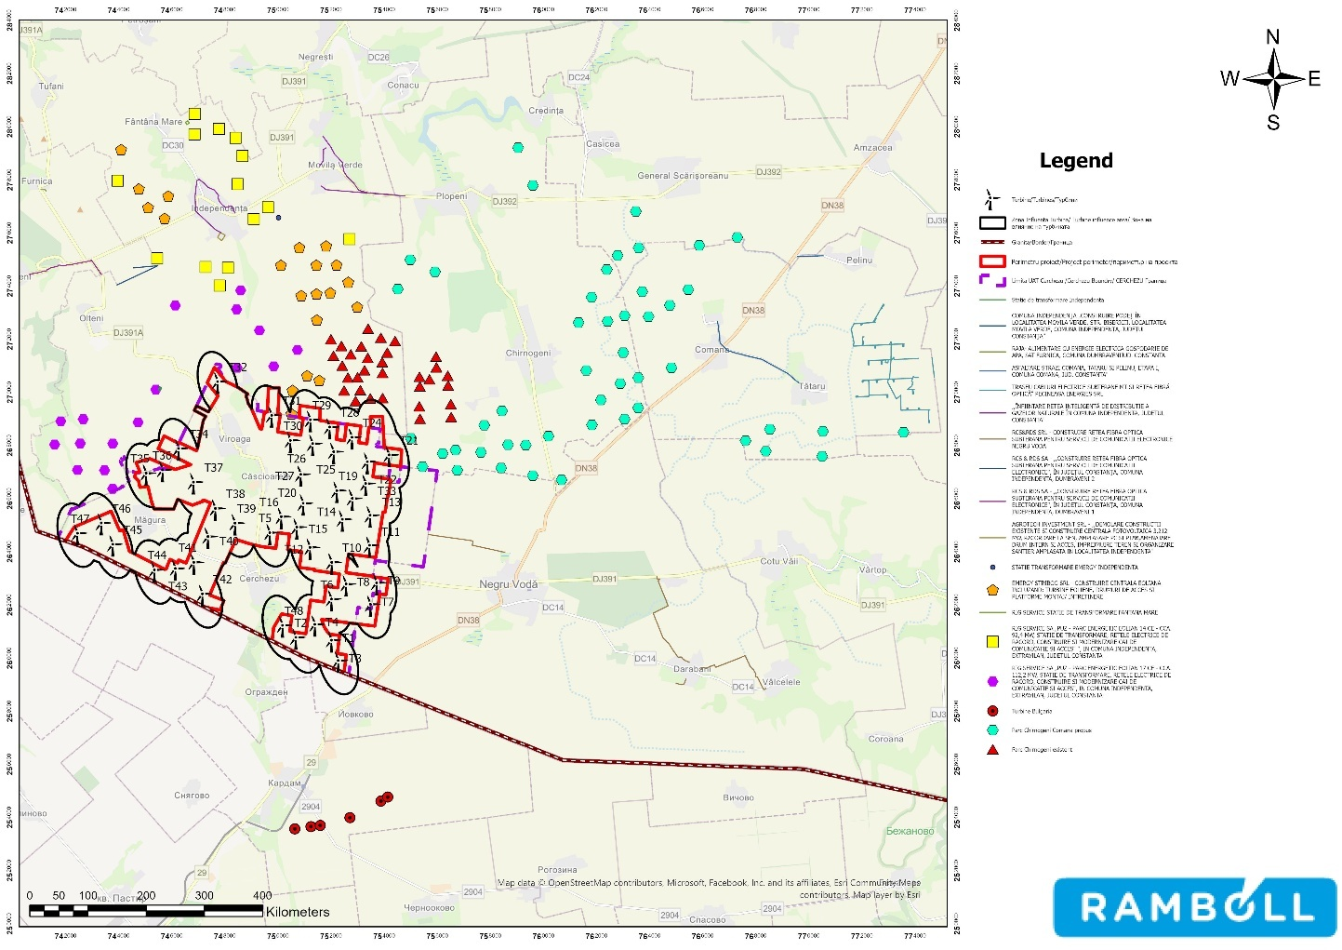

Figure no. 49 Map showing the location of the proposed project in relation to other plans and programs, projects

For existing projects (Chirnogeni-Independența Wind Farm, Bulgaria Wind Farm), the cumulative impact of the operation of the farms during the construction period of the Cerchezu Wind Farm and the cumulative impact of the operation of the farms during the operation period of the proposed farm were estimated.
Given the significant distance between the Bulgaria wind farm and the Cerchezu wind farm, no cumulative impact is estimated in any of the project development stages (construction, operation).
Given that wind farms have no impact on environmental aspects such as air, water, soil/subsoil, resource use, waste management, climate change, and cultural heritage during operation, the cumulative impact of the operation of the Chirnogeni-Independența wind farm and the construction phase of the Cerchezu wind farm is the same as that estimated during the construction phase (insignificantly negative, except for the impact on soil/subsoil, which is significantly negative).
In terms of noise, during the construction of the Cerchezu wind farm, the noise generated by the works will be added to the noise generated by the operational wind farm. However, given the topography of the area, the fact that the works will be carried out in stages, and the lack of other sources of noise, the cumulative impact is not expected to exceed that estimated during the construction phase, i.e., it will be insignificant.
In terms of landscape, the construction of the Cerchezu wind farm will not bring about a significant change to the existing landscape, as it will blend harmoniously into the existing environment, given the presence of the Chirnogeni-Independența wind farm, which has been operating in the area since 2014.
In terms of biodiversity, reports monitoring the operation of wind turbines in the Chirnogeni-Independența wind farm concluded that they do not constitute a significant disturbance to local fauna, especially bird species, as no clear avoidance behavior was observed in the areas where they are located, with the structure and composition of the birdlife being similar to similar periods in previous years prior to the project implementation phase. In addition, no major changes were observed in terms of flora, with the structure and composition of the vegetation developed on and around the site being similar to previous monitoring periods.
Therefore, the cumulative impact of the operation of the Chirnogeni-Independența wind farm with the construction phase of the Cerchezu wind farm is estimated to be insignificant.
The cumulative impact of the operation of the Chirnogeni-Independența wind farm and the operation of the Cerchezu wind farm is estimated as follows:
- Impact on noise: Wind turbines generate both mechanical and aerodynamic noise. The accumulation of several wind farms can increase the noise level in the area, affecting the quality of life of nearby residents, However, considering the noise study conducted for the proposed wind farm, its location approximately 1.5 km from the Chirnogeni-Independența wind farm, and the open topography of the area, it can be estimated that the cumulative effect of the noise associated with the simultaneous operation of the wind farms is insignificantly negative.
- Impact on the landscape: Wind turbines are structures that are visible from long distances and can significantly change the local landscape. The accumulation of several wind farms can lead to a cluttered visual perception and impact on the natural and cultural landscape, However, given the small number of wind turbines proposed for the Cerchezu wind farm and the fact that the Chirnogeni-Independența wind farm has been operating since 2014 and is integrated into the landscape, the cumulative impact

of the simultaneous operation of the farms on the landscape will be insignificant, as the new turbines will ensure visual continuity and blend harmoniously into the landscape.
- Impact on human health: In addition to noise, wind turbines can produce flicker effects (intermittent shadows caused by rotating blades). From the shadow study conducted for the Cerchezu wind farm, it can be estimated that in the contact area of the two farms, their shadow effects may overlap, but this area is outside the built-up areas, 1.2 km away from inhabited areas, so the cumulative impact of the simultaneous operation of the Cerchezu wind farm and the Chirnogeni-Independența wind farm is estimated to be insignificantly negative.
- Impact on the electricity grid: The addition of a new wind farm in an area with several existing and proposed wind farms may affect the stability and balance of the electricity grid. The projects for connection to the National Energy System (SEN) assess in detail the capacity of the grid to manage the energy produced and ensure efficient integration, so that no cumulative impact is estimated from the simultaneous operation of the proposed farm and the Chirnogeni-Independența farm.
- Impact on biodiversity In order to assess the impact on species and habitats in Natura 2000 sites considered in the assessment, the cumulative impact of the project on them was analyzed. To this end, the presence of pressures and threats in the Management Plans and Standard Forms of the sites was analyzed, as well as other projects to be carried out or currently under implementation that have the potential to affect habitats and species of Community interest.
The management plans for potentially affected Natura 2000 sites indicate several pressures and threats that may affect habitats and species of Community interest, the most common being urbanization and the expansion of built-up areas. The construction of roads or motorways and motor traffic are also mentioned as pressures/threats in the case of several of the sites included in the assessment.

Cause-and-effect mechanisms for cumulative impact analysis

The cumulative impact analysis for the proposed project aims to identify and describe the cause-and-effect relationships through which the project interventions, together with other existing or foreseeable plans/projects/activities in the area of influence, may generate additive, synergistic, or chain effects on environmental receptors. The approach is based on the fact that, although the direct effects of the project are generally local and specific (land occupation, construction site, infrastructure), for certain receptors—especially birds and bats—the relevant area of analysis is extensive, and the cumulative impact may manifest itself on a larger scale than the project footprint, including in the vicinity of nearby Natura 2000 sites and in a cross-border context.

Table 55 Assessment of the project's impact on the landscape (overall assessment, operational phase)

Component/environmental aspect | Current situation | Effects generated by the project | Impact generated by the project | Potentially affected recipients | Characteristics of projects with which the analyzed project may generate cumulative impact
Biodiversity | Predominantly agricultural landscape (arable land, linear agricultural features), with generally anthropized habitats; no overlap with protected areas. | Under construction: stripping/excavation, traffic, noise; in operation: turbine (rotor) operation, maintenance. | Mainly local and sporadic: habitat loss/alteration (sporadic), temporary disturbance; in operation, risk to flying fauna (bird collision; bat collision/barotrauma) and avoidance/barrier effect. | Birds, bats, herpetofauna, and small mammals (especially during construction); biodiversity associated with linear elements (valleys/channels). | Cumulation with other wind farms/energy projects in the region (additive risks for birds/bats), with power lines/linear infrastructure and with existing agricultural pressures (fragmentation/disturbance).
Protected natural areas / Natura 2000 | The project does not intersect Natura 2000 sites; there are sites in the vicinity, including cross-border (Bulgaria). | Indirect effects through species mobility (especially birds/bats) and physical factors (noise/light) assessed in a cross-border context. | No direct impact through overlap; potential indirect impact controlled through operational measures and monitoring; requires compliance with cross-border conditions. | ROSCI/ROSAC and ROSPA  in the vicinity; neighbouring Bulgarian BG sites; Natura 2000 target species (especially birds/bats). | Cumulation with other projects in the area of influence that may affect the same sites/species (wind + energy/transport infrastructure), especially during sensitive periods (migration/dispersion).
Air (air quality) | Typical rural quality; current sources: agricultural activities, local traffic. | Under construction: dust from earthworks/transport, exhaust gases; in operation: insignificant emissions (maintenance traffic only). | Temporary, local, reversible (under construction); low/negligible impact during operation. | Local population (especially near work fronts), local vegetation (dust deposits). | Cumulation with other local construction sites/investments and seasonal agricultural activities (dust episodes), plus regional traffic.
Noise and vibrations | Rural background noise; current sources: low traffic, agricultural machinery. | Under construction: heavy machinery, transport; in operation: aerodynamic/mechanical noise from turbines + maintenance traffic. | Execution: temporary/local; operation: permanent local, with the need to comply with limits at receivers. | Nearby homes/localities, sensitive fauna (during construction/operation), including cross-border receptors if nearby. | Cumulation with other wind farms/industrial installations and road traffic; cross-border – need for monitoring at the border (according to the conditions communicated by the Bulgarian side).
Soil and subsoil | Soils used for agriculture; susceptible to local compaction by traffic/machinery. | Stripping, excavation, foundations, roads/platforms; risk of | Permanent (infrastructure footprints) and temporary (organization/ditches); accidental risk | Agricultural soil, soil biota; | Accumulation with other land uses/infrastructure and agricultural pressures

Environmental component/aspect | Current situation | Effects generated by the project | Impact generated by the project | Potentially affected recipients | Characteristics of projects with which the analyzed project may generate cumulative impact
 |  | accidental spills;  temporary storage. | local (oil pollution) manageable through measures. | owners/users  agricultural. | (compaction/erosion), plus  parallel construction sites.
Surface waters/hydrology | Local watercourses/valleys and linear elements (canals/valleys); hydrological regime specific to the area. | Specific works (ditches, crossings), construction site runoff; risk of accidental pollution; minimal effects during operation. | Local/temporary impact during construction (especially if there are crossings/drainage points); low impact during operation, depending on maintenance and water management. | Local streams/valleys, areas with drainage potential; fauna associated with wetland microhabitats. | Cumulation with agricultural works/local developments and other projects that alter runoff/erosion; diffuse agricultural pressures.
Groundwater | Local uses; vulnerability related to occasional accidental pollution. | Accidental risk (fuel/oil spills) during construction/maintenance; no significant exploitation during operation. | Under normal conditions: insignificant; in accidental scenarios: local, preventable by measures (retention/waterproofing/kits). | Local groundwater, local users (if there are catchments in the area). | Accumulation with other potential sources of pollution (agriculture, other construction sites/investments).
Waste | Typical rural flows; management by services/contractors. | Execution: construction waste, packaging, metal, wood, excavated soil (non-hazardous) + hazardous fractions (oils/absorbents).  Operation: maintenance waste (oils/filters/packaging) + household waste. | Impact controllable through separate collection, compliant temporary storage, and delivery to authorized operators; risk only in case of non-compliant management. | Soil/water (in case of non-compliant storage), public health (odour/hygiene). | Combination with other sites and local flows if collection/transport capacity is limited; requires logistical planning.
Landscape/visual impact | Open agricultural landscape, high visibility; existing anthropogenic elements (roads/infrastructure). | Introduction of vertical elements (turbines), stations, roads; modification of the landscape on a local and regional scale. | Permanent, visually significant (but without direct physical impact on protected habitats); may influence landscape perception. | Population, road users, tourists; cross-border receptors (depending on the field of vision). | Cumulation with other wind farms/energy facilities in Dobrogea (visual  visual "congestion" effect).
Intermittent shadow flicker/light | Normal rural conditions, low lighting; proximity to the border requires attention to lighting effects. | Shadow flicker from blades; lighting/safety signaling; potential reflections if finishes are not adequate. | Local, dependent on distance and orientation; manageable through design and operational rules; cross-border requires dedicated assessment of light effects and monitoring at the border. | Housing/sensitive receptors; nocturnal fauna; receptors in nearby Bulgarian settlements (if exposed). | Cumulation with other wind farms (multiple light/signal sources) and existing lighting/infrastructure; potential cross-border effect.

Environmental component/aspect | Current situation | Effects generated by the project | Impact generated by the project | Potentially affected recipients | Characteristics of projects with which the analyzed project may generate a cumulative impact
Non-ionizing radiation/interference | Typical levels for existing electrical infrastructure; perceived sensitivity at property/boundary limits. | EMF fields from electrical equipment and connection networks; possible local interference (depending on design). | Usually low and within limits; requires verification/monitoring according to cross-border conditions (at the border). | Population (perception/exposure), communications equipment (if nearby). | Cumulation with other power lines/stations in the area (field overlap), especially in energy corridors.
Population and human health | Rural community, low density; limited current pressures (agriculture/local traffic). | Construction: dust, noise, traffic, risk of accidents; operation: noise, shadow flicker, visual perception; socio-economic benefits (jobs, taxes). | Local/temporary negative impact during construction; during operation, impact depends on compliance with limits and management of light effects; possible positive socio-economic impact. | Residents of Cerchezu and surrounding areas; traffic participants; cross-border receivers (depending on noise/light at the border). | Combination with other projects if there are overlaps in construction sites, traffic, and noise/light pollution; cross-border – monitoring and reporting to the Bulgarian side for noise/radiation/light.

Current pressure levels

The area analyzed for the project is currently characterized by a predominantly agricultural level of anthropogenic pressure, specific to the extra-urban area in southern Dobrogea. The site is dominated by arable land and agricultural infrastructure (farm roads, linear elements such as local canals/valleys), which indicates an anthropized landscape with generally simplified habitats and biodiversity strongly conditioned by land use.
The main current pressures can be summarized as follows:

- Change and intensification of agricultural land use: recurring agricultural work (plowing, harrowing, sowing/harvesting), reduction of semi-natural elements (field margins, strips of vegetation), which generates functional fragmentation and a decline in habitat quality for some fauna groups (especially invertebrates, herpetofauna, small mammals).
- Local traffic and routine activities outside built-up areas: periodic traffic on agricultural and communal roads associated with land use, with the potential to disturb and, in some cases, cause accidental mortality among terrestrial fauna.
- Diffuse pollution specific to agriculture: the use of fertilizers and plant protection products can cause chronic pressure on the soil and biota (especially invertebrates and food chains), even if the effects are dispersed and difficult to attribute to specific sources.
- Fragmentation and disturbance by existing infrastructure: the network of agricultural/farming roads and other existing linear features contribute to habitat discontinuity and increased accessibility to the area, maintaining a constant background disturbance.
- Pressures on flying fauna at regional level (cumulative): in the regional context, the assessment also takes into account cumulative pressures generated by other projects/activities in the area (including energy infrastructure), which may influence birdlife and bats through barrier effects, avoidance, and collision risk, especially on migration routes.
- Transboundary context: proximity to the Bulgarian border and the existence of Natura 2000 sites in the vicinity require consideration of pressures and sensitivities on a broader scale, but current pressures at the site remain dominated by agricultural use and usual anthropogenic activities, not by strict conservation interventions.
Overall, the current level of pressure in the implementation area can be classified as moderate (due to the dominance of agricultural activities and associated infrastructure), with specific elements of reduced pressure in less used areas and with increased relevance for mobile receptors (birdlife/chiroptera) in the regional and cross-border context. This characterization is important for interpreting the potential impact of the project: the project overlaps with an already anthropized landscape, and significant effects (if any) are more likely to be associated with the specific mechanisms of turbine operation on flying fauna than with a major transformation of existing habitats, which are already influenced by current agricultural pressures.

Climate change
The chapter on climate change has been improved and updated from the version presented in
Presentation Memorandum and Environmental Report - PUZ phase, in accordance with the Practical Sectoral Guidelines

JASPERS on climate resilience protection for the Energy, Municipal Solid Waste, and Transport sectors, version 1.0 – November 2024. The update aimed to strengthen the methodological approach, align it with the latest best practices, and integrate specific requirements for climate risk assessment and adaptation measures, thus ensuring a more robust and consistent analysis of the project's resilience.

Climate change mitigation (climate neutrality)

This type of project does not fall within the category of projects for which a carbon footprint assessment is required under the "Technical Guidance on Climate Resilient Infrastructure 2021-2027".
During operation, wind farms do not generate direct greenhouse gas emissions, and indirect emissions associated with maintenance, monitoring, and operation activities are low and insignificant compared to the emissions avoided through the production of renewable energy. Therefore, the project's contribution to climate change mitigation is considered substantially positive, being aligned with national and European objectives for GHG emission reduction, energy transition, and long-term climate neutrality.
The installed capacity of the entire wind farm is approximately 316.8 MW, and the estimated annual production capacity, corresponding to a capacity factor of 35% and the specific wind conditions in the Dobrogea region, is approximately 970,000 MWh/year.
To calculate the greenhouse gas (GHG) emissions reduced by producing 970,000 MWh/year of energy, it was assumed that energy from renewable sources replaces energy from conventional sources. Estimates were made taking into account an energy mix equivalent to approximately 0.23-0.24 tCO₂e/MWh, which is specific to an average European mix/energy system with lower coal weights.
Reduced emissions (tCO₂e)=Production (MWh)×Emission factor (tCO₂e/MWh)

Estimates indicate an annual amount of electricity delivered from renewable sources of approximately
970,000 MWh/year, corresponding to a reduction in greenhouse gas emissions of 223,100–232,800
tCO₂e/year.

Climate change adaptation review (STAGE 1 analysis)

Sensitivity

To perform a sensitivity analysis of the project, all components relevant to the Wind Farm were identified. In accordance with the EU Communication on climate change resilience, the project components were grouped into the following categories: assets and processes, inputs, outputs, and interdependencies.
Each component was then subjected to sensitivity analysis to understand which climate hazards are relevant. This structures and focuses the assessment on demonstrating that the proposed project is resilient to possible climate risks.

Project components

Inputs |  | Assets | Life  (years)²⁴ |  | Processes |  | Output
Renewable energy sources (Wind) |  | Turbine tower  Rotor-nacelle assembly (rotor blades, hub, and nacelle) Mechanical and electrical equipment of the nacelles (gearbox, generator, controller, etc.) Support structure/foundation Mechanical equipment Mechanical for monitoring and control systems (e.g., for blade adjustment or for turbine shutdown in case wind speed exceeds safe operating thresholds)  Lines for transport for power  in the national grid Transformer station  facilities for manufacturing or  assembly of components | 20-30  20-25  20  25  15  25-40  20 |  | Electricity production Monitoring and control  Maintenance and repairs Environmental monitoring activities to assess and  mitigate impacts on ecosystems Land management activities, including management of vegetation around turbines and associated infrastructure |  | Electricity  Electric

An average duration of approximately 25 years has been considered for this project.
Interdependencies

Interdependencies
Access roads to the wind farm
Electricity transmission and distribution network
Electricity consumption

The relevant climate hazards, both chronic and acute, that may affect each wind farm project are presented in the table below. The color coding (no sensitivity - gray, low - green, medium - moderate, high - red) reflects the overall sensitivity level of wind farm projects, assessed in relation to the specific infrastructure type.
Table 56 Relevant climate hazards affecting the energy subsectors analyzed²⁵
Climate hazards | Wind farms
CHRONIC
Temperature change/temperature variability
Permafrost thawing
Changing wind patterns
Precipitation pattern change/Precipitation or hydrological variability
Sea level rise; Saltwater intrusion
Coastal erosion/soil erosion
ACUTE
Heat waves
Cold wave/frost
Fires

²⁴ The values are indicative and may differ depending on the characteristics of the project, as appropriate. The actual lifetime of assets depends on the material, regional context, economic conditions, procurement processes, etc. As such, a fairly wide range is observed in the tables. It should be noted that lifetime is particularly important for defining adaptation measures as a result of risk analysis.
²⁵ JASPERS practical sectoral guidelines on climate resilience Energy – Municipal solid waste – Transport Version 1.0 – November 2024

Climate hazards | Wind farms
Extreme wind (including storm, hurricane, tornado)
Drought
Flooding/Storm surge/Heavy rainfall
Landslide/Avalanche/Subsidence

The project sensitivity assessment is presented in the following table:

Table 57 Project sensitivity assessment
Climate risks | Sensitivity
Flooding/Storm surge/Heavy rainfall | Flooding, storm surges, and heavy rainfall can lead to a loss of uniform contact between the foundation and the ground, causing significant stability problems for the wind turbine tower.  The same climatic phenomena (flooding, storm surges, and heavy rainfall) can cause physical damage to buried electrical cables, transformer stations, and interdependent infrastructure (including access roads and transport and distribution networks), affecting operation and operational access.  distribution networks), affecting operational functioning and access.
Overall score: High | Assets and  processes | Inputs | Outputs | Interdependencies
3 | 3 | 0 | 0 | 3
Vegetation fire | Vegetation fires can cause physical damage to onshore wind farm assets and energy transmission and distribution infrastructure, with a direct impact on electricity generation and evacuation capacity.  Damage to electrical networks and auxiliary equipment can lead to power outages, affecting the wind farm's control, monitoring, and communications systems.  Temporary restrictions on access to sites, imposed by safety conditions during or after fires, may limit operation, inspection, and maintenance interventions.  and maintenance interventions.
Overall score: High | Active and  processes | Inputs | Output | Interdependencies
3 | 3 | 0 | 2 | 2
Cold wave | Periods of very low temperatures and frost can cause structural damage to turbine blades through ice formation, which can lead to dynamic imbalances and additional stress on the shaft and rotation systems. Ice deposits, even in small quantities, affect the aerodynamic performance of the blades, causing a decrease in electricity production.  Extreme negative temperatures can cause malfunctions or improper operation of sensitive electrical and mechanical equipment, including control systems, sensors, and drive components.  Cold and wet conditions can accelerate corrosion processes in metal components, leading to increased maintenance costs and intervention requirements. Significant snow accumulation can temporarily block access roads and auxiliary paths, making inspections and maintenance work difficult.  Frost and severe weather conditions can affect the accuracy of measurement and control systems  and control systems, impacting the safe and efficient operation of turbines.
Overall score:  Moderate | Active and  processes | Inputs | Outputs | Interdependencies
2 | 2 | 0 | 2 | 2
Change in wind patterns | Changes in wind patterns, reflected in lower average speeds or a decrease in the frequency of optimal operating intervals, can lead to a reduction in the electricity production of onshore wind farms.  Increased wind speeds or the frequency of episodes of stronger winds can have a positive effect on production, to the extent that the technical characteristics of the turbines, the configuration of the farm and the operational limits allow the exploitation in  the safe exploitation of xml-ph-0007@deepl.internal
Overall score:  Moderate | Active and  processes | Inputs | Outputs | Interdependencies
2 | 0 | 2 | 2 | 0

Climate risks | Sensitivity
Extreme wind (including storms, lightning, hurricanes, tornadoes) | Extreme structural stresses on wind turbine components, including blades, tower, and foundation system, generated by the intensification of severe weather phenomena (extreme winds, turbulent gusts, freeze-thaw cycles).  Increased risk of mechanical damage and electrical failure in critical and sensitive equipment due to exposure to thermal stress, excessive humidity, atmospheric electrical discharges, and extreme climate variations.  Damage to the physical integrity of interconnected infrastructure, including transmission lines, electrical stations, and access roads, through exacerbated climatic processes (flooding, erosion, land instability), with the potential to interrupt operation and  increase in maintenance costs.
Overall score: Moderate | Assets and  processes | Inputs | Outputs | Interdependencies
2 | 2 | 0 | 0 | 2
Landslides/Avalanches/Subsidence | Physical damage to onshore wind farm assets (turbines, foundations, technological platforms) and associated infrastructure caused by extreme weather events such as heavy rainfall, freeze-thaw cycles, droughts followed by torrential rains, and sharp temperature variations.  Blockage or restriction of access roads due to soil instability, accumulation of eroded material, silting, and local landslides or rockfalls, with a direct impact on operational continuity.  The occurrence of landslides and the degradation of road shoulders and access structures, which limits the conduct of inspections, interventions of maintenance and  repair work, increasing downtime and operating costs.
Overall score: Moderate | Assets and  processes | Inputs | Outputs | Interdependencies
2 | 2 | 1 | 1 | 2
Sea level rise/saline intrusion | Potential physical damage to onshore wind farms located in coastal areas, mainly manifested by structural instability and deformation of permanent foundations as a result of coastal flooding, coastal erosion, and sea level rise.  Increased structural stress on wind turbines caused by amplified hydrodynamic actions and wave energy associated with higher sea levels, with possible failure modes including tower tilting, loss of foundation bearing capacity, and degradation of the anchoring system.
Overall score: Moderate | Active and  processes | Inputs | Outputs | Interdependencies
2 | 2 | 0 | 0 | 0
Thawing  of permafrost | Repeated cycles of soil freezing and thawing generate frost heave and subsidence processes, placing additional stress on wind turbine foundations and affecting the long-term stability of structures.  Permafrost degradation in polar regions, associated with global warming, can lead to changes in the dynamics of floating sea ice; mechanical loads induced by drifting sea ice can be a risk factor for tower stability  and structural integrity of the turbine.
Overall score: Moderate | Active and  processes | Inputs | Outputs | Interdependencies
2 | 2 | 0 | 0 | 0
Heat waves | The increasing frequency of heat waves can affect the reliability of onshore wind farm equipment, particularly electrical components, conversion systems, and gearboxes, through overheating and accelerated degradation processes.  Extreme temperature events can amplify the risks associated with integrated onshore energy storage systems, including the occurrence of thermal instability phenomena, with the potential for fire or major damage. Imbalances between energy production and peak consumption demand can become more pronounced during heat waves, when demand increases significantly, while the efficiency of production systems can be affected by thermal conditions, generating  additional pressure on the continuity of energy supply.
Overall score: Moderate | Active and  processes | Inputs | Outputs | Interdependencies
2 | 2 | 0 | 0 | 2

Climate risks | Sensitivity
Temperature variations | The increase in average air temperature leads to a reduction in air density, which causes a decrease in the aerodynamic efficiency of turbines and, implicitly, a decrease in the electricity production of onshore wind farms.  In the case of onshore sites located in coastal areas or with structural elements exposed to humid/saline environments, higher temperatures can accelerate corrosion and biodegradation processes (e.g., the growth of algae and microorganisms on exposed metal structures or foundations), with an impact on  the sustainability of the infrastructure.
Overall score:  Low | Active and  processes | Inputs | Outputs | Interdependencies
1 | 1 | 0 | 1 | 0
Drought | Prolonged periods of drought and excessive soil drying can reduce the electrical conductivity of the ground, affecting the efficiency of onshore wind turbine grounding systems and increasing their vulnerability to power surges and lightning strikes.
Overall score:  Low | Assets and  processes | Inputs | Outputs | Interdependencies
1 | 1 | 0 | 0 | 0
Soil erosion  Coastal erosion | The occurrence of differential settlement of the foundation ground, with a direct impact on the overall stability of the foundations and the wind turbine structure.  The uncovering or exposure of underground electrical cables as a result of soil erosion or degradation of the covering layer increases the risk of accidents due to electrocution and  damage to electrical systems.
Overall score:  Low | Active and  processes | Inputs | Outputs | Interdependencies
1 | 1 | 0 | 0 | 0
The project is highly sensitive to the following climate hazards:
Vegetation fires
Flooding, Storm surge, Heavy rainfall The project shows moderate sensitivity to the following climate hazards:
Cold wave
Changing wind patterns
Extreme winds (including storms, lightning, hurricanes, tornadoes) Landslides/Avalanches/Subsidence
Sea level rise/Saline intrusion Permafrost thaw
The project shows low sensitivity to the following climate hazards:
Heat waves
Temperature variations Drought
Soil erosion/Coastal erosion

The following section presents information on the current and future exposure of the area where the project will be located
project will be located for the category of climate hazards specified above.

Exposure

CURRENT EXPOSURE

Flooding/Storm surge/Heavy rainfall
According to the map of areas with significant flood risk, the location of the wind farm and the location of the wind farm do not overlap with areas identified as being at risk of flooding. Flood-prone areas are located along watercourses outside the project perimeter, without posing a direct risk to the proposed infrastructure. Therefore, the flood risk for the project site is assessed as low.
The watercourses in the location area (Măgura, Cerchez, Ceair) are not included in the Dobrogea Litoral River Basin Management Plan and do not appear in the flood hazard and risk maps - cycle 2. With

However, in accordance with Law 575/2001 on the approval of the National Spatial Planning Plan
- Section V Natural Risk Areas, the commune of Cerchezu is exposed to the risk of torrential flooding.

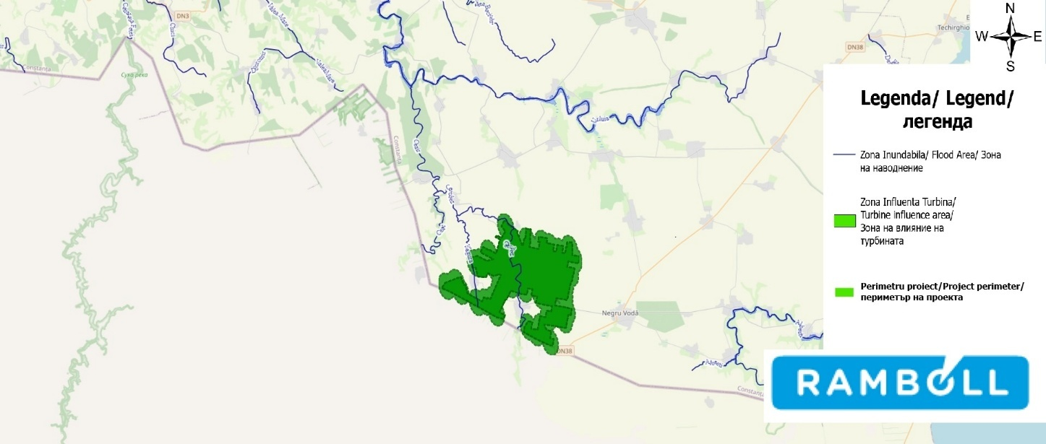
Source: Processed from inundații.ro
Figure no. 50 Map of areas with significant flood risk

Analysis of historical precipitation values indicates that the Cerchezu commune area is characterized by relatively low annual precipitation, typical of the Dobrogea region. According to global climate data for the period 1970-2000 available on WorldClim, the annual amount of precipitation in the park's location, at the level of the Cerchezu commune, varies between 460÷476 mm.
Intense precipitation events are rare and short-lived, and the project site does not overlap with areas prone to significant water accumulation or concentrated surface runoff. Therefore, the risk associated with torrential rains is considered low.
According to available climatological studies (Antonescu & Bell, 2014), tornadoes are rare meteorological phenomena in Romania, including in the Dobrogea region. The estimated frequency is very low, on the order of one event every few years on a regional scale, with most tornadoes being of low intensity (EF0–EF1) and having a localized impact. Although climate change may favor the occurrence of more intense convective storms (Met Office, 2021), the probability of such a phenomenon occurring at the Cerchezu site remains low.
Precipitation can take various forms, such as liquid water droplets, snow crystals, or ice pellets. Extreme precipitation can have significant effects on water supply and sewerage infrastructure by increasing the turbidity of surface water sources.

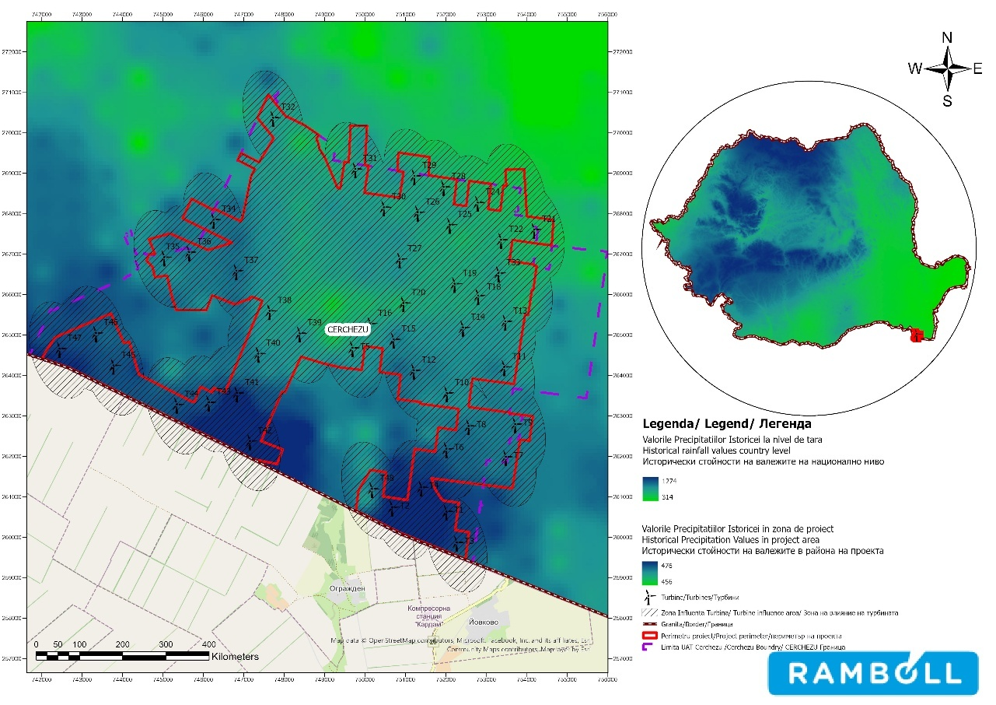

Source: Adapted from www.worldclim.org
Figure 51 Historical precipitation values in the project area

Fire Vegetation
Vegetation fires are fires that spread through areas with vegetation, such as forests, grasslands, or bushes. These fires can have multiple causes, including careless human activity, lightning strikes, or natural phenomena such as drought.
The risk of vegetation fires in the Cerchezu commune is considered low, with a moderate local possibility of occurrence during periods of severe drought and high temperatures, characteristic of the summer season. Potential fires are predominantly small in scale, associated with low vegetation and agricultural land. The area where the wind farm is to be built, which has no forest vegetation, does not present favorable conditions for forest fires, and the risk associated with this type of event is assessed as low.

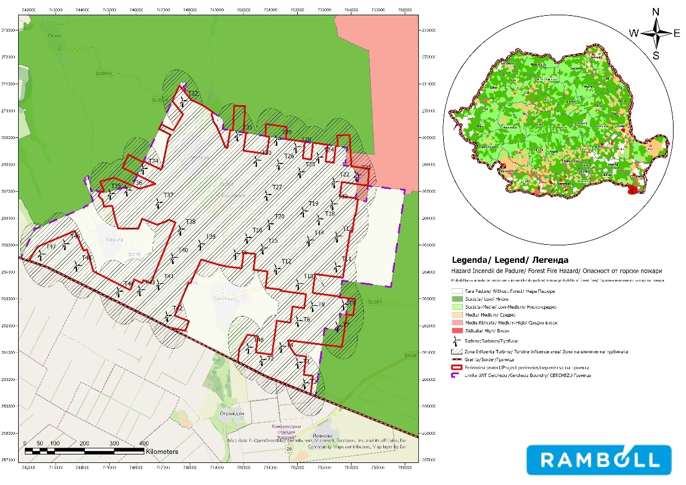

Figure 52 Map of the probability of forest fires

Cold wave
According to the "Constanța County Risk Analysis and Coverage Plan – 2024," Constanța County is characterized by a temperate continental climate with Pontic influences, in which episodes of extreme minimum temperatures occur sporadically, for relatively short periods, mainly during the cold season. Low temperatures can cause temporary discomfort and operational difficulties, but are not reported as phenomena with a major recurring impact at the local level.

Changing wind patterns
Wind is a dominant climatic element in Dobrogea, with high frequency and seasonal variations, determined by the circulation of continental and maritime air masses. Interannual variations in wind patterns associated with climate change are mentioned, which can influence the dynamics of meteorological phenomena, without being classified as major emergencies. In the case of the analyzed site, these changes are considered a chronic climate hazard, with a potential impact on energy production levels, without affecting the structural integrity of wind turbines.

Extreme wind (including storms, lightning, hurricanes, tornadoes)
Extreme wind events, including strong storms and atmospheric electrical discharges, may occur sporadically in the region. However, phenomena such as hurricanes or tornadoes are very rare in the Dobrogea area.
The "Constanța County Risk Analysis and Coverage Plan – 2024" mentions storms and temporary wind intensifications, including episodes associated with convective phenomena, as possible meteorological risks at the county level. On the other hand, hurricane- or tornado-type phenomena are extremely rare, with no systematic occurrence or significant documented impact in Constanța County.

This type of climatic hazard is considered acute, with low probability, and the associated risk is managed by designing and operating turbines in accordance with applicable technical standards.

Landslides/Avalanches/Subsidence
According to the landslide hazard map, the wind farm site and its areas of influence are predominantly classified as having low to very low landslide potential. No areas with high or very high slope instability potential have been identified within the project perimeter, indicating a low risk associated with this type of geodynamic hazard.
Given the low-altitude plain and plateau relief, the lack of steep slopes, and the absence of significant snow accumulation, there are no geomorphological and climatic conditions favorable to avalanches in the Cerchezu commune area. Therefore, the risk associated with this type of hazard is considered negligible.
Analysis of geological and geomorphological conditions indicates that the Cerchezu commune area is not characterized by known natural or anthropogenic subsidence phenomena. In the absence of mining activities, underground cavities, or other contributing factors, the risk of subsidence is considered low.
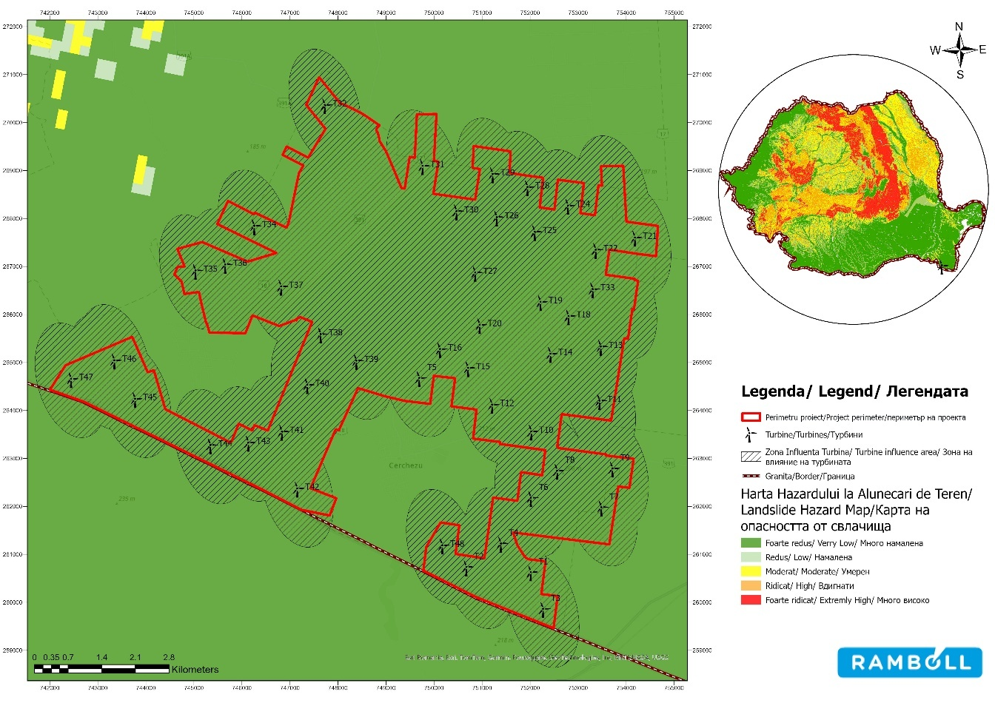
Figure no. 53 Map of landslide hazard zoning

Sea level rise/saline intrusion
In the RCP 2.6 climate scenario, the studied area has a low degree of exposure to the risks associated with sea level rise and saltwater intrusion. The impact is considered negligible due to the distance from the coastline and the limited sea level rise predicted in this scenario.

Permafrost thawing
There is no permafrost in the project area, therefore we consider that there is no possibility
of exposure to the effects of this hazard.

Heat wave
Under current climatic conditions, the commune of Cerchezu is characterized by a relatively high frequency of extreme temperature episodes, specific to the Dobrogea region. Heat waves occur mainly in the summer season, being associated with high maximum temperatures and periods of severe heat stress. According to national and regional climate trends, southeastern Romania is among the areas most exposed to such phenomena, even in the current climate.

Temperature variations
Analysis of historical maximum temperature distribution indicates that the Cerchezu commune area falls within a zone characterized by high temperatures during the summer months, typical of southeastern Romania.
According to global climate data for the period 1970-2000 available on WorldClim, the average annual maximum temperature in the project's area of influence, at the level of the Cerchezu commune, ranges between 5.820C and 6.390C.
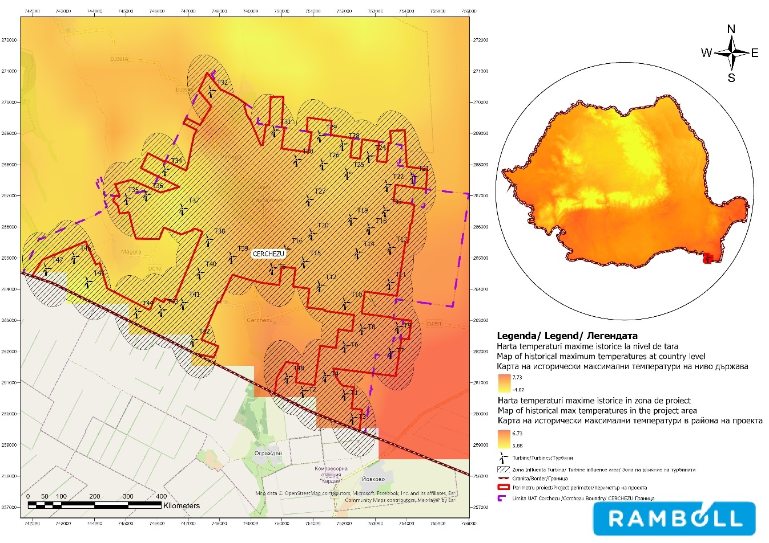

Figure no. 54 Historical average annual maximum temperature values at the project site
project

Drought
The concept of drought can be defined as "a deficit of precipitation over a long period of time (usually a season or more), leading to a 'water shortage'.
Several types of drought are classified as follows:

        - meteorological drought refers to an extended period of time when there is little or no rainfall;
        - agricultural drought occurs when soil moisture levels are low and the water deficit damages or destroys agricultural crops;
        - Hydrological drought refers to reduced water supply to rivers, lakes, aquifers, and other reservoirs and usually follows meteorological drought.
        - ecological drought is an episodic deficit in water availability that pushes ecosystems beyond their vulnerability thresholds and triggers reactions in natural and/or human systems, occurring when widespread ecological damage is caused by a lack of soil moisture;
        - Socio-economic drought occurs when water supply is reduced or stopped due to a lack of water resources.
The analysis of complex drought indicators highlights that the Cerchezu commune area is characterized by a climate prone to recurrent drought episodes, specific to the Dobrogea region. According to the map, the site is predominantly located in areas affected by precipitation deficits and anomalies associated with meteorological and pedological drought, with a potential impact on soil conditions, vegetation, and infrastructure exploitation. Drought is a chronic climate hazard, with a tendency to intensify in the context of climate change.

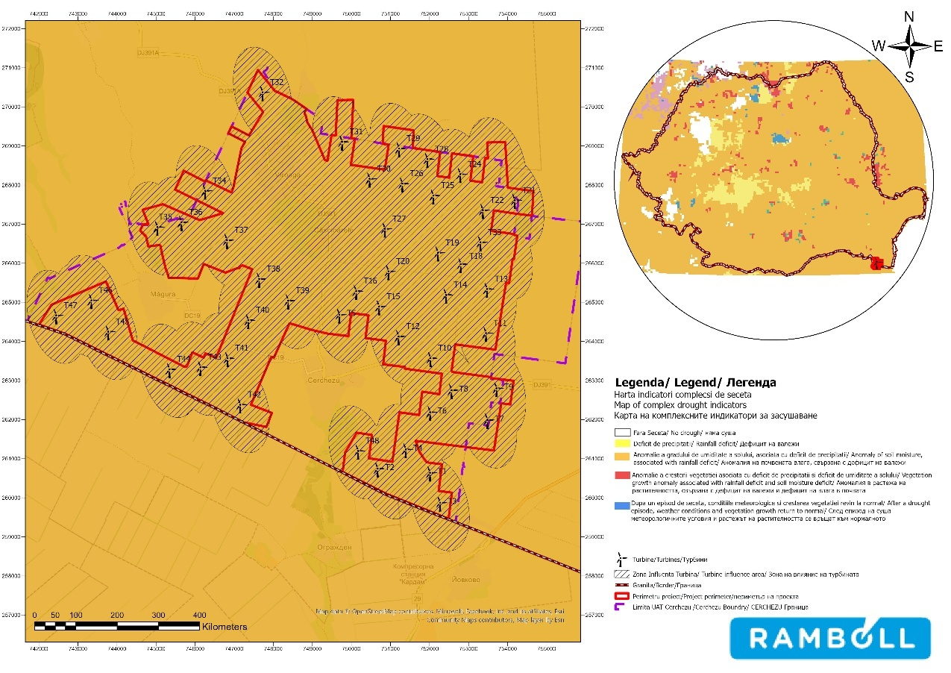

Source: Processing after European Drought Observatory
Figure 55 Map of drought distribution types

Soil erosion/Coastal erosion
The project site is not located in a coastal area. A review of climate change scenarios on the coastal flood risk map and coastal erosion risk map confirms that there is no current or future exposure to coastal and ocean hazards.
FUTURE EXPOSURE

Flooding / Heavy rainfall
In both the RCP 4.5 and RCP 8.5 scenarios, the Cerchezu site remains characterized by low rainfall, specific to Dobrogea. Climate projections indicate that average annual precipitation will remain stable or decrease slightly, with an increase in seasonal variability. From a climate risk perspective, precipitation does not pose a major flood risk, but it contributes to the intensification of chronic risks associated with drought and extreme temperatures.

Vegetation fire
According to the Fire Weather Index (FWI) developed by the Copernicus Climate Change Service, the Dobrogea region, including the project site, shows an increase in weather conditions favorable to vegetation fires in future climate scenarios. In the RCP 4.5 scenario, the risk is assessed as moderate, and in the RCP 8.5 scenario, these conditions are expected to intensify. However, in the absence of extensive forest vegetation, potential fires are predominantly small in scale, associated with low vegetation, with the overall risk assessed as low to moderate.

Cold wave
According to RoADAPT data on the duration of cold spells for the RCP 4.5 climate scenario (2041–2070), the Cerchezu site is located in an area characterized by a relatively short duration of extreme cold spells compared to the central and northern regions of Romania. Projections indicate a decreasing trend in the frequency and duration of cold waves in the south-east of the country, suggesting a low acute climate risk with limited and temporary impact on the project's infrastructure and operation.
For the RCP 8.5 scenario (2071–2100), the data indicate a general trend of decreasing frequency and duration of cold spells in the south-east of the country, including Dobrogea, as a result of long-term increases in average temperatures. From a climate risk perspective, cold spells represent an acute climate hazard with low probability and limited impact on the infrastructure and operation of the project.

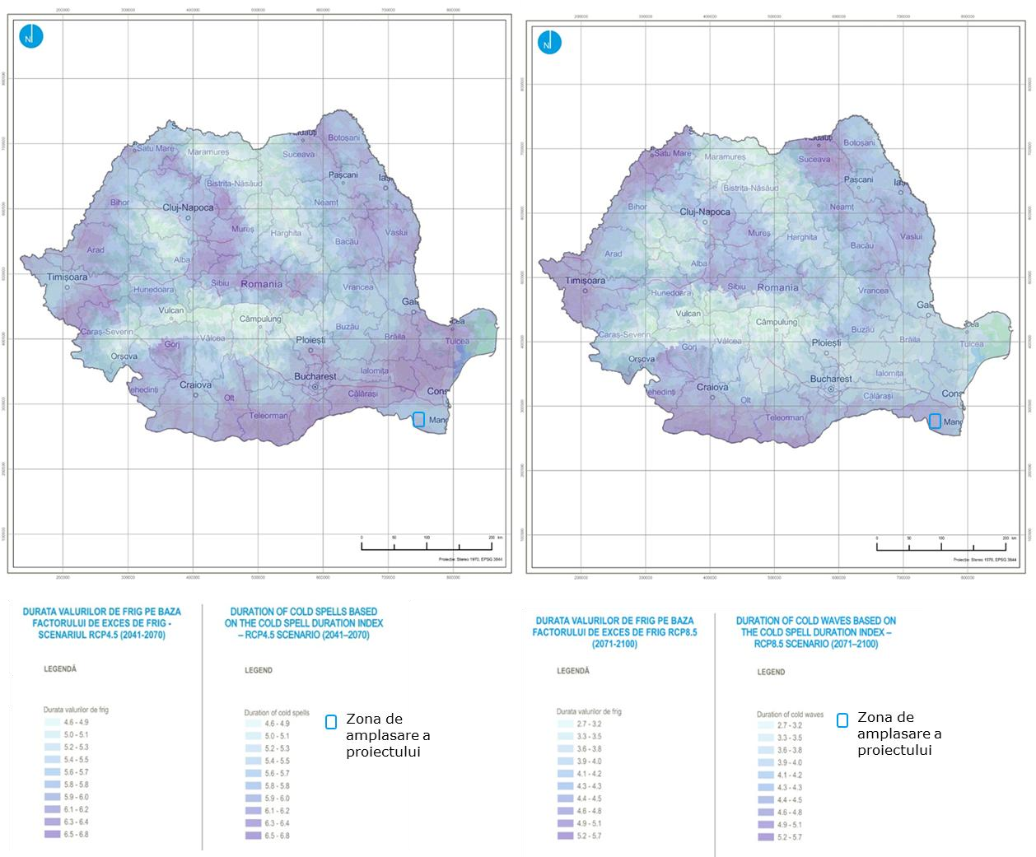
Environmental impact report for Wind Farm 48 (46) wind turbines approx. 316.8MW (303.6MW), transformer stations, connection grids, construction and modernization of communication and access roads

Figure 56 Duration of cold spells TN10p - RCP4.5 scenario................... Figure 57 Duration of cold spells TN10p - RCP4.5 scenario

Source: ROADAPT platform

Environmental impact report for Wind Farm 48 (46) wind turbines approx. 316.8MW (303.6MW), substations
Transformer stations, Electrical connection networks, Construction and modernization of communication and access routes

Extreme wind (including storms, lightning, hurricanes, tornadoes)
According to the maximum wind speed map for the RCP 4.5 climate scenario (2041–2070), the site in Cerchezu commune is located in an area characterized by moderate annual maximum wind speeds, estimated at approximately 10.0–11.0 m/s. These values are specific to the Dobrogea region and do not indicate a significant intensification of extreme wind phenomena compared to other regions of the country.
According to the maximum wind speed map for the RCP 8.5 climate scenario (2071–2100), the site in Cerchezu commune is located in an area characterized by estimated maximum annual wind speeds of approximately 10.5–11.5 m/s. Compared to the RCP 4.5 scenario, there is a slight increase in maximum values, but without the occurrence of pronounced extremes or local concentrations of high intensity.
In terms of the number of tornadoes in the project area, there are between 0.1 and 0.25 tornadoes per year.

Change in wind patterns
According to the average wind speed map for the RCP 4.5 climate scenario, the Cerchezu site is located in an area characterized by moderate average annual wind speeds, typical of the Dobrogea region. In the RCP 4.5 climate scenario, the Cerchezu site is characterized by moderate average wind speeds, with no indications of a significant increase in the frequency or intensity of extreme wind phenomena. The estimated values are in the range of approximately 4.0–4.5 m/s, which is higher than the national average and confirms the maintenance of a favorable wind regime.
In the RCP 8.5 scenario, the Cerchezu site maintains a relatively stable average wind speed regime, with moderate to high values (4.0–4.5 m/s), specific to Dobrogea. The projected changes in wind patterns do not indicate significant climate risks to infrastructure integrity, being classified as a manageable chronic risk.

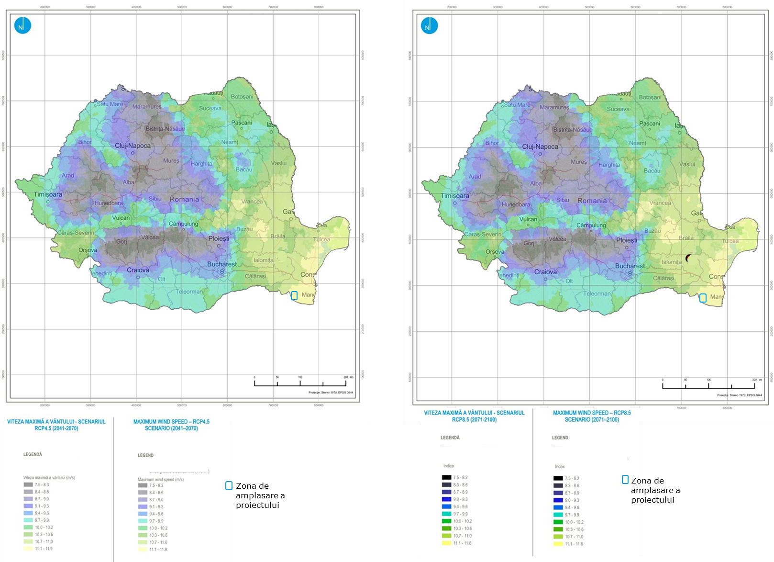
Figure no. 58 Maximum wind speed - RCP4.5 scenario Figure 59 Maximum wind speed - RCP4.5 scenario

Source: ROADAPT platform

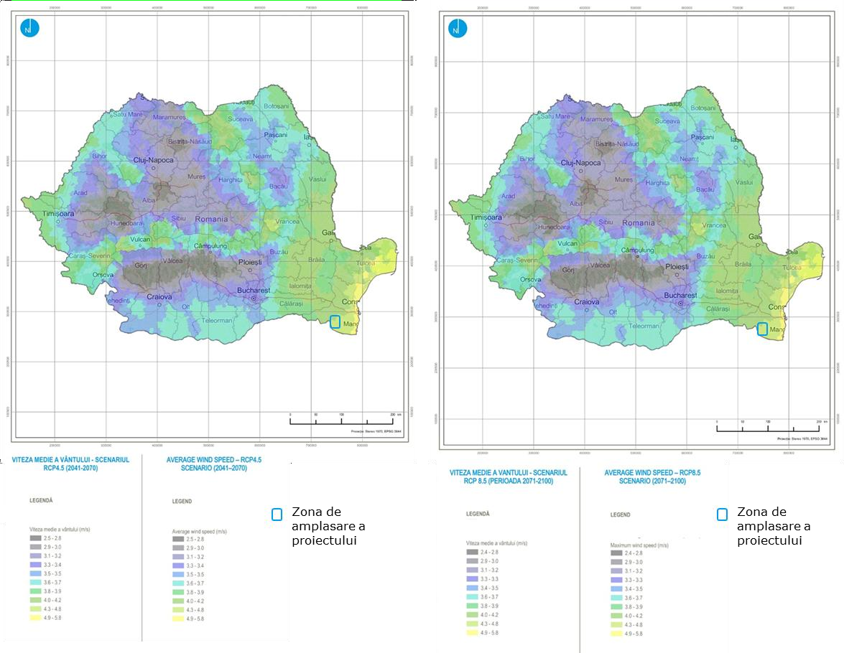
Figure 60 Average wind speed - RCP4.5 scenario Figure 61 Average wind speed - RCP4.5 scenario

Source: ROADAPT Platform

Environmental impact report for Wind Farm 48 (46) wind turbines approx. 316.8MW (303.6MW), substations
Transformer stations, Electrical connection networks, Construction and modernization of communication and access routes

Landslides/Avalanches/Subsidence
In future climate scenarios (RCP 4.5 and RCP 8.5), the studied area presents a low risk of landslides due to its geomorphological characteristics (flat relief, plain). However, the increase in the frequency of extreme precipitation events (heavy rainfall concentrated in a short period of time) could cause localized soil instability (e.g., local erosion on road embankments, canal banks, dikes) and possible damage to surface infrastructure in the event of water accumulation or infiltration.

Sea level rise/saline intrusion
In the studied area, sea level rise according to the RCP 4.5 and RCP 8.5 scenarios does not generate direct coastal erosion effects, but it does cause increased pressure on hydrotechnical defenses and the risk of river flooding.

Permafrost thaw
There is no permafrost in the project area, therefore we consider that there is no possibility of exposure to the effects of this hazard.

Heatwave
According to RoADAPT climate projections for scenarios RCP 4.5 and RCP 8.5, the site in Cerchezu commune is located in an area characterized by a significant increase in the annual duration of heat waves by the end of the century. The area is associated with high values of cumulative heatwave duration, estimated at over approximately 30–35 days/year, placing southeastern Romania among the regions most exposed to this climate phenomenon. Heat waves represent a chronic climate risk, with the potential for marked intensification in the future, having implications for operating conditions, thermal stress on equipment and personnel, and the need to implement climate adaptation measures.

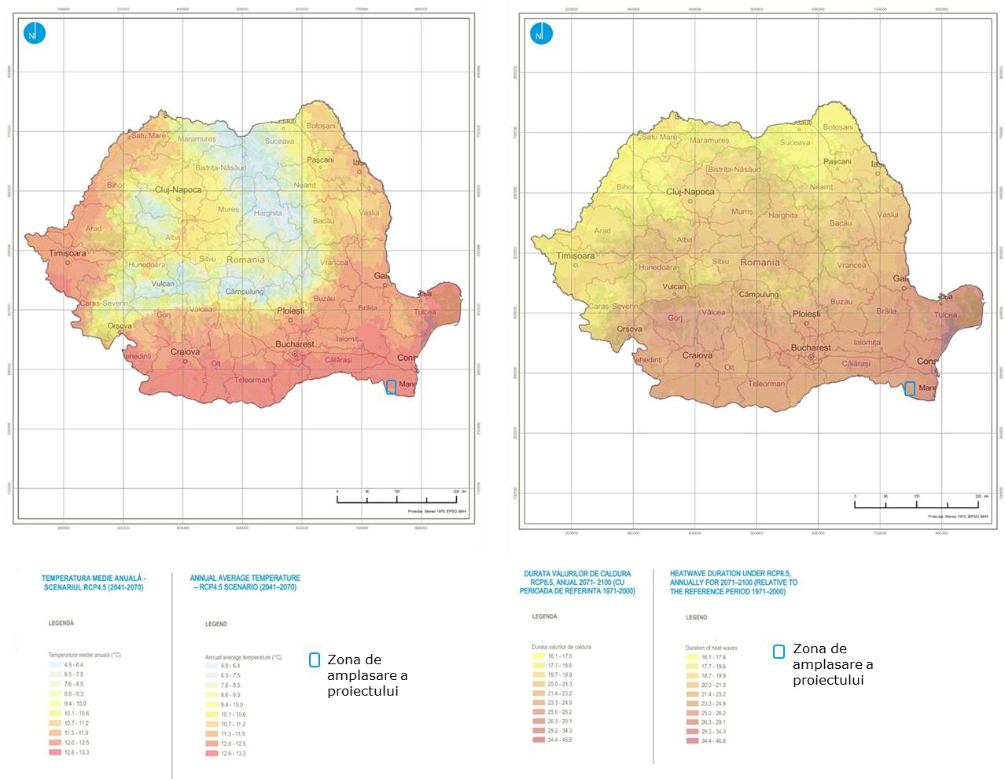
Environmental impact report for Wind Farm 48 (46) wind turbines approx. 316.8 MW (303.6 MW), transformer stations, connection grids, construction and modernization of communication and access routes

Figure 63 Duration of heat waves - RCP4.5 scenario
Figure 62 Duration of heat waves – RCP4.5 scenario.............

Source: ROADAPT platform

Environmental impact report for Wind Farm 48 (46) wind turbines approx. 316.8MW (303.6MW), substations
Transformer stations, Electrical connection networks, Construction and modernization of communication and access routes

Temperature variations
According to the average annual temperature map for climate scenario RCP 4.5 (2041–2070), the site in Cerchezu commune is located in one of the warmest regions of Romania. The south-eastern part of the country, including Dobrogea, is characterised by high average annual temperatures, estimated at approximately 11.5–12.5°C, with an upward trend compared to the reference period.
According to the average annual temperature map for climate scenario RCP 8.5 (2071–2100), the site in Cerchezu commune is located in an area characterized by the highest average annual temperatures nationwide. Southeastern Romania, including Dobrogea, is associated with estimated values in the range of approximately 13.5–15.0°C, indicating a marked increase compared to the RCP 4.5 scenario and the reference period.

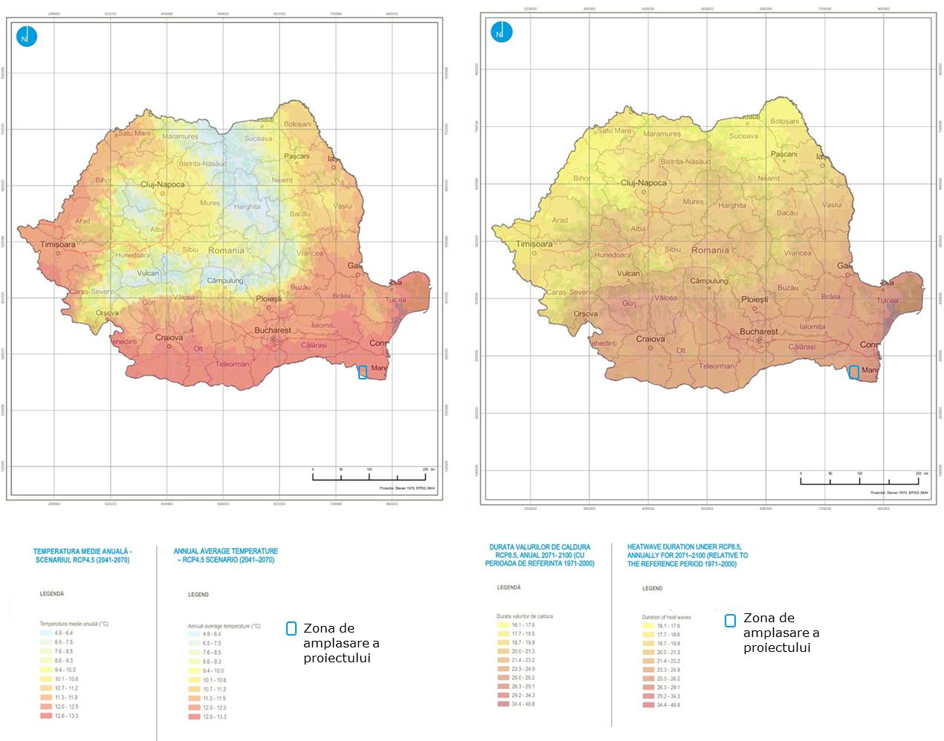
Environmental impact report for Wind Farm 48 (46) wind turbines approx. 316.8 MW (303.6 MW), transformer stations, connection networks, construction and modernization of communication and access routes

Figure no. 64 Average annual temperature - RCP4.5 scenario Figureno.65Temperatureaverageannual-scenarioRCP4.5

source: data processing taken from RO-ADAPT

Drought
According to the map showing changes in drought frequency, based on climate projections for future exposure, the Dobrogea area, including the Cerchezu site, falls into a class of slight to moderate increase in the frequency of drought episodes compared to the reference period. The values indicated suggest a limited intensification of rainfall deficit phenomena, without major or extreme jumps at the regional level.
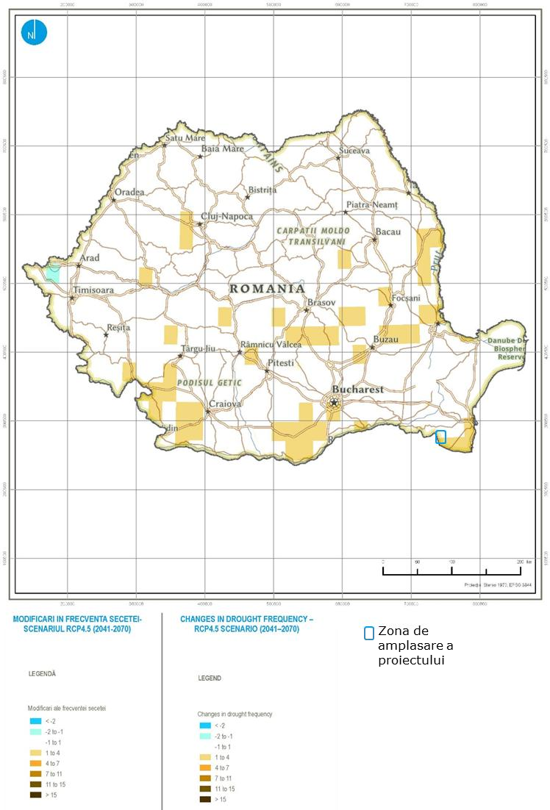

Figure 66 Changes in drought frequency – future exposure

Soil erosion/Coastal erosion
In the Cerchezu site area, soil erosion may be exacerbated by climate change in the future. The main factors are the intensification of heavy rainfall events and heat waves, which promote drying and disintegration of the topsoil. The risk of coastal erosion is reduced directly, but indirect effects on the banks of the Danube and local hydrotechnical infrastructure may occur.
Exposure assessment results

The assessment of exposure to climate risks was carried out by correlating the characteristics of the site with available climate projections, with the results presented reflecting the relative level of exposure for each hazard analyzed.
Table 58 Exposure assessment
Climate hazard | Current exposure RCP 2.6 |  | Medium-term exposure  RCP 4.5 | Long-term exposure  RCP 8.5 | Trends
Flooding/Storm surge/Heavy rainfall | 1 |  | 1 | 1 | →
Fire Vegetation | 1 |  | 2 | 2 | ↑
Cold wave | 1 |  | 1 | 1 | →
Change in wind patterns | 1 |  | 1 | 1 | →
Extreme wind (including storm, lightning, hurricane, tornado) | 1 |  | 2 | 2 | ↑
Landslides/Avalanches/Subsidence | 0 |  | 0 | 1 | →
Sea level rise Saline intrusion | 0 |  | 0 | 0 | x
Permafrost thawing | 0 |  | 0 | 0 | x
Heat wave | 2 |  | 2 | 3 | ↑
Temperature variations | 2 |  | 2 | 3 | ↑
Drought | 2 |  | 2 | 3 | ↑
Soil erosion/Coastal erosion | 1 |  | 1 | 1 | →
Legend
→ |  | Stable
↑ |  | Increasing
x |  | Not specific/No exposure

The scores reflect the Cerchezu site's specific exposure to climate hazards, taking into account local geographical conditions and climate projections. The dominant risks are associated with high temperatures and drought, particularly in the RCP 8.5 scenario, while other hazards are assessed as low or irrelevant.

Vulnerability

The vulnerability analysis was performed using the matrix presented in Chapter VIII.2, resulting from the correlation between the sensitivity level and the exposure level. The results of the assessment of the project's vulnerability to climate change are presented below, taking into account the highest score assigned to exposure, regardless of whether it is current or projected.

Table 59 Vulnerability analysis
Exposure |  |  |  | Sensitivity  Overall | Vulnerability
Climate hazard | RCP 2.6 | RCP 4.5 | RCP 8.5 | Sensitivity  Overall | RCP 2.6 | RCP 4.5 | RCP 8.5
Flooding/Heavy rainfall | 1 | 1 | 1 | 3 | 3 | 3 | 3
Fire Vegetation | 1 | 2 | 2 | 3 | 3 | 6 | 6
Cold wave | 1 | 1 | 1 | 2 | 2 | 2 | 2
Changing wind patterns | 1 | 1 | 1 | 2 | 2 | 2 | 2
Extreme wind (including storm, lightning,  hurricanes, tornadoes) | 1 | 2 | 2 | 2 | 2 | 4 | 4
Landslide/Avalanche/  Subsidence | 0 | 0 | 1 | 2 | 0 | 0 | 2
Sea level rise  Saltwater intrusion | 0 | 0 | 0 | 2 | 0 | 0 | 0
Permafrost thawing | 0 | 0 | 0 | 2 | 0 | 0 | 0
Heat wave | 2 | 2 | 3 | 2 | 4 | 4 | 6
Temperature variations | 2 | 2 | 3 | 1 | 2 | 2 | 3
Drought | 2 | 2 | 3 | 1 | 2 | 2 | 3
Soil erosion/Coastal erosion | 1 | 1 | 1 | 1 | 1 | 1 | 1

The vulnerability analysis showed that the project has medium to high vulnerability to the following climate hazards, to which the analyzed area is currently and will be exposed in the future:

High vulnerability to the following climate hazards: RCP 4.5 scenario: Vegetation fire
RCP 8.5 scenario: Vegetation fire, Heat wave
Moderate vulnerability to the following climate hazards:
RCP 2.6 scenario: Flooding/Heavy precipitation, Wildfires, Heat waves
RCP 4.5 scenario: Extreme wind (including storm, lightning, hurricane, tornado), Flooding/Storm surge/Heavy precipitation, Heatwave
RCP 8.5 scenario: Extreme wind (including storm, lightning, hurricane, tornado). Flooding/Storm surge/
Heavy rainfall, Heat wave, Temperature variations, Drought

Wind farm vulnerability matrix
Sensitivity |  | Current exposure
Sensitivity |  | 0 | 1 | 2 | 3
Sensitivity | 0 |  | Landslide/Avalanche/Subsidence
Sensitivity | 1 | Sea level rise  /Saline intrusion Permafrost thawing Landslides/Avalanches/Subsidence
Sensitivity |  |  | Soil erosion/Coastal erosion | Drought
Sensitivity | 2 |  | Cold wave  Changing wind patterns Extreme wind (including storm, lightning, hurricane, tornado) Temperature variations | Heat waves
Sensitivity | 3 |  | Flooding / Heavy rainfall  Fire Vegetation
Sensitivity |  | Medium-term exposure
Sensitivity |  | 0 | 1 | 2 | 3
Sensitivity | 0 |  | Landslides/Avalanches/Subsidence
Sensitivity | 1 |  | Soil erosion/Coastal erosion | Temperature variations
 |  |  |  | Drought
Sensitivity | 2 | Landslides/Avalanches/Subsidence Permafrost thawing Sea level rise  /Saltwater intrusion | Cold wave  Wind pattern change | Heat waves  Extreme wind (including storm, lightning, hurricane, tornado)
Sensitivity | 3 |  | Flooding / Heavy rainfall
 |  |  |  | Fire Vegetation
Sensitivity |  | Long-term exposure
Sensitivity |  | 0 | 1 | 2 | 3
Sensitivity | 0
Sensitivity | 1 |  | Soil erosion/Coastal erosion |  | Temperature variations
 |  |  |  |  | Drought

 | 2 | Sea level rise  /Saline intrusion Permafrost thawing | Cold wave  Changing wind patterns Landslides/Avalanches/Subsidence | Extreme wind (including storm, lightning, hurricane, tornado) | Heat waves
 | 3 |  | Flooding/Heavy rainfall | Fire Vegetation
Sensitivity * Exposure
Vulnerability class
High vulnerability | ≥6
medium vulnerability | 3
low vulnerability | 1
no vulnerability | 0

Exposure
Sensitivity |  | 0 | 1 | 2 | 3
Sensitivity | 0 | 0 | 0 | 0 | 0
Sensitivity | 1 | 0 | 1 | 2 | 3
Sensitivity | 2 | 0 | 2 | 4 | 6
Sensitivity | 3 | 0 | 3 | 6 | 9

Detailed analysis for adaptation to climate change (STAGE 2 analysis)
Risk assessment provides a structured method for analyzing climate hazards and their impact on the proposed project. This process works by assessing the probabilities and severity of the impact associated with the hazards identified in the vulnerability assessment (or in the initial examination of relevant hazards) and by assessing the significance of the risk to the success of the project.
The risk assessment was performed exclusively for climate variables that, according to the results of the vulnerability analysis, show medium or high levels of vulnerability in future climate scenarios, with direct relevance to the operation and integrity of the project.

Probability analysis

The probability of occurrence represents the probability that an event will occur in the area where the proposed works are located. The probability of occurrence of climate hazards was assessed based on the regional climate characteristics of Dobrogea, the local conditions of the site, and observed and projected climate trends, using a five-level qualitative-quantitative scale.
The following table presents the results of the analysis of the probability of occurrence of climate hazards.

Table 60 Analysis of the probability of occurrence of climate hazards
Climate hazard | Level | Score | Qualitative | Probability  of occurrence | Justification
Flood / Storm surge / Heavy rainfall | Low  likely | 2 | Unlikely  likely | 11–30 | Rainfall regime rainfall Reduced; episodes of torrential rain are possible, but localised and short-lived; no major watercourses in the immediate vicinity  .
Vegetation fires | Moderate | 3 | Possible | 31–60 | Seasonal frequency of drought and high temperatures; grass/agricultural vegetation susceptible to  ignition.

Climate hazard | Level | Score | Qualitative | Probability  of occurrence | Justification
Cold wave | Low  likely | 2 | Unlikely  likely | 11–30 | Southeastern Romania has milder winters; episodes of extreme cold are rare and short-lived.
Change in wind patterns | Moderate | 3 | Possible | 31–60 | Interannual and seasonal variability specific to Dobrogea; chronic phenomenon associated with climate change.
Extreme wind (storm, lightning, hurricane, tornado) | Moderate | 3 | Possible | 31–60 | Recurring convective storms; rare tornadoes, but historically documented in southeastern Romania.
Landslides / Avalanches / Subsidence | Rare | 1 | Very unlikely | 0–10 | Predominantly flat terrain; lack of geomorphological conditions for landslides/avalanches; subsidence possible only in isolated cases.
Sea level rise / Saltwater intrusion | Rare | 1 | Very unlikely | 0 | The site is located in a coastal area; no direct mechanisms of influence.
Thawing  of permafrost | Rare | 1 | Very  little  likely | 0 | Hazard not relevant for Romania (no permafrost).
Heat wave | Almost certain | 5 | Very likely | 91–100 | Already a recurring phenomenon; clear increase in frequency and duration in Dobrogea, confirmed by climate projections.
Temperature variations | Likely | 4 | Likely | 61–90 | Increase in temperature range and rapid transitions between seasons.
Drought | Almost certain | 5 | Very likely | 91–100 | Dobrogea is one of the most exposed regions to meteorological and pedological drought.
Soil erosion / Coastal erosion | It is  likely | 1 | Low  likely | 11–30 | Coastal erosion not relevant; wind/torrential rain erosion possible locally, but controllable.

Severity and risk analysis

The magnitude (severity) of the impact was assessed on the basis of a five-step qualitative and quantitative scale, applied to seven risk areas (RA1–RA7), in accordance with the principles of the European Commission's Technical Guidance on Climate Risk Assessment

Risk areas (RA) Impacts
RA1: Damage to assets/Engineering/Operational | Extensive physical damage: Wind turbines are susceptible to damage from extreme weather conditions such as hurricanes, strong winds, and lightning, which can lead to downtime and increased repair costs.  Turbine component wear: The mechanical components of wind turbines, including the gearbox and bearings, are subject to wear over time.
RA2: Safety and health | Maintenance and inspection risks: Maintenance, repair, and inspection activities on wind turbines  can pose safety risks to workers if precautions are not taken to account for all hazards, electrical risks, and the remote nature of offshore turbines.
RA3: Environment | Manufacturing turbine components: The production of wind turbine components, including the manufacture of blades, towers, and nacelles, contributes to embodied carbon. The energy-intensive processes involved in producing materials such as steel and composites release greenhouse gases, adding to the overall carbon footprint of wind farms and contributing to climate change.  Transportation and installation: Transporting turbine components to construction sites and  subsequent installation involves additional carbon emissions. The logistics of transporting large and heavy components over significant distances contribute to the embodied carbon of wind farms.
RA4: Social | Energy accessibility and social acceptance: Communities that rely on wind energy may face challenges to energy accessibility if turbines experience frequent outages or malfunctions, affecting energy supply and overall social acceptance of the wind farm. Note that this is quite unlikely in the interconnected European system.  European interconnected system.

Risk areas (RA) Impacts
RA5: Financial impacts | Energy supply disruptions: Downtime at wind farms can disrupt energy supply to the grid, leading to potential financial losses for farm owners/operators, utilities, and energy consumers.  Supply chain disruptions: Delays in replacing components caused by  Malfunctions or extreme weather events can further increase revenue losses as well as maintenance and repair costs.
RA6: Reputation | Reliability and safety: Maintaining a positive reputation is based on demonstrating reliability and safety. Frequent turbine failures, downtime, or accidents can damage the reputation of wind farm operators.

The risk assessment was carried out for climate variables that, according to the vulnerability analysis, show medium and high levels of vulnerability in future climate scenarios and are relevant to the project under analysis. This allows the risk assessment to focus on the most critical hazards and describe how the built-in resilience measures that are part of the proposed project address multiple climate hazards.
The risk matrix was developed by combining the probability of occurrence (scale 1–5) with the magnitude of consequences (scale 1–5) assessed for risk areas RA1–RA7. For each hazard, the severity of the impact was determined based on the highest estimated consequence among the relevant RA areas, and the final risk score was calculated as the product P×I
The following table shows the risk matrix:

Table 61 Risk matrix
Climate hazard | Probability | Severity | Risk | Risk level | Associated risk area | Justification
Flooding/Precipitation  Heavy | 2 | 3 | 6 | low | RA1, RA5 | may temporarily affect access roads turbine platforms and drainage systems, with limited impact on operational continuity. Heavy rainfall in a short period of time can cause surface water erosion, which can erode the soil and reduce the anchoring capacity of renewable energy production systems.  Restriction of access to technological  during periods of extreme rainfall
Fire Vegetation | 3 | 4 | 12 | high | RA1, RA2, RA3, RA6 | May generate OHS risks during interventions and temporary stoppages of operation.  Damage to renewable energy production infrastructure  Damage to the transmission infrastructure for  energy generated by the wind farm
Extreme wind (including storm, lightning, hurricane, tornado) | 3 | 3 | 9 | Moderate | RA1, RA2, RA5 | Extreme gusts and lightning strikes can cause damage to turbines and equipment, trigger protection systems, and cause unplanned outages.  High wind speeds can break or damage wind turbine blades.  Deactivation of the system due to exceeding  the maximum speeds at which wind turbines are  programmed to shut down
Heat wave | 5 | 3 | 15 | high | RA2, RA1, RA5 | Operational limitations and thermal stress on  equipment.  Exposure personnel responsible for  maintenance of wind turbines to unfavorable environmental conditions  unfavorable environmental conditions

Climatic hazard | Probability | Severity | Risk | Risk level | Associated risk area | Justification
 |  |  | 12 |  |  | Overloading of the system of production and  electricity transmission
Temperature variations | 4 | 3 | 12 | high | RA1, RA2 | Increased thermal amplitudes can accelerate material wear and affect the thermal comfort of maintenance personnel, with effects that can be managed through operational measures.
Drought | 4 | 2 | 8 | Moderate | RA3, RA1, RA6 | Although the project does not require water for its operation, drought contributes to the drying of vegetation and increases the risk of vegetation fires - damage to infrastructure/equipment, roads, as well as soil degradation and dust generation, with a potential impact on access,  maintenance, and public perception.

The risk matrix analysis indicates that, for the wind project, the relevant climate risks
Operational risks are those classified as moderate and high risk, which have the potential to affect the operation of facilities, personnel safety, and overall project performance.

High-level risks identified

- Vegetation fires
- Heat waves
- Temperature variations

Moderate risks identified

- Floods / heavy rainfall
- Drought
Overall conclusion: Overall, the identified climate risks are manageable, and their impact can be significantly reduced by applying appropriate technical and organizational measures. The most significant potential effects relate to operational continuity, asset integrity, and staff safety, with no critical or catastrophic impacts on the project anticipated, provided that the proposed adaptation measures are implemented.

Identification of options for adaptation to climate change

For climate risks identified as moderate and high, adaptation measures have been proposed, with the main objective of reducing the vulnerability of the project and ensuring long-term operational continuity. These measures were considered as early as the design stage and are integrated into the project's technical solutions through the selection of equipment suitable for future climate conditions, the appropriate sizing of infrastructure, and the adoption of design standards that are resilient to extreme weather events.
At the same time, measures specific to the operational phase—including those related to monitoring, adaptive maintenance, emergency management, and staff training—will be implemented throughout the project's operation, in accordance with applicable operational procedures and management plans. Through this integrated approach, the project ensures proactive management of climate risks, limiting potential impacts on assets, personnel, and overall performance, both under current climate conditions and in future climate scenarios.

Table 62 Climate change adaptation measures
Climate hazard | Probability | Severity | Risk | Risk level | Associated risk area | Design and construction measures | Operation and maintenance measures
Flooding/Precipitation  Heavy | 2 | 3 | 6 | low | RA1, RA5 | Installation of underground cable protection systems, including pipes and mechanical protection layers, as well as erosion protection solutions, so that the electrical infrastructure is protected against the effects of water, soil washing, and friction caused by surface runoff.  Application of land stabilization measures on sloping surfaces, such as terracing, use of anti-erosion blankets, slope reinforcement, and drainage systems, in order to reduce the risk of erosion and landslides during heavy rainfall.  Implementation of environmentally friendly erosion protection solutions for onshore wind turbine foundations, including vegetation restoration, use of permeable materials and nature-based solutions to ensure long-term stability of foundations and their integration  them into the surrounding environment. | monitoring of the level of drainage of  areas within the site
Fire Vegetation | 3 | 4 | 12 | High | RA1, RA2, RA3, RA6 | Use of appropriate insulation materials and solutions for electricity transmission infrastructure, including cables and equipment designed for extreme weather conditions, in order to limit losses, protect against thermal stress, and increase the system's resilience to temperature variations and severe weather events. | Regular vegetation management and maintenance work in the turbine site area and along associated infrastructure routes to reduce the risk of vegetation fires, ensure operational access, and prevent damage to equipment.  Application of the principle of graded protection of installations by configuring electrical systems so that wind turbines can be selectively and controllably disconnected from the grid in order to prevent overvoltages and limit the risks associated with electrical faults or  extreme weather events.
Extreme wind (including storms, lightning, hurricanes, tornadoes) | 3 | 3 | 9 | Moderate | RA1, RA2, RA5 | Use of wind turbine blades with flexible structural characteristics and increased strength, designed to withstand high wind speeds and extreme dynamic loads, reducing the risk of structural damage and extending the service life of  turbines. | Taking out adequate insurance policies to cover the costs associated with damage caused by extreme weather events (wind) (strong winds  , storms, lightning), contributing to

Climate hazard | Probability | Severity | Risk | Risk level | Associated risk area | Design and construction measures | Operation and maintenance measures
 |  |  |  |  |  | Design and construction of robust foundations, adapted to local conditions and extreme climatic demands, including appropriate dimensioning for wind loads, freeze-thaw cycles, and variations in soil properties, to ensure the long-term stability of the turbines. Implementation of lightning protection systems, dedicated current conduction paths, and appropriately dimensioned grounding systems, in accordance with applicable technical standards, to prevent damage to turbines,  electrical equipment and transport infrastructure | reducing financial risk and ensuring the operational continuity of the project.
Heat wave | 5 | 3 | 1 | high | RA2, RA1, RA5 | Selecting wind turbines certified for operation in hot climates, by choosing models tested and designed to operate efficiently at high ambient temperatures (above 40°C), in order to ensure reliability and maintain operational performance. | Planning operational and maintenance activities outside peak temperature intervals, scheduling work in the early morning or evening hours to reduce staff exposure to heat stress and increase workplace safety.  Implement adaptive SCADA systems capable of dynamically adjusting turbine operating parameters (including output power, speed, and blade angle) based on thermal conditions and anticipated thermal stress to protect equipment and optimize its service life.  Landscaping and maintenance of green areas with vegetation adapted to drought conditions in the vicinity of the project infrastructure as a complementary measure to reduce the heat island effect and  improving the local microclimate
Temperature variations | 4 | 3 | 12 | high | RA1, RA2 | Optimization of blade geometry and operating parameters (including tip speed ratio) according to air density variations associated with high temperatures, to maintain aerodynamic efficiency and energy performance in extreme climatic conditions. | Increase the frequency of preventive maintenance and cleaning activities, including the removal of dust, particles, and atmospheric pollutants from blades and exposed components, to  ly reduce aerodynamic losses, ly reduce wear

Climatic hazard | Probability | Severity | Risk | Risk level | Associated risk area | Design and construction measures | Operation and maintenance measures
 |  |  |  |  |  |  | Accelerated and risk of failure during periods of drought and wind.
Drought | 4 | 2 | 8 | Moderate | RA3, RA1, RA6 | Applying strict design criteria for grounding systems, including proper sizing of grounding electrodes and selection of appropriate materials, to ensure safe operation of installations under variable climatic conditions and extreme electrical events. | Regular monitoring of soil grounding resistance and implementation of necessary corrective measures (e.g., improving soil conductivity, expanding the grounding network) if measured values exceed permissible limits.  Implementation and maintenance of vegetation cover along turbine corridors and associated infrastructure as a measure to reduce excessive soil drying and erosion processes, while contributing to land stability and landscape integration of the  project.

Impact in a cross-border context

Given the nature of the project, its location, and its characteristics, we believe that there may be potential for direct or indirect transboundary impacts. The distance between the project and the Romanian border with the Republic of Bulgaria is less than 100 m.
Thus, each environmental component likely to be affected by the construction and operation of the project was analyzed, and the information is described below.
Population and human health

The park is being developed on the site of the Cerchezu UAT, outside its built-up area, with the nearest localities on Bulgarian territory being Iovkov, 1.56 km from turbine T3, and Kraiste, 2.1 km from turbine T47.
Iovkovo and Kraiste are two villages in the municipality of General Toshevo, Dobrich region, Southern Dobruja,
Bulgaria 26 .
38F

The total population of the municipality of General Toshevo as of December 31, 2023, is 5,429, of which 2,634 are male and 2,795 are female. Compared to 2011, in 2023 the female population in Gheneral-Toșevo decreased by about 21%, and the male population by 22% 27 .
39F
The population structure by age and gender as of December 31, 2023, in the Dobrich region is presented
in the table below:

Table 63 Population structure by age group and gender
 |  | AGE GROUPS
 | Total | under  5 | 5  9 | 10  14 | 15  19 | 20  24 | 25  29 | 30  34 | 35  39 | 40  44 | 45  49 | 50  54 | 55  59 | 60  64 | 65  69 | 70  74 | 75  79 | 80  84 | over  85
Total | 2714 | 8 | - | 1 | 3 | 4 | 1 | 9 | 14 | 33 | 54 | 84 | 137 | 224 | 297 | 417 | 433 | 415 | 580
Male | 1433 | 3 | - | - | 1 | 4 | 1 | 7 | 11 | 20 | 42 | 60 | 91 | 149 | 205 | 252 | 210 | 175 | 202
Female | 1281 | 5 | - | 1 | 2 | - | - | 2 | 3 | 13 | 12 | 24 | 46 | 75 | 92 | 165 | 223 | 240 | 378
Source: INS Bulgaria (https://www.nsi.bg/en/content/2981/population-towns-and-sex)

According to data provided by the National Institute of Statistics, the population of the municipality of General Toshevo shows a downward trend between 2010 and 2023, as shown in the graph below:

26https://ro.wikipedia.org/wiki/Krai%C8%99te,_Dobrici
27 Deaths by districts, municipalities, and sex | National Statistical Institute (nsi.bg)

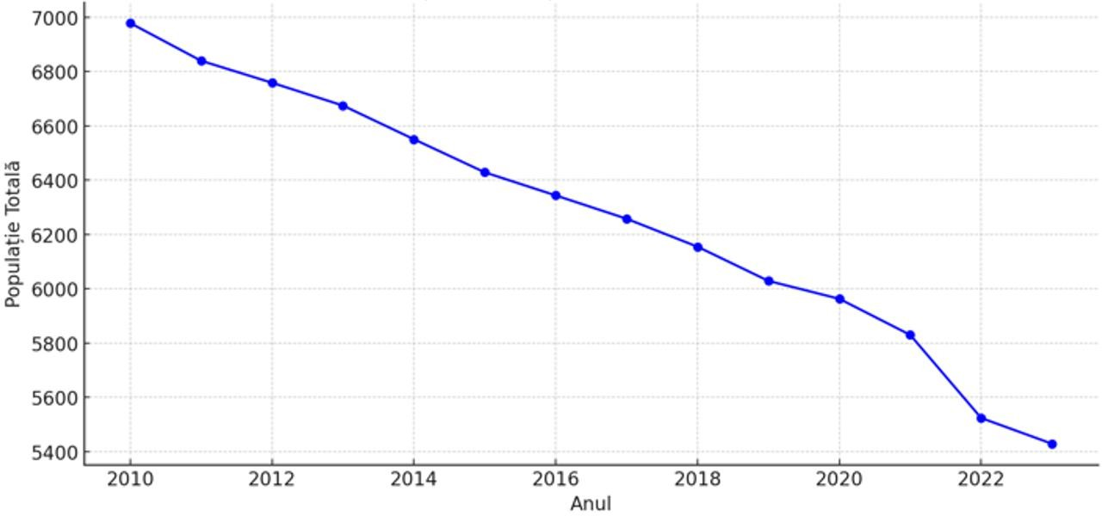

Figure 67 Total population evolution between 2010 and 2023 in Bulgaria

The construction and operation of the wind farm outside the town of Cerchezu won't affect people in Bulgaria. As mentioned in the previous chapters, during construction, noise, vibrations, and dust emissions will be local and temporary, with a low impact. During the operational phase, the noise produced by the turbines will be below 40 dB in the reception areas, complying with legal limits. The shadow effect is insignificant, and the visual impact is subjective. During the decommissioning phase, the impact will be similar to that during the construction phase, being local and temporary. In this respect was elaborated the ,,Shadow Flickering Study” in order to accomplish the condition imposed by the letter of the Ministry of Environment and Water of the Republic of Bulgaria, no. 99.00.268-40/17.09.2025 the mandatory conditions to be included in the regulatory act to be issued by the competent authorities in Romania for the investment in question, both in the planning, design phase, and the monitoring measures subsequent to the implementation of the investment proposal, respectively after the construction of the proposed investment:
,, ... 2. "The Wind Farm 48 (46) wind turbines, transformer stations, electrical connection networks, construction and modernization of communication and access roads" – will be implemented in compliance with all the measures provided in the Environmental Report submitted, in order to prevent, reduce and eliminate adverse effects on the environment, the living environment and the health of the population, as a result of the implementation of the project...”. The studiy conclusions are: ,, ...The shadow flicker assesment was conducted using a conservative worst – case scenario, asuming continuous turbine opration, uninterrupted sunlight and full visibility from all receptor directions. Despite de unrealistic conditions, the results confirm that none of the modeled receptors – either the road crossing Romania and Vulgaria or receptors near the boundary – exceed the IFC thresholds of 30 hours per year or 30 minutes per day. This indicated full compliance with interational standards. The negligile impact observed within the study area, including bith transboundary roadside and receptors, is further supported by conservative modelling approach, which was based on the largest turbine configuration and an extended study radius.”

Biodiversity

A number of natural areas of community interest in Bulgaria have been identified in the vicinity of the project, at a distance of less than 5 km: BG0000569 Kardam, located approximately 410 m from the project boundary, and BG0000570 Izvorovo – Kraishte, located approximately 3.64 km from the project boundary.
A significant negative impact is expected on some species within protected natural areas: ROSCI0071/ROSAC0071 Dumbrăveni - Valea Urluia - Lacul Vederoasa, ROSCI0157/ROSAC157 Pădurea Hagieni - Cotul Văii, ROSPA0036 Dumbrăveni, ROSPA0166 Plopeni-Chirnogeni, ROSPA0094 Hagieni Forest-Cotul Văii, BG0000569 Kardam, BG0000570 Izvorovo – Kraishte. The groups potentially significantly affected by the implementation and operation of the wind energy project will be terrestrial mammals, chiroptera, and avifauna.
A detailed analysis of the project's impact on biodiversity components for the two areas in Bulgaria was carried out in the Appropriate Assessment Study prepared at the PUZ stage, as well as in the annexes to this study, and was submitted to the Bulgarian side as part of the cross-border environmental impact assessment procedure with Bulgaria for the PUZ stage. By letter No. 99-00-268-22/26.06.2025, the Ministry of Environment and Water of the Republic of Bulgaria communicated that, " The impact analysis of the project to build 46 turbines near the border with Bulgaria is objective and the proposed measures are sufficient to minimize/eliminate the negative impact on biodiversity and in particular on Natura 2000 protected areas.”
Soil/subsoil

The northern part of Bulgaria, on the border with Romania, is relatively anthropized and has predominantly fertile soils. The distribution of land use categories in the coverage area, on Bulgarian territory, in the vicinity of the proposed project, shows an area of arable land (majority), with small intercalations of deciduous forests, predominantly agricultural land mixed with natural vegetation, discontinuous urban space, and industrial or commercial units.
In terms of impact on soil and subsoil, there is no significant impact on soil and subsoil in the neighboring territory of Bulgaria. During the execution phase, the impact on the soil is temporary and reversible, limited to the perimeter of the construction works (on Romanian territory). Any sources of pollution from vehicle and machinery activities are monitored and controlled to prevent contamination. In addition, wind turbines have a small footprint compared to other forms of energy, which limits soil erosion and compaction.
During operation, the wind farm does not generate pollutants that affect soil or subsoil quality, thus ensuring long-term environmental protection.

Water

The closest surface water bodies identified in the project area on Bulgarian territory are located south of the site boundary: BG1DJ900R1015 at a distance of approx. 1 km, BG2DO700L017 at a distance of approx. 34 km, and BG2BS000C001 at a distance of approx. 36 km, southeast of the site boundary.
The project area is located in the vicinity of two groundwater bodies in Bulgaria (BG1G000000N049 and BG1G0000J3K051).
The construction and operation of the Cerchezu wind farm will not involve the extraction of water from underground or surface sources in the area, so there will be no impact on the hydrology of the area, nor will other activities dependent on this resource be affected.
The construction of the wind farm outside the built-up area of Cerchezu will not have a significant negative impact on the quality of surface or groundwater bodies in Bulgaria.

Air

According to the info published in the area of Bulgaria where the project is located (the North region), the following aspects have been highlighted:
- Sulfur dioxide (SO2): According to reports for the fourth quarter of 2022, SO2 standards were not exceeded
- Nitrogen dioxide (NO2): NO2 levels were within the permitted limits and did not exceed them significantly
significant exceedances.
- Fine particulate matter (PM10 and PM2.5): Problems related to PM10 pollution continued, with occasional exceedances
occasional exceedances of the standards, especially during the cold season.

As can be seen above, no significant exceedances of the limit values set by the legislation in force in Bulgaria were found in the project implementation area.
Taking into account the activities currently carried out, air quality can be considered generally good, as it is an open rural area uncluttered by urban construction and without intense industrial activity.
The construction of the wind farm outside the village of Cerchezu will not have a significant negative impact on air quality in Bulgaria. During the construction phase, dust emissions from excavation, vehicle traffic, and the installation of construction materials, as well as emissions of pollutants specific to the combustion of fossil fuels associated with machinery and means of transport, are the main sources of emissions. Erosion caused by excavation work may also alter local air quality.
During operation, wind turbines contribute to reducing greenhouse gas (GHG) emissions by replacing a quantity of electricity produced from fossil fuels, thus contributing to climate change mitigation and having a significant positive impact on air quality.

Noise and vibrations

During the construction phase, the means of transport and machinery used, as well as the activities at the work site, will generate noise and vibrations. However, given that the area is crossed by local roads and agricultural land, the impact will be local, temporary, and insignificant, with no impact on the territory of neighboring Bulgaria.
During the operational phase, the noise produced by the wind turbines will increase with the wind speed and the rotation speed of the blades. The modern design of the turbine includes nacelle insulation to prevent the transmission of mechanical noise and vibrations. The noise level varies between 92 and 107.7 dB, and noise modeling shows that in the reception areas the level will be below 40 dB.
Thus, the construction and operation of the wind farm will not generate significant noise and vibrations that would affect the territory of Bulgaria. Mitigation measures, such as the strategic placement of turbines and the use of modern technologies, will reduce noise and vibration emissions. Thus, communities and the environment in Bulgaria will not be affected.

Cultural heritage

No data sources have been found that comprehensively list all historical monuments in Bulgaria by region, as is the case in Romania. However, the construction of the proposed park will not affect the territory of Bulgaria, thus ensuring the preservation of the country's cultural and historical heritage.
In accordance with Law 22/2001 ratifying the Convention on Access to Information, Public Participation in Decision-Making and Access to Justice in Environmental Matters (the Aarhus Convention), it is essential to ensure full transparency and the involvement of the local and cross-border community in all stages of the project. This includes access to relevant information on environmental and health impacts and active public participation in the decision-making process. Compliance with this law ensures that all stakeholders are informed and have the opportunity to contribute to decision-making, thus ensuring effective and equitable management of environmental impacts.

Landscape

According to the map showing the types of landscape characteristic of the area where the project is proposed, it can be seen that the types of landscape in the project area are similar for both countries, as follows:
- Continental landscape - this area consists of hills and arable land with sedimentary soils. It is predominant in most of the project coverage area.
- Steppe landscape - this area represents a steppe landscape with hills and sedimentary soils.

Land fragmentation and relief energy are essential for understanding potential environmental impacts and for planning infrastructure projects.
In Bulgaria, in the vicinity of the project perimeter, very low fragmentation prevails. The relief is moderately fragmented, suggesting the presence of low hills and valleys. This type of landscape can support diversified agricultural activities and has moderate biodiversity.
The construction and operation of the wind farm outside the town of Cerchezu won't mess with the landscape in Bulgaria.

Use of natural resources

The implementation of the wind farm in the municipality of Cerchezu, Romania, provides an opportunity to capitalize on renewable energy resources. The following resources will be used to build the park: topsoil from stripping (approximately 108,600 m³), natural soil from excavation (24,350 m³), crushed stone fill (114,250 m³), and insignificant amounts of water for various activities on site.
The construction of the wind farm will not use natural resources from Bulgarian territory, nor will it affect its natural resources. All resources necessary for the project will be extracted and managed on Romanian territory. Thus, Bulgarian soils and subsoils will remain unaffected by activities related to the construction and operation of the wind farm outside the village of Cerchezu.

Waste management

As part of the implementation of the wind farm project in Cerchezu, Romania, adequate waste management will be ensured through proper collection, storage, and disposal. The waste generated will include construction materials, packaging, and household waste, all of which will be managed in accordance with Romanian legislation. No waste will be transported or managed on Bulgarian territory, thus ensuring that Bulgaria's resources and environment will not be affected by activities related to the construction and operation of the wind farm.

Climate change

Bulgaria's national climate policy is determined, on the one hand, by the country's international commitments under the United Nations Framework Convention on Climate Change (UNFCCC), the Kyoto Protocol (KP) and the Paris Agreement, which provide the general framework for international efforts to address the challenges posed by climate change, and, on the other hand, by the obligations arising from the country's membership of the EU and from current and recently adopted European legislation in this area.
As an EU member state, Bulgaria has committed to reducing greenhouse gas (GHG) emissions by 55% by 2030 compared to 1990 levels, as part of the EU's goal to achieve climate neutrality by2050.
According to the National Report on the State and Protection of the Environment in Bulgaria 29, major GHG emissions for the period 1988-2021 are trending downward. In 2021, total GHG emissions amounted to 53,917.27 Gg CO2-eq. This means that GHG emissions have decreased by 52.55% compared to emissions in the reference year 1988.
41F
The following three graphs show the quantities of the main GHGs emitted by different sectors in Bulgaria.

28https://ec.europa.eu/regional_policy/whats-new/newsroom/21-12-2023-eu-supports-just-climate-transition-in-bulgaria-with-a-budget-of-eur1-2-billion_en

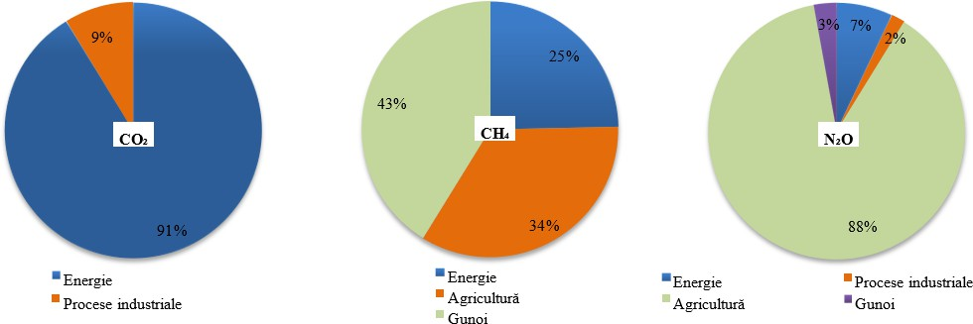

Source: National GHG Inventory Report 2021
Figure 68 Share of main sources of GHG emissions in 2021, %

The National Report on the State and Protection of the Environment in Bulgaria 30presents the following aspects regarding
42F
climate factors:

- average annual temperature - between 1988 and 2021, the average annual air temperature for the lower part of the country fluctuates between 10.6°C and 13.3°C, as shown in the graph below
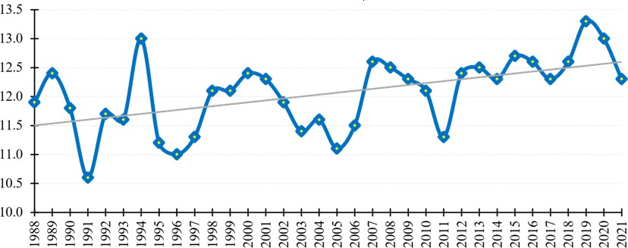

Source: NIMH
Figure 69 Fluctuations in average annual air temperature (oC) between 1988 and 2021
In 2021, the average annual temperature for the lower part of the country was 12.3 °C, which is 0.3 °C above normal. This is the thirteenth warmest year in the period 1988-2021, and January is the fifth warmest since 1930 – an average of 2.5 °C above the monthly norm (from +1.2 °C in the village of Kostenets to +3.7 °C in Ruse).

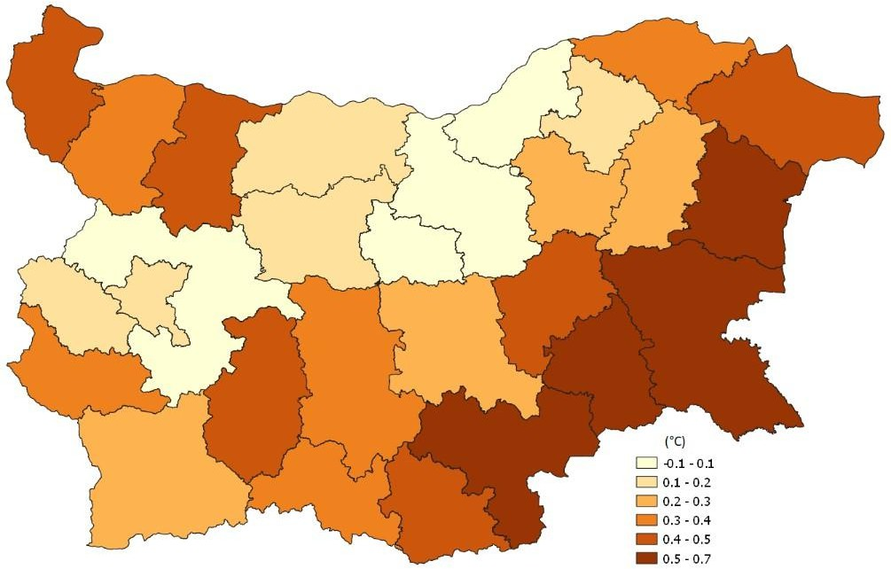
Source: NIMH
Figure 70 Deviations of the average annual air temperature (°C) in 2021 from the climate norm
for the period 1991-2020

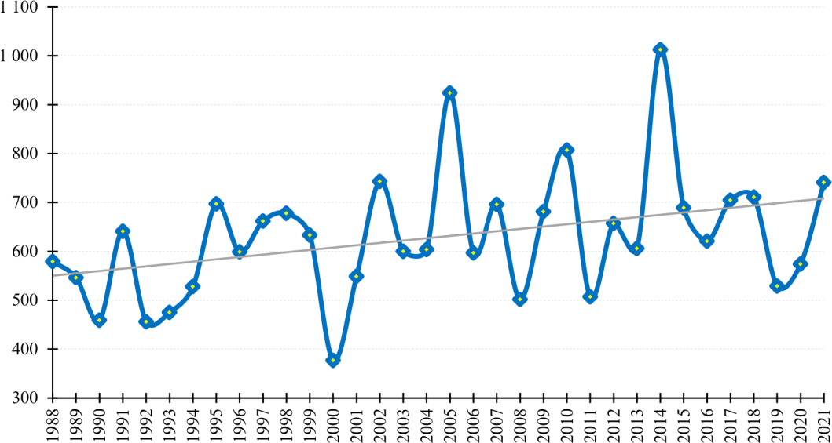
- The average annual precipitation for the period 1988-2021 for regions with an altitude of up to 800 m varies between 377 mm and 1013 mm, while maintaining the positive trend of this indicator (+4.2 mm/year). In 2021, the average annual precipitation was 741 mm, which is about 20% above the norm for the period 1991-2020.

Source: NIMH
Figure 71 Fluctuations in average annual precipitation (mm) for regions with an altitude of up to 800 m in the period 1988-2021
- Snow - during the period 1988-2021, there was no significant downward trend in fluctuations in the average maximum snow depth in areas with an altitude between 800 and 1800 m. The value for 2021 is 43 cm – below the average for the period 1991-2020.
Climate phenomena - Between January 8 and 12, 2021, torrential and river flooding was recorded, mainly in western and southeastern Bulgaria, due to heavy rainfall, combined in some places with snowmelt. In the districts of Sofia, Blagoevgrad, Yambol, and Burgas, the amount of rainfall over 72 hours exceeded the monthly norm by three times. A state of disaster due to

flooding, destroyed bridges, and broken roads was declared in eight districts. Heavy snowfall
in northwestern Bulgaria led to power outages in many places.

A comprehensive analysis of the construction, operation, and decommissioning phases shows that noise, air quality, water, and other environmental components at the border remain permanently below the limits permitted by European standards, meaning that the project does not pose any significant risks to the population or ecosystems of the neighboring country.
To clarify the extent to which the operation, construction, and decommissioning of the wind farm may affect the health of the population in the neighboring country, the following paragraphs summarize the results of noise, air, water, and vibration modeling, reported in relation to internationally established safety thresholds and European legislation, as well as the potential associated climate benefits.
- Noise and vibrations

Construction/decommissioning. SoundPLANnoise modeling shows that, at the most exposed point of the Romanian localities, the equivalent continuous level reaches ≈ 36 dB(A) – below the limit of 55 dB(A) per day and more than 1 km from the border; the area where 55 dB(A) could be exceeded is limited to < 5 ha, directly on the work front and at a maximum of 300 m from it.
Operation. After commissioning, the cumulative noise of the 46 turbines is modeled at < 40 dB(A) in villages and 27 dB(A) at the Natura 2000 site BG0000569 "Kardam" in Bulgaria, i.e. +0.2 dB above the natural background and well below the WHO guideline of 40 dB(A) at night. The calculated increase in the nearest households is only 0.008-0.016 dB – clinically imperceptible.
Thus, the potential cumulative impact of the plan with the activities in the area (agriculture around the plan, transport infrastructure Road II-29 Dobrich–border - 1.5 km and energy infrastructure – Karnobat wind farm – 5.6 km) will be low, insignificant.
Health implications. The literature cited in the report mentions cardiovascular effects at chronic exposures > 45 dB(A); the value at the border (27 dB(A)) remains ~18 dB below this threshold, resulting in a virtually zero risk for the Bulgarian population.
- Air quality

Construction activities produce dust and exhaust gases, but ADMS modeling indicates a contribution below detectable levels at the boundary line; locally, the PM₁₀ background level in the municipality is ~12 µg/m³, which is less than half the European limit of 40 µg/m³.
During operation, the turbines do not emit pollutants, and the energy produced replaces gas or coal generation,
reducing regional emissions.

Thus, the potential cumulative impact of the plan with activities in the area (agriculture around the plan, transport infrastructure Road II-29 Dobrich–border - 1.5 km and energy infrastructure – Karnobat wind farm – 5.6 km) will be reduced and insignificant.
Health implications. Additional exposure to particulate matter and NO₂ is practically zero.

- Drinking water and surface water
Construction activities do not include technological discharges; rainwater is collected in gutters and infiltrates the site. There is no connection to transboundary water bodies, and DSP Constanţa monitoring shows compliant drinking water parameters throughout the Cerchezu commune.
During operation, maintenance work is carried out on platforms equipped with retention trays sized to collect any oil spills in their entirety, thus eliminating any discharge of liquid substances into the environment.
Therefore, the cumulative impact with activities in the area (agriculture around the plan, transport infrastructure Road II-29 Dobrich–border - 1.5 km and energy infrastructure – Karnobat wind farm – 5.6 km) is insignificant, as there is no vector for the transport of contaminants to Bulgaria.
Health implications. The safety of drinking water sources in the neighbouring country remains unaffected.

- Soil and seismic vibrations

During the construction phase, limited excavations and isolated foundations are carried out; the excavated soil remains on site, and the vibrations caused by the machinery are limited in time.
During operation, there is no further work on the ground, and the vibrations generated by the turbines dissipate rapidly in the geological layer, falling below the threshold of human perception at the boundary.
Cumulative potential. The sum of all sources does not exceed 0.2 mm/s at the boundary, so the effect remains
insignificant.

- Shadow flicker and visual effect

Modeling indicates 0.1–8 h/year of intermittent shadows at the closest Romanian households; at the border, the duration falls below the detection limit. The Karnobat wind farm adds an apparent angle of only 0.3–0.4°, insufficient for shadow overlap.
Cumulative potential: even if both farms were to generate shadows simultaneously, the total would remain < 10 h/year, well below the international threshold of 30 h/year, resulting in an insignificant cumulative visual impact.
- Traffic and road pollution

The increase in traffic on DJ 391 during the construction phase adds < 3 µg/m³ NO₂ and < 2 µg/m³ PM₁₀, values that dissipate before reaching the neighboring country's border.
During operation, service visits amount to only a few commercial vehicles per day, and during decommissioning, the flow of trucks is lower than during construction and limited in time.
Health implications. Pollutant concentrations remain below the limits set at European level; thus, there are no exceedances of the existing values at the level of Bulgarian communities.
- Climate benefit, with indirect health effects

The installed capacity (≈ 303 MW) will avoid ~0.55 Mt CO₂ at regional level over its lifetime, reducing the risk factors associated with mortality from fine particles and heat waves
During construction and decommissioning, CO₂ emissions from diesel fuel used in machinery are sporadic and low compared to the total carbon economy.
Health implications. By contributing to the decarbonisation of the regional energy mix, the project reduces the population's exposure to fossil-based air pollutants and limits the intensity of extreme heat waves

; these factors, which are epidemiologically correlated with the incidence of cardiovascular and respiratory diseases, are mitigated, which supports increased life expectancy and reduced public health costs on both sides of the border.
A comparative assessment of the three stages shows that:

- Construction causes localised temporary disturbances (dust, noise, inert waste), but these dissipate before reaching the border; there are no exceedances of international standards for air or noise, and water works are controlled by horizontal drilling and emergency plans.
- Operation has the lowest degree of pressure: the turbines do not emit liquid or gaseous pollutants, the noise calculated at the border is 18 dB below the maximum permissible threshold, and the project generates a net climate gain by avoiding fossil fuels.
- Decommissioning repeats the disturbances caused by construction, but over a shorter period and with the possibility of recycling over 90% of the dismantled materials; waste transport and treatment are managed exclusively within the national territory, eliminating the cross-border vector.
Therefore, no environmental factor combined over the life cycle exceeds the maximum permissible values at European level. The effects remain local, temporary, and low in intensity, and in terms of climate and energy, the balance is positive for both countries. Thus, the project has an insignificant cross-border impact throughout its operational life.
A detailed analysis of the project's impact on biodiversity components for the two areas in Bulgaria was carried out in the Appropriate Assessment Study prepared at the PUZ stage, as well as in the annexes to this study, and was submitted to the Bulgarian side as part of the cross-border environmental impact assessment procedure with Bulgaria for the PUZ stage. By letter No. 99-00-268-22/26.06.2025, the Ministry of Environment and Water of the Republic of Bulgaria communicated that, " The impact analysis of the project to build 46 turbines near the border with Bulgaria is objective and the proposed measures are sufficient to minimize/eliminate the negative impact on biodiversity and in particular on Natura 2000 protected areas."
The environmental impact assessment procedure in a cross-border context at the PUZ stage was completed after analyzing all studies and requests for clarification. The Ministry of Environment and Water of the Republic of Bulgaria, by letter no. 99.00.268-40/17.09.2025, communicated the mandatory conditions to be included in the regulatory act to be issued by the competent authorities in Romania for the investment in question, both in the planning and design phase and in the monitoring measures following the implementation of the investment proposal, i.e. after the construction of the proposed investment, namely:
,, 1. "Wind Farm 48 (46) wind turbines, transformer stations, electrical connection networks, construction and modernization of communication and access roads" – will be implemented in compliance with all measures provided for in the submitted Environmental Report, with a view to preventing, reducing, and eliminating adverse effects on the environment, the living environment, and the health of the population as a result of the project's implementation;
- Given that the energy park is located in the immediate vicinity of the border with the Republic of Bulgaria, an assessment of the impact of physical factors in a cross-border context, in particular light effects, will be carried out during the design phase. The assessment will be forwarded to the Republic of Bulgaria;

- The paint used for wind turbines (tower and rotor) must be of the "absorbent" type, so as not to create conditions for reflections of incident light;
- After implementation of the investment proposal, controlled monitoring of noise levels, non-ionising radiation and light effects at the border with the affected Bulgarian localities will be ensured. The results of the monitoring will be transmitted to the Republic of Bulgaria.
The conditions imposed by the Bulgarian state were included in Environmental Notice No. 8/20.11.2025, issued by the Constanța County Directorate for Environmental Protection, a document that was translated into Bulgarian and English and sent, in accordance with the procedures in force, to the Ministry of Environment and Water of the Republic of Bulgaria. Also, the conditions will be included into the Environmetal Permit for project phase and all the monitoring during construction and operation will be submitted also to the Republic of Bulgaria.
Also, for condition no. 2 mentioned above, the Shadow Study was submitted, whose conclusions indicate that the results show a negligible impact on the analyzed area, including in the case of cross-border roads and the evaluated receptors, a conclusion supported by the use of a conservative modeling scenario based on the largest turbine configuration and an extended analysis radius.

Project phase | Activities in the vicinity of the plan | Cumulative cross-border impact
Project phase | Activities in the vicinity of the plan | Water | Air | Ground/Basement | Natural resources | Waste | Noise and vibration | Population and human health | Climate | Cultural heritage
Construction/decommissioning | Agricultural activities – immediate vicinity | Rainwater infiltrates the soil and does not reach the transboundary rivers  No wastewater is discharged into surface water bodies crossing the border, and the regional groundwater has no significant transboundary flow. | The relevant emissions are dust and exhaust gases from machinery; dissipates quickly, and the distance to the border (> 1.5 km) and the short duration do not allow the limit concentrations to be exceeded on the territory of the neighboring state | The excavations only produce temporary storage of earth and gravel on site; There is no mechanism for the effect to cross the border. | The materials (ballast, cement, steel) come from the local market of the host country; their extraction/reduction of availability does not affect resources across the border. | Plant and construction debris are collected and disposed of at nearby licensed facilities. No waste is transported or deposited across the border. | Site noise levels (70-75 dB(A) at source) fall below 35-40 dB(A) at 1 km; at the border are below the WHO materiality thresholds, so there is no cross-border health impact. | Direct exposure is limited to nearby rural areas; The population across the border is not exposed to any additional risk factors. | GHG emissions from construction (diesel machinery) are negligible compared to the national inventory and irrelevant on a transboundary scale. | There are no common archaeological sites on the border that are influenced by the works.
Construction/decommissioning | Power generation activities (Karnobat Wind Farm) – 5.6 km | Bulgarian turbines do not discharge water; The direction of the underground flow is opposite to the border | The air is not loaded with pollutants, and there are no odor sources. | The foundations are stable; no particles are transported to Romania, the cross-border impact being zero | In the process of operating the park, no natural resources related to the Romanian state are used | The waste is not transported across borders, so the impact is zero | Given the distance from the border and the fact that the disturbance caused by the noise produced by a wind farm is felt at a maximum of 500 m, the transboundary impact is zero | The localities in the immediate vicinity, given the distance from the wind infrastructure, are not affected | The operation of the park does not bring a GHG contribution to the local level | Turbines do not influence Romanian historical sites
Construction/decommissioning | Transport infrastructure Road II – 29 Dobrich – Border with Romania – 1.5 km | Road gutters prevent cumulative cross-border impacts | Possible temporary impact due to site traffic and construction work | Existing infrastructure has no potential to have a cross-border impact | The existing infrastructure does not use natural resources other than local ones | No cross-border waste is conveyed | Even if the noise level will increase locally, it does not cumulate with the existing infrastructure | The Romanian population will not perceive changes, the exposure remaining unchanged | The climate impact will be insignificant | The existing infrastructure does not affect common cultural areas or historical landscapes
Operation | Agricultural activities – immediate vicinity | Rainwater penetrates the ground and does not reach the border rivers. | The dust produced dissipates quickly and does not increase pollution at the border. | Light tillage does not create erosion that influences transboundary soiling. | Fertilizers and fuel come from the local market; no resources from the neighboring country are used. | The straw remains in the field and is briquetted or incorporated; No waste is transported across the border. | The sound of the machines fades before the border and remains below the level allowed in rural areas. | The distance to the villages in the neighboring country is too long for risks or discomfort to occur. | Emissions from agriculture are very low and do not influence the climate abroad. | The agricultural landscape does not contain common cultural objectives that could be affected.
Operation | Power generation activities (Karnobat Wind Farm) – 5.6 km | Turbines do not generate wastewater; Any hydraulic oil is in closed circuits, with retention systems, so the risk of cross-border contamination is non-existent. | The operation does not produce atmospheric emissions; in fact, it replaces fossil sources and reduces regional pollution. | Minimal contact with the ground after the completion of the foundations; there are no erosion or contamination processes that cross the border. | The consumption of resources is limited to spare parts; their extraction is not related to territories in the neighboring state. | Maintenance waste (filters, oils) is small in volume and is managed by authorized operators in the host country. | Acoustic modelling for turbines shows < 35 dB(A) at distances > 1 km; The border is far enough, so the reception limits in the neighboring state are not exceeded. | Possible visual discomfort for the inhabitants of the vicinity (< 2 km), but the settlements across the border are further away; There are no proven medical or psychological effects at that distance. | The impact is positive (reduction of CO₂ emissions); The benefit is global, so it does not generate negative cross-border "impacts". | No cross-border sight-line heritage sites were identified that would be affected by the presence of turbines.
Operation | Transport infrastructure Road II – 29 Dobrich – Border with Romania – 1.5 km | The water from the road drains into the gutters next to the road and does not cross the border. | The normal level of traffic does not produce an increase in air pollution beyond background values. | The infrastructure does not bring a contribution of dangerous substances to the Romanian soil. | Only local resources are used | The resulting waste is disposed of locally through authorised operators | The existing noise will not be cumulated with the noise produced by the operation of the park | The level of comfort and health for the inhabitants of the immediate vicinity will not change | The operation of the existing infrastructure will not lead to an influence on the transboundary climate balance | Common cultural objectives will not be affected

DESCRIPTION OF FORECASTING METHODS

Description of the methodology used to assess the environmental effects of the project
National and European environmental protection regulations were taken into account in the preparation of this documentation. The size of the project, the types of interventions proposed by the project, its location, and the specific characteristics of the project site were also considered.
Particular attention was paid to the works proposed by the project that are likely to have a significant impact on the environment, as provided for in the General Guide for Environmental Impact Assessment approved by Order No. 269/2020, as well as the requirements of other existing European guidelines, such as the Millieu/COWI-2017 Guide.
The following steps were taken to identify and quantify the effects:
Analysis of the interventions proposed by the project and the specific activities of the execution and exploitation stages
Identification of the effects on the physical and socio-economic environment resulting from the execution and operation of the interventions proposed by the project
Identification of receptors that may be affected and classification of their sensitivity
Impact assessment - identification of quantitative and qualitative changes at the level of sensitive receptors
The criteria used to assess the significance of the impact include the magnitude of the effect produced and the sensitivity of the receiving environment likely to be affected

Figure 72 Steps taken to quantify the impact

The effects were assessed using an impact matrix, and the criteria presented in the table below were taken into account in the impact assessment:

Table 64 Criteria for assessing environmental impact
Assessment criteria | Variability | Description
Impact type | Positive | Change that contributes to improving the initial conditions.
Impact type | Negative | Change that contributes to worsening the initial conditions or introduces a new, undesirable factor.
Impact type | Neutral | No changes/An impact that involves a negative (adverse) change but also a positive change in the initial conditions.
Nature of impact | Direct | Results from the direct interaction between a project activity and an environmental factor  (e.g., permanent occupation of land areas).
Nature of impact | Indirect | Results from other activities or as a consequence or circumstance of the project (e.g., increased road traffic in the project area).
Nature of impact | Secondary | Direct or indirect impact as a result of repeated interaction between project components and environmental factors (e.g. direct secondary impact  - an impact on wildlife due to collisions; indirect secondary impact -  impact on wildlife due to habitat loss).
Nature of impact | Cumulative | The impact has the potential to generate, together with other effects/impacts from the same project or from different projects, greater changes to the environmental component under analysis.
Temporal  temporal | Period of  execution | The impact manifests itself during the implementation period.
Temporal  temporal | Operational  operation | The impact manifests itself during the operation period.
Temporal  temporal | Decommissioning period | The impact manifests itself during the decommissioning period.
Expansion  spatial | Local | The impact manifests itself locally at distances of up to 500 m.
Expansion  spatial | Regional | The impact is felt at distances > 5 km.
Expansion  spatial | National | The impact is felt across several counties.
Expansion  spatial | Cross-border | The impact is felt in neighboring countries.
Duration | Temporary | impact manifests itself on a short duration of time and possibly  intermittent/occasional.
Duration | Short term | The impact is expected to be active for a limited, short period of time and will cease entirely upon completion of the activity causing it (e.g.  noise and vibrations generated during construction).
Duration | Long term | The impact manifests itself over a long period of time, but ceases upon  the project is completed.
Duration | Permanent | The impact manifests itself in all phases of the project and remains active even after  the project closes.
Magnitude | Small | When the environmental factor has a low value and/or sensitivity. The impact can be predicted but is usually at the limit of detection and does not lead to permanent changes in the structures and functions of the receptor. In other words, the effects of the impact fall within the natural limits of variability of the receptor, without the need to restore the receptor.
Magnitude | Medium | When the environmental factor has a medium value and/or sensitivity. The structures and functions of the receptor are affected, but the basic structure/function is not affected.
Magnitude | High | Impact on receptors (resources) that may cause irreversible changes beyond acceptable limits, locally or on a larger scale. The changes may alter the long-term character of the receptor (resource) and other dependent receptors. An impact that persists after the cessation of the activity that  causes it has a large magnitude.
Probability of  occurrence | Uncertain | The probability of the impact occurring is unknown/it is most likely not to  occur.
Probability of  occurrence | Unlikely | It is possible that it will occur/manifest itself, but the probability of impact is low.  impact is low.
Probability of  occurrence | Likely | It is very likely to occur, the probability of manifestation is high.
Probability of  occurrence | Continuous | The occurrence and manifestation of the impact is certain.
Reversibility | Reversible | When the affected environmental factor (receptor) can return to its initial state  (before the impact).
Reversibility | Irreversible | When the environmental factor can no longer return to its initial state (e.g., permanent occupation of land).  land occupation).
Probability of diminution | Total | Measures can be implemented to completely eliminate the impact.
Probability of diminution | Partial | Measures can be implemented to partially eliminate the impact, in compliance with legal limits.
 | Yes | Control measures may be applied.

Evaluation criteria | Variability | Description
Probability of monitoring | No | No control measures can be applied.
There is residual impact after the measures are applied. | Yes | There is residual impact after the measures are applied.
There is residual impact after the measures are applied. | No | After the measures are applied, there is no residual impact.

For the purposes of the assessment, sensitivity was defined as the sensitivity of the receiving environment on which the effect is manifested, including its ability to adapt to the changes that the projects may bring to the environment. Five sensitivity classes were defined for the environmental factors assessed (shown separately in the analysis below).
The starting point for establishing these sensitivity classes is the current state of the environment in
project area.

Table 65 Sensitivity classes used for environmental impact assessment
Environmental factor | Sensitivity classes
Environmental factor | Very low | Low | Moderate | High | Very high
Water | Surface water bodies with ecological status, potentially poor/bad and poor chemical status  Heavily modified water bodies  No groundwater bodies | Surface water bodies with ecological status, poor ecological potential, and poor chemical status  Surface water bodies with good ecological status, good ecological potential but poor chemical status  Groundwater bodies with poor quantitative and chemical status  Project location more than 1 km away from watercourses | Surface water bodies with moderate ecological status, moderate ecological potential, and moderate chemical status  Groundwater bodies with moderate quantitative and chemical status  Surface water bodies with good ecological status, good ecological potential but poor chemical status  Surface water bodies with ecological status, poor ecological potential but good chemical status | Surface water bodies with ecological status, good ecological potential and good chemical status  Groundwater bodies with good quantitative and chemical status | If protected areas have been identified in the area where the works are to be carried out:  - areas designated for water abstraction for drinking water purposes;  - areas designated for the protection of economically important species;  - water bodies designated as recreational waters, including areas designated as bathing waters;  - nutrient-sensitive areas, including areas designated as vulnerable zones;  - areas designated for the protection of habitats or species where maintaining or improving the status of waters is an important factor for their protection, including areas important for Natura 2000.  Surface water bodies with good ecological status, very good ecological potential  and good chemical status
Air | Agglomerations and areas where the lower assessment threshold for public health is not exceeded and there are no activities in the area that could lead to an increase in the level of pollutants in the atmosphere | Agglomerations and areas where maximum concentrations are not exceeded, but the recorded values are between the lower and upper assessment thresholds for public health | Agglomerations and areas where no exceedances of the maximum concentrations set by Law No. 104/2011 are recorded but exceedances of the upper assessment threshold for the protection of human health for relevant atmospheric pollutants relevant atmospheric pollutants for the proposed project  project | Agglomerations and areas where the maximum concentration values set by Law No. 104/2011 for one or more monitored pollutants are occasionally exceeded | Agglomerations and areas where the maximum concentration values set by Law No. 204/2011 for one or more monitored pollutants are frequently exceeded
Noise | Natural areas where there are no anthropogenic noise sources | Agglomerations and areas where there are no exceedances of the level of noise during  during the day and night and no | Agglomerations and areas where noise levels are not exceeded during the day and night but | Agglomerations and areas where noise levels are occasionally exceeded during the day and  night | Agglomerations and areas where noise levels are frequently exceeded during the day and at night

Environmental factor | Sensitivity classes
Environmental factor | Very low | Low | Moderate | High | Very high
 |  | There is a prospect of being exceeded in the short term (1-3  years) | There is a prospect of being exceeded in the short term (1-  3 years)
Soil/subsoil | Industrial or heavily urbanized  Areas without high geological interest | Land used for grazing domestic animals  Arable land along  rivers | Agricultural land agricultural with moderate productivity (used for cereal crops) | Agricultural with high productivity  Land with orchards | Areas protected from a pedological and/or geological point of view  Inhabited areas and farm buildings
Biodiversity | Habitats affected by anthropogenic impact (urbanization, industrial activities) | Agricultural land agricultural intensively cultivated  Land covered with ruderal/spontaneous vegetation  Unproductive land | Land from the national forest fund | protected natural areas at local and national level  Sustainable development areas within Natura 2000 sites Natural habitats  Natural of national interest, located outside the boundaries of protected natural areas  Areas where nationally protected flora/fauna species and nationally protected fish species have been identified  Grasslands of high natural value (e.g., grasslands important for feeding/nesting of certain bird species)  Semi-natural ecosystems without high conservation value  (orchards, parks, gardens) | Natura 2000 sites – areas with high conservation status RAMSAR wetlands Protected natural parks Species of Community interest Priority natural habitats Protective forests
Cultural heritage Landscape | Areas where abandoned or degraded built elements | Areas with high building density  Areas with landscape affected by urbanization/industrialization expansion Areas located more than 1 km away from cultural and historical sites  and historical sites | Areas in the vicinity of historical monuments and archaeological sites that require special protection measures | Areas within the protection zone of historical monuments and archaeological sites  Natural areas valued by ee/ | Areas of high landscape value Areas with cultural heritage sites included in the UNESCO heritage  Areas with protected natural areas
Social and economic environment | Areas with low population density per km² | Areas where other external factors oppose the implementation of the project  Areas located more than 500 m from the boundary of the site under study | Areas where stakeholders express concern about possible impacts on the local community as a result of of the implementation of the project | Areas dependent on a specific resource that will be used for the project and could affect the local community  Areas in where landowners oppose the implementation of this project and consider that their | Areas at risk of flooding for transport infrastructure  Areas at risk of flooding for economic activities  Areas at risk of flooding for agricultural land  Areas at risk of flooding for  public utility networks

Environmental factor | Sensitivity classes
Environmental factor | Very low | Low | Moderate | High | Very high
 |  |  |  | would be affected the and  quality | Areas at risk of flooding for health and life  Areas where the health of the population is affected by environmental conditions

To assess the magnitude of the impact, a color-coded rating system was used, on a scale ranging from significantly negative to significantly positive, with intermediate values: weak and moderate, as follows:
Table 66 Magnitude of impact on environmental factors
SIGNIFICANT  IMPACT | Negative  Significant | Negative  Insignificant | Neutral | Positive  insignificant | Positive  Significant
Type of impact | Direct and  cumulative | Direct and indirect | None  impact | Direct and indirect | Direct and  Cumulative
Reversibility  of impact | Irreversible | Momentary and  reversible | No  impact | Immediate impact  and reversible | Irreversible
Temporal  temporal | Temporary scale  extended | During  construction | Without  impact | During  construction | Temporary staircase  Extended
Spatial  spatial | Regional/National  /  Cross-border | Local | None  impact | Local | Regional/National  /  Cross-border
Duration | Long term | Short/medium term | None  impact | Short/medium term | Long term
Frequency of occurrence | Periodic Permanent | Accidental Intermittent  Once/temporary | Once/temporary | Accidental Intermittent  Once/temporary | Periodic Permanent
Probability  of occurrence | Very likely | Probable/unlikely | Unlikely | Likely/unlikely | Very likely
Significance threshold  significance | Significant | Not significant | No  impact | Significant | Not really
Possibility of reduction | None | Total | None  impact | Total | None
Possibility of  monitoring | None | Total | None  impact | Total | None

The environmental impact assessment was carried out separately for each relevant environmental component, during the project's operation and decommissioning phases.
Estimates of the potential impacts of the project were made using standardised methodologies and internationally recognised modelling tools, supplemented by project-specific data and the professional experience of the consulting team.
Calculations related to the estimation of pollutant emissions into the atmosphere were performed based on EMEP/EEA methodologies, and the dispersion of pollutants in the air was modeled using dedicated software, ADMS 6, widely used in environmental impact assessments.
Ambient noise modeling was performed using the SoundPLANnoise application, both for the execution phase and for the operation phase, in accordance with the ISO 9613-2 calculation model, taking into account the maximum capacity operating scenario.
The analyses were based on technical data provided by the designer, including the spatial location of the project, the areas affected temporarily and permanently, the type and number of heavy machinery and vehicles used, the volumes of work, the quantities of materials involved, and the estimated volumes of waste generated. In addition, estimates and assumptions based on the experience of the consultant and the designer, obtained from similar projects and the results of other relevant assessments and simulations, were used, thus ensuring a consistent and realistic approach to impact forecasts.

Description of the methodology used for impact assessment on climate change

The climate change impact assessment took into account Commission Communication No. 373/01/2021 Technical Guidelines on Climate Resilient Infrastructure for 2021-2027 and the JASPERS Practical Sector Guides on Climate Resilience Energy – Municipal Solid Waste – Transport. version 1.0 - November 2024
The assessment process was based on two components:

- Climate change mitigation (climate neutrality)
- Climate change adaptation.

Climate change mitigation (climate neutrality)

Wind farms themselves are not included among the categories of projects that have an explicit obligation to calculate and report their carbon footprint, according to Romanian national legislation or standard European environmental regulations (e.g., EIA Directive 2011/92/EU amended by 2014/52/EU).
Wind farms contribute directly and significantly to climate change mitigation by producing electricity from renewable sources, with very low greenhouse gas (GHG) emissions during operation. Wind energy replaces electricity production from conventional fossil fuel sources, thus contributing to the reduction of CO₂ emissions and other atmospheric pollutants at the energy system level.
Although there are emissions associated with the wind farm's life cycle, mainly in the turbine manufacturing, transport, construction, and decommissioning phases, these emissions are recovered in a relatively short period of time (carbon payback), usually estimated at 1–2 years of operation, depending on the technical characteristics of the project and the national energy mix. Over the entire life of the project, the net balance of emissions is strongly positive, contributing to the decarbonization of the energy sector.
By producing renewable electricity on a large scale, wind farms support the increase in the share of renewable energy in the national energy mix and reduce dependence on fossil fuel power plants, including those used to cover peak consumption. This reduces both direct GHG emissions and indirect emissions associated with the extraction, transport, and combustion of fossil fuels.
Emissions avoided as a result of the wind farm's operation refer to the amount of GHG emissions (expressed in tCO₂e) that are no longer generated because electricity produced from wind sources replaces high-carbon energy in the energy system. The level of emissions avoided depends on the estimated annual production of the farm and the emissions factor of the replaced electricity.
.

Environmental Impact Report Wind Farm Project 48 (46) wind turbines approx. 316.8MW (303.6MW), transformer stations, connection grids, construction and modernization of communication and access roads

Climate change mitigation (climate neutrality)
In order to identify the climate risks to which the project will be exposed and to identify measures for adapting to climate change, two stages are followed:




Preparation,

Detailed assessment – STAGE II

YES

Review – STAGE 1 (adaptation)

NO Based on sensitivity, exposure, and vulnerability analysis, there are climate risks to the project that warrant detailed analysis
Climate risk assessment, including analysis of probability of occurrence and impact

Addressing significant climate risks by identifying, assessing, planning, and implementing relevant adaptation measures

Assessment of the scope and need for regular monitoring and follow-up, for example of critical assumptions regarding future climate change

Verification of consistency with EU and, where appropriate, national, regional, and local strategies and plans on adaptation to climate change

Documentation of the review of climate change resilience

Stage 1 (Review) - the analysis is divided into:

- Sensitivity Analysis;
- Risk Exposure Assessment;
- Vulnerability Analysis;
Regardless of the planned location of the project, the purpose of this stage is to assess the extent to which a type of infrastructure could be affected by a particular climate risk. This stage refers to the type of infrastructure proposed without taking into account the specific characteristics of the project location.
If the sensitivity analysis of risk exposure and vulnerability assessment reveals climate risks
(significant potential), then proceed to step 2.

The list of climate risks taken into account is presented in the following table.

Table 67 List of climate risks
Climate hazards | Wind farms
CHRONIC
Temperature change/temperature variability
Permafrost thawing
Changing wind patterns
Precipitation pattern change/Precipitation or hydrological variability
Sea level rise; Saltwater intrusion
Coastal erosion/soil erosion
ACUTE
Heat wave
Cold wave/frost
Fires
Extreme wind (including storm, hurricane, tornado)
Drought
Flooding/Heavy rainfall
Landslides/Avalanches/Subsidence

COMMISSION COMMUNICATION - Technical guidance on climate-proofing infrastructure for 2021-2027 (2021/C 373/01) recommends four categories of sensitivity scores, as presented in the table below.
Table 68 Sensitivity scoring system
Class | Score |  | Description
Sensitivity  High | High | 3 | Climate hazards could have a significant impact on assets and processes, inputs, outputs, and interdependencies as a result of climate risk arising from the proposed investment's operation being interrupted for more than 2 days
Medium sensitivity | Moderate | 2 | Climate hazards could have a minor impact on assets and processes, inputs, outputs, and interdependencies, as a result of climate risk, the operation of the proposed investments will be interrupted for 1-2 days.
Sensitivity  Low | Low | 1 | Climate hazard climatic no has no impact (or has an impact insignificant)  Operation of the proposed investments will be interrupted for up to 24 hours  Non-critical assets/operations may temporarily lose functionality, but the repercussions  are considered minimal
No  sensitivity | No  impact | 0 | No possible impact of climate hazards on any component of the project No impact on the ability to manage the infrastructure – under normal operating conditions

The purpose of the exposure analysis is to identify hazards that are relevant to the site of the "Regional water and wastewater infrastructure development project in Vaslui County," regardless of the type of project.
The exposure analysis focuses on the site, while the sensitivity analysis focused on the type of project.
The exposure analysis is structured in two parts:

exposure to the current climate
- exposure to future climate (medium term – RCP 4.5 scenario and long term – RCP8.5 scenario). Historical and current data available for the project site were taken into account for the assessment of current and past exposure.
Given that the project development period began in 2018, data for this year was also analyzed for the assessment of current exposure, data for this year was also analyzed.

Climate model projections were analyzed to understand future exposure. Particular attention was paid to changes in the frequency and intensity of extreme weather events.
According to the "COMMISSION COMMUNICATION Technical guidelines on climate-proofing infrastructure for 2021-2027 (2021/C 373/01)", the projected increase in global average temperature is essential for selecting global and regional climate data sets. It is important to note that for a given project location, local climate variables may change differently than the global average.
The European Commission's technical guidance on integrating climate considerations requires examination (adaptation in phase 1) to cover exposure at the project site and other places where project interdependencies may be affected, e.g., water supply projects where water resources are distant from treatment and distribution facilities. This could be extended to cover a project's area of influence on climate hazards, as evidence to support cumulative impact assessment in the environmental impact assessment.

The specific steps of an exposure assessment are shown in the following diagram:

  Period |  |   Climate projection/scenario  Climate |  |   Changes in exposure indices,  Hazards
- Define and document the life span of the proposed infrastructure. This should reflect the operational life span of the project.  - It is considered that economic development in response to the project is longer than the life of the project investment.  - Based on these, select a time period for future exposure assessment. It should always be more than  50 years. |  | - Choose the most appropriate projection regarding climate change.  - Looking 50 years into the future, all scenarios have a very similar projection of sea level rise. However, in 100 years there are notable differences in impact between scenarios. |  | - Specific hazard analyses and existing hazard and risk maps (e.g., flood hazard maps) have already translated climate change indicators into a hazard.  - For other climate impacts, indicators, expert opinion, and interpretation of how climate impacts will affect the environment will be needed. affect affects climate-related hazards.  - Defining a rating level for  ssessment initial and  future exposure (from 0 to 3).

Climate projection of scenarios considered for assessment

The exposure assessment took into account the latest available IPCC reports (currently the 6th Assessment Report AR6) in terms of shared socio-economic pathways (SSPs).
For Romania, data for RCP (Representative Concentration Pathways) scenarios were available at the local level. These selected RCP scenarios are comparable to SSPs. RCP scenarios are used in climate change modeling to predict the impact of greenhouse gas emissions on the climate.
It is expected that the wind farm will continue to operate for a period of 25 years, so more extreme projections were taken into account.
The exposure assessment was based on the following climate projections:

The exposure assessment was based on the following climate projections:

- RCP 2.6 for current exposure (2025-2040) represents the stringent trajectory and assumes that CO2 emissions will begin to decline starting in 2020, reaching 0 in 2100.
- RCP 4.5 for medium-term exposure (2041-2070) – in this scenario, emissions peak
in 2040, followed by a slow decline thereafter
- RCP 8.5 for long-term exposure (2071-2100) – the most pessimistic scenario in which emissions
continue to rise throughout the 21st century

It is anticipated that the first year of project operation will be in the middle of the short-term period (2026-2040) and therefore the conditions of a 1.5 °C warmer world will be used as the current exposure data. If RCP 1-2.6 is followed, this will also reflect the long-term future exposure of the project location.
RCP4.5 is considered a stabilization scenario, which means that it assumes that mitigation measures will be sufficient to stabilize radiative forcing at approximately 4.5 W/m² by the year 2100 (higher radiative forcing leads to a warmer climate). It assumes a moderate increase in greenhouse gas emissions over the coming decades, followed by a significant reduction over the course of the century, thanks to the adoption of clean energy technologies and effective environmental policy.
On the other hand, RCP8.5 is a high emissions scenario, sometimes described as a "business as usual" scenario, assuming that no major changes will be made to emissions policy, leading to a continuous increase
in greenhouse gas emissions throughout the 21st century. This scenario projects a radiative forcing of approximately 8.5 W/m² by the end of the century, leading to significant increases in global temperature and severe climate change.
Data available on RO-ADAPT was used to assess future exposure. Up to 2005, the data is based on measurements taken by the National Meteorological Administration. After 2005, the data are fully simulated using the RCP4.5 and RCP8.5 forecast scenarios, as defined by the Intergovernmental Panel on Climate Change (IPCC).

Transposing climate change impact indices to exposure to climate hazards

Past and recent climate trends were not used to assess future exposure because the future trajectory of climate change impacts is often not captured. They were used to inform current exposure. Relying solely on trends to assess impact could lead to the development of projects that are not resilient to climate impacts across a range of plausible futures.
The following table shows the scoring system established for exposure assessment, the method used to assign exposure scores for each climate hazard.
Table 69 Exposure assessment rating system
Exposure type | Scoring system  for |  | Description
High  High | High | 3 | - Any hazard: has occurred (current exposure) or is expected to occur (future exposure) several times in five years  - Flood hazard: For climate hazards for which hazard or risk mapping is available, this would be the exposure in maps with a high probability of occurrence [e.g., for flood hazard and risk maps, this may be 10% AEP (annual exceedance probability)].  - Extreme temperature: region with very high average temperatures in summer (above 23 °C) and a large number of hot days (Tmax≥35 °C). Very high average temperatures in summer (above 23 °C). Heat waves have a  frequency of ≥ 1 event per year
Moderate exposure | Moderate | 2 | - Any hazard: has occurred (current exposure) or is expected to occur (future exposure) twice in 10 years  - Flood hazard: For climate hazards for which hazard or risk mapping is available, this would be the exposure in the medium probability maps (e.g., for flood hazard and risk maps, this may be 1% of AEP)  - Extreme temperature: the average summer temperature exceeds 20 °C. Heat waves  occur once every 1-5 years
Exposure  Low | Low | 1 | - Any hazard: a hazard has occurred (current exposure) or is expected to occur (future exposure) once every 25 years  - Flood risk: For climate hazards for which hazard or risk mapping is available, this would be the exposure in low probability maps (e.g., for flood hazard and risk maps, this may be 0.1% of flood risk programs)  - Extreme temperature : average temperature in during summer has acceptable values  acceptable (≤20 ºC). Heat waves have a frequency of ≤ 1 event every  every 5 years.
There is no exposure | No  exposure | 0 | - Any hazard: there is no possibility of the hazard occurring at the project location (e.g., an inland project cannot be exposed to coastal erosion)  - Flood hazard: For climate hazards for which hazard or risk mapping is available, the project location is outside the low probability maps (e.g., for flood hazard and risk maps, this may be 0.1% of flood risk programs)  - Extreme temperature: No heat waves are expected
For the current climate (i.e., the first year of operation of the proposed project), exposure was assessed by considering the recent history of the project site and where it has been affected by climate hazards such as floods, drought, high temperatures, or coastal erosion.

For climate hazards, for which detailed hazard and risk mapping data were not available, the exposure level assigned to these climate hazards was based on the most exposed component of the project.
The purpose of the vulnerability analysis is to identify the climate hazards relevant to the specific type of project at the planned site. The vulnerability of a project is a combination of two aspects: how sensitive the project components are to climate hazards in general (sensitivity) and the likelihood that these hazards will occur at the project site now and in the future (exposure). These two aspects can be assessed separately or together.
An initial examination may focus on climate hazards classified as "high" in the sensitivity analysis and/or exposure analysis as input for the vulnerability assessment.
Vulnerability scoring is based on the methodology in the following figure.

Table 70 Vulnerability matrix – scoring system
Vulnerability = Sensitivity * Exposure
Score | Vulnerability class
≥6 | High vulnerability | The project is vulnerable to this climate risk  Move to detailed assessment (phase 2)
3 | medium vulnerability | The project may be vulnerable to this climate risk  Consideration is given to moving to a detailed assessment (phase 2)
1- | low vulnerability | The project is not vulnerable to this climate risk No transition to detailed assessment
0 | No vulnerability

Exposure
Sensitivity |  | 0 | 1 | 2 | 3
Sensitivity | 0 | 0 | 0 | 0 | 0
Sensitivity | 1 | 0 | 1 | 2 | 3
Sensitivity | 2 | 0 | 2 | 4 | 6
Sensitivity | 3 | 0 | 3 | 6 | 9
The results of the vulnerability assessment are presented below.

The vulnerability analysis showed that the project has medium to high vulnerability to the climate hazards to which the site may be exposed now and in the future.
For , this study took into account the period 2025-2100 in the vulnerability assessment.

- Current vulnerability (2025-2040),
- Medium-term vulnerability (2041-2070),
- Long-term vulnerability (2071-2100).

Stage 2 (Detailed Risk Analysis) - to quantify the impact of risk on the project under
current and future climate conditions, the analysis involves:

  - Probability Analysis;
  - Impact Analysis;
  - Risk Assessment.
If the Risk Assessment concludes that there are significant climate risks to the project, these will be managed and reduced to an acceptable level. For each significant risk identified, a risk mitigation strategy will be developed and implemented.

assess specific adaptation measures. The measures identified should then be integrated into the design and/or operation of the project to improve its resilience to climate change.
Risk assessment provides a structured method for analyzing climate hazards and their impact on the proposed project. This process works by assessing the probabilities and severity of the impact associated with the hazards identified in the vulnerability assessment (or in the initial examination of relevant hazards) and by assessing the significance of the risk to the success of the project.
The acceptable level of risk will be determined in order to identify measures for adapting to climate change, so that all risks can be managed at an acceptable level. Some acceptable risks may already be defined in construction/design standards and are therefore already taken into account in the project. The acceptable level of risk varies depending on the climate hazard and is identified in climate change scenarios or described in qualitative terms.
The approach used to assess the risk and establish appropriate measures to mitigate and improve the potential impact that climate change and its adverse effects may have on the works proposed in this project is presented below.

Probability of occurrence

The probability of occurrence represents the probability that an event will occur in the area where the proposed works are located. To assess the probability of occurrence of a hazard, a rating scale from 1 to 5 is used, the meanings of which are shown in the table below.
Table 71 Risk exposure probability assessment scale
Rating system
5 | Almost certain
- The incident is very likely to occur, even repeatedly
- 95% probability over the lifetime of the project
- The project component is presented as being exposed in risk/hazard maps with a high probability
of occurrence (e.g., current/future map with 10% AEP of flood risk)
4 | Probable
- The incident is likely to occur
- 80% probability of occurrence during the project's lifetime
- The project component is shown as being exposed in risk/hazard maps with a medium probability
of occurrence (e.g., current/future map with 2% AEP of flood hazard)
3 | Possible
- The incident occurred in another country with similar climatic characteristics
- 50% probability of occurrence during the project lifetime
- The project component is shown as being exposed in risk/hazard maps with a medium probability
of occurrence (e.g., current/future map with 1% AEP of flood hazard)
2 | Unlikely
- Considering current practices and procedures, this incident is unlikely to occur
- 20% probability of occurrence over the lifetime of the project
- The project component is presented as being exposed in risk/hazard maps with medium probability
of occurrence (e.g., current/future map with 0.1% AEP of flood risk)
1 | Rare
- Very unlikely for the risk to occur
- 5% probability of occurrence during the project's lifetime
- The project component is not presented as being exposed in risk/hazard maps with probability
(e.g., current/future map less than 0.1% AEP of flood hazard)
Table 72 Risk areas and severity for wind farms

Risk area Severity

RA1: Asset damage/Process disruption | Extensive physical damage: Wind turbines are susceptible to damage from extreme weather conditions such as hurricanes, strong winds, and lightning, which can lead to downtime and increased repair costs.  Turbine component wear: The mechanical components of wind turbines, including the gearbox and bearings, are subject to wear over time.
RA2: Safety and health | Maintenance and inspection risks: Maintenance, repair, and inspection activities on wind turbines can pose safety risks to workers if precautions are not taken to account for all hazards, electrical risks  and the remote nature of offshore turbines.
RA3: Environment | Manufacturing turbine components: The production of wind turbine components, including the manufacture of blades, towers, and nacelles, contributes to embodied carbon. The energy-intensive processes involved in  producing materials such as steel and composites release greenhouse gases, adding to the overall carbon footprint of wind farms and contributing to climate change.  Transportation and installation: Transporting turbine components to construction sites and subsequent installation involves additional carbon emissions. The logistics of transporting large and heavy components over significant distances  contributes to the embodied carbon of wind farms.
RA4: Social | Energy affordability and social acceptance: Communities that rely on wind energy may face challenges to energy affordability if turbines experience frequent outages or malfunctions, affecting energy supply and overall social acceptance of the wind farm. Note that this  is quite unlikely in the European interconnected system.
RA5: Financial impact | Power outages: Downtime at wind farms can disrupt power supply to the grid, leading to potential financial losses for farm owners/operators, utilities, and energy consumers. Supply chain disruptions: Delays in replacing components caused by breakdowns or extreme weather events can further increase revenue losses as well as maintenance and repair costs.  RA6: Reputation
RA6: Reputation | Reliability and safety: Maintaining a positive reputation is based on demonstrating reliability and safety. Frequent turbine failures, downtime, or accidents can damage the reputation of wind farm operators.

Environmental Impact Report Wind Farm Project 48 (46) wind turbines approx. 316.8MW (303.6MW), transformer stations, connection grids, construction and modernization of communication and access roads
Depending on the hazards identified during the examination stages, levels from 1 to 5 are used to assess the severity of exposure of the designed works to these hazards, the meanings of which are shown in the table below.

Table 73 Magnitude (severity) of impact
Risk areas (RA) | Magnitude of impact
Risk areas (RA) | 1 |  |  | 2 |  |  |  |  | 3 | 4 |  | 5
Risk areas (RA) | Insignificant |  |  | Minor |  |  |  |  | Moderate | Major |  | Catastrophic
RA1: Damage to assets/processes | Qualitative: Impact can be absorbed through normal activity, with possible minor damage minor to components, with no consequences for project operation. Quantitative: Damage < 5% of total project cost of reconstruction. Immediate recovery possible. |  |  | Qualitative: Adverse event that can be absorbed through routine activities (e.g. use of redundancies), with minor consequences on operation. Quantitative: Damage 5–10%. Recovery within a few days (1–2 days). |  |  |  |  | Qualitative: Serious event requiring additional emergency and business continuity actions, with moderate consequences on operations. Quantitative: Damage 10–25%. Recovery in a few days (5–10 days). | Qualitative: Critical event requiring extraordinary business continuity actions, with significant consequences for operations. Quantitative: Damage up to ~50%. Slow recovery (e.g., 20–100 days). |  | Qualitative: Disaster with the potential to halt operations, collapse, or loss of assets/network. Quantitative: Damage > 50%. Recovery time undetermined.
RA2: Health and safety | First aid case. |  |  | Medical tr |  | treatme | ment |  | Accident Serious or temporary  temporary incapacity for work. | Injuries  injury  disability. | major/multiple, permanent or | One or more deaths.
RA3: Environment | No impact on the reference environment. Impact localized at the source. No recovery necessary. |  |  | Impact localized to the site. Measurable in < 1 month. |  |  | Perimete Recovery |  | Moderate damage with possible widespread effect.  Recovery in ≤ 1 year. | Significant damage with local effect. Recovery > 1 year. Non-compliance with environmental regulations. |  | Significant damage with widespread effect. Recovery > 1 year.
RA4: Social | No negative social impact. |  |  | Localized impacts  Localized. | Social | temporary |  | and | Long-term, localized social impacts. | Failure to protect vulnerable groups. Long-term national social impacts. |  | Loss of social license to operate. Community protests.
RA5: Financial impacts | Direct and indirect costs < 2% of annual turnover. |  |  | Direct and indirect costs 2–10% of annual turnover. |  |  |  |  | Direct and indirect costs 10–25% of annual turnover. | Direct and indirect costs 25–50% of the facility's annual turnover. |  | Direct and indirect costs > 50% of annual turnover.
RA6: Reputational | Local impact, public opinion. | Temporary | on | Local, short-term impact on public opinion. |  |  |  |  | Local, long-term impact on public opinion, with negative local media coverage. | Short-term national impact on public opinion, with negative national media coverage. |  | Long-term national impact, with potential to affect government stability.
RA7: Cultural heritage | Insignificant impact. |  |  | Short-term impact. Possible recovery or repair. |  |  |  |  | Serious damage with widespread impact on tourism. | Significant damage with national and international impact. |  | Permanent loss with major impact on society.

According to the Guide to Climate Change Adaptation and Risk Assessment in the Danube Macroregion (SEERISK, 2014), the methodological steps of a risk analysis are:
- establishing the context and identifying the risk;
- developing scenarios with the determination of the probability of occurrence of a particular hazard;
- assessing the impact of this specific hazard on the selected element at risk;
- defining risk levels/risk classification (quantitative or qualitative).
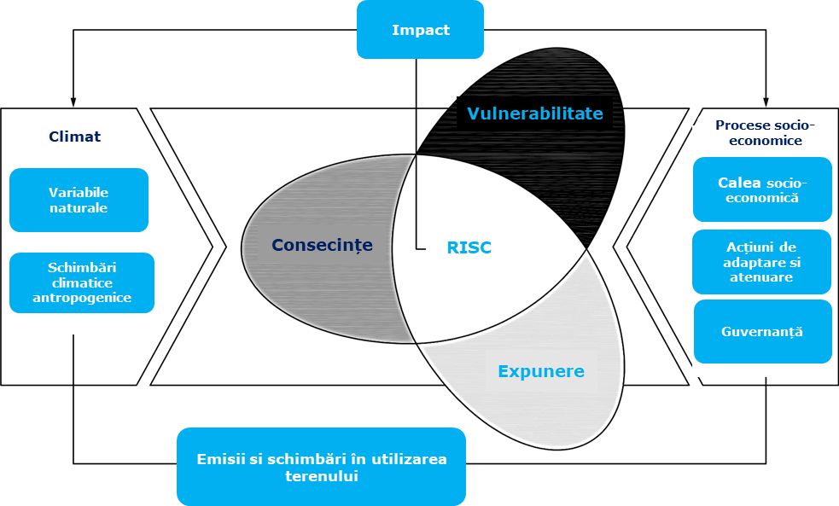

Figure 73 Illustrative diagram for defining risk
Source: IPPC, AR5

In this case, risk is assessed as a function of the probability of damage occurring and the likely consequences/severity, and is thus understood as a measure of the magnitude of a natural hazard. In this context, the identified risk has the meaning presented below.

Table 74 Risk assessment matrix
Probability x Severity = RISK
Severity score | Probability Score
Severity score |  |  | Rare | Unlikely | Possible | Likely | Almost  Certain
Severity score |  |  | 1 | 2 | 3 | 4 | 5
Severity score | Not significant | 1 | 1 | 2 | 3 | 4 | 5
Severity score | Minor | 2 | 2 | 4 | 6 | 8 | 10
Severity score | Moderate | 3 | 3 | 6 | 9 | 12 | 15
Severity score | Major | 4 | 4 | 8 | 12 | 16 | 20
Severity score | Catastrophic | 5 | 5 | 10 | 15 | 20 | 25

RISK |  | Description
1-3 | Negligible risk | No adaptation plan is likely to be necessary for these risks
4-6 | Low risk | Monitoring of these risks should be part of the project adaptation plan.
7 | Medium | Measures to mitigate major risks to the project should be considered.  Monitoring these risks may be sufficient.
12-19 | High risk | Measures to mitigate major risks to the project should be considered.
20-25 | Extreme risk | Measures to mitigate major risks to the project must be considered.

The overall risk category for each climate hazard and component is derived using the matrix in the figure above and tabulated where the risk assessment for each hazard with medium or high vulnerability will be presented. Components are grouped together to simplify the assessment process. These risk assessment tables include details on the probability and severity scoring approach, relevant built-in resilience measures, proposed adaptation strategies, and the resulting residual risk.

Adaptation measures

All risks with a medium, high, or extreme risk score must be managed to an acceptable level through climate change adaptation measures. The adaptation solutions selected must be proportionate to the identified risk level and aligned with the technical, financial, and operational resources available for the project.
Depending on the nature of the selected adaptation options, their implementation may lead to the following outcomes in terms of climate risk management:
- risk reduction, by decreasing the probability of occurrence and/or the potential consequences of impacts;
- risk sharing, for example through insurance mechanisms or other financial instruments;
- risk avoidance, including through relocation, redesign of components, or exclusion of certain exposed activities.
Appropriate measures for adapting to climate change are described in the risk assessment tables, and responsibility for implementation lies with the project owner.

Description methodology used for assessing for assessing the impact on protected natural areas
The assessment of impacts on ANPICs was carried out based on the conservation objectives of each ANPIC established by the authority responsible for the management/administration of protected natural areas of

The assessment was carried out for all habitats and species for whose protection the ANPICs were designated as potentially affected by the project, at the level of each OSC parameter.
At this stage, the potentially affected ANPICs are known and therefore the specific conservation objectives (OSC) of the habitats and species of Community interest in these sites are available.
Identifying and quantifying the impact
The type and extent of the impact depends largely on the species involved, their ecology and conservation status, as well as the location, size, and design of the entire project.
The approach proposed in this study is based on the relationship: CAUSE – EFFECTS – IMPACTS.

- The causes are represented by the interventions proposed within the project.
- Effects are physical, chemical, and biological changes in the environment resulting from a cause (examples: increased noise levels, increased concentrations of pollutants in the air, water, or soil, increased light intensity, invasion of invasive species, other effects).
- Impacts are changes occurring at the level of sensitive receptors (habitats and species) as a result of interaction with effects.
The main forms of impact that could affect the structure and functions of the protected natural areas identified for the proposed project are as follows:

Habitat loss
This form of impact consists of the loss of areas of habitat of Community interest, i.e., areas of habitat favorable to the various stages of development and activities of species of Community interest (reproduction, rest, feeding, etc.), as a result of works.
The significance of habitat loss depends on the rarity and vulnerability of the habitats affected and/or their importance as areas used by certain species for feeding, breeding, or resting, particularly in relation to the conservation of species of European interest. The potential role of certain habitats as components of corridors or important crossing points for dispersal and migration, as well as for various local movements, for example between feeding and nesting sites, should also be taken into account.

Habitat alteration
This form of impact arises as a result of physical, chemical, and biological changes to terrestrial and aquatic habitats, and includes those structural and functional changes that lead to a decrease in their carrying capacity (e.g., populations of flora species of Community interest suffer changes as a result of reduced trophic support or increased competition with alien/invasive species). Over time, altered habitats can lead to habitat loss for species of Community interest.
Habitat alteration broadly refers to a process of temporary or long-term loss of the initial, characteristic qualities of the affected areas, expressed through changes that diminish both their structure and composition and their suitability for fauna species. Habitat alteration refers to both Natura 2000 habitat types and species habitats (environments defined by abiotic and biotic factors in which species live at any stage of their biological cycle).
During the construction phase, habitat alteration occurs both on the areas where work is carried out and in the areas adjacent to them. During the operational phase, habitat alteration occurs mainly on the areas affected by the presence of pollutants.

Interventions that may lead to habitat alteration during the construction, operation, and decommissioning phases may include:
- Temporary occupation of a habitat area with materials or equipment without removing natural vegetation;
- Crossing a habitat area with vehicles without destroying/removing natural vegetation;
- The presence of pollutants that may inhibit the growth of vegetation or other organisms without destroying them;
- The introduction and spread of invasive species;
- Modification of the physical, chemical, and biological parameters of the habitat without removing individuals belonging to species characteristic of the habitat.

Fragmentation of specific habitats
While activities related to project implementation (construction and assembly phases) may result in local destruction of natural habitats on the areas occupied by the related structures, during the operational phase, habitat degradation ceases and the impact becomes negligible.
In this project, habitat fragmentation may be caused by:

- The creation of physical barriers (fences);
- The emergence of behavioral barriers (e.g., as a result of noise, artificial lighting, human presence, and others).
Noise, artificial lighting, and human presence are factors that are conventionally analyzed under the impact category "disturbance of species activity," as they are easier to quantify from this perspective.

Disturbance of wildlife activity
This form of impact is associated with human presence and human activity and occurs during both the construction and operation phases.
In the case of project implementation, the disturbance of wildlife species is due to:

- increased noise levels - noise disturbance affects not only nesting, but also inter- and intraspecific communication, reproduction, and feeding of wildlife species;
- artificial lighting - affecting the nesting and feeding activities of certain bird species, or inducing behavioral changes in the activity of nocturnal species such as invertebrates, amphibians, birds, or bats;
- human presence.
As a result of land occupation, human presence, increased noise levels, the appearance of artificial light sources, or the contribution of other effects, the following changes may occur:
- Impairment of inter- and intraspecific communication;
- Abandonment of nests/breeding areas;
- Changing travel routes, increasing the energy consumption of the individuals affected;
- Removal of individuals of a species (with their relocation inside or outside the Natura 2000 site).

Reducing population numbers
At the level of a Natura 2000 site, population reduction may occur:

Directly, as a result of:

- accidental/intentional killing of individuals;
- accidental/intentional destruction of eggs, nests.
Indirectly, as a result of other forms of impact:

- Loss of habitat area (including destruction of habitats/breeding sites). Reduction in habitat area can lead to a decline in population numbers;
- Alteration of habitats, which can lead to a reduction in food resources and indirectly to a reduction in population numbers;
- Habitat fragmentation, which can affect the reproduction of individuals or prevent them from accessing favorable habitats within the site;
- Disturbance of species activity, which may lead to the relocation of individuals outside the site.
The risk of mortality of individuals belonging to fauna species may occur at all stages of the project (construction, operation, decommissioning).

Mortality risk – bats

The mortality risk analysis for bat species was carried out using Bats and onshore wind turbines - survey, assessment, and mitigation developed by NatureScot and takes into account both the collision risk of bat species and the risk of barotrauma due to pressure differences generated by wind turbine operation, species vulnerability, their activity in the project area (assessed based on field observations), the location of the project, and the types of interventions proposed.
Based on the methodology described, the project site presents a habitat of moderate value, i.e., an area with buildings, trees, or other structures with moderate to high potential to serve as shelters, which can be widely used by bats searching for food. In terms of size, the project falls into the category of large projects (> 40 turbines) with other wind energy projects under development within a 5 km radius, with turbines taller than 100 m. Based on the initial risk assessment matrix, the project site falls into the high-risk category.
Taking into account the information listed above and the data obtained from monitoring, and using the general risk assessment matrix, the project site has a high risk in terms of collision and, implicitly, mortality for bats.
However, existing methodologies do not allow for the calculation of a potential number of victims for bat species, as is done for bird species.

Mortality risk – avifauna

The collision risk of the observed species is calculated according to the Scottish National Heritage guide: "Wind farms and Birds: Calculating a theoretical collision risk assuming no avoiding action."
In a first stage, the collision risk was assessed using two different calculation models, depending on the species phenology (migratory species or resident/migratory breeding species):
- Calculation model 1: used for flights during migration and transit flights
- Calculation model 2: used for irregular flights.

Calculation model for the risk of bird collisions with wind turbines during migration flights

This approach is used for birds that fly regularly through the wind farm in a defined and known direction. This applies, for example, to birds that migrate seasonally. The calculation method consists of five steps:
    - Defining a "risk zone" equal to the width of the wind farm and equal in height to the maximum height of the tallest wind turbine. Cross-sectional area W = width x height.
    - Estimating the number of birds n flying through this risk window per year
    - Calculating the area A described by the wind farm turbines. A = N x πR2 where N is the number of rotors and R is the radius of the rotor
    - Expressing the total area of the rotor as a proportion A/W of the risk window
    - Identification of the number of birds passing through the rotors as the number of birds in the risk window x proportion occupied by the rotors = n x (A / W)
In the case of the Cerchezu wind farm, the following input data were used:

      - Number of turbines (N): 46;
      - Maximum height of wind turbines: 170 m;
      - Rotor radius (R): 56 m;
      - Average width of the risk area: 9764 m;
      - Area covered by the wind farm turbines: 82,354,461m²;
      - Risk area surface (W): 2011384 m²;

Model for calculating the risk of bird collisions with wind turbines in the case of irregular flights
This approach is suitable for birds such as birds of prey that occupy a recognized territory and where observations have led to a certain understanding of the probability of flight distribution in this territory. The calculation method consists of six steps:
    - Identification of a "flight risk volume" Vw, which is represented by the area of the wind farm multiplied by the height of the turbines.
    - Calculate the combined volume of the wind farm's rotor action area Vr = N x πR2 x (d + l ) where N is the number of wind turbines, d is the rotor depth, and l is the length of the bird.
    - Estimating bird occupancy within the flight risk volume. This is the number of birds present multiplied by the time spent flying within the flight risk volume during the period for which the collision estimate is made.
    - Determination of the volume occupied by birds within the volume of the wind farm's rotor action area
eolian

n x ( Vr / Vw ) bird-sec
    - Calculating the time required for a bird to make a complete transit through the rotor:
t = (d + l ) / v where v m/sec is the speed of the bird through the rotor

    - Calculation of the number of bird passages through the rotors, dividing the total occupancy of the wind farm rotor action area in bird-seconds by the transit time t

Number of birds passing through the rotors = n x ( Vr / Vw ) t

In the case of the Cerchezu wind farm, the following input data were used:

      - Maximum height of wind turbines: 170 m;
      - Wind farm area – 82354461 m3 ;
      - "Flight risk volume" (Vw) – 16965019042 m³;
      - Rotor radius (R): 56 m;
      - Rotor depth (d) – 4 m.
The second step, regardless of the calculation model used, was to calculate the probability of the bird being struck when flying through the rotor area.

Total probability = (1/πR2 ) // p(r, ϕ) r dr dϕ

And,
Probability p of collision for a bird at a radius r from the hub
p(r) = ( bΩ/2πv ) [ K | ± c sinγ + α c cosγ | + l for α < β
w α F for α > β
where b = number of blades in the rotor
Ω = angular velocity of the rotor (radians/sec) c = chord width of the blade
γ = blade pitch angle
R = outer radius of the rotor
To obtain a more realistic collision risk value, both for model 1 and model 2, an avoidance rate recommended by Scottish National Heritage was taken into account: "Use of Avoidance Rates in the SNH Wind Farm Collision Risk Model."This avoidance rate is different for each species and is presented in the table in the following section.

MEASURES TO AVOID AND REDUCE IMPACT AND
MONITORING – who is responsible for each factor

Measures to avoid and reduce significant environmental impact

Within the documentation, the analysis was structured according to each environmental component likely to be affected, considering the potential effects related to the construction phase, the operation phase and, where applicable, the decommissioning phase, and specific measures for avoidance, reduction and control were established for the effects identified as relevant. The measures applicable to limit the effects on biodiversity (including technical and operational conditions) are presented in detail in the chapter on the impact on biodiversity, as they represent preconditions for implementation, and their application is expected to reduce the intensity, duration, and extent of the initially estimated impacts.
The effects that may persist after the application of avoidance and mitigation measures are treated as residual impact, which at this stage can only be estimated based on the characteristics of the project, operating scenarios, and analyses performed. Confirming the effectiveness of the measures and verifying the level of residual impact requires the implementation of an appropriate monitoring program, carried out both during the execution and post-construction periods, with parameters, frequency, and duration adapted to the components analyzed (especially avifauna and chiroptera).
In addition, given the project's location in the immediate vicinity of the border, the environmental impact assessment procedure was also carried out in a cross-border context with the Republic of Bulgaria.
The cross-border procedure was completed after analyzing the technical documentation provided and the responses to the requests for clarification made during the consultations. In this context, the Ministry of Environment and Water of the Republic of Bulgaria sent letter no. 99.00.268-40/17.09.2025, communicating the mandatory conditions to be included in the normative act to be issued by the competent authorities in Romania for the investment under review, as follows:
- Full implementation of the measures in the Environmental Report: the project will be carried out in compliance with all the measures set out in the Environmental Report, in order to prevent, reduce, and eliminate the negative effects on the environment, the living environment, and the health of the population as a result of the project's implementation.
- Cross-border assessment of physical factors during the design phase, with a focus on light effects: given the proximity to the border, a dedicated assessment of the impact of physical factors in a cross-border context, in particular light effects, will be carried out during the design phase, and this assessment will be forwarded to the Bulgarian side.
- Requirements for turbine finishes: the paint used for wind turbines (tower and rotor) must be of the "absorbent" type so as not to create conditions for the reflection of incident light.
- Post-implementation monitoring at the border: after the investment is put into operation, controlled monitoring of noise levels, non-ionising radiation and light effects at the border with the affected Bulgarian localities will be ensured, and the results of the monitoring will be transmitted to the Republic of Bulgaria.

Therefore, the documentation developed at the PUZ stage and the associated procedure provide a comprehensive framework for assessing and managing the effects by: defining the relevant receptors and areas of influence, identifying and addressing the impact mechanisms in stages, establishing avoidance/reduction measures (detailed in the biodiversity chapter), estimating the residual impact and establishing a monitoring program, including specific cross-border requirements and obligations set by the Bulgarian authorities. Also, for condition no. 2 mentioned above, the Shadow Study was submitted, whose conclusions indicate that the results show a negligible impact on the analyzed area, including in the case of cross-border roads and the assessed receptors, a conclusion supported by the use of a conservative modeling scenario based on the largest turbine configuration and an extended analysis radius.

Monitoring

Monitoring the impact generated by the execution and operation of the project serves to objectively verify the estimates made prior to implementation (including the level of residual impact), to quantify the effectiveness of the avoidance and mitigation measures already applied, and to identify, where necessary, the need for additional measures or adjustments to existing ones. The monitoring program is designed to cover both the implementation and operation periods (and, where applicable, the decommissioning phase), with a focus on the identified sensitive receptors.
The monitoring results will be integrated into a unified database, which will allow tracking the evolution of indicators over time, comparison with applicable reference/limit values, and substantiation of decisions regarding the implementation of additional measures or the expansion/optimization of monitoring locations and methods, so as to reflect the actual situation at the site and in the area of influence, including in the vicinity of the border.
The team(s) contracted to carry out the monitoring are required to perform their activities in accordance with best practices and the requirements of the applicable guidelines, to prepare periodic monitoring reports and, depending on the results, to prepare residual impact assessment reports highlighting the effectiveness of the measures implemented and any deviations from the estimated scenarios.
Regardless of the monitoring program, the holder is required to report, in accordance with the legislation in force, any accidental killing of bird species and strictly protected species, including those listed in the relevant annexes to GEO No. 57/2007, as well as any incident with the potential to affect the environment associated with the project activities.
The scope of the monitoring activities (number of campaigns, duration, intensity, and spatial coverage) will be scaled so that the data collected is representative of the entire site and the area of influence, relative to the methods applied and the seasonality of the monitored components. In this regard, a monitoring plan structured by components and subcomponents (e.g., biodiversity – avifauna/chiroptera; physical factors – noise, light effects), with the establishment of indicators, minimum duration, minimum frequency of field campaigns and reporting frequency, as well as the indication of monitoring locations/stations for each element monitored.
The responsibility for implementing the monitoring program lies with the project owner, who will contract teams of experts, ensure the integration of data in a uniform format, and report the results to the competent authorities, including in accordance with applicable cross-border requirements (where applicable).

applicable). Responsibility for the quality of the data collected and reported lies with the experts involved and the authors of the reports, which is why the project owner will include in the terms of reference for monitoring services the methodological requirements and quality standards set out in the environmental documentation.

If, during monitoring, exceedances of the maximum permissible values for the monitored indicators (e.g., noise, non-ionizing radiation, light effects) are found, these will be promptly communicated to the National Environmental Guard – Constanța County Commissariat, and the licensee will initiate the necessary corrective measures to bring the parameters back within the limits imposed by the applicable regulations and the conditions in the regulatory documents.
Depending on the results obtained during project monitoring, in the event of unforeseen circumstances or effects that require additional measures, the holder shall notify DJM Constanța of the proposed measures and how they will be implemented, and the monitoring program will be reviewed and updated periodically, in agreement with the competent environmental authority, so as to reflect the actual conditions on the ground and the requirements of the regulatory acts.
All data and information collected under the monitoring program will be reported quantitatively, with explicit indication of the units of measurement, the areas/sectors investigated, the methodology applied (including the equipment used, the sampling effort, and the working conditions), and the time intervals during which the activities were carried out (including time references where relevant, e.g., for nighttime monitoring or for parameters that vary between day and night). The results will be presented both as raw data (tables) and in graphical and spatial form, by representing the monitoring points/sectors and the distribution of the monitored indicators on maps.
Each data set will be accompanied by an interpretation of the results, which will include qualitative and quantitative assessments of the recorded values, comparison with applicable reference/limit values, highlighting of observed trends, and formulation of assessments regarding the likely evolution of the monitored indicators, including in relation to the avoidance and reduction measures implemented.
The following is the program for monitoring the impact on environmental components, with components/subcomponents, indicators, monitoring locations, minimum durations, minimum campaign frequencies, and reporting frequencies.

Table 75 Proposed monitoring program for the project

Measure |  | Affected species/habitat | Parameter addressed by the measure | Impact addressed by the measure | Timeline for implementation of measures |  |  |  |  |  |  |  |  |  |  |  | Responsible | Budget
 |  |  |  |  | 1 | 2 | 3 | 4 | 5 | 6 | 7 | 8 | 9 | 10 | 11 | 12 | Responsible | Budget
General measures
M1 | Conduct regular training for all personnel involved in construction/decommissioning works on general environmental issues, habitats and protected species, and measures to avoid and reduce impacts. Particular attention shall be paid to issues related to the prohibition of collecting plants and animals or deliberately injuring/killing protected species. | All bird species*  potentially affected and bats** in ROSCI0071, ROSCI0157, ROSPA0166, ROSPA0036, ROSPA0094, BG0000569,  BG0000570 | Population size Population trends for each species Habitat area | All forms of impact | X | X | X | X | X | X | X | X | X | X | X | X | Builder | No additional costs
M2 | Implementation of low-attractiveness lighting systems with exclusive dispersion on the ground (exclusion of incandescent bodies that generate heat) | All potentially affected bird species*  potentially affected and bats** in ROSCI0071, ROSCI0157, ROSPA0166, ROSPA0036, ROSPA0094, BG0000569,  BG0000570 | Population trends for each species Habitat area | PAS, REP | X | X | X | X | X | X | X | X | X | X | X | X | Builder | No additional costs
M3 | Compliance with the proposed work schedule and the period proposed in this project. | All bird species*  potentially affected and bats** in ROSCI0071, ROSCI0157, ROSPA0166, ROSPA0036, ROSPA0094, BG0000569,  BG0000570 | Population trends for each species Habitat area | PAS | X | X | X | X | X | X | X | X | X | X | X | X | Builder | No additional costs
M4 | Compliance with the perimeter of the proposed construction site to be located in the immediate vicinity of the work area. | All potentially affected bird species*  potentially affected and bats** and mammals* from ROSCI0071, ROSCI0157, ROSPA0166, ROSPA0036, ROSPA0094, BG0000569,  BG0000570 | Population trends for each species Habitat area | PAS | X | X | X | X | X | X | X | X | X | X | X | X | Builder | No additional costs
M5 | Carrying out activities within the perimeter on the strictly necessary areas. | All bird species*  potentially affected and bats** and mammals*** from ROSCI0071, ROSCI0157, ROSPA0166, ROSPA0036, ROSPA0094, BG0000569,  BG0000570 | Population trends for each species Habitat area | AH,PAS | X | X | X | X | X | X | X | X | X | X | X | X | Builder | No additional costs
M6 | Construction materials shall be stored only in the areas specified in the project within the site organization and work areas, without affecting the surrounding areas. | All bird species*  potentially affected and bats** and mammals*** from ROSCI0071,  ROSCI0157, | Population trends for each species Habitat area | AH, PAS | X | X | X | X | X | X | X | X | X | X | X | X | Builder | No additional costs

Measure |  | Affected species/habitat | Parameter addressed by the measure | Impact addressed by the measure | Timeline for implementation of measures |  |  |  |  |  |  |  |  |  |  |  | Responsible | Budget
 |  |  |  |  | 1 | 2 | 3 | 4 | 5 | 6 | 7 | 8 | 9 | 10 | 11 | 12 | Responsible | Budget
 |  | ROSPA0166, ROSPA0036, ROSPA0094, BG0000569, BG0000570
M7 | Avoid any spills of liquid fuels, oils, paints, etc. on the ground. In the event of accidental pollution, these will be eliminated by applying absorbent materials and removed from the site by contracting companies specialised in the management of these types of hazardous waste. | All potentially affected bird species*  potentially affected and bats** and mammals*** from ROSCI0071, ROSCI0157, ROSPA0166, ROSPA0036, ROSPA0094, BG0000569,  BG0000570 | Population trends for each species Habitat area | AH,PAS | X | X | X | X | X | X | X | X | X | X | X | X | Builder | No additional costs
M8 | Ensuring proper waste management with regular disposal without using intermediate and non-compliant storage facilities. It is prohibited to abandon waste in the immediate vicinity of the construction site and beyond. | All bird species*  potentially affected and bats** and mammals*** in ROSCI0071, ROSCI0157, ROSPA0166, ROSPA0036, ROSPA0094, BG0000569,  BG0000570 | Population trends for each species Habitat area | AH,PAS | X | X | X | X | X | X | X | X | X | X | X | X | Builder | No additional costs
M9 | Access to the work sites will be via existing access routes so as not to affect additional land areas. | All bird species*  potentially affected and bats** and mammals*** in ROSCI0071, ROSCI0157, ROSPA0166, ROSPA0036, ROSPA0094, BG0000569,  BG0000570 | Population trends for each species Habitat area | AH,PAS | X | X | X | X | X | X | X | X | X | X | X | X | Builder | No additional costs
M10 | Use of machinery and equipment to carry out the work that produces a minimum level of noise and vibration, is high-performance, low-polluting, and quiet, so that wildlife species are not affected. | All potentially affected bird species*  potentially affected and bats** and mammals*** in ROSCI0071, ROSCI0157, ROSPA0166, ROSPA0036, ROSPA0094, BG0000569,  BG0000570 | Population trends for each species Habitat area | PAS | X | X | X | X | X | X | X | X | X | X | X | X | Builder | No additional costs
M11 | Topsoil or fertile soil resulting from excavations will be properly stored and protected, then reused. Restoration of the topsoil in temporarily occupied areas. | All bird species*  potentially affected and bats** and mammals*** from ROSCI0071, ROSCI0157, ROSPA0166, ROSPA0036, ROSPA0094, BG0000569,  BG0000570 | Population trends for each species Habitat area | AH,PAS | X | X | X | X | X | X | X | X | X | X | X | X | Builder | No additional costs

Measure |  | Affected species/habitat | Parameter addressed by the measure | Impact addressed by the measure | Timeline for implementation of measures |  |  |  |  |  |  |  |  |  |  |  | Responsible | Budget
 |  |  |  |  | 1 | 2 | 3 | 4 | 5 | 6 | 7 | 8 | 9 | 10 | 11 | 12 | Responsible | Budget
Specific measures
M12 | Construction and installation works must be planned so as to take place outside the breeding and rearing seasons of species of Community interest, regardless of the presence or absence of nests on site. The planning of activities must take into account the biological calendar of the species concerned in order to prevent any negative impact on them. | All Natura 2000 components related to the protected natural areas ROSCI0071, ROSCI0157, ROSPA0166, ROSPA0036, ROSPA0094, BG0000569, BG0000570 | Population size Population trends for each species | REP | X | X | X | X | X | X | X | X | X | X | X | X | Builder | No additional costs
M13 | Turbines must be marked at night with flashing lights, with long intervals between two consecutive flashes. These turbines are easier for birds to recognize when flashing lights are used instead of continuous lights. | All potentially affected bird species*  potentially affected and bats** in ROSCI0071, ROSCI0157, ROSPA0166, ROSPA0036, ROSPA0094, BG0000569,  BG0000570 | Population size Population trends for each species | REP | X | X | X | X | X | X | X | X | X | X | X | X | Builder | No additional costs
M14 | Regular mowing of vegetation around turbines in order to maintain a low abundance of insect species that are a food source for both bat species  and birds. | All potentially affected bird species*  potentially affected and bats** in ROSCI0071, ROSCI0157, ROSPA0166, ROSPA0036, ROSPA0094, BG0000569,  BG0000570 | Population size Population trends for each species | REP |  |  |  | X | X | X | X | X | X | X |  |  | Builder | 10,000 euros/year
M15 | Installation of a conditional activation lighting system (Aircraft Detection Lighting System – ADLS) for turbines T47, T46, T35, T36, T34 to reduce the risk of mortality of species sensitive to artificial light (birds and bats). The measure will be applied from the first year of project operation. | All bird species*  potentially affected and chiroptera** in ROSCI0071, ROSCI0157, ROSPA0166, ROSPA0036, ROSPA0094, BG0000569,  BG0000570 | Population size Population trends for each species | REP | X | X | X | X | X | X | X | X | X | X | X | X | Certified and experienced builders/experts  in biodiversity monitoring  biodiversity | Approximately €100,000
M16 | To reduce the risk of mortality, the following measures are proposed: limiting the entry into production of turbines (T47, T46, T35, T36, T34) at wind speeds of 6.5 m/s, during the sensitive period (migration), starting half an hour before sunset until sunrise, and bat protection systems that emit ultrasonic deterrent signals to remove bats from the rotor wash area. The measure will apply from  the first year of operation of the wind farm. | All potentially affected bird species*  potentially affected and chiroptera** in ROSCI0071, ROSCI0157, ROSPA0166, ROSPA0036, ROSPA0094, BG0000569,  BG0000570 | Population size Population trends for each species | REP | X | X | X | X | X | X | X | X | X | X | X | X | Park owner/Certified and experienced experts  in biodiversity monitoring  biodiversity | No additional costs
M17 | The installation of collision risk prevention systems will be implemented from the first year of operation of the wind farm. An automatic control system for shutting down/reducing the operating speed of turbines (e.g., DTBird, IdentiFlight, Robin Radar Max, STRIX BirdTrack). The system will target bird species for which a significant potential impact has been identified and will be applied from the first year of operation. | All bird species*  potentially affected and in ROSPA0166, ROSPA0036, ROSPA0094 | Population size Population trends for each species | REP |  |  | X | X | X |  |  |  | X | X | X |  | Park owner  /Certified and experienced experts  in monitoring  biodiversity | Approximately €150,000

Measure |  | Affected species/habitat | The parameter to which the measure is addressed | Impact addressed by the measure | Timeline for implementing the measures |  |  |  |  |  |  |  |  |  |  |  | Responsible | Budget
 |  |  |  |  | 1 | 2 | 3 | 4 | 5 | 6 | 7 | 8 | 9 | 10 | 11 | 12 | Responsible | Budget
M18 | Installation of a video system for bird detection on turbines T8, T18, T29, T32, and T37. High-resolution camera systems will be installed. The signal deviation system must be installed during the first year of operation of the wind farm.  The camera system detects birds from a distance of up to 600 m and emits repellent sounds. If the bird continues to approach the turbine, after 300 meters the blades begin to slow down to a speed  of 3 rpm, which eliminates the risk of collision | All bird species*  potentially affected  in ROSPA0166, ROSPA0036, ROSPA0094 | Population size Population trends for each species | REP | X | X | X | X | X | X | X | X | X | X | X | X | Park owner  /Certified and experienced experts  in monitoring  biodiversity | Approximately 200,000 euros
M19 | Installation of radar systems and day and night video cameras (on turbines T8, T18, T29, T32, and T37) to detect and prevent the risk of collision of bats with wind farm structures.  The diversion signal system must be installed during the first year of operation of the wind farm. | All potentially affected bat species* in  ROSCI0071, ROSCI0157, BG0000569,  BG0000570 | Population size Population trends for each species | REP |  |  |  | X | X | X | X | X | X | X |  |  | Park owner  /Certified and experienced experts  in monitoring  biodiversity | Approximately 200,000 euros
*Aquila pomarina, Falco peregrinus, Hieraaetus pennatus, Lanius minor, Milvus migrans, Accipiter brevipes, Accipiter nisus, Acrocephalus arundinaceus, Acrocephalus palustris, Acrocephalus schoenobaenus, Acrocephalus scirpaceus, Alauda arvensis, Alcedo atthis, Anser albifrons, Anser anser, Anthus campestris, Aquila heliaca, Aquila pomarina, Bubo bubo, Burhinus oedicnemus, Buteo buteo, Buteo lagopus, Buteo rufinus, Calandrella brachydactyla, Caprimulgus europaeus, Carduelis cannabina, Carduelis carduelis, Carduelis chloris, Carduelis spinus, Ciconia ciconia, Circaetus gallicus, Circus aeruginosus, Circus cyaneus, Circus macrourus, Circus pygargus, Coccothraustes coccothraustes, Coracias garrulus, Coturnix coturnix, Cygnus olor, Emberiza melanocephala, Falco cherrug, Falco columbarius, Falco peregrinus, Falco subbuteo, Falco tinnunculus, Falco vespertinus, Ficedula hypoleuca, Fringilla coelebs, Fringilla montifringilla, Galerida cristata, Gallinago gallinago, Hieraaetus pennatus, Hirundo daurica, Hirundo rustica, Jynx torquilla, Lanius collurio, Lanius excubitor, Lanius minor, Lanius senator, Larus cachinnans, Larus melanocephalus, Larus minutus, Locustella fluviatilis, Locustella luscinioides, Lullula arborea, Melanocorypha calandra, Merops apiaster, Miliaria calandra, Milvus migrans, Monticola saxatilis, Motacilla alba, Motacilla flava, Muscicapa striata, Nycticorax nycticorax, Oenanthe isabellina, Oenanthe oenanthe, Oenanthe pleschanka, Oriolus oriolus, Pelecanus crispus, Pernis apivorus, Philomachus pugnax, Phylloscopus collybita, Phylloscopus sibilatrix, Phylloscopus trochilus, Porzana porzana/Calidris pugnax, Pyrrhula pyrrhula, Recurvirostra avosetta, Regulus ignicapillus, Regulus regulus, Riparia riparia, Saxicola torquata, Serinus serinus, Streptopelia turtur, Sturnus roseus, Sturnus vulgaris, Sylvia atricapilla, Sylvia curruca, Tadorna ferruginea, Turdus iliacus, Turdus merula, Turdus philomelos, Turdus pilaris, Turdus viscivorus, Upupa epops
** Miniopterus schreibersii, Rhinolophus mehelyi, Rhinolophus ferrumequinum, Myotis capaccinii, Nyctalus noctula, Pipistrellus pipistrellus

*** Spermophilus citellus, Mustela eversmanii

Transformation, electrical connection networks, construction and modernization of communication and access routes

RISK SITUATIONS

Introduction

Risk is defined as the probability of exposure of humans, their property, and components of the environment to the action of a particular hazard of a certain magnitude. Risk represents the probable level of loss and damage caused by a particular natural or anthropogenic phenomenon or group of phenomena in a particular place and during a particular period.
Two aspects are very important in risk analysis:

- consequence: characteristics of the impact (the interaction that occurs between an activity and a receptor—financial losses, health impacts, environmental impacts, etc.)
- probability: the likelihood of an event occurring (can be expressed as the frequency of occurrence of the event (units of time)-1).

Compliance with safety distances

ANRE Order No. 239/2019 approving the Technical Standard on the delimitation of protection and safety zones related to energy capacities, Annex No. 3 imposes safety distances from wind turbines, depending on their characteristics.
Thus, in the case of the Cerchezu wind farm, the installed turbines have the following characteristics (maximum values):

- the nominal power of the electric generators is 6.6-7 MW;
- tower height – 165 m
- rotor diameter – 170 m;
- blade length – 85 m;
- tower base diameter – 7 m.

Safety distances are measured from the edge of the above-ground structure (i.e., from the lower edge of the tower), and in the case of a multi-component facility (wind farm), the distance from the component closest to the neighboring object is taken into account.

Table 76 Safety distances according to ANRE Technical Regulation
Name of the facility adjacent to the wind farm | Safety distance (m) | Minimum minimum  (m) | Safety Safety distance  (m) | Distances from the turbines of the Cerchezu wind farm
Public roads of national or county interest | H + 3 m, where H = tower height plus blade length H=165+85=250 m | The distance to the road axis shall not be less than 50 m | 253 | T3 is located approximately 1.55 km from DN38 T5 is located approximately 466 m from DJ 391 T9 is located approximately 267 m from DJ 391 T8 is located approximately 461 m from DJ 391 T10 is located approximately 260 m from DJ 391 T12 is located approximately 717 m from DJ 391 T39 is located approximately 881 m from DJ 3919 T16 is located approximately 851 m from DJ 391 T32 is located approximately 260 m from DJ 391A  T32 is located approximately 680 m from DJ 391A
Municipal public roads, local public roads | Equal to the length of a shovel | Not less than 30 m | 85 | T40 is located approximately 686 m from DC 19 T41 is located approximately 384 m from DC 19 T34 is located approximately 634 m from DC 18 T37 is located approximately 352 m from DC 18 T31 is located approximately 167 m from DC 17 T29 is locatedapproximately 424 m from DC 17
Railways | H + 3 m, where H = tower height plus blade length | The distance to the railway axis shall not be less than  100 m | 253 | Not applicable. There are no railway lines in the project area.
Power lines | H + 3 m, where H = the height of the pylon plus the length of the blade | - | 253 | T40 is located approximately 680 m from LE Cerchezu-Măgura  T41 is located approximately 384 m from LE Cerchezu-Măgura  T37 is located approximately 305 m from LE Măgura-Viroaga  T34 is located approximately 588 m from LE Măgura-Viroaga  T32 is located approximately 630 m from LE Viroaga-  Olteni
Aerial overhead telecommunications  telecommunications | H + 3 m, where H = the height of the tower plus the length of the blade | - | 253 | -
Above-ground pipes carrying flammable fluids | H + 3 m, where H = height of the pole x 1.5 plus the length of the blade If the target is fenced, the safety distance is measured  to the fence | - | 332.5 | Not applicable. No above-ground pipelines for flammable fluids have been identified in the project area  in the project area
Oil and natural gas extraction facilities, oil pumping, stations regulation  gas measurement stations | H + 3 m, where H = tower height x 1.5 plus blade length | - | 332.5 | Not applicable. No oil and natural gas extraction facilities, oil pumping stations, natural gas metering stations, or other facilities that could affect the project area have been identified in the project area.  natural gas metering stations
Bridges | H + 3 m, where H = the height of the pylon plus the length of the blade Where applicable, the distance is set equal to H + 3 m if a national road, a county road, or a railway crosses the bridge.  taking into account the conditions imposed above for roads and paths | Not more than less than  30 m | 253 | T27 is located approximately 1597 m from a bridge over which the local road from the village of Căscioarele passes

Name of the facility adjacent to the wind farm | Safety distance (m) | Minimum minimum  (m) | Safety Safety distance  (m) | Distances from the turbines of the Cerchezu wind farm
railway, respectively a distance equal to the length of a blade, but not less than 30 m, if a communal road, a
local road or a private road
Dams, dykes | H + 3 m, where H = the height of the tower plus the length of the blade | - | 253 | Not applicable. No dams or dykes have been identified in the project area.  dams, dykes
Inhabited buildings | H = height of the pylon x 3; This distance may be reduced, in relation to the residential area, with the agreement of the local community, to a minimum value equal to the height of the pylon plus the length of the blade.  + 3 m; - The distance of the wind turbine intended to meet the consumption needs of a residential area shall be at least equal to the height of the tower plus the length of the blade + 3 m; - The distance of a wind turbine belonging to a residential property is not regulated. | 253 | 253 | T5 is located approximately 1053 m from the inhabited building in the village of Cerchezu  T27 is located approximately 1237 m from an inhabited building in the village of Căscioarele  T31 is located approximately 1134 m from an inhabited building in the village of Viroaga  T35 is located approximately 1171 m from a building  in the village of Măgura
Production and/or storage buildings classified in category A, B or C  fire hazard | H + 3 m, where H = height of the pylon plus length of the blade | - | 253 | Not applicable. No production and/or storage facilities classified as category A, B, or C have been identified in the project area.  fire hazard
Airports | This is determined with the approval of the competent authorities, which are mentioned in the urban planning certificate. | - | - | -
Telecommunications transmission and reception facilities
telecommunications
Historical sites and buildings
Areas with protected flora and/or fauna
protected
Approved sports grounds | H + 3 m, where H = the height of the tower plus the length of the blade | - | 253 | T21 is located approximately 63 km from the Central Stadium – Gheorghe Hagi Academy  In the town of Negru Vodă, there is a municipal stadium, which is not approved and is  is located about 4.29 km from T9
Car parks on open-air platforms  outdoors | H + 3 m, where H = the height of the pillar plus the length of the blade | - | 253 | Not applicable

Safety distance from public roads of national or county interest
In the area where the Cerchezu wind farm is located, the identified transport infrastructure includes:

  - DN 38 Constanta – Negru Voda
  - DJ391 Mangalia – Negru Vodă – Cobadin – Tuzla
  - DJ391A

Spatial analysis of the project location in relation to national and county transport infrastructure confirmed that the wind turbines are located within the safety distance from these, in accordance with ANRE Technical Regulations. The minimum distance requirement is 30 m, and the safety distance for this wind farm is 253 m. The closest road to the wind turbines is DJ391A 244H, located 260 m from T32.

Safety distance from public municipal or local roads

The minimum regulated distance for municipal or local public roads is 30 m, and the safety distance for this wind farm, calculated based on the height of the blades, is 85 m. The closest municipal and local public roads to the project's turbines are as follows:
  - T40 is located approximately 686 m from DC 19
  - T41 is located approximately 384 m from DC 19
  - T34 is located approximately 634 m from DC 18
  - T37 is located approximately 352 m from DC 18
  - T31 is located approximately 167 m from DC 17
  - T29 is located approximately 424 m from DC 17

Safety distance from railways

Not applicable, there are no railway lines in the project area

Safety distance from overhead power lines (LEA) and telecommunications lines
The safety distances regulated for overhead power lines and telecommunications lines are 253 m. The shortest distance to the power line located in the western part of the site is 305 m measured from wind turbine T37. The safety distance is respected for all wind turbines included in the project.

Safety distance from bridges

According to the regulations in force, the safety distance calculated based on the height of the turbines is
253 m. The Cerchezu wind farm meets the safety distance requirements for bridges, the

nearest such structure is the road bridge on the local road in the village of Căscioarele, located at a
distance of 1597 m from T27.

Safety distance from dams

Not applicable, as no dams or dykes have been identified in the project area.

Safety distance from residential buildings

The residential buildings in the area of the site are represented by houses in the localities of Cerchezu, Căscioarele, Viroaga, and Măgura. In this case, the regulated safety distance calculated in accordance with the height of the turbines is 465 m.
Following the spatial analysis, it was found that the closest dwelling is located in Cerchezu, 1053 m away from the closest wind turbine, T5. Therefore, all dwellings in the villages neighbouring the proposed wind farm are outside the established safety zone.

Other risks

Seismic risk

From a seismic point of view, in accordance with Standard P 100-1/2013 (Seismic Design Code), Part 1 – Design Provisions for Buildings, the location of the Cerchezu wind farm is characterized, for seismic events with an average recurrence interval (of magnitude) IMR = 225 years, as follows:
  - design ground acceleration ag = 0.10 g/0.15 g;
  - control period (corner) Tc = 0.7 sec.

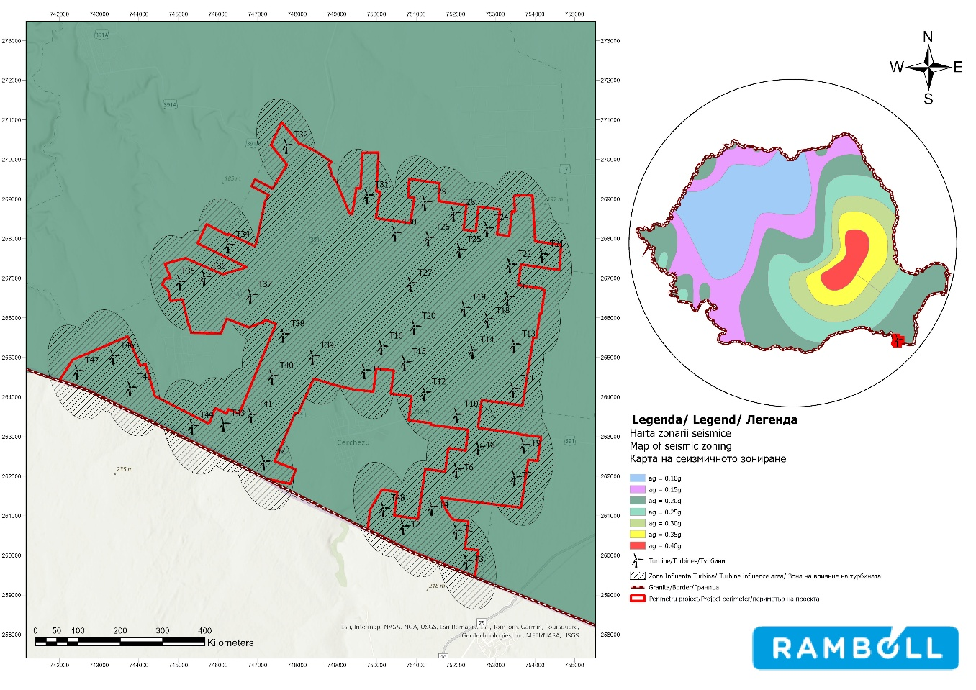

Figure no. 74 Seismic zoning map in terms of peak ground acceleration values (ag)
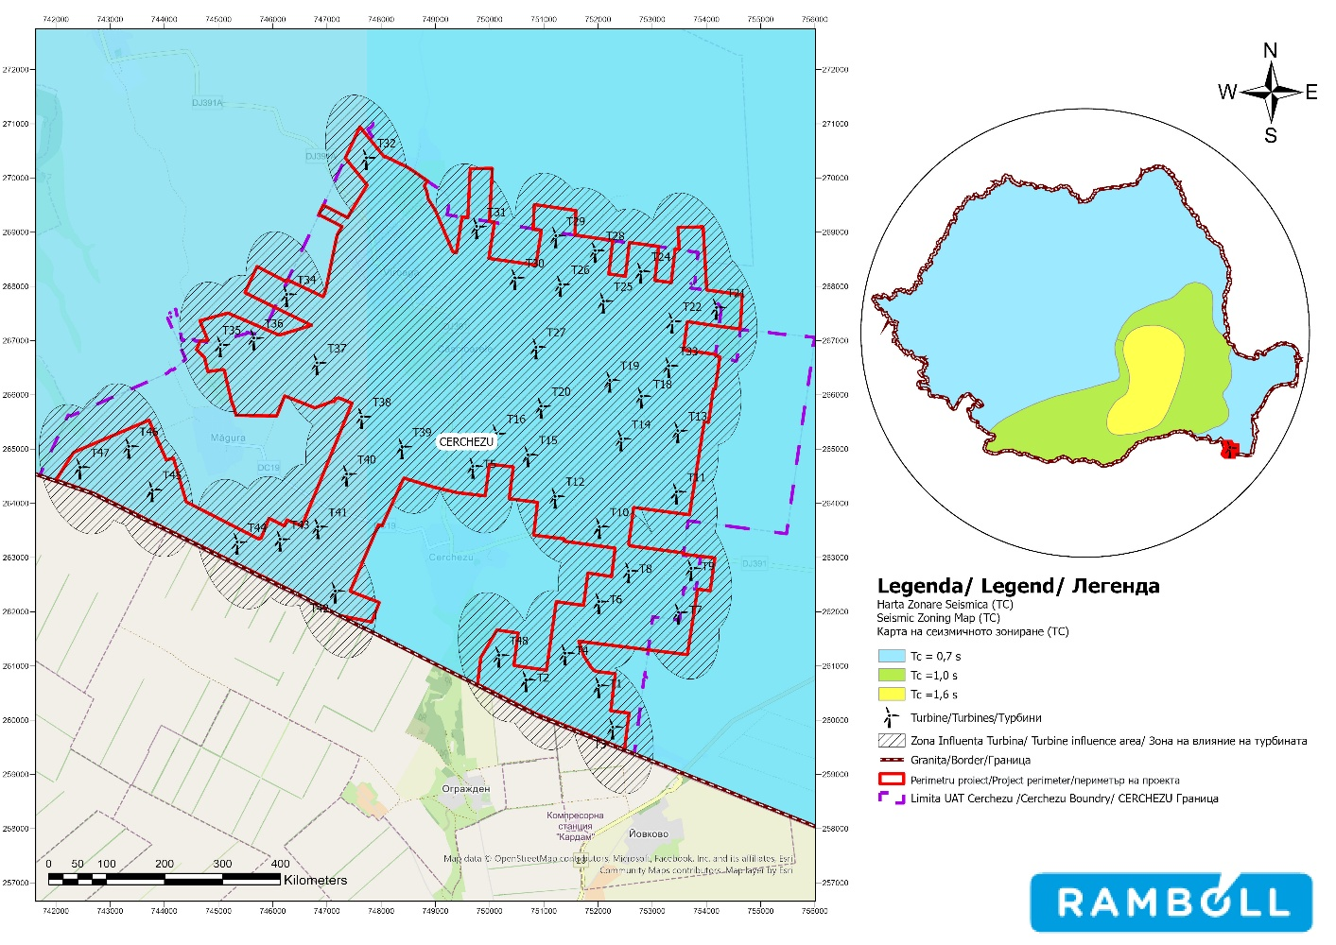
Figure no. 75 Seismic zoning map in terms of control period (Tc)

Given the above, exposure to earthquake risk in the project implementation area is very low.

Landslide risk

Landslides are caused by gravitational forces, but can be triggered by a variety of processes. Some of the most common triggers include earthquakes and prolonged and/or intense periods of rainfall. Deforestation can also increase the likelihood of landslides.
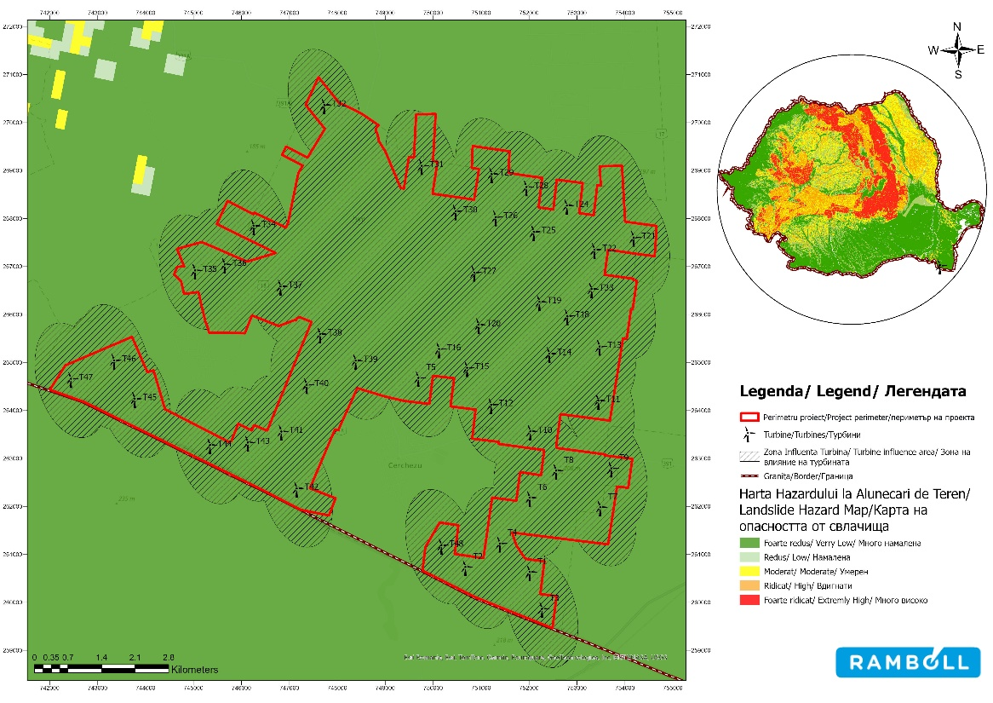
Figure 76 Landslide hazard zoning map

In the Cerchezu commune, the risk associated with landslides is very low, and it can be concluded that
that the risk of landslides in the Cerchezu wind farm area is very low.

Lightning risk

The direct and indirect effects of lightning can cause damage to the mechanical and electrical components of wind turbines, resulting in significant and undesirable reductions in turbine efficiency and serious damage.
The analysis of the risks posed by lightning was based on the study by Anderson, G & Klugmann, D. (2014), which presents the lightning density values in Europe for the period 2008-2012. Expressed in lightning strikes/km²/year, the maximum values recorded in Europe were 7.9 km²/year, while in the area of project implementation values range between 1 and 1.6 lightning strikes/km²/year, which can be considered an average value.

The electrical discharges are captured by the turbine blades through a receiver that transmits them through a conductor inside the rotor. From there, they pass into the hub through special pre-stressed and conductive connections capable of withstanding the power of lightning. The current passes from the busbar to the tower through pre-stressed and resistant connections. It can be discharged at the base of the tower, in parallel, through PE-insulated cables that are connected to the base of the structure and to the nacelle through grounding bars. From here, the current flows to the wind turbine foundation. If the electrical discharge occurs through a lightning rod, it is conducted to the main base of the turbine, and from there the current has the same flow as that from the rotor blades.
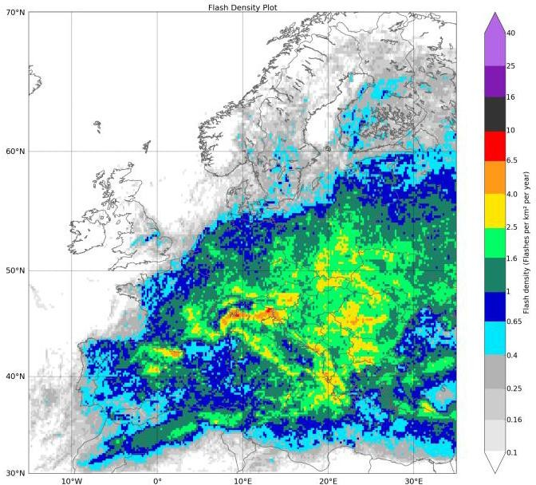

Source: Anderson, G., & Klugmann, D. (2014)

Figure 77 Annual density of detected lightning strikes

Risk of strong winds

Strong wind gusts are the cause of much damage to wind turbines worldwide. The effects
of these risks depend mainly on the technical characteristics of the turbines and the climatic conditions of the location.
Wind turbines have an automatic system for orienting the rotor according to the wind direction, combined with systems for changing the angle of the blades to maintain consistency at high wind speeds and to optimize the power generated at low wind speeds. The wind speed at which the turbines will be disconnected is 24.5 m/s, and the speed at which they will be reconnected is 22.5 m/s.
The risk of damage to wind turbines as a result of extreme winds could arise in the event of spontaneous failure of the automatic turbine disconnection systems (when wind speeds exceed 24.5 m/s). Although the probability of such a situation occurring is low, it should be emphasized that the effects on the turbines can be catastrophic (including blade breakage and even turbine collapse).
According to the paper "Climate change – from physical bases to risks and adaptation", prepared by the National Meteorological Administration (ANM) in 2015, wind speed shows major changes in its long-term evolution. Ninety-three percent of all stations in Romania show a downward trend in average annual wind speed. The intra-Carpathian region is less affected than the rest of the country. Regional climate models indicate minor changes in wind speed at the end of the century (2071-2100), showing an increase of 1 m/s.
The probability of an accident (especially one that could involve the population) caused by strong winds is low.

Fire risk

Fires are one of the main risks to which wind projects are exposed. They can be caused by natural phenomena (such as lightning), technical faults (overheating of components or electrical faults), and the quantities of combustible materials present in the nacelle.
The wind turbines in the proposed wind farm are state-of-the-art and incorporate the highest quality and safety standards.
The risk of fire is present and will be present in any installation where electronic components are found together with flammable oils and hydraulic fluids.
Fires can spread easily because the nacelle contains combustible materials such as mineral oils, lubricants, other cleaning agents and chemicals, plastic, and electrical components.
The oils used by wind turbines in the hydraulic system, in the transformer cooling system, and the oils present in the gearbox continue to pose a fire risk, with the potential to spread throughout the entire structure.
The turbines are equipped with a smoke detection system, with sensors in the nacelle, the transformer compartment, the main electrical cabinets in the nacelle, and above the high-voltage switch at the base of the tower. If the system detects smoke, the turbine safety system ensures that the high-voltage switch is opened immediately.
Wind turbines have oil spill collection systems so that any oil spills are collected at the bottom of the nacelle enclosure. The wind turbine is also equipped with smaller oil collection systems for its individual components.

Fire extinguishers are provided inside the turbine for fires that can be detected in time. As safety measures inside the power plant, the use of fire, the introduction of flammable materials, and smoking are prohibited.
The major risks in the event of a fire mainly concern the staff and especially the people inside the turbine. Their obligation is to use the appropriate fire extinguishers, and if this operation does not produce immediate results, the area will be evacuated, as there is a fairly high risk of asphyxiation.
The probability of a fire occurring in a wind turbine as a result of lightning or a technical fault is low. This is mainly due to the existence of an adequate lightning protection system, as well as measures to reduce the amount of flammable materials in the nacelle.
In the event of a fire, the most likely damage will occur at the nacelle level, with the worst-case scenario being the collapse of components (blades, rotor, entire nacelle) in the immediate vicinity of the tower (max. 75 m around the tower).

Risk of flying blades or ice

A rotor blade or part of it may be "thrown" as a result of a rotor blade failure, which could have an impact on public safety. The risk associated with a blade being thrown is negligible. Pieces of ice may fall from the rotor while the turbine is in operation or may be thrown from it while it is at rest if ice accumulates on the blades, which can occur in weather conditions specific to locations in cold areas (IFC, 2015).
Reducing these risks depends on weather conditions (especially wind), the control system with which the turbine is equipped, and the operational management procedures applied within the wind farm. Wind turbine specifications state operation at temperatures of -30°C.
Avoiding such events and identifying sensitive receptors can be achieved by calculating the distance over which such events can occur.
A simplified empirical equation was introduced in (Seifert et al., 2003): representing a "risk circle." The formula is presented below.
𝑑 = (𝐷 +𝐻 ) ∗ 1.5
Where:
d = maximum throw distance (m);
D = rotor diameter (in m);
H = tower height (m)

The IFC Guide (2015) proposes calculating "setback distances" that must be observed between turbines and populated areas. The formula is presented below.
𝐷𝑖𝑠𝑡𝑎𝑛ț𝑎𝑑𝑒 𝑟𝑒𝑔𝑟𝑒𝑠 = (𝑡𝑢𝑟𝑛 +𝑟𝑎𝑧𝑎 𝑟𝑜𝑡𝑜𝑟𝑢𝑙𝑢𝑖 )∗1.5

Considering the specifications of the turbines to be installed in the wind farm, the results of the calculations are presented in the following table.

Reference guide for calculating the risk area | Tower height  m | Rotor diameter | Rotor radius | Risk area
Seifert et al. (2003) | 165 | 170 | - | 502.5
IFC Guide (2015) | 165 | - | 85 | 375

Spatial analysis of the results obtained from the calculations (shown in the figure below) revealed that the risk areas do not intersect with any localities, and the turbines do not pose a risk to the inhabitants of nearby settlements. However, the risk areas do intersect with a number of service roads. Also, the risk circles calculated using the two formulas intersect county road DJ391 in the case of turbines T5, T8, T9, T10, and T32, as well as communal roads DC19 and T41 in the case of turbine the DC18 communal road in the case of turbine T37 and the DC17 communal road in the case of turbines T31 and T29, but they comply with the ANRE standard distance from national or county roads.
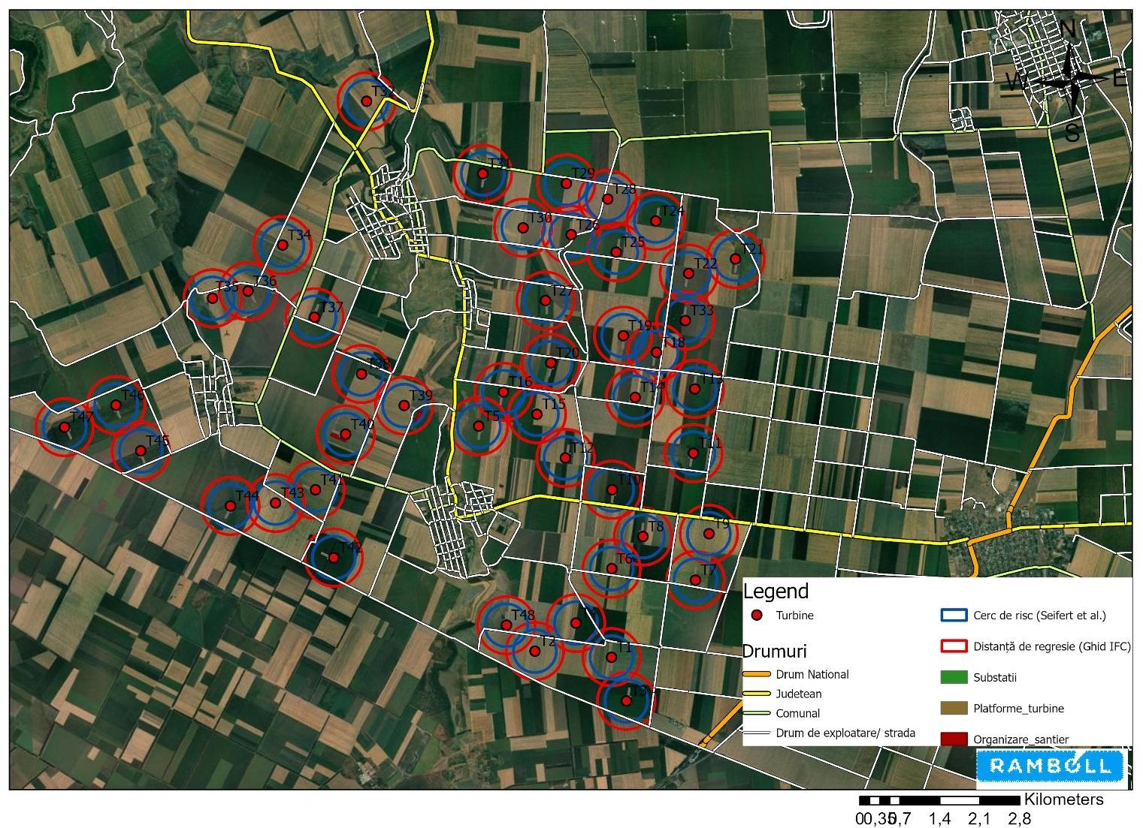

Figure no. 78 Potential radius within which ice can be thrown

NON-TECHNICAL SUMMARY

This summary has been prepared to present in non-technical language the conclusions of the Environmental Impact Report for the Wind Farm Project 48 (46) wind turbines approx. 316.8MW (303.6MW), Transformer Stations, Connection Networks, construction and modernization of communication and access roads.

Project overview

The project aims to build and operate a wind farm in Cerchezu, Constanța County, with the goal of producing electricity from renewable sources and contributing to the decarbonization of the energy mix. The configuration analysed includes 46 wind turbines (resulting from the optimisation of the sites in relation to the conditions imposed by technical approvals), the related electrical infrastructure (internal collection networks, transformer stations/equipment and connection), as well as access and site organisation works.
During the execution phase, the main activities include: site preparation, construction of foundations and technological platforms, execution/modernization of access roads, installation of electrical networks, and assembly of turbines. During the operation phase, activities are mainly limited to turbine operation and periodic maintenance work, with non-permanent staff in the substation/on site.

Project location

The investment is located outside the town of Cerchezu, Constanța County, in a predominantly agricultural landscape
agricultural landscape (arable land/pastures and farm roads), with no major industrial developments in the vicinity.

The site is located in the immediate vicinity of the border with the Republic of Bulgaria, which is why the environmental impact assessment was also carried out in a cross-border context, including with reference to the nearby Bulgarian protected areas

Project characteristics

The technology used is specific to modern wind turbines: three-bladed rotor, automatic nacelle orientation system, and blade angle adjustment to optimize production and reduce stress/noise. The turbines are programmed to start at wind speeds of approx. 3 m/s and to stop automatically at speeds above approx. 24 m/s, through safety controls (pitch and braking).
In addition to the turbines, the project includes foundations and technological platforms, internal electrical networks (cables), roads/accesses, and temporary areas for site organization, so that the execution is carried out in a controlled manner, within clearly defined perimeters, and the temporarily affected areas are restored after completion of the works.

Raw materials and natural resources

During the execution phase, the main consumption is associated with civil and electrical works. Estimates include (centralized): steel and ferrous materials ~1.147.70 t, aluminum ~72.22 t, copper ~18.86 t (0.46 t foundations + 18.40 t cables), polymers ~161.46 t (0.46 t foundations + 161.00 t cables), concrete ~22,245.14 t, and water
~7,785.77 t, and crushed stone ~1,184,018.53 m³ for roads/fillings (LCA estimate).
Water is used in different ways: bottled drinking water for staff, water for sanitary purposes provided by the contractor (usually via cisterns), and small amounts of water for technical purposes (dust suppression, moistening/maintaining foundations during the drying period), without the need for new dedicated catchments/drillings; Concrete is delivered from authorized local concrete stations. For road and platform works, crushed stone fillings are required (the documentation also includes an operational estimate of ~114,250 m³ for certain works), and the soil from excavations is managed primarily through reuse in fillings/restorations.
During the operational phase, the natural resource used for electricity production is wind (wind energy), and material consumption is limited to maintenance consumables (oils/lubricants, greases, etc.), used on an ad hoc basis.

Estimation of the type and quantities of emissions and waste

During execution, the relevant emissions are mainly temporary atmospheric emissions (dust from material handling/work on unpaved roads and exhaust gases from machinery/transport), as well as local noise and vibrations generated by construction site activities. During operation, direct atmospheric emissions are practically non-existent, and the potential effects are concentrated on noise, visual perception, and intermittent shadow flicker, which can be managed through design and operational rules.
Substances used in execution include fuels (diesel/gasoline) ~38.33 t (hazardous, flammable), coolant/other glycols ~3.22 t (hazardous) and oil ~19.17 t (non-hazardous but flammable), with environmental risks only in the event of accidental releases, which are prevented by proper storage/handling.
The estimated waste generated includes, indicatively: mixed municipal waste ~41.48 t; packaging (paper/cardboard ~0.84 t; plastic ~0.50 t); wood waste ~0.88 t; mixed metals ~259.25 t; concrete
~32.93 t; ballast waste ~20.74 t; excavated material ~48.53 t; as well as hazardous fractions (contaminated packaging ~0.77 t; waste oils ~1.30 t; oil filters ~0.15 t), with separate collection, controlled temporary storage, and delivery to authorized operators.
In operation, waste is mainly associated with maintenance: hydraulic oils ~0.35 t; synthetic oils
~2.30 t; heat transfer oils ~23.00 t; contaminated packaging ~0.19 t; plastic packaging ~0.176 t; air filters ~0.176 t (and other "n.a." fractions depending on interventions), with similar management (collection in dedicated containers and delivery to authorized operators).

Description of relevant aspects of the current state of the environment

The project area is characteristic of southern Dobrogea, with predominantly agricultural use and a degree of anthropization associated with recurrent agricultural work, the network of farm roads, and diffuse pollution specific to agriculture (fertilizers/plant protection products). These pressures result in generally simplified habitats and biodiversity that is strongly conditioned by land use.
Air quality is considered to be generally good, typical of an open rural area without intense industrial sources, and current sources of noise are mainly associated with road traffic on the DJ391 and municipal roads, agricultural activities, and occasional construction work.

In the vicinity of the border, environmental elements on Bulgarian territory were also taken into account (fertile soils, predominantly agricultural use, surface water bodies at a distance of several kilometers, and groundwater bodies in the vicinity), concluding that the project does not involve water abstraction from the site and that any cross-border effects are mainly associated with physical factors (noise/light/non-ionising radiation) and require dedicated monitoring.

Description of the significant environmental effects of the project

During execution, the potential effects are mainly local and temporary: temporary land occupation, soil modifications/compaction in work areas, risk of dust and noise emissions, construction site traffic, and risk of accidental pollution (fuel/oil). These effects are manageable through site organization, dust control, proper waste collection/management, and measures to prevent accidental spills.
In operation, the relevant potential effects are: noise, visual/landscape perception, shadow flicker, and, for biodiversity, risks specific to wind infrastructure (depending on the use of the area by birds and bats), which are addressed through avoidance/mitigation measures and post-implementation monitoring.. At the same time, the project generates a major positive effect through the production of energy from renewable sources and the reduction of emissions associated with the production of energy from fossil fuels.
Given the proximity of the border, specific cross-border requirements were established: full implementation of the measures set out in the Environmental Report, carrying out a dedicated assessment of physical factors in a cross-border context (in particular light effects) during the design phase, use of "absorbent" paint for the tower and rotor to avoid reflections, and post-implementation monitoring at the border for noise, non-ionizing radiation, and light effects, with the results being transmitted to the Bulgarian side. Also, for the above-mentioned condition, a dedicated assessment of physical factors in a cross-border context (in particular light effects) was submitted to the Ministry of Environment and Water of the Republic of Bulgaria. The shadow study, whose conclusions indicate that the results show a negligible impact on the analyzed area, including in the case of cross-border roads and the evaluated receptors, a conclusion supported by the use of a conservative modeling scenario based on the largest turbine configuration and an extended analysis radius.

Analysis of reasonable alternatives

Alternative "0" (not implementing the project) would lead to maintaining the existing situation at the site (agricultural use and associated pressures), without contributing to renewable energy production and without the climate and socio-economic benefits associated with the investment. On the other hand, it would eliminate both the temporary effects of construction and the operational effects (noise, shadow flicker, visual impact) that must be managed if the project is implemented.
The design/optimization alternatives mainly focused on: adjusting the site configuration (including abandoning two turbine positions – T17 and T23 – to comply with technical conditions/approvals), choosing technological solutions and routes/work organization so that temporary occupations are minimized, and restoring the affected areas after completion. In addition, management alternatives (operational measures, turbine finish requirements, monitoring, and adaptation) were considered to reduce the effects on sensitive receptors, including in a cross-border context.

BIBLIOGRAPHY

1. Government Decision 1076/2004 establishing the procedure for conducting environmental assessments for plans and programs
2. Generic Guide on environmental assessment for plans and programs
3. Manual for the application of the procedure for conducting environmental assessments for plans and programs
4. Guidelines on environmental assessment for development plans and programs in the energy sector
5. Guidelines on environmental assessment for land use and urban planning plans and programs
6. https://eur-lex.europa.eu/resource.html?uri=cellar:1bd46c90-bdd4-11e4-bbe1-01aa75ed71a1.0012.03/DOC_1&format=PDF
7. https://eur-lex.europa.eu/legal-content/RO/TXT/PDF/?uri=CELEX:22016A1019(01)&from=EN
8. European Green Deal (https://eur-lex.europa.eu/resource.html?uri=cellar:b828d165-1c22-11ea-8c1f-01aa75ed71a1.0020.02/DOC_1&format=PDF)
9. The 2030 Climate and Energy Package (https://eur-lex.europa.eu/legal-content/RO/TXT/PDF/?uri=CELEX:52020DC0562 )
10. European Climate Law (https://eur-lex.europa.eu/legal-content/RO/TXT/PDF/?uri=CELEX:32021R1119 )
11. "Fit for 55" legislative package
12. REPowerEU Plan REPowerEU Plan (https://eur-lex.europa.eu/resource.html?uri=cellar:fc930f14-d7ae-11ec-a95f-01aa75ed71a1.0014.02/DOC_1&format=PDF )
13. Commission Communication An Industrial Plan for the Green Deal for the Net-Zero Era (https://eur-lex.europa.eu/legal-content/RO/TXT/PDF/?uri=CELEX:52023DC0062 )
14. EU Biodiversity Strategy for 2030 (https://eur-lex.europa.eu/resource.html?uri=cellar:a3c806a6-9ab3-11ea-9d2d-01aa75ed71a1.0023.02/DOC_1&format=PDF )
15. Strategy for the exploitation of renewable energy sources
16. Romania's energy strategy 2007-2020
17. Romania's Energy Strategy 2022-2030, with a view to 2050
18. Integrated National Energy and Climate Plan 2021-2030, including the 2023 update
19. Romania's National Strategy for Sustainable Development 2030 and Action Plan
20. National Strategy on Climate Change and Low-Carbon Economic Growth
carbon emissions for the period 2016-2020
21. National Strategy on Adaptation to Climate Change for the period 2022-2030 with a view to 2050
22. National Action Plan for the implementation of the National Strategy on Adaptation to Climate Change
23. Romania's long-term strategy for GHG reduction Romania Neutral in 2050

24. National Strategy on the Circular Economy
25. Constanța County Sustainable Development Strategy for 2021–2027
26. Land use plan – Constanța County
27. South-West Dobrogea LAG Strategy 2014-2020, amended in 2023
(https://galdobrogeasv.ro/modificari-ale-strategiei-de-dezvoltare-locala/ )
28. Local Environmental Action Plan (http://apmct.anpm.ro/-/planul-local-de-actiune-pentru-mediu-constanta )
29. Danube Littoral River Basin Management Plan 2022-2027
30. CESTRIN 2022 Traffic Census
31. County report on the state of the environment in Constanța County, 2022
32. County Waste Management Plan for Constanța County
33. Final report on biodiversity monitoring within the future Dumbrăveni-Cerchezu wind farm
34. National Institute of Statistics, population statistics
35. State of Health in the EU: Romania 2021 country profile on health
36. Landscape fragmentation Effective Mesh Density time-series: major and medium anthropogenic fragmenting elements (FGA2-S) — European Environment Agency (europa.eu)
37. East, A., E.,Sankey, J. B. (2020), How is modern climate change affecting landscape processes?

Annex

ANNEX A – DOCUMENTS ANNEX B – PLANS AND MAPS

